‘Talking really helps’ suicide prevention campaign
Please support the campaign through your own social media channels by creating your own posts or liking and sharing the social content posted from:

Twitter: @publichealthni
Facebook: @publichealthagency
Instagram: @publichealthni
TikTok: @publichealthagency
Assets | Post copy
30s TV  https://vimeo.com/789740882  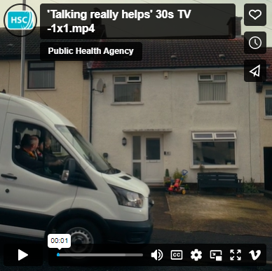 | If you are in distress or crisis, or you know someone who is, you can talk to one of Lifeline’s qualified counsellors for free, 24/7. Call Lifeline on 0808 808 8000.  Link:  Learn more at lifelinehelpline.info
Signs to call Lifeline video  https://vimeo.com/790401344  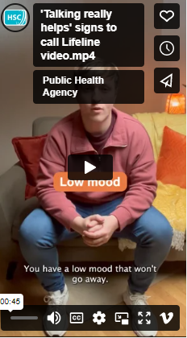 | SPOT THE SIGNS ⚠️ If you’re struggling to cope, you can speak to Lifeline’s qualified counsellors for free, 24/7. Call 0808 808 8000.  Link:  Learn more at lifelinehelpline.info
15s female video  https://vimeo.com/789080618  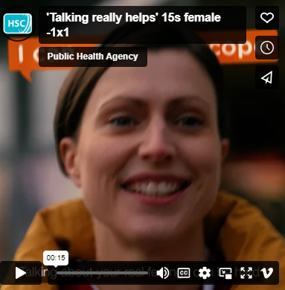 | When you are struggling to cope, it’s important to talk about it. Talk to a friend, family member of someone you trust. You can also call Lifeline and speak to a qualified counsellor for free, 24/7.  Link:  Call Lifeline on 0808 808 8000 or visit lifelinehelpline.info to learn more.
15s male video  https://vimeo.com/789080421  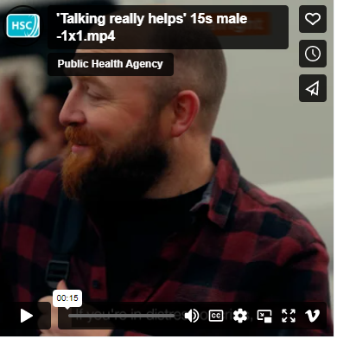 | Sometimes life can get on top of us. But that’s when talking matters most. Talk to one of Lifeline’s qualified counsellors for free, 24/7. Call Lifeline on 0808 808 8000.  Link:  Learn more at lifelinehelpline.info
Texting video  https://vimeo.com/790401516  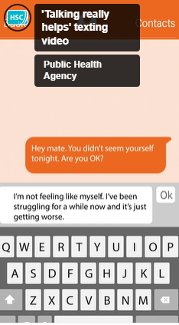 | If you are worried about someone but aren’t sure how to talk to them, you can call Lifeline for advice on 0808 808 8000.  Link:  Learn more at lifelinehelpline.info
Lifeline counsellor video (calls)  https://vimeo.com/790441470  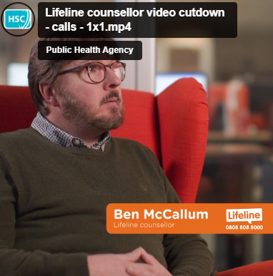 | If you’re struggling or feeling low, you can speak to one of Lifeline’s counsellors about anything that is troubling you, for free, 24/7.  Link:  Call Lifeline on 0808 808 8000 or visit lifelinehelpline.info to learn more.
Lifeline counsellor video (not a burden)  https://vimeo.com/790088196  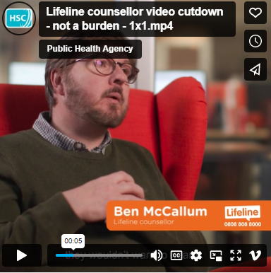 | Trained counsellors like Ben are able to provide immediate help and support to anyone in crisis or despair. If you’re struggling to cope, don’t suffer alone. Talk to Lifeline today.  Link:  Call Lifeline on 0808 808 8000 or visit lifelinehelpline.info to learn more.
Lifeline counsellor video (things can get better)  https://vimeo.com/790088275  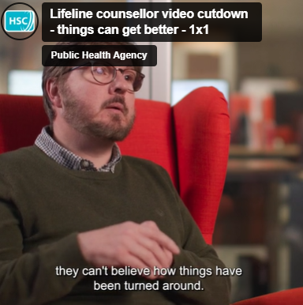 | When you’re struggling or feeling low, it’s important that you talk to someone. Because when you start talking, you can start feeling better. Speak to a qualified Lifeline counsellor for free, 24/7.  Link:  Call Lifeline on 0808 808 8000 or visit lifelinehelpline.info to learn more.
I’m not fine static  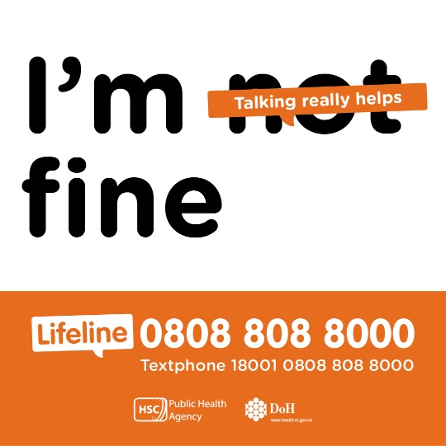 | When you’re struggling to cope, saying “I’m fine” can seem easier than talking about your real feelings. But talking is the first step to feeling better. You can talk to one of Lifeline’s qualified counsellors for free, 24/7.  OR  It can be difficult to open up and talk about your feelings when you’re struggling or going through a difficult time. But that’s when talking matters most. You can talk to one of Lifeline’s qualified counsellors today.  Link:  Call Lifeline on 0808 808 8000 or visit lifelinehelpline.info to learn more.
I’m not feeling ok static  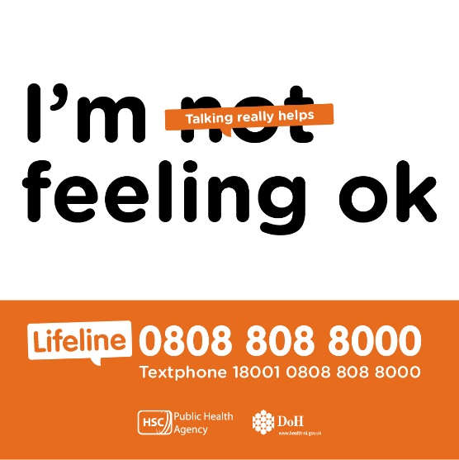 | Sometimes we think we must reach the point of crisis before asking for help. This is NOT true and reaching out for help early is a good thing. If you’re struggling, you can talk to one of Lifeline’s qualified counsellors for free, 24/7.  OR  When you’re struggling or feeling very low, saying “I’m ok” can seem easier than talking about your real feelings. But talking is the first step to feeling better. You can talk to one of Lifeline’s qualified counsellors for free, 24/7.  Link:  Call Lifeline on 0808 808 8000 or visit lifelinehelpline.info to learn more.
I can barely cope static  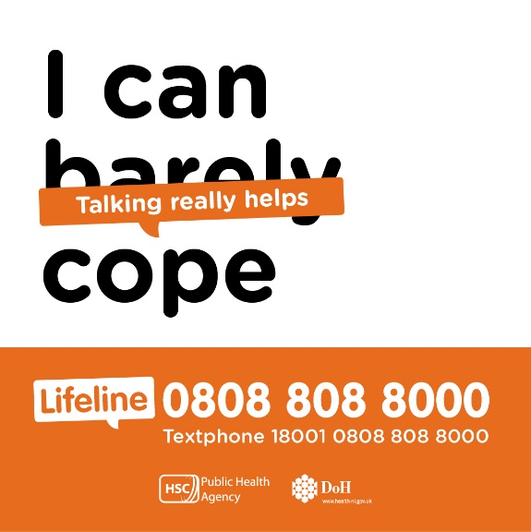 | There are lots of reasons why life can feel overwhelming. Whatever the reason, you can talk to one of Lifeline’s qualified counsellors for free, 24/7, if you are struggling to cope.  OR  If you are struggling to cope, it’s important that you talk to someone. You can speak to Lifeline’s qualified counsellors for free, 24/7. When you start talking, you can start feeling better.  Link:  Call Lifeline on 0808 808 8000 or visit lifelinehelpline.info to learn more.

