Equality and Disability Action Plans 2023-2028

Consultation Document

April 2023

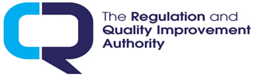
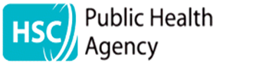

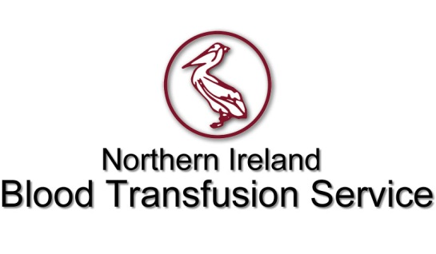
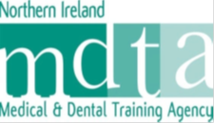
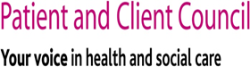

Children’s Court Guardian Agency
for Northern Ireland

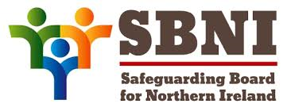

What is in this document? | Page
Accessibility information | 3
What are Equality and Disability Action Plans? | 5
What the law says | 8
How we made our plans | 8
Equality Action Plan | 9
Disability Action Plan | 10
What difference will it make? | 11

You can also get a copy of these action plans by looking on the organisations websites:

Business Services Organisation Equality and Human Rights (hscni.net)

Public Health Agency Equality | HSC Public Health Agency (hscni.net)

Northern Ireland Blood Transfusion Service Search Results for “equality action plan” – Northern Ireland Blood Transfusion Service (hscni.net)

The Regulation and Quality Improvement Authority Regulation and Quality Improvement Authority - RQIA

Social Care Council Equality and Diversity - NISCC

Patient and Client Council Equality and Human Rights - Patient and Client Council Northern Ireland (pcc-ni.net)

Children’s Court Guardian Agency for Northern Ireland Equality & Disability | NI Guardian Ad Litem Agency (hscni.net)

Northern Ireland Medical and Dental Training Agency Northern Ireland Medical and Dental Training Agency - Northern Ireland Medical & Dental Training Agency (nimdta.gov.uk)

Northern Ireland Practice and Education Council for Nursing and Midwifery NIPEC | NIPEC (hscni.net)

You can get a different version of these action plans:

- Paper copy
- Audio
- Large print
- Other languages
- Other formats

by contacting us, the Business Services Organisation

 | Telephone: 028 9536 3961
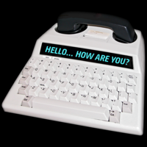 | For Text Relay use 18001 028 9536 3961
 | Email: Equality.Unit@hscni.net

This book is about our Equality and Disability Action Plans. It explains what we are going to do over the next 5 years.
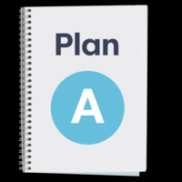

Equality Action Plan
This is a plan about what we are going to do about equality. This is to help make things more fair and equal for people in the nine equality groups in the table below.

Nine Equality Groups
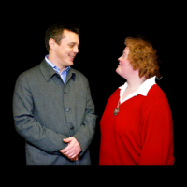 | Men and women
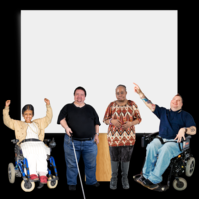 | Disabled people
People from ethnic minorities. These are people who come from another country or whose families came to Northern Ireland from another country.
It includes Irish Travellers.

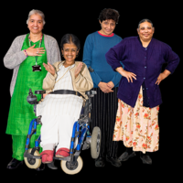 | People with different religions or beliefs
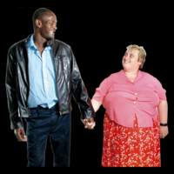 | People who have different sexual orientations. Sexual orientation means a man and woman attracted to each other, two men attracted to each other or two women attracted to each other
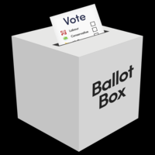 | People with different political views
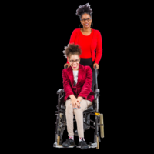 | People who care for their children or care for other adults who are sick or have a disability
 | People who are married, in a civil partnership (between two men or between two women), single, widowed or divorced
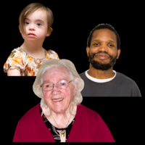 | Younger people and older people

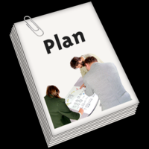

Disability Action Plan
This is a plan about what we are going to do to ensure people with a disability are treated fairly and have the same chances as people who don’t have a disability.

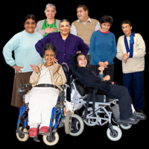

This is to make things better for people with a disability.

What the law says

The equality law says that we need to treat people in the 9 groups listed on page 4 fairly.
WHAT THE LAW SAYS

The disability law says that we must involve people with different disabilities when we plan and do things. It also says that we must encourage people to think about and treat disabled people in a positive way.

How we made our plans
We looked at what we have done so far.
We asked our staff to think about what worked well and what could have worked better.
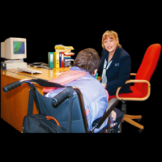
For the new plans, we asked them to think about how we can make things better for people who use our services and our staff.
We held meetings with staff to find out what we can do to improve things for our staff with a disability or who look after someone who has a disability.

Equality Action Plan 2023-2028
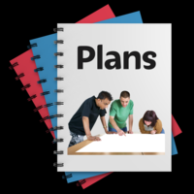
HSC is made up of several organisations who each have their own draft plans with actions that they have created.

Disability Action Plan 2023-2028:

This is a list of some of what we will do about disability.

We will provide information for staff on certain disabilities. We want all our staff to know more about disabilities.

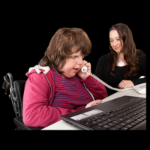

We will offer work placements for disabled people.

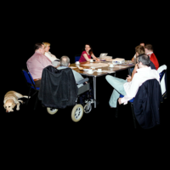

We will encourage our staff to attend our disability staff network meetings.

What difference will it make?
Disability Action Plan
People who make decisions in our organisations will know more about what it is like for staff who have a disability and what they need to do their jobs.

There will be more support for staff with a disability.

People with disabilities will get a better chance to work with us in work placements.

There will be better information on the numbers of staff with disabilities.

People with disabilities will have better access to our services.

People with disabilities will have better chances of getting a job with us. More of our staff who become disabled keep working with us.

Artwork

Artwork is from the Photo Symbols Easy-Read Library Welcome to Photosymbols

