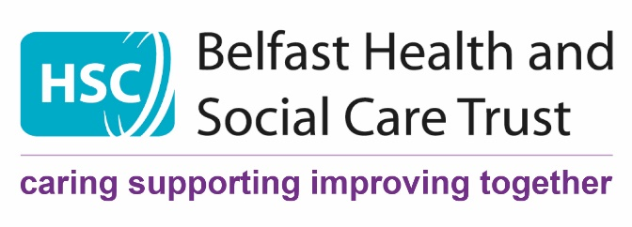

PSYCHOLOGICAL INFECTION CONTROL DURING COVID-19

EMOTIONS and BEHAVIOURS can also spread like virus
STOP, BREATHE, and then THINK – slowing our breathing slows the stress cycle and re-engages our frontal lobes – then we can think.
Constant talking and thinking about the potential or actual challenges will feed our anxiety and worry

- Keep up to date but don’t Ruminate
  - Have one or two reputable and reliable sources of information
  - Avoid constant checking on social media – especially Twitter
  - Avoid ongoing NEWS cycles on TV/ Newspapers

- Take “Covid-19 free” breaks
  - find other things to talk about during breaks
  - appoint enforcers
  - have a covid swear jar – it will buy next day’s buns!

- Have clear transitions between Home and Work
  - Use the Pre-shift and post-shift Hope in Work & Joy at Home Checklists – available on HUB
  - The trust BWell website and app have suggestions to help with sleep and emotional support

- We all have different needs during stress
  - Some need to know everything about everything
  - Others are overwhelmed by too much information
- Define a minimum level of information needed by all
- For those who want and need more info – establish other ways of sharing

Psychological Services
BHSCT

