Cervical screening: what you should know

What is cervical cancer?
Cervical cancer is cancer of the cervix (lower part of the womb). Every year there are about 80 new cases of cervical cancer in Northern Ireland. Each year around 20 women in Northern Ireland die from cervical cancer. Anyone with a cervix can get cervical cancer. Cervical screening can prevent cervical cancer from developing, or pick it up at an early stage. Early detection and treatment can prevent around 8 out of 10 deaths from this cancer.
The diagram below shows the female reproductive system with the Fallopian tube, ovary, uterus (womb) cervix and vagina labelled.
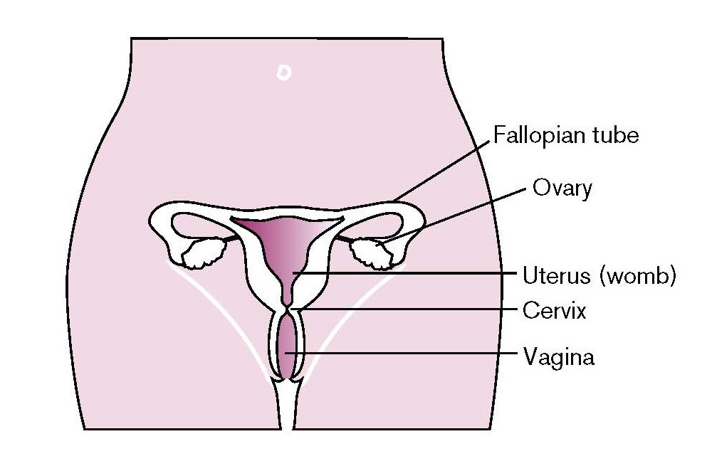

What causes cervical cancer?
Almost all cases of cervical cancer are caused by a virus called human papillomavirus (HPV). This is a very common virus that most people will have at some time during their life. It can stay in the body for many years and usually it doesn’t cause any problems.
HPV is generally spread by skin-to-skin contact. For HPV in the cervix, this is through sexual contact with a person of any gender. This can be by having vaginal, anal or oral sex, genital touching or sharing sex toys.
Only certain types of HPV can cause cervical cancer. These are called high-risk types. The types of HPV that cause cervical cancer do not have any symptoms.
Having HPV does not necessarily mean that you will get cell changes or cancer. In around 9 out of 10 people, their body will clear the infection naturally within two years.
However, in a small number of cases HPV in the cervix can develop into a persistent infection. Persistent infection with high-risk HPV can cause the cells on your cervix to change, and these changes can develop into cervical cancer.

Does smoking increase my risk of cervical cancer?
Smoking doubles the risk of developing cervical cancer because it makes it harder for your body to get rid of HPV infections. Find your local stop smoking service at www.stopsmokingni.info

What is cervical screening?
Cervical screening involves taking a sample of cells from your cervix for testing. It is also known as a smear test. The sample is checked for high-risk types of HPV that can cause cell changes. If high-risk HPV is found, your sample will be checked for cell changes under a microscope.
Most types of cervical cancer take a long time to develop. By finding cell changes early, screening can prevent cervical cancer from developing. Women aged between 25 and 49 years old are routinely invited for cervical screening every three years, or every five years for women between 50 and 64.

How will I be invited for screening?
You will receive a letter when your cervical screening test is due inviting you to book an appointment. You can have your cervical screening test at your GP practice or some sexual and reproductive healthcare clinics may also offer this service. If you would like to be seen by a female health professional, you can ask when booking your appointment.
If you do not identify as a woman or are transgender, are aged 25 to 64 and have a cervix, you can have cervical screening, but we may not be able to proactively invite you if you are registered with your GP as male. You will need to arrange screening with your GP practice or clinic. You can find more information on screening for transgender and non-binary people in our leaflet at:
https://www.publichealth.hscni.net/publications/screening-information-transgender-non-binary-and-gender-fluid-service-users
or on the Jo’s Cervical Cancer Trust website at:
www.jostrust.org.uk/information/cervical-screening/trans-non-binary

Do I need to take the test if I’ve had the HPV vaccine?
Yes. The vaccine does not protect against all types of HPV and will not protect against any HPV infections you picked up before you had the vaccine. So although the vaccine offers good protection, it’s still important to attend for regular cervical screening tests.

Do I need to take the test if I’m in a long-term relationship?
Yes. You can have HPV for many years without knowing it and you can get it during your first sexual contact. So regular cervical screening is still important even if you’ve been with the same person for a long time.

Do I need to take the test if I have not been sexually active for a long time?
Yes. Many people have HPV for months or years without knowing it. So it’s important you have regular cervical screening tests if you’ve ever been sexually active.

Do I need to take the test if I’ve never had sex before?
Yes. If you’ve never been sexually active there’s a lower chance of you having HPV. But remember, being sexually active includes vaginal, oral or anal sex and other types of sexual contact, such as skin-to-skin contact of the genital area, or using sex toys. Speak to a health professional if you’re unsure.

Do I need to take the test if I only have sex with women?
Yes. The types of HPV that can cause changes in the cells of your cervix are passed on by any sexual contact, such as skin-to-skin contact of the genital area, or using sex toys.

Do I need to take the test if I’ve been through the menopause?
Yes. You still need to check your cervix is healthy. Sometimes the test may be more uncomfortable because of dryness in the vagina after menopause. But your nurse or GP will be able to make it more comfortable.

Do I need to take the test if I’m an HIV-positive person?
Yes. If you are a person living with HIV, you’ll be invited for a cervical screening test every year. HIV infection affects your immune system and can mean it’s not as able to get rid of the types of HPV that cause most cervical cancers. Speak to your health professional about this.

Do I need to take the test if I’m a trans man or a non-binary person?
Possibly. You can have cervical screening if you have a cervix and are aged 25 to 64. However, if you are not registered as female with your GP (for example, you are a transgender man or a non-binary person), you will not get an invitation for cervical screening. Instead you will need to arrange for screening with your GP practice or clinic.

Do I need to take the test if I’ve had a hysterectomy?
Possibly. You may not need a test, depending on the type of hysterectomy you had, for example if your cervix was removed. Check with your health professional before making an appointment.

Do I need to take the test if I’m pregnant?
No. Cervical screening is not recommended during pregnancy. If you’re invited for cervical screening while pregnant, please let your GP know. You can make an appointment for three months after your baby is born instead.

What if I have symptoms?
Cervical screening is not for anyone with cervical cancer symptoms.
It is also not a test for cancer, although occasionally cancer can be found. It is designed to find cell changes in your cervix which, if
left untreated, could turn into cancer. If you have any of the cervical cancer symptoms below, contact your GP practice right away – don’t wait until your next cervical screening invite or appointment.
- Bleeding between periods, during or after sex or after the menopause (after your periods have stopped).
- Unusual vaginal discharge.
- Pain during sex, or lower tummy or back pain.

How is the test done?
- The appointment will take around 10 minutes. The cervical screening test itself only takes a couple of minutes and is carried out in a private room, usually by a nurse. Try to make an appointment for when you will not be having your period.
- You will be asked to take off your clothes from the waist down (or just your underwear if you are wearing a loose skirt). You will be asked to lie on your back (or sometimes on your side), on a bed, with your knees bent and your legs open. Your lower body will be covered with a sheet.
- The nurse will gently put a speculum (a hollow tube which opens) into your vagina so they can see your cervix. They will then gently brush cells from the cervix using a soft brush.
- The test should not be painful but sometimes it can be uncomfortable. Tell the person taking your test if it is very painful. A different position or smaller speculum may help. You can stop the test at any time. There may be some light bleeding after the test. This can be normal and does not mean anything is wrong.
- It can be normal to feel embarrassed about having cervical screening, especially at your first appointment. Remember, your health professional carries out screening tests every day. You can take somebody with you for support.
- The person taking your test will tell you when, how and where to get your result.

Is there anything I should do before screening?
Do not use lubricating or spermicidal jelly for the 24 hours before you are screened. This can make it difficult to get a clear result and the test may need to be repeated.

What if I need extra support?
There are many reasons why someone might need extra support to go for screening, but we can help. Contact your GP practice or clinic before making your appointment to discuss your needs.
- If you have experienced sexual violence, you may find the idea of cervical screening traumatic or distressing. You can request a double appointment so that you don’t feel rushed, or take someone you trust along to the appointment.
- If you have a physical or learning disability, or a sensory impairment, you can tell us if you need adjustments or additional support to come for screening (such as a sign language interpreter, if you are part of the Deaf Community).
- If English is not your first language, we can arrange an interpreter for you. You can find information about cervical screening in different languages on our website www.pha.site/cervical-screening-translations

What do my results mean?

No high-risk HPV found (HPV negative)
You are at very low risk of developing cervical cancer. We will invite you for another routine screening test in three years’ time, if you are aged 25 – 49, or five years’ time if you are aged 50 – 64.

High-risk HPV found (HPV positive) but no cell changes
If you have high-risk HPV, we will look at your sample for cell changes. If no cell changes are found, you will be invited for another test in 12 months’ time. This is because the majority of people will clear the virus on their own within two years.
If you continue to test positive for HPV for the duration of three annual cervical screening tests, we will invite you for further tests to check your cervix, even if you have no cell changes.

High-risk HPV found (HPV positive) and cell changes
If you have high-risk HPV and cell changes, we will refer you to a specialist clinic at the hospital for a test called colposcopy. Colposcopy is a closer examination of your cervix.

Inadequate result
This means the laboratory was unable to give a reliable result. The screening test will need to be repeated after three months to give time for your cells to rebuild after the first test.

Important
A positive HPV result does not mean your partner has had sex with someone else while you have been together. You might have HPV even if you have not been sexually active or had a new partner for many years.

What happens at the colposcopy clinic?
Colposcopy is a simple examination of the cervix using a colposcope (a type of magnifying glass). It is carried out at your local hospital. It lets the health professional look more closely at your cervix to decide if there are cell changes that need treatment. The examination is similar to the screening test. If you need colposcopy, information about the procedure will be sent to you with your appointment for the colposcopy clinic. Colposcopy may be done safely during pregnancy, although treatment may be delayed until after your baby has been delivered. Colposcopy will not affect your ability to get pregnant in the future.

What does treatment involve?
Any treatment you may require is usually simple and is carried out under a local anaesthetic as an outpatient at your local hospital. Your specialist will explain what to expect. Treatment involves removing the area of affected cells from the cervix and the process is nearly always successful. The choice of treatment and any risks involved will be discussed with you in detail at the clinic. In some cases you may be asked to come back to the clinic for further colposcopy examinations.

Helping you decide
No screening test is 100% effective but evidence shows that cervical screening is still the best way to prevent cervical cancer. If you are worried about going for cervical screening, talk to your health professional for support.

Benefits
Cervical screening can save lives by preventing cervical cancer from developing.
Screening can pick up changes to your cells even if you look and feel healthy.
If everyone attended for screening regularly, around 8 out of 10 deaths from cervical cancer could be prevented.

Risks
Screening does not prevent all cervical cancers.
If the results of the screening test show that you are found to have cell changes, treatment may be recommended. All medical treatments are associated with some risks. You should speak to your healthcare professional to understand these more fully.
When abnormal cells are found, it is not possible to tell who will and who will not develop cancer. This means some women will be treated who would never have gone on to develop cervical cancer.
A very small number (less than 1 in 100) of cervical cancers can not be linked to high-risk HPV and we need more research to understand the cause of these cancers.

Where did you obtain my contact details?
Your details were obtained from your GP. It is important that your GP always has your correct name and address to make sure you receive your invitation for cervical screening.

What happens to my sample and information?
Depending on your screening result, your screening sample may be kept by the laboratory for at least 10 years. This is so we can compare your results and make sure you get any treatment you
need. The Northern Ireland Cervical Screening Programme regularly reviews screening records to monitor and improve the quality of the programme and the expertise of specialist staff. Staff working for the programme may see and review your records. Any information relating to you will remain strictly confidential. We may review your previous screening results if you are diagnosed with cervical cancer. You will be able to see the results of this review if you wish. If you need more information on how your records are kept and used, you can contact the screening programme at screening.cervical@hscni.net

Further information
For this leaflet in another language or format, visit:
www.pha.site/cervical-screening-translations
For further information on cervical screening, visit:
www.nidirect.gov.uk/articles/cervical-screening
or
www.jostrust.org.uk/information/cervical-screening
For further information on cancer, visit:
www.becancerawareni.info
Adapted from About your cervical screening (smear) test, Cervical Screening Wales, July 2022, with Q&A adapted from A smear test could save your life, Public Health Scotland, July 2023, licensed under the Open Government Licence v3.0. This leaflet was developed with assistance from Jo’s Cervical Cancer Trust.
Published in November 2023 by the Public Health Agency.
Document ends.

