Breast awareness

Looking out for changes
Breast cancer is the most common type of cancer in women in Northern Ireland – 1 in 10 will develop breast cancer before the age of 75.
Breast cancer can occur at any age. However, the risk of developing it increases with age. Most breast cancers occur in women over 50. If it is found early, there is a better chance that treatment will be successful.
Breast awareness means knowing your own breasts and being aware of what changes are normal for you.

How can I be breast aware?
You can become familiar with your breasts by looking at, and feeling, them in any way that is best for you, eg in the bath, shower, or when dressing. Do this regularly, eg monthly. Medical professionals no longer recommend a set way to check your breasts. It is important to feel all parts of your breasts, including your nipples and in and around your armpits.

The normal breast
Until you reach the menopause, your breasts may feel different in the days before a period when the milk- producing tissue becomes active. At this time, some women’s breasts may become larger or feel lumpy and tender, especially near their armpits.
After a hysterectomy, breasts usually show the same monthly differences until the time when periods would have stopped.
Hormone replacement therapy (HRT) may make breasts feel firmer and quite tender.
After the menopause, activity in the milk-producing tissue stops. Breasts may change size, feel softer, less firm and not so lumpy.

What changes should I look and feel for?

Appearance
A change in size or outline of either breast, especially those caused by
arm movement; any puckering, dimpling or redness of the skin; or veins that stand out more than usual.
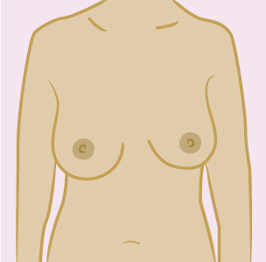
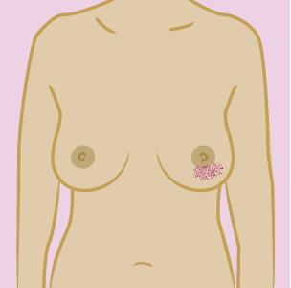

Lumps
Any lumps or thickening in either breast that feels different from the other breast; any swelling or lumps under your armpit or around your collarbone.
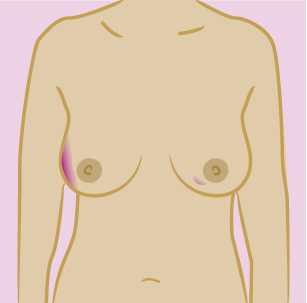
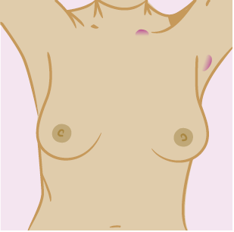

Nipple change
A nipple that has become pulled in, changed shape or shows signs of any discharge, bleeding, rash or crusted, flaky skin.
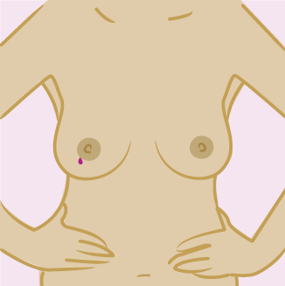
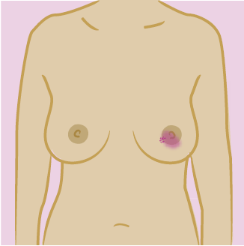
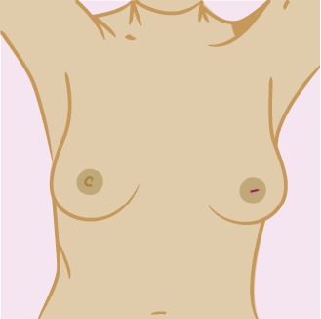
Pain on its own is not usually a sign of breast cancer.

The breast awareness 5 point code
1. Know what is normal for you
2. Know what changes to look and feel for
3. Look and feel
4. Report any changes to your GP immediately
5. Attend for breast screening from the age of 50

Breast screening
If you are aged between 50 and 70, you will be invited for breast screening every 3 years as part of the Northern Ireland breast screening programme. Your name will be obtained from your GP and you will be sent an invitation to come for a mammogram (breast X-ray).
If you are aged over 70, you will not automatically be invited for breast screening. However, you could still develop breast cancer as the risk continues to increase with age – about a third of all breast cancers occur in women over the age of 70. You are therefore encouraged to make your own appointment for screening every 3 years by contacting your local screening centre (see page 10).
At present, women under the age of 50 are not invited for breast screening because below this age:
- the risk of breast cancer is lower;
- women generally have denser breast tissue which makes their mammograms much more difficult to read; and
- the evidence doesn’t support a breast cancer population screening programme for younger women.
You can develop breast cancer at any time. This includes the time in between breast screening appointments. If you are worried about a breast problem, or have a family history of breast cancer, you should contact your GP.
For more information please visit www.nidirect.gov.uk/breast-screening
Your risk of breast cancer increases as you get older.
Diagram
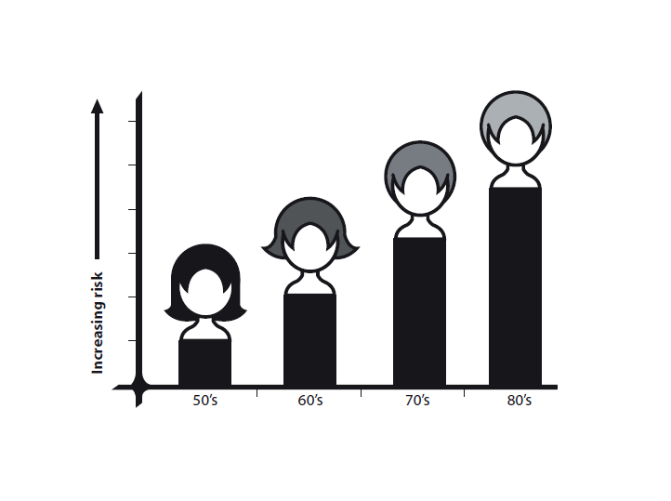

Screening centres
Belfast Health and Social Care Trust
(also covering South Eastern HSC Trust)
The Screening Centre
12-22 Linenhall Street
Belfast BT2 8BS
Tel: 028 9033 3700
Email: breastscreeninglhst@belfasttrust.hscni.net

Northern Health and Social Care Trust
Northern Area Breast Screening and Assessment Unit
Level A, Antrim Area Hospital
45 Bush Road
Antrim BT41 2RL
Tel: 028 9442 4425
Email: breast.screening@northerntrust.hscni.net

Southern Health and Social Care Trust
The Breast Screening Unit Firbank House
Craigavon Area Hospital
Lurgan Road
Portadown BT63 5QQ
Tel: 028 3756 0820
Email: breast.screening@southerntrust.hscni.net

Western Health and Social Care Trust
The Breast Screening Unit
Ground Floor, The Nurses’ Home
Altnagelvin Area Hospital
Glenshane Road
Londonderry BT47 6SB
Tel: 028 7161 1443
Email: altnagelvin.breastscreening@westerntrust.hscni.net

For further information visit:
http://pha.site/breastscreening-info
www.nidirect.gov.uk/breast-screening
www.becancerawareni.info/breast-cancer

Published February 2024 by the Public Health Agency.
Document ends.

