***Improving Your Health and Wellbeing***

# Managing COVID-19 and FLI Outbreaks in Care Homes and Other Residential Facilities

**(Updated December 2022)**

Please view with the navigation pane open in Microsoft Word to help you move between sections quickly.

Managing COVID-19 and FLI Outbreaks in Care Homes and Other Residential Facilities 1

1. Introduction 4

2. Prevention of Acute Respiratory Illness 5

COVID-19 Vaccines 5

Influenza Vaccines 6

3. Case definition for respiratory illness, including COVID-19 6

Evidence of transmission within the facility (outbreak definition) 7

Household or close contacts 7

4. Recognition of an Outbreak 8

5. Actions in Event of an Outbreak 8

Outbreak Control Measures 8

Environmental Cleaning and Disinfection 9

6. COVID-19 testing and results 10

Care home testing 10

Performing tests 10

Role of the PHA 10

Symptomatic residents 11

Positive test results 11

Negative test results 12

7. Actions for Care Home following an outbreak 12

8. Outbreak Prevention 14

Social Distancing and Shielding 14

Daily Monitoring 14

Personal Protective Equipment (PPE) 14

Caring for residents 14

Isolation 14

Cohorting of Residents 15

Cohorting of Staff 15

Care Routines 15

9. Outbreak Management 16

Infection Prevention and Control (IPC) Measures 16

Respiratory and Cough Hygiene 16

Environmental Cleaning 16

Waste Disposal 16

Equipment 16

Laundry 16

Alert Measures 17

10. Movements in and out of the facility 17

Visiting 17

Admissions / Transfers INTO Facility 17

Discharges/Transfers OUT of a Facility 17

Appointments/Visits/Activities 17

11. Declaring an outbreak over 18

12. Staff 18

Social Distancing & PPE 18

External Training 18

Use of Agency Staff 18

Returning To Work / Caring 18

Appendix 1 Important Contact Details 20

Public Health Agency – Out of Hours 20

RQIA 20

TRUST CARE HOME SUPPORT TEAMS 20

Appendix 2 Summary Outbreak Report (Form R2) 21

Appendix 3 Transfer Form (Form R3) 22

Appendix 5 Donning and Doffing PPE Poster 23

Appendix 6 Hand Hygiene Poster (7 STEPS) 24

Appendix 7 5 Moments for Hand Hygiene Poster 25

Appendix 8 Catch It. Bin It. Kill It. Poster 26

Appendix 9 Audit of RQIA App Submissions 27

Appendix 10 Care Home COVID-19 vaccine: The Facts 28

## 1. Introduction

The COVID-19 pandemic has presented many difficulties and challenges to our care homes province wide. The Omicron variant continues to circulate and remains infectious. As a result, despite best efforts, COVID can still spread quickly in health and social care settings, particularly within care homes.

We acknowledge the huge efforts of care home staff who have continued adhere to testing, IPC measures and have participated in the vaccination programme to keep their residents and themselves safe.

Northern Ireland has entered a different phase of the COVID-19 pandemic. Whilst case numbers continue to be high, the risk of serious illness, hospitalisation and death for those who contract COVID-19 is now much lower now than during previous waves. This is due to the success of the COVID-19 vaccination programme. The autumn booster programme is currently underway for individuals who are eligible and our health service is continuing to utilise innovative antiviral treatments.

We are conscious that transmission in care homes continues to cause outbreaks of COVID-19 despite best efforts and all IPC measures being implemented. This guidance document sets out current outbreak guidance for care homes, which aims to protect residents and staff by reducing risk of further transmission. This guidance will be reviewed as the landscape of COVID-19 transmission changes over time.

This guidance aims to provide advice to staff working in facilities e.g. care homes on the management of respiratory related outbreaks. This outbreak pack focuses largely on COVID-19 but some of these principles are also applied for FLU outbreaks. Where the measures are different, follow the COVID-19 guidance unless directed by PHA to do otherwise.

General guidance on COVID-19 can be found on the following websites:

* [**www.publichealth.hscni.net**](http://www.publichealth.hscni.net)
* [**https://www.nidirect.gov.uk/campaigns/coronavirus-covid-19**](https://www.nidirect.gov.uk/campaigns/coronavirus-covid-19)
* [**www.rqia.org.uk**](http://www.rqia.org.uk)
* [**https://www.health-ni.gov.uk/covid-19-guidance**](https://www.health-ni.gov.uk/covid-19-guidance)
* [**www.niinfectioncontrolmanual.net**](http://www.niinfectioncontrolmanual.net)
* [**https://www.gov.uk/government/organisations/uk-health-security-agency**](https://www.gov.uk/government/organisations/uk-health-security-agency)

## 2. Prevention of Acute Respiratory Illness

### COVID-19 Vaccines

#### Vaccination of Care Homes Residents and Staff

COVID-19 is primarily transmitted by person to person spread through respiratory

aerosols, direct human contact and fomites (objects/materials which are likely to carry infection).

Safe and effective vaccines against COVID-19 have been developed and are widely available across Northern Ireland, as part of the [NI COVID Vaccination Programme](https://www.nidirect.gov.uk/articles/get-covid-19-vaccination-and-booster-northern-ireland). The 2022 Autumn Booster Programme is underway for those who are eligible, including residents and care home staff.

The main priority of the vaccination and booster programmes is the prevention of severe illness death from COVID-19 infection as well as the protection of health and social care staff and systems. The single greatest risk of mortality from COVID-19 is increasing age, with the oldest age groups at highest risk. There is clear evidence that those living in care homes have been disproportionately affected by COVID-19 as they have had a high risk of exposure to infection and are at higher clinical risk of severe illness and death. Given this increased risk in these enclosed settings elderly adults and their care home workers have been placed in JCVI priority group 1” (those at very high risk and are considered a very high priority for vaccination).

Being vaccinated against COVID-19 primarily reduces the individual risk of severe illness and death. However, there is also evidence to suggest that onward transmission of COVID-19 is reduced if the infected individual is vaccinated. Further information can be found in the [Green Book](https://www.gov.uk/government/publications/covid-19-the-green-book-chapter-14a)..

Uptake of COVID-19 vaccines across Care Home settings has been very high however we should continue to help to limit the spread of COVID-19 through social distancing and adherence to the infection prevention and control (IPC) measures described below, particularly during times of outbreak.

The PHA has produced a number of FAQs on COVID-19 vaccinations, including information on safety, effectiveness and side effects amongst other topics. These can be accessed here: [FAQs](https://www.publichealth.hscni.net/covid-19-coronavirus/northern-ireland-covid-19-vaccination-programme/covid-19-vaccination-programme). A helpful COVID-19 vaccine poster, containing commonly asked questions, has also been included in Appendix 10 of this pack.

#### Vaccination and COVID-19 Testing

Having the COVID-19 vaccine can result in side effects which are usually very minor and of short duration, such as a sore arm or a mild fever. Having a COVID-19 vaccine cannot cause the individual to develop a positive COVID-19 test result. In the weeks or months after having a COVID-19 vaccine, if a person becomes symptomatic or has a positive LFD test, they should be treated in the same way as someone who has not had the vaccine i.e. immediate isolation or exclusion and testing as appropriate. The PHA should be advised of two or more cases within the same facility. (symptomatic and/or positive tests). This information, unless urgent, can be shared with the PHA on the next working day or at the weekend, between 9-5pm.

**COVID-19 Vaccination during outbreak**

If a care home is experiencing an outbreak the vaccine programme can go ahead as normal.

### Influenza V**accines**

Influenza vaccines are available during flu season and vulnerable populations and staff working with them, should be actively encouraged to have the ‘flu’ vaccine.

## 3. Case definition for respiratory illness, including COVID-19

The clinical presentation and symptoms of COVID-19 have changed significantly since the start of the pandemic. The three cardinal symptoms associated with COVID-19 - cough, temperature and loss of smell and taste - were the symptoms that best predicted that an individual had COVID-19 at earlier stages in the pandemic, although we have always advised that there were other symptoms of COVID-19. Currently, the most common symptoms of COVID-19 are similar to other respiratory viruses such as influenza and include:

* continuous cough;
* high temperature, fever or chills;
* loss of, or change in, your normal sense of taste or smell
* shortness of breath;
* unexplained tiredness, lack of energy;
* muscle aches or pains that are not due to exercise;
* not wanting to eat or not feeling hungry;
* headache that is unusual or longer lasting than usual;
* sore throat, stuffy or runny nose;
* diarrhoea, feeling sick or being sick.

Regardless of their vaccination status, older people in care homes may present with more nuanced symptoms of respiratory illness such as new onset confusion, reduced alertness, reduced mobility, or diarrhoea and they sometimes do not develop fever. Care home staff should remain vigilant for new symptoms in residents and also be aware of reports of circulating respiratory virus in their geographical area.

Individuals with symptoms suggestive of COVID-19 should isolate and take a lateral flow device (LFD) test immediately. A PCR test is no longer needed.

* If the LFD test result is positive the individual should isolate in line with current guidance.
* If the LFD test is negative, it may be appropriate to consider a PCR multiplex test which could identify influenza and ascertain any further risk to others in the care home. The resident should continue to isolate for 5 days or until they have fully recovered to prevent spread of respiratory infection.

### Evidence of transmission within the facility (outbreak definition)

1. Two (or more) confirmed cases linked by contact within the facility during the infectious period of the first confirmed case i.e.

* Contact occurred from 2 days before and up to 14 days after symptom onset / positive test date of the first case (the infectious period).

2. Resident case(s) with no potential transmission link outside of the facility i.e. no visitors and no visits out.

3. Other criteria for contacting PHA Duty Room

* Two or more hospitalisations due to respiratory illness in 48 hours
* Two or more deaths due to respiratory illness within 48 hours
* >20% residents symptomatic at any stage of outbreak in the affected unit
* Significant concerns not addressed by the guidance

### Household or close contacts

Residents who are asymptomatic (residents who do not have symptoms) do not need to isolate or undertake any testing if they are either suspected or confirmed as a close contact of an individual who has tested positive for a respiratory infection such as COVID-19 or Influenza either through exposure within the care home or during a visit out of the home setting.

Care Home staff should remain vigilant for symptoms of respiratory infection in any resident.

Regarding attendance to the Care Home:

Care home staff who are a household or overnight contact of a case of COVID-19 and who have direct contact with residents should be vigilant for developing symptoms and if they should do so take an LFD test.

Whilst they are attending work, staff must continue to comply rigorously with all relevant infection control precautions.

## 4. Recognition of an Outbreak

A single positive case of respiratory illness, including COVID-19 does not need to be routinely reported to the PHA. It is important to identify potential clusters of cases. Where two or more new cases of respiratory infection (including COVID-19 or Influenza) are identified, or clinically suspected, (in staff or residents) with onset of symptoms within 14 days of each other, the Health Protection Duty Room (HPDR) should be notified promptly for advice PHA.DutyRoom@hscni.net.

The HPDR will undertake an assessment to determine if the criteria for an outbreak are met. An outbreak consists of two or more positive (or clinically suspected) linked cases (among staff or residents) of illness such as COVID-19 or Influenza, that occur in the care home within a 14-day period.

Early identification allows immediate steps to be taken to prevent spread. If you have potential clusters of cases in residents and/or staff, the person in charge of the facility should

* contact the GP of each affected individual case to arrange clinical assessment.
* contact the Public Health Agency (PHA) duty room (Appendix 1 for Important Contact Details), to complete a risk assessment.

The risk assessment will be based on the outbreak definition below. Whether an outbreak is declared or not, the PHA duty officer will advise you of what further action to take.

## 5. Actions in Event of an Outbreak

### Outbreak Control Measures

Outbreak control measures should be taken to reduce the spread of COVID-19 and thereby reduce the morbidity and mortality of residents and staff.

Control measures include:

* Infection prevention and control (IPC) measures
  + standard infection control
  + respiratory – based precautions
* Environmental control measures, including cleaning and waste disposal
* Containment and alert measures to reduce exposure
* Specific control measures

The PHA poster “Guidance on the management of COVID-19 in care homes and other residential facilities” summarises information on recognising an outbreak of COVID-19, on notifying the PHA, and infection control measures. Section 6 covers a summary of the infection control measures that the PHA duty room has discussed with facility staff. It is vitally important that each home accurately updates the RQIA app each day, highlighting any further symptomatic individuals or cases based on the previous 24 hours. The RQIA reports this information to the PHA, so that the PHA can monitor the management of the outbreak. This information helps inform the advice and support given by the duty room team (for more information see Appendix 9).

### Environmental Cleaning and Disinfection

For advice on environmental cleaning in general and during/after an outbreak follow the link below:

[Cleaning & disinfection | PHA Infection Control (niinfectioncontrolmanual.net)](https://www.niinfectioncontrolmanual.net/cleaning-disinfection)

## 6. **COVID-19 testing and results**

### Care home testing

**Testing for Residents and Staff with symptoms**

* Residents/staff with symptoms suggestive of COVID-19 should isolate and **take a lateral flow device (LFD) test immediately.**
* Five most recent symptomatic residents should be tested only
* There is no longer a need for whole home PCR testing, **samples for up to five symptomatic service users should be submitted to the local Trust laboratory for a Multiplex PCR test. Multiplex PCRs will test for COVID-19 and Influenza. Tests will be referred to the Regional Virology Laboratory (RVL) as required. Samples from those with the most recent onset of symptoms should be prioritised**
* In the context of a COVID-19 outbreak, Whole Home Testing (WHT) is now unlikely to be advised in most circumstances. Prior to widespread vaccination when COVID-19 was an infection that led to significant morbidity and death in frail elderly populations, it was important to case find and isolate all cases. Service users and staff are now much better protected through vaccination and robust infection control.
* In exceptional circumstances there may still be a clinical need to test further cases, for example, to confirm the diagnosis in individuals with other respiratory symptoms or if the outbreak is particularly prolonged. Requirements for any further testing will be guided by the HPDR.
* Asymptomatic residents or staff will no longer be carried out.

### **Performing tests**

* Care home staff should only carry out resident/staff testing if they are trained to do so.
* Testing should only be performed by someone wearing the appropriate PPE.
* If PPE is not available, the care home should be advised not to perform the test and obtain information on obtaining PPE from local Trust. Care home staff should obtain advice on the appropriate swabs to use and on completing laboratory forms from their local Trust Care Home team.
  + The care home should clearly mark ‘care home’ on the Multiplex PCR test lab form if PCR is indicated.
* This will mean that the test result will be flagged by the Trust laboratory residents / staff and results can be identified and communicated more easily.
* All LFD results for staff and residents both positive and negative, should be reported on: <https://www.gov.uk/report-covid19-result> in order for anyone eligible for antiviral treatment to be identified.

[Guidance](https://www.health-ni.gov.uk/sites/default/files/publications/health/doh-hss-58-2022.pdf) was issued to the HSC service including Primary Care on 8 December 2022 on [treatments for residents who have Influenza](https://www.health-ni.gov.uk/sites/default/files/publications/health/doh-hss-58-2022.pdf).

### **Role of the PHA**

* Public health advice can be obtained from the PHA duty room.
* Unless urgent, notify PHA of positive results between 9am – 5pm Monday - Sunday
* PHA will monitor the RQIA app daily update reports and provide ongoing support.

### **Symptomatic residents**

* Isolate symptomatic residents for the required isolation period, if it is safe to do so and perform LFD test immediately
* Clinical advice should be obtained using usual channels e.g. GP.
* If a resident is unwell, do not delay seeking clinical advice for a COVID-19 test / result

### **Positive test results**

**Residents**

* Isolate residents with positive COVID test
* Unless otherwise advised by the HPDR, the self-isolation period for individuals with respiratory infection is 5 days. After this time residents may leave isolation providing they have fully recovered from their acute illness.

**If there are positive cases of influenza associated with the home, a letter will be sent by the HPDR to recommencement of antivirals.**

**Staff**

* Exclude staff members / care partners with positive COVID test
* Care home staff who test positive can leave self-isolation and return to work on day 6 after completing 5 full days of isolation providing the following requirements are met
* The staff member should have a negative LFD test on day 5 and 24 hours later on day 6 after the date that symptoms started or the date of their initial positive test, whichever is the sooner;
* If the staff member following return to work has a positive LFD test result between day 6 and 10 they must isolate and should not attend work. Staff should only end their self-isolation following 2 consecutive negative LFD tests (which should be taken at least 24 hours apart);
* They should not have a temperature and should be medically fit.
* They should continue to undertake daily LFD tests until day 10 (if working with residents whose immune system means that they may be at [higher risk of serious illness despite vaccination](COVID-19:%20guidance%20for%20people%20whose%20immune%20system%20means%20they%20are%20at%20higher%20risk%20-%20GOV.UK%20(www.gov.uk)))

On days the staff member is working, the LFD test should be taken prior to beginning their shift, as close as possible to the start time.

* If the staff member works with the most clinically vulnerable residents (as determined by the care home), a risk assessment should be undertaken, and consideration given to redeployment of the returning staff member for the remainder of the original 10-day isolation period.
* The likelihood of a positive LFD in the absence of symptoms after 10 days is low. Staff members who test positive at day 10 should take a daily LFD test on days 11 – 14 until they get a single negative result. After day 10 they can return to work immediately following a single negative result. If the staff member works with patients whose immune system means that they are at higher risk of serious illness despite vaccination, a risk assessment should be undertaken.
* The likelihood of a person who is well and not immunocompromised, being infectious after 14 days is very low. If the staff member’s LFD test result is still positive on the 14th day, they can stop testing and return to work on day 15. If the staff member works with patients whose immune system means that they are at higher risk of serious illness despite vaccination, a risk assessment should be undertaken.

### **Negative test results**

Staff

* Staff members who have COVID-19 symptoms should take a lateral flow test at the onset of symptoms (day 0) and take a further LFD test 48 hours later (day 2) if the first test is negative. A PCR test is no longer required. If symptoms begin at home (off-duty), they should not attend work while awaiting both lateral flow test results. If symptoms begin at work, they should inform their line manager and return home as soon as possible.
* Contact tracing of community close contacts ceased on 22 April 2022. Since 22 April, contact tracing has focused on providing appropriate public advice and guidance to positive cases and their household members. People who live in the same household as someone with COVID-19 or who have stayed overnight in the same house as the case are at the highest risk of becoming infected.
* Whilst they are attending work, staff must continue to comply rigorously with all relevant infection control precautions.

Residents

* Residents who are symptomatic and test negative on LFD should continue to isolate for 5 days or until they have fully recovered to prevent spread of respiratory infection. It may be appropriate to consider a PCR multiplex test which could identify influenza and ascertain any further risk to others in the care home.

## 7. Actions for Care Home following an outbreak

**Immediate Actions**

RESIDENTS

* Any positive residents should self-isolate immediately.
* Any other residents who have symptoms should have a LFD as soon as possible
* If possible, test the 5 residents with the most recent symptom onset for COVID and influenza
* The resident should continue to isolate for 5 days or until they have fully recovered to prevent spread of respiratory infection.

STAFF/CARE PARTNERS

* Any positive staff members/care partner should self-isolate immediately and not attend the care home.
* Other staff members who have COVID-19 symptoms should take a lateral flow test at the onset of symptoms (day 0) and take a further LFD test 48 hours later (day 2) if the first test is negative.
* If symptoms begin at home (off-duty), they should not attend work while awaiting both lateral flow test results.
* If symptoms begin at work, they should inform their line manager and return home as soon as possible
* The staff member/care partner should inform the care home ASAP.
* Staff member/care partner should ensure adequate supply of LFD tests for return to work testing

**Next Actions**

* Collect all relevant information including symptom onset, date of test and patient details including H&C / DOB / vaccination status
* A risk assessment is performed by the PHA
* An OUTBREAK will be declared by the PHA Duty Room Team
* Follow actions advised by PHA

**Further Actions**

Testing symptomatic residents in an outbreak scenario:

When an outbreak has been declared, there may be more than two individuals with similar symptoms. Samples for up to five symptomatic service users typically should be submitted to Pillar 1. Multiplex testing will be used to confirm the pathogen (COVID-19 and Influenza). Additional cases matching the outbreak case definition do not all need to be tested once the pathogen is identified however all residents with symptoms should isolate for a minimum of five days after which they can leave isolation providing they have recovered from their acute illness.

**Continuing Actions**

To declare an outbreak over, the HPDR must be satisfied that:

* existing cases have been isolated in line with guidance;
* guidance on IPC and other interventions are being applied appropriately:
* a terminal clean has been completed; and
* an outbreak summary report has been submitted

Once complete the outbreak can be closed.

Continue daily update via RQIA app

## 8. Outbreak Prevention

### Social Distancing and Shielding

* For more information on guidance for those who are clinically extremely vulnerable or clinically vulnerable please see the following link: <https://www.nidirect.gov.uk/articles/coronavirus-covid-19-guidance-clinically-extremely-vulnerable-and-vulnerable-people>
* Current isolation guidance for severely compromised residents can be found at: [Infection prevention and control for seasonal respiratory infections in health and care settings (including SARS-CoV-2) for winter 2021 to 2022 - GOV.UK (www.gov.uk)](https://www.gov.uk/government/publications/wuhan-novel-coronavirus-infection-prevention-and-control/covid-19-guidance-for-maintaining-services-within-health-and-care-settings-infection-prevention-and-control-recommendations)

### Daily Monitoring

* Twice daily temperature checking for residents has been stood down.
* The ceasing of twice daily temperature checks does not negate the need for staff to be vigilant to the signs and symptoms (typical or atypical) of COVID-19 or other illness and, if a resident becomes unwell, staff must respond in accordance with testing guidance and seek medical advice when required.

### Personal Protective Equipment (PPE)

* All staff should be trained in the use of PPE.
* PPE should also be worn when in contact with:
  + ALL residents
  + Other staff (except when eating and drinking; when PPE is not worn, social distancing should be maintained at all times even when eating and drinking).
* The type of PPE and how often it should be changed will depend on the task that is being performed. Guidance can be found [here](https://www.publichealth.hscni.net/sites/default/files/2020-04/Recommended_PPE_for_primary_outpatient_and_community_care_by_setting_poster.pdf).
* PPE includes plastic aprons, disposable gloves and a fluid repellent surgical mask.
* If splashes / coughs are a possibility, eye protection googles or a visor should be worn.
* Special care should be taken when donning and doffing PPE as this is the point where contamination is most likely to occur (Appendix 5)
* All visitors including care partners, family, friends and HSC / non-HSC staff, to the home are asked to continue to wear a face covering for the duration of their visit. There is no longer a requirement for visitors to wear an apron or gloves. However, hands must be sanitised on arrival and prior to leaving.
* Please note that the requirements for full PPE remains in place, when providing direct care to a resident, either as a care partner or as a HSC/non-HSC staff member.

### Caring for residents

Any individual who develops symptoms should be isolated (residents) / excluded (staff) and tested for COVID-19 immediately. Testing and isolation guidance on page 23 and 24 should be followed.

### Isolation

* All necessary procedures including personal care and environmental cleaning should be carried out within the individual’s room.
* Allocate a personal commode to the affected person’s room if only shared bathrooms are available.
* If shared bathrooms must be used, designate a bathroom for affected residents only and ensure that unaffected residents cannot use this bathroom by mistake.
* If a shared bathroom must be used, washing / bathing of affected residents after all unaffected residents have washed first.
* Clean the bathroom after it has been used by an affected resident.

### Cohorting of Residents

* Where there are shared bedrooms / bathrooms and/or multiple cases, cohorting (grouping of) residents into those affected and those unaffected) should be considered.
* Grouping residents may make care easier and may reduce the risk of spread to unaffected residents.
* The following groups could be used:
  + confirmed cases / possible or probable cases / resident contacts /asymptomatic (vulnerable) / asymptomatic (extremely vulnerable).
* Groups should not be mixed and in some cases should be kept as far away from each other as possible e.g. affected residents should not be located near immunosuppressed residents.
* If residents are being moved to enable cohorting, rooms should be terminally cleaned before a different resident is moved in.
* When transferring symptomatic or positive residents between rooms including to shared bathrooms, the affected resident should wear a surgical face mask.
* If this is not possible, because of an underlying health condition, ensure the vicinity is clear of other residents and staff before moving the resident.

### Cohorting of Staff

* Staff caring for symptomatic patients should also be cohorted / grouped together.
  + This means, where practical or possible, those caring for symptomatic or positive residents should have limited or no contact with unaffected residents and staff.
  + If possible, staff should only work with either symptomatic or asymptomatic residents.
* Vulnerable staff members should follow guidance about minimising risk: <https://www.nidirect.gov.uk/articles/coronavirus-covid-19-guidance-clinically-extremely-vulnerable-and-vulnerable-people>.
* Pregnant staff members should have regular risk assessments in line with the most current [guidance](https://www.hseni.gov.uk/articles/new-and-expectant-mothers) with alterations to their role as necessary.
* Further information for pregnant staff can be found at: [Coronavirus (COVID-19), infection and pregnancy FAQs | RCOG](https://www.rcog.org.uk/guidance/coronavirus-covid-19-pregnancy-and-women-s-health/coronavirus-covid-19-infection-in-pregnancy/coronavirus-covid-19-infection-and-pregnancy-faqs/#A15)

### Care Routines

* If cohorting of staff, residents and equipment is not possible, perform all tasks e.g. care rounds, in following order:
  + Unaffected residents / resident contacts / symptomatic residents / confirmed residents.
* Change PPE between residents.
* Clean equipment between residents and again, when moving between cohorts.

## 9. Outbreak Management

### Infection Prevention and Control (IPC) Measures

* Promote frequent, regular handwashing.
  + Observe the 5 moments for hand hygiene (Appendix 7).
  + Follow the 7 step technique for hand washing (Appendix 6).
* Ensure liquid soap, disposable paper towels and foot operated bins are available at all hand wash sinks.
* Emphasise proper drying of hands and use of moisturiser to prevent hands from drying and cracking.
* Only use alcohol hand gel if immediate decontamination is required and handwashing facilities are not available. Wash hands as soon as possible after.
* Encourage individuals to keep hands away from eyes, mouth & nose.

### Respiratory and Cough Hygiene

* Promote CATCH IT, BIN IT, KILL IT (Appendix 8)
* Provide paper tissues and covered sputum pots for affected residents.
* Provide small rubbish bags to individuals for immediate disposal of tissues (if safe to do so).

### Environmental Cleaning

* Follow cleaning guidance provided in the pack.
* Increase frequency of cleaning of the environment (enhanced cleaning).
* Pay special attention to touch points e.g. toilet flush, door handles.
* Clean with detergent and a chlorine release product/or a combined detergent & chlorine release product/or chlorine dioxide product.
* Wear appropriate PPE when cleaning an isolation room.

### Waste Disposal

* Dispose of any waste that has been in contact with the affected resident including tissues / sputum pots, and PPE as clinical waste.
* Clinical waste should be placed in a plastic rubbish bag, double bagged and tied and stored securely for 72 hours before disposal.
* Waste should be stored in a secure location awaiting uplift in line with local policies for contaminated waste.

### Equipment

* If possible, dedicate specific medical equipment (e.g. thermometers, blood pressure cuff, pulse oximeter, etc.) for affected residents.
* Clean and disinfect equipment before re-use with another patient.
* Restrict sharing of personal devices (mobility devices, books, electronic gadgets).
* Ensure proper cleaning & replacement of oxygen/nebuliser equipment.

### Laundry

* Treat laundry of affected residents as infected.
* Place in a red alginate bag then a secondary clear bag.

### Alert Measures

* Display signs to inform of the outbreak and infection control measures.
* Signs preventing entry should also be placed on isolation room doors.

## 10. Movements in and out of the facility

### Visiting

Following a dynamic risk assessment by the manager of the facility, if the care home has the capacity and the visitors are aware of the ongoing situation there should be no restrictions on visiting. Appropriate IPC mitigations should be adhered to.

### Admissions / Transfers INTO Facility

*Testing of residents for COVID-19 prior to admission to care homes from hospital or community settings either for permanent or short stays including shared care and respite*

* Asymptomatic individuals being admitted from a community setting should test using a Lateral Flow Device (LFD) for COVID-19 on admission to the care home. There is no need to test in the community prior to admission.
* If the resident has a negative LFD test is negative on admission, regardless of the source of admission, there is no need for isolation or further testing.
* Individuals being discharged from hospital who have symptoms of COVID-19 must have a multiplex PCR test (for Influenza and COVID-19) before discharge. Information on the test result must be provided to the care home so that appropriate arrangements can be made in respect of to support discharge planning.
* Asymptomatic individuals (those with no symptoms of respiratory infection) being admitted from an acute hospital setting should be tested using a Lateral Flow Device (LFD) or a LumiraDX test where available for COVID-19 prior to discharge to the care home.
* If the individual cannot tolerate COVID-19 testing, then a dynamic risk assessment should be undertaken by the care home. The aim is that this risk assessment will facilitate admission to the care home, including for overnight and short stays, and that the inability to test should not be an automatic barrier to admission. Unless an individual is symptomatic or COVID-19 positive – there should be no requirement to isolate on admission.
* Follow advice regarding testing and isolation if symptoms of COVID-19 develop.

### Discharges/Transfers OUT of a Facility

* NIAS should be alerted if a resident in an affected facility requires transfer.
* The local Trust should be alerted if a resident in an affected facility is being admitted.
* The facility should send a completed copy of Form R3 (Appendix 3) with the patient.

### Appointments/Visits/Activities

Residents who are asymptomatic do not need to isolate or undertake any testing if they are either suspected or confirmed as a close contact of a COVID-19 case either through exposure within the care home or during a visit out of the home setting. Visits out of the home include:

* attendance at a healthcare appointment;
* attendance at an Emergency Department;
* trips out of the home;
* overnight stays in the community.

## 11. Declaring an outbreak over

The decision to declare an outbreak over is made by PHA. An outbreak can only be declared over when the HPDR is satisfied that:

* existing cases have been isolated in line with guidance;
* guidance on IPC and other interventions are being applied appropriately:
* a terminal clean has been completed; and
* an outbreak summary report has been submitted

## **12. Staff**

### **Social Distancing & PPE**

* Social distancing should be followed by staff, both in and out of the workplace.
* Communal areas e.g. break rooms and changing rooms should be tailored to allow social distancing e.g. limiting the number of staff who can take a break at the same time and/or use of larger spaces for breaks to allow appropriate distancing between staff.
* Staff should socially distance from each other including when eating or drinking / on breaks.
* Staff should wear PPE when in contact with each other and not eating or drinking.

### External Training

Exposed staff should not attend external training.

### Use of Agency Staff

Agency and temporary staff should be COVID-19 symptom free and not have tested positive. They should shower, wash hands and put on a clean uniform before moving to another facility to complete a shift.

### Returning To Work / Caring

* The Expert Testing Advisory Group has agreed that staff working in care homes should contact their local Trust occupational health service for advice if they do not have access to an occupational health service.
* The guidance for Health and Social Care workers can be found [here](https://www.health-ni.gov.uk/sites/default/files/publications/health/doh-hss-md-17-2022_0.pdf)
* Care home staff who test positive can leave self-isolation and return to work on day 6 after completing 5 full days of isolation providing the following requirements are met:
* The staff member should have a negative LFD test on day 5 and 24 hours later on day 6 after the date that symptoms started or the date of their initial positive test, whichever is the sooner;
* If the staff member following return to work has a positive LFD test result between day 6 and 10 they must isolate and should not attend work. Staff should only end their self-isolation following 2 consecutive negative LFD tests (which should be taken at least 24 hours apart);
* They should not have a temperature and should be medically fit.
* They should continue to undertake daily LFD tests until day 10 (if working with residents whose immune system means that they may be at higher risk of serious illness despite vaccination
* On days the staff member is working, the LFD test should be taken prior to beginning their shift, as close as possible to the start time.
* The staff member must continue to comply with all relevant infection control precautions throughout the day.
* If the staff member works with the most clinically vulnerable residents (as determined by the care home), a risk assessment should be undertaken, and consideration given to redeployment of the returning staff member for the remainder of the original 10 day isolation period.
* The likelihood of a positive LFD in the absence of symptoms after 10 days is low. Staff members who test positive at day 10 should take a daily LFD test on days 11 – 14 until they get a single negative result. After day 10 they can return to work immediately following a single negative result. If the staff member works with patients whose immune system means that they are at higher risk of serious illness despite vaccination, a risk assessment should be undertaken.
* The likelihood of a person who is well and not immunocompromised, being infectious after 14 days is very low. If the staff member’s LFD test result is still positive on the 14th day, they can stop testing and return to work on day 15. If the staff member works with patients whose immune system means that they are at higher risk of serious illness despite vaccination, a risk assessment should be undertaken.

## Appendix 1 Important Contact Details

Public Health Agency – In Hours (9am to 5pm)

Health Protection Duty Room

4th FLOOR, 12-22 Linenhall Street

Belfast

BT2 8BS

Tel: 0300 555 0119

Email: [**pha.dutyroom@hscni.net**](mailto:pha.dutyroom@hscni.net) (non urgent communication)

### Public Health Agency – Out of Hours

The contact details for urgent public health advice out of hours is via NIAS ambulance control on 028 9040 4045.

It would be helpful to give a short reason for the call to the NIAS call handler that will help prioritisation of calls e.g. to report a new outbreak of COVID-19, flu like illness, C. difficile or meningococcal disease.

### RQIA

Tel: 028 95 361111 or Email: [**bsu.admin@rqia.org.uk**](mailto:bsu.admin@rqia.org.uk)

Providers are also able to seek help or report daily status via a newly launched mobile app: <https://rqiani.glideapp.io/>

### TRUST CARE HOME SUPPORT TEAMS

#### ****Western Trust****

[***CareHomeSupportTeam@westerntrust.hscni.net***](mailto:CareHomeSupportTeam@westerntrust.hscni.net)

#### Southern Trust

#### [community.covid19screening@southerntrust.hscni.net](mailto:community.covid19screening@southerntrust.hscni.net)

#### Belfast Trust

Weekdays

• Governance Team for Commissioned Services-Care Home Support Team (CHST)- [*CommSvcsTeam@belfasttrust.hscni.net*](mailto:CommSvcsTeam@belfasttrust.hscni.net)

• Belfast Trust Testing Centre - [*MOTtestingCentreTeam@belfasttrust.hscni.net*](mailto:MOTtestingCentreTeam@belfasttrust.hscni.net)

Weekends/Public Holidays

• BHSCT Site Coordinator 8am-8pm, Site Co-ordinators- [*SM@belfasttrust.hscni.net*](mailto:SM@belfasttrust.hscni.net)

• Governance Team for Commissioned Services-CHST- [*CommSvcsTeam@belfasttrust.hscni.net*](mailto:CommSvcsTeam@belfasttrust.hscni.net)

• Belfast Trust COVID Testing Centre[*MOTtestingCentreTeam@belfasttrust.hscni.net*](mailto:MOTtestingCentreTeam@belfasttrust.hscni.net)

***Northern Trust***

[***hcw.testing@northerntrust.hscni.net***](mailto:hcw.testing@northerntrust.hscni.net)

#### ****South Eastern Trust****

#### [Permanent.Placement@setrust.hscni.net](mailto:Permanent.Placement@setrust.hscni.net)

## Appendix 2 Summary Outbreak Report (Form R2)

To be completed when terminal clean is complete and outbreak is declared over by PHA.

|  |  |
| --- | --- |
| FACILITY DETAILS | |
| Name |  |
| Address |  |
| Telephone |  |
| Email |  |

|  |  |
| --- | --- |
| OUTBREAK DETAILS | |
| Number of Residents at time of Outbreak |  |
| Number of Staff |  |
| Name of Staff Member responsible for Infection Control |  |
| Name of Nurse / Person in Charge |  |
| Date Outbreak Declared: |  |
| Notified to:  (name of person at Public Health Agency) |  |
| Total Number of symptomatic residents with positive COVID test |  |
| Total Number of symptomatic staff with positive COVID test |  |
| Total number of asymptomatic residents with positive COVID test |  |
| Total number of asymptomatic staff with positive COVID test |  |
| Number of COVID-19 positive residents Admitted to Hospital |  |
| Number of Persons Deceased: |  |
| Main Symptoms: |  |
| Number of Samples Obtained: |  |
| Results  Was a virus/organism detected:  If yes, state results |  |
| Control Measures  Main measured taken to contain outbreak (please list): |  |
| Any additional information: |  |

|  |  |
| --- | --- |
| Completed by |  |
| Job title |  |
| Date |  |

This form should be competed and returned to:

Duty Room ([**PHA.DutyRoom@hscni.net**](mailto:PHA.DutyRoom@hscni.net))

## Appendix 3 Transfer Form (Form R3)

For Suspected/Confirmed COVID-19 or FLI Outbreaks

* Please be advised that ______________________________ (NAME) is being transferred from a facility where there is an acute respiratory outbreak of *SUSPECTED / CONFIRMED COVID-19. (delete as appropriate)
* Please ensure that appropriate isolation precautions are taken upon receipt of this resident.

At the time of transfer, this resident was:

|  |  |
| --- | --- |
|  | COVID-19 |
| FREE OF SYMPTOMS OF |  |
| SUSPECTED |  |
| CONFIRMED |  |

Antiviral Medication

|  |
| --- |
| Medication / Dose / Frequency |
|  |

Vaccination Status

|  |  |  |
| --- | --- | --- |
|  | YES | NO |
| PNEUMOCOCCAL |  |  |
| INFLUENZA |  |  |
| COVID 1st | YES date | NO |
| COVID 2nd | YES date | NO |
| COVID Booster(s) | YES date | NO |
| Other | YES date | NO |

For further information please contact:

|  |  |
| --- | --- |
| Name |  |
| Job title |  |
| Contact details |  |

## **Appendix 5 Donning and Doffing PPE Poster**

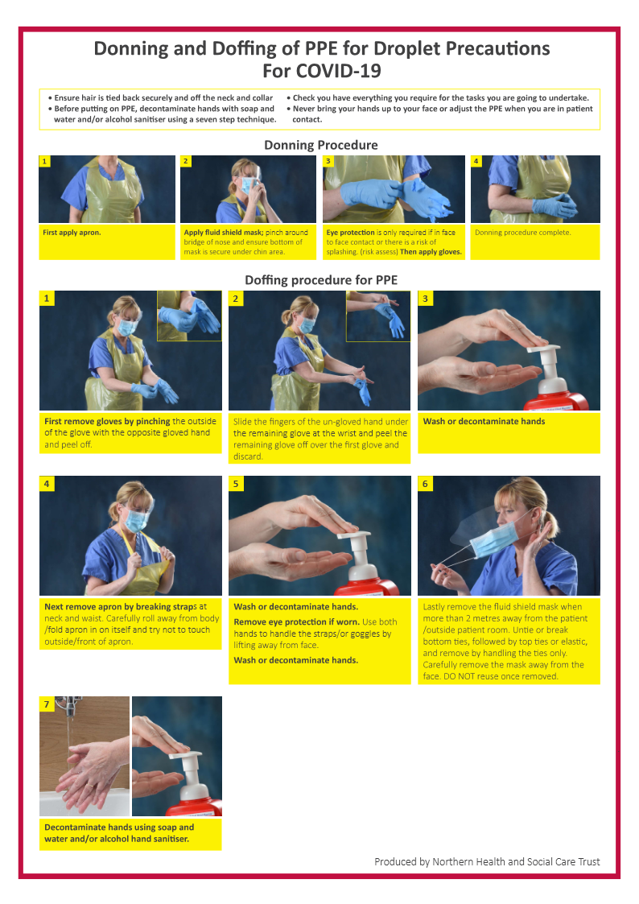

## Appendix 6 Hand Hygiene Poster (7 STEPS)

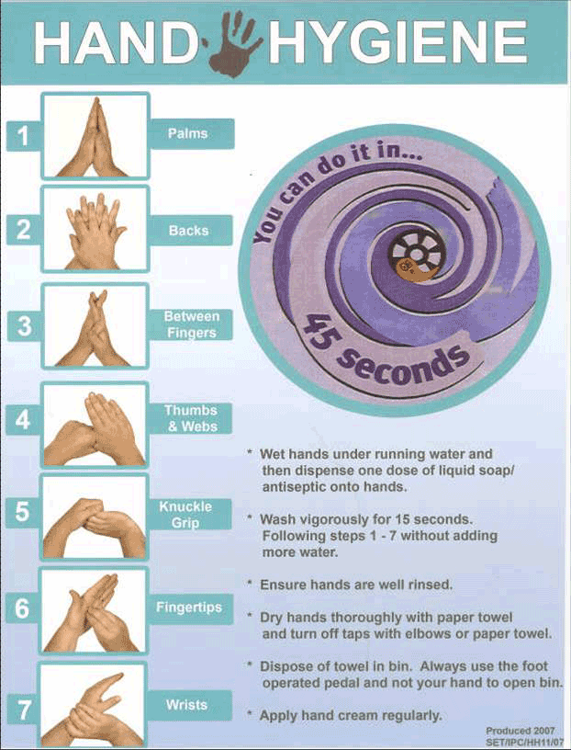

## Appendix 7 5 Moments for Hand Hygiene Poster

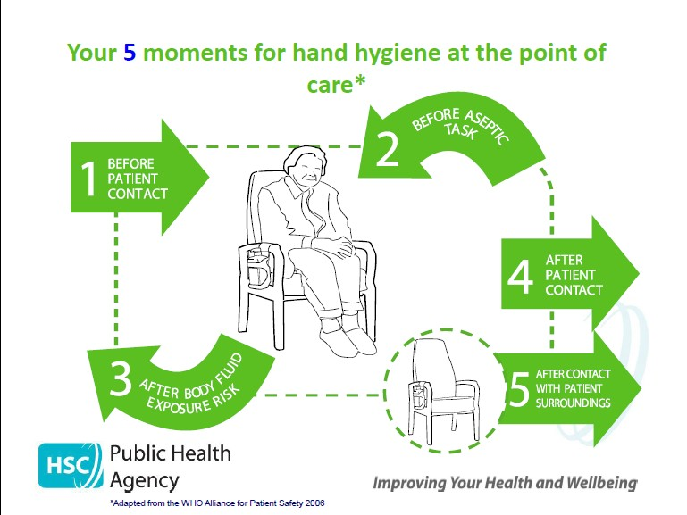

## Appendix 8 Catch It. Bin It. Kill It. Poster



## Appendix 9 Audit of RQIA App Submissions

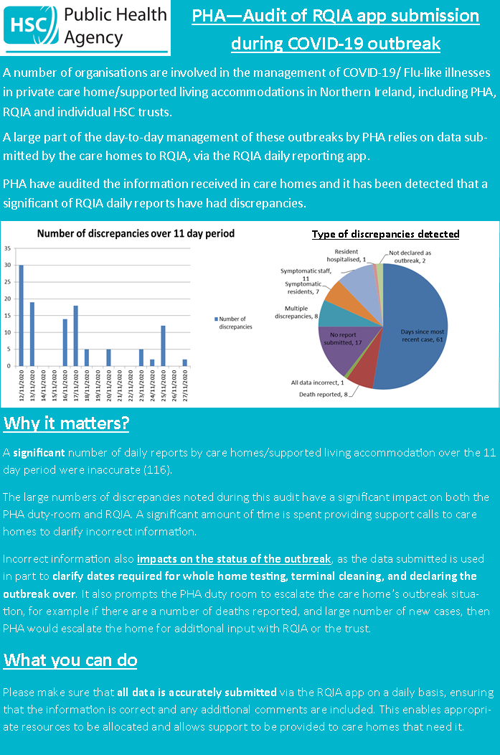

## Appendix 10 Care Home COVID-19 vaccine: The Facts

[Care homes COVID-19 vaccine - The facts poster | HSC Public Health Agency (hscni.net)](https://www.publichealth.hscni.net/publications/care-homes-covid-19-vaccine-facts-poster)

