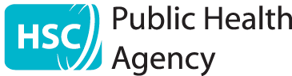


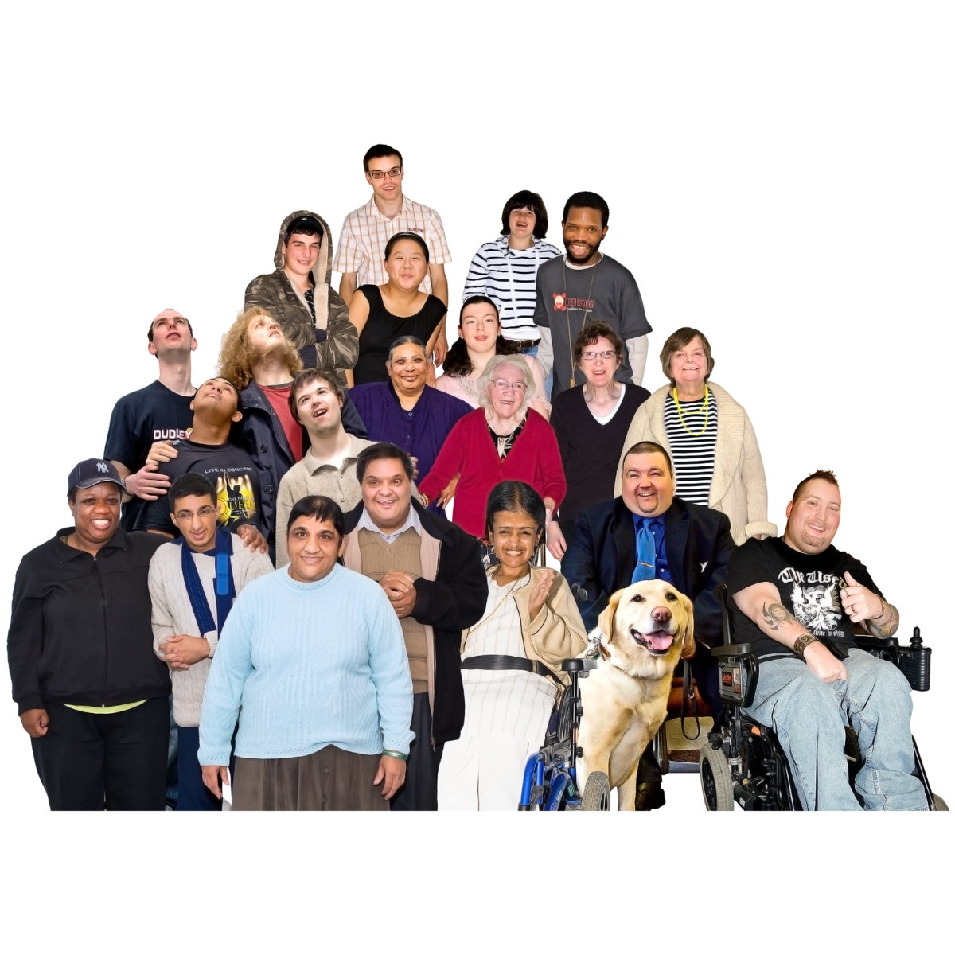
The work we will do to help everyone in Northern Ireland to be healthy
This is work we will do from 2025 to 2030

This is an easy read version of our Corporate Plan 2025-2030

About this plan

We are called the Public Health Agency.
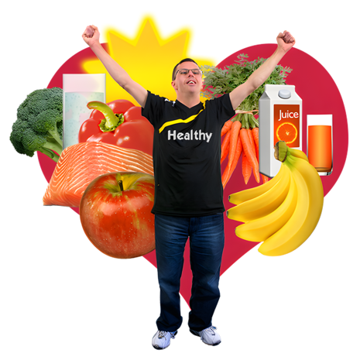

We work to make sure that
everyone in Northern Ireland
can be healthy and have a good life.



This plan is about the main things
we will work on in the next 5 years.

From 2025 to 2030.

We also made a plan like this from 2017 to 2021.

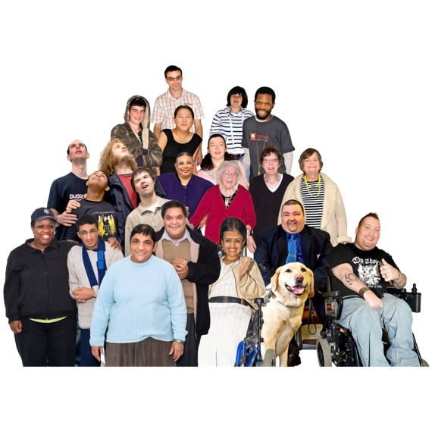

We want everyone in Northern Ireland to have better health.

That means making sure that all groups of people can get the healthcare they need.

And making sure that healthcare is good and safe.
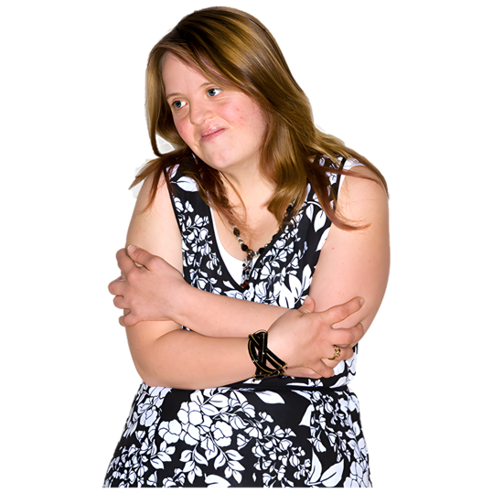
We have done lots of work on this already. But there is more to do.

For example, some people in Northern Ireland are less healthy than they could be.

We want to change that.

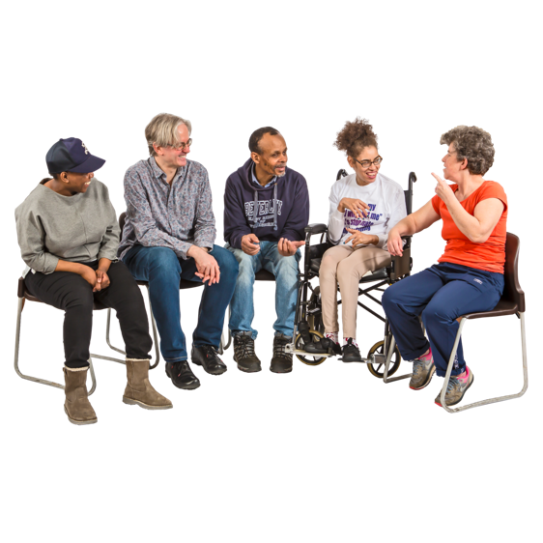
We will work with many people on this plan.

For example:
- People who get healthcare and their families.
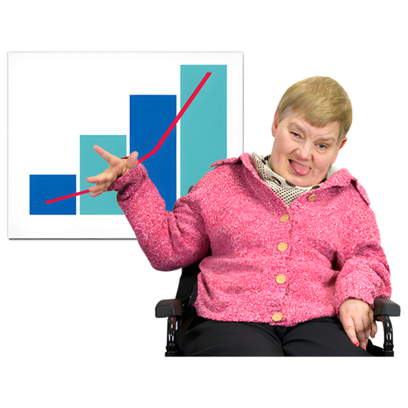
- Other health experts.
- Other organisations and companies.
- Other parts of the government.

We will also use good information to help us make our decisions.
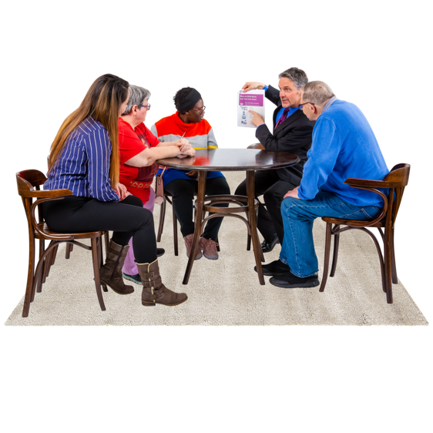

We will keep checking this plan to see how it is working.


The main things we will work on

There are 4 main things we will work on in the next 5 years.

- Keeping people in Northern Ireland safe from big health problems that could happen

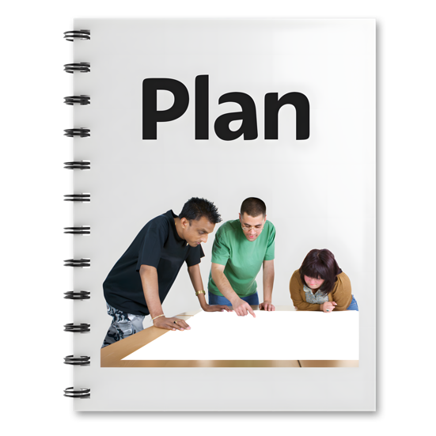
The main work we will do

We will make plans to help us get ready for any big health problems that could happen in Northern Ireland.

Like big diseases that many people could get.

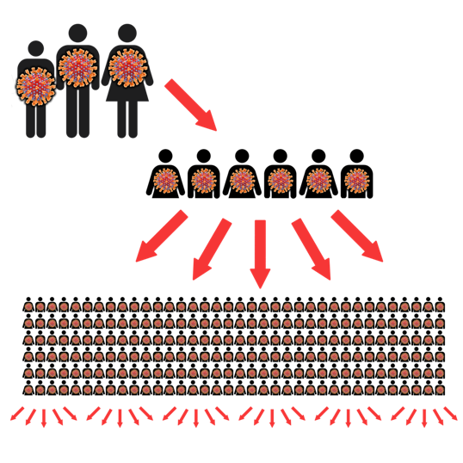

Some diseases can spread from person to person.

Some medicines are not working very well anymore for diseases that spread.

We will do more to keep people safe from problems like that.
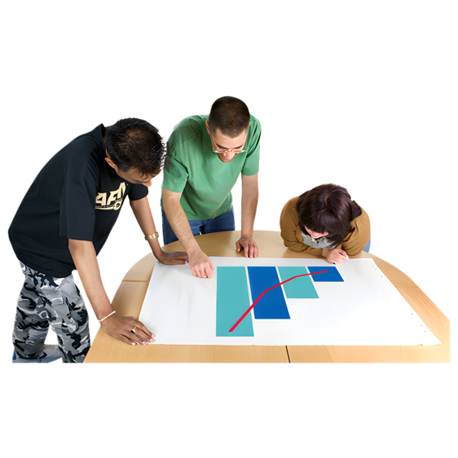
We will do more to understand why some health problems happen and how to stop them.



Some illnesses can spread to people in hospitals and other places.

We will make sure that many people work together to stop this from happening.

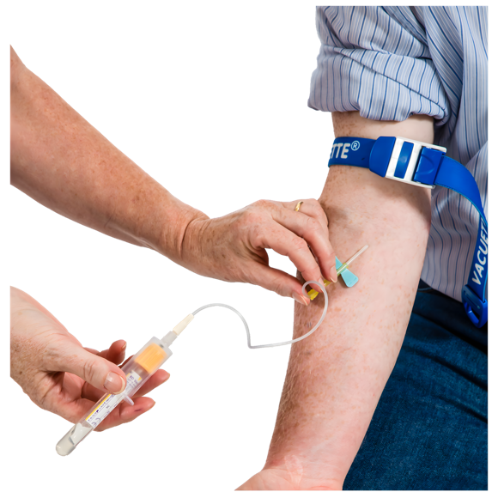
We will give people good tests to see if they may have some health problems.

For example, some people may be more likely to get cancer.

They can have a health check to see if they could have cancer.

This means people can get the care they need sooner if there is a problem.

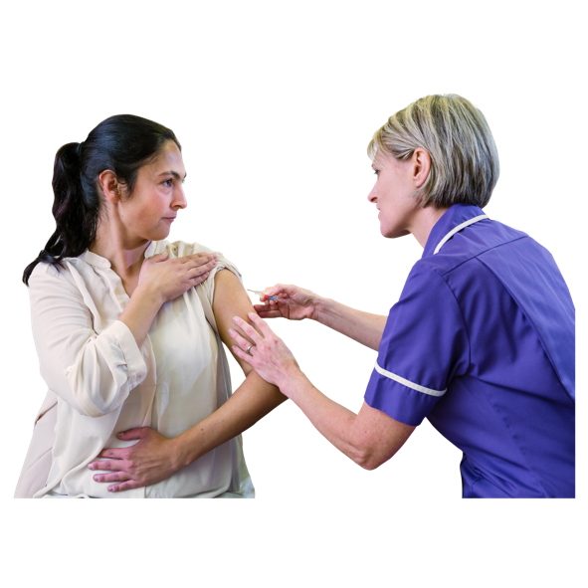
We will work to make sure that everyone in Northern Ireland gets the vaccines they need.

Vaccines are things that people can get from a doctor or nurse.

They can help to stop people getting some illnesses.

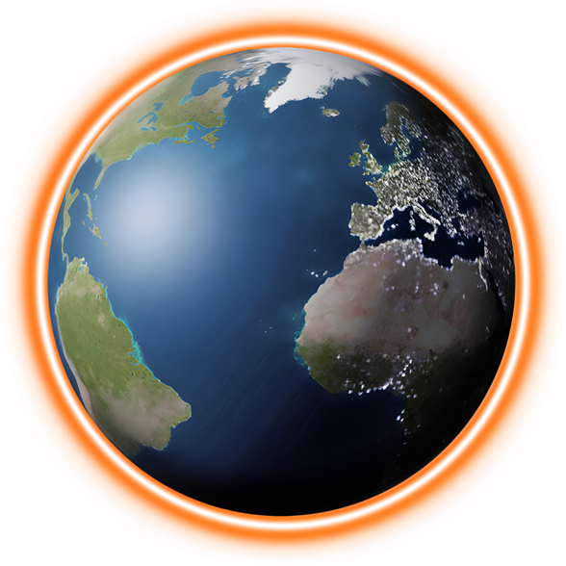

We will make a plan about how to keep people safe from climate change.

Climate change is about the earth getting warmer.

This is causing big problems for people and the earth we live on.

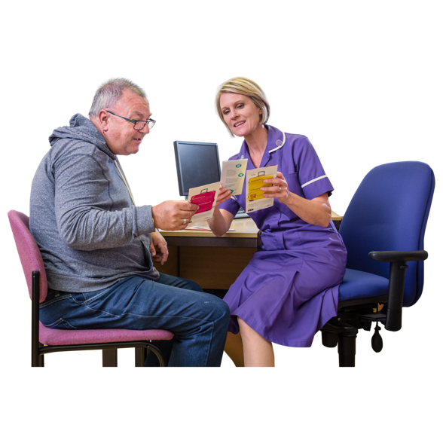

We will give people better information and advice about how to keep well.

People can use the information to help them make decisions about their health.

- Giving all children in Northern Ireland a good start in life

That means supporting children before they are born until they are adults.

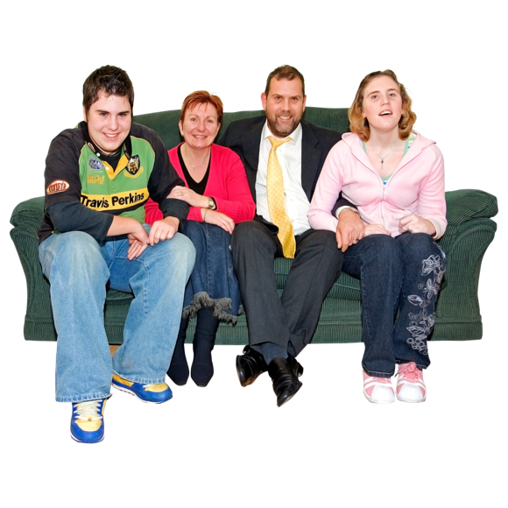
The main work we will do

We will support families to take care of their health.

That also means their mental health.


Mental health is about how you feel.

We will do more to support all people who are pregnant to keep well.

Some people who are pregnant may find it harder to keep well.
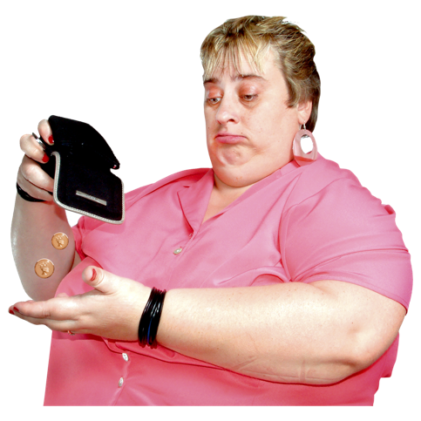

This may be because of some problems in their life.

Like problems with money or housing.
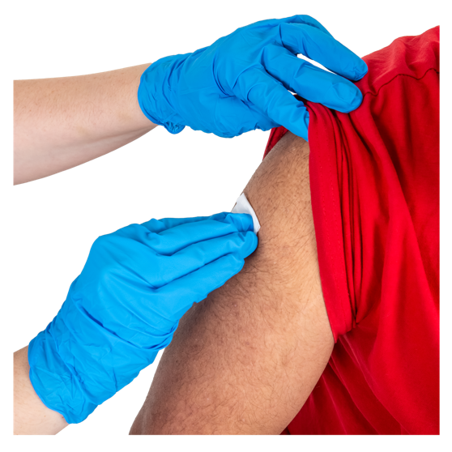
We will help to keep children and young people safe from some illnesses.

That means making sure all children can get vaccines to keep them healthy.

And it means giving babies some health checks before and after they are born.
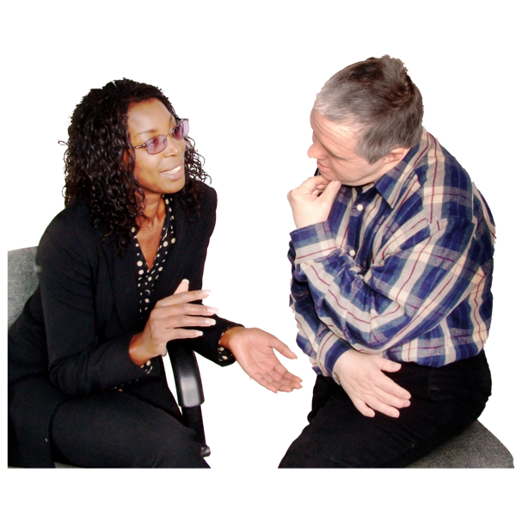

We will make sure that all families can get good advice, information and support.

This is to help them support their children in the best way.

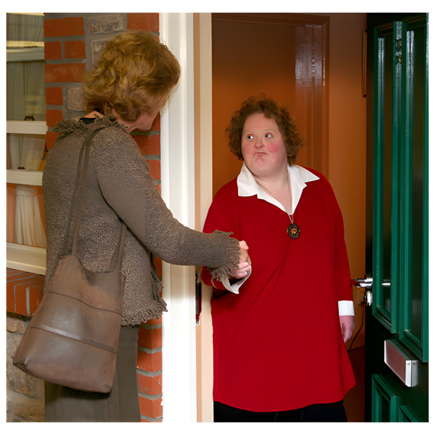

For example, people called health visitors go to see families from time to time.

They check if families need any support to care for their children.


Some families can get extra support if they need it.

Like people who have their first child when they are young.

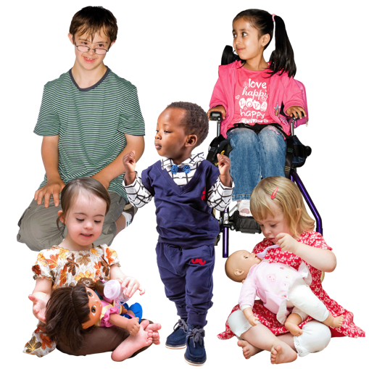

We will work to stop more children from dying when they are born or when they are young.

We will use good information to help us know how to do that.

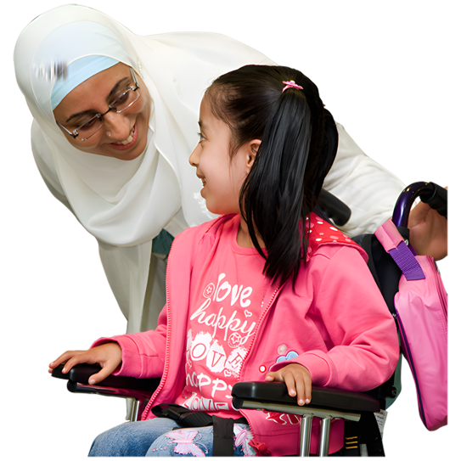

We will give support to children who may need extra support with their health.

Like disabled children and their families.
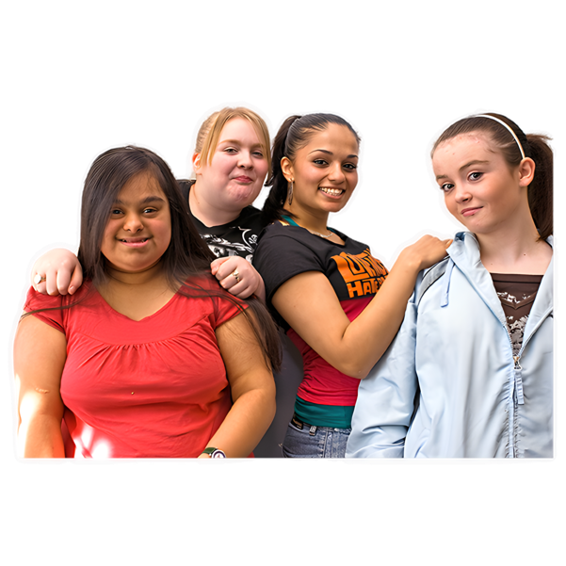

We will do more to keep children and young people safe from harm.

For example, we will support young people to know how to be healthy and how to feel OK.

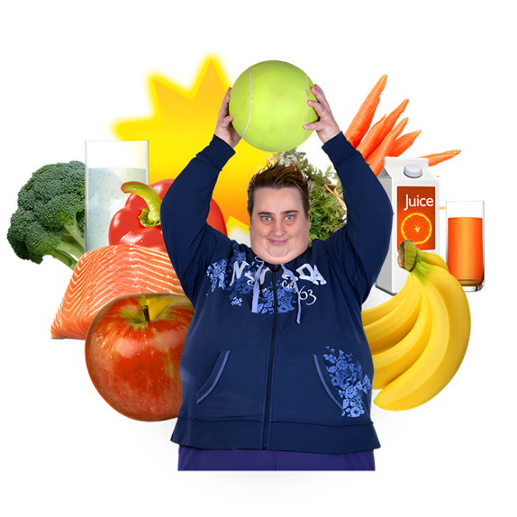
- Supporting people to live and work in a healthy way

The main work we will do

We will make it easier for all groups of people to be healthy.

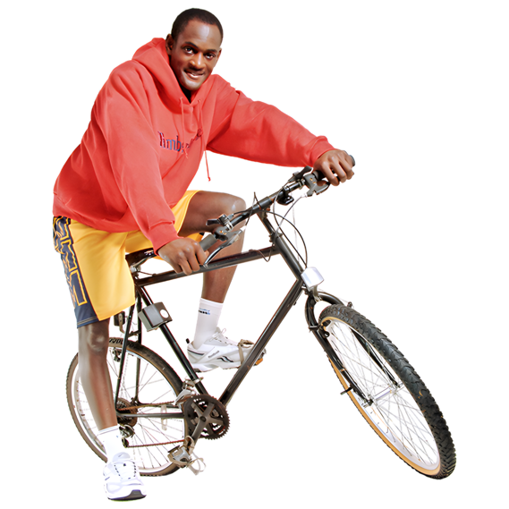
For example, people can be more healthy by:

- Getting the right healthcare, information and support.

- Doing exercise.

- Not smoking or vaping.

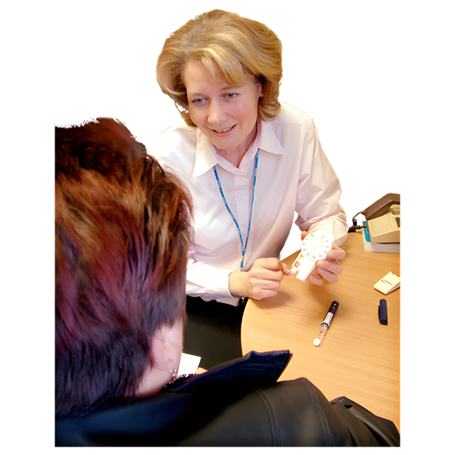
- Eating healthy foods.

Some people have health conditions that last a long time.

Like diabetes or asthma.

We will support them to live well with their health conditions.

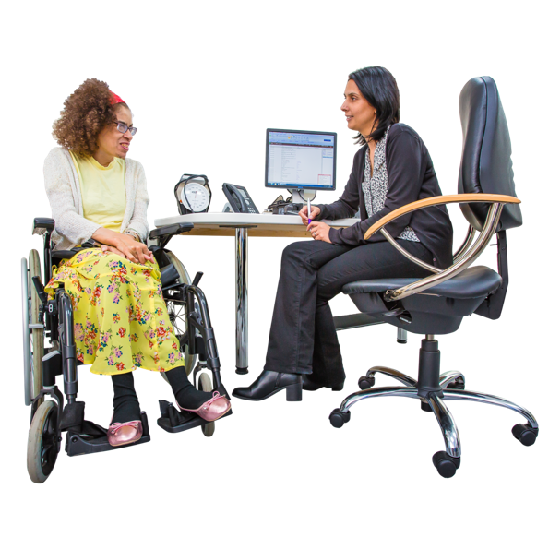
We will start some new ways to give people care for their health and mental health.

For example, we will support more people to get the right healthcare early on.

This is to stop problems getting worse later on.



We will also give better support to people who have drug or alcohol problems.


That means making sure people get the right support at the right time.

We will do more to stop people from hurting themselves or taking their own lives.
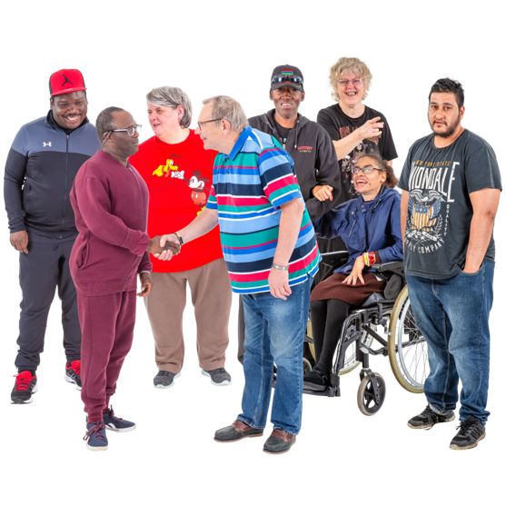

We will support communities to work together to keep everyone healthy.
- Supporting people to be healthy as they grow older

The main work we will do
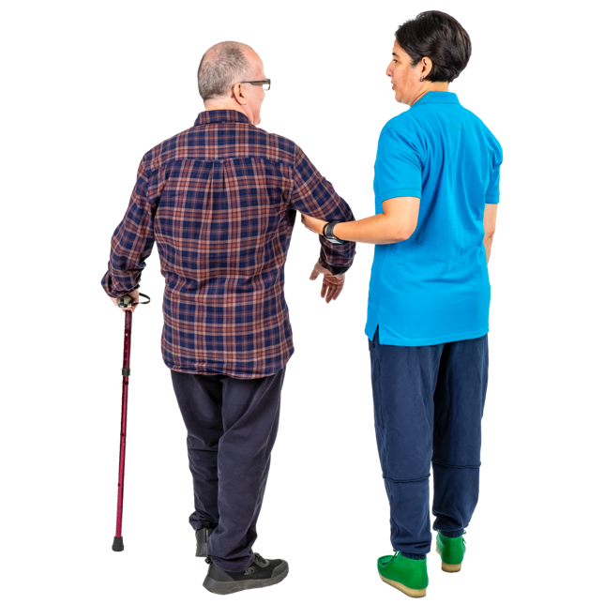

We will help to make life better for people as they get older.

For example:

We will do more to stop older people from falling over and having accidents at home.

We will support older people to do more exercise and to move around more.
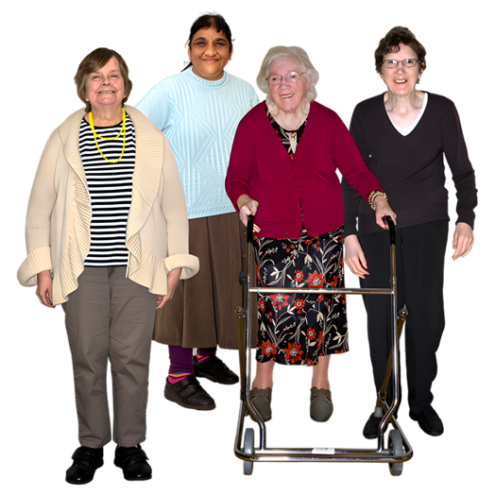

We will do more to stop older people from being lonely.



We will listen to older people more.

We will support them to say what they need.

We will also support more people to plan the care they want at the end of their life.
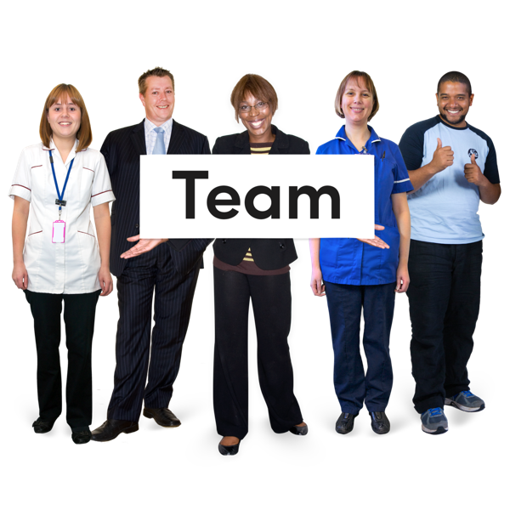
Making sure we work in the best way

We want to be a really good organisation to work for.

That means giving our staff the right support and training to do well.


We are changing the way we work to make it better.

For example, we want to use technology more.

Technology is things like computers, the internet and artificial intelligence.


We want to get better information to help us know what we need to do.
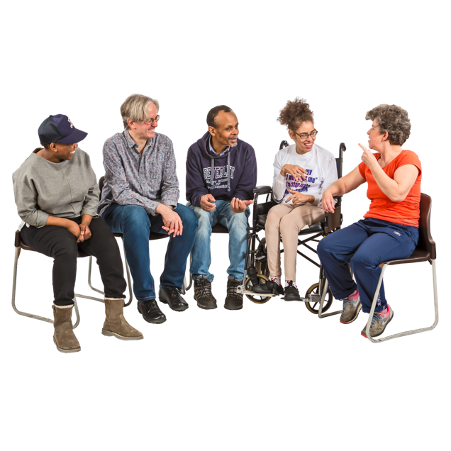
We will set up a new team to work on that.

We also want to work with more people and organisations.


This is so everyone can work together to get better health for people in Northern Ireland.

