Conference agenda and guest speaker biographies
9:00am | Registration
Opening session
Chaired by Dr John Cuddihy, National Director of Public Health, HSE
10:00am | Opening address  Dr Joanne McClean, Director of Public Health, Public Health Agency, Northern Ireland
10:10am | Keynote address: Health protection, a changing paradigm  Prof Sir Michael McBride, Chief Medical Officer for the Department of Health
10:30am | Health inequalities, the Northern Ireland perspective  Dr Joanne McClean, Director of Public Health, Public Health Agency, Northern Ireland
10:45am | Inequalities and health protection  Dr Jillian Johnston, Consultant Public Health, Public Health Agency, Northern Ireland
11:00am | Improving equity in immunisation programmes – The role of the social inclusion working group of the HSE national immunisation oversight committee (NIOC), 2022–2025  Aileen Kitching. HSE National Social Inclusion Office
11:10am | Networking tea and coffee break, with opportunities to browse posters from the scientific programme in the Britannic suite (25 mins)
Mid - morning session
Chaired by Dr John Cuddihy, National Director of Public Health, HSE
11:35am | Keynote address - Shared problems, shared solutions; unlocking our collective power  Prof Mary Horgan, Chief Medical Officer, Department of Health and Professor of infectious diseases, UCD
11:55am | Health protection collaboration: strength together  Dr Éamonn O’Moore, Director of National Health Protection, HSE Public Health: National Health Protection Office
12:10pm | Understand the views of people living in prison on vaccination and co-producing resources to promote uptake: NHS Greater Glasgow and Clyde experience  Helen Benson. Public Health Protection Unit, Public Health Directorate, NHS Greater Glasgow and Clyde
12:20pm | TB in a Limerick Prison: Considerations on contact tracing in a complex setting  Kenneth Beatty. HSE Public Health Midwest, Ireland
12:30pm | Panel Discussion  With Prof Mary Horgan, Prof Sir Michael McBride and Dr Mike Ryan
1:00pm | Group photo on the staircase
1:10pm | Networking lunch, with opportunities to browse posters from the scientific programme in the Britannic suite (50 mins)
Afternoon Session
Chaired by Dr Jillian Johnston, Consultant Public Health, Public Health Agency, Northern Ireland
2:00pm | Update on HSE National Public Health Strategy  Dr John Cuddihy National Director of Public Health, HSE
2:15pm | Developing capability to detect public health threats to Northern Ireland- the health protection situational awareness report (HPSAR)  Christopher Nugent. Public Health Agency, Northern Ireland
2:25pm | Cross-border molecular epidemiology of human mycobacterium bovis isolates from the island of Ireland using whole genome sequencing  Emma Roycroft. Irish Mycobacteria Reference Laboratory (IMRL)
2:35pm | Impact of a national RSV immunisation programme using nirsevimab in Ireland, 2024/2025 season  Lisa Domegan. HSE Health Protection Surveillance Centre
2:45 pm | Networking tea and coffee break, with opportunities to browse posters from the scientific programme in the Britannic suite (15 mins)
3:00pm | Keynote: Protecting the Principals and Practice of Public Health in an increasingly Fragmented and Polarised World  Dr Mike Ryan, Former Director of Emergency Response Division, World Health Organization
3:30pm | Implementing the MMR catch-up campaign in Northern Ireland  Rachel Spiers, Public Health Agency, Northern Ireland
3:40pm | Ireland’s measles response: A national collaboration in action  Lois O'Connor. HSE National Health Protection Office
3:50pm | Prize giving for the oral presentations  Dr Mike Ryan  Closing remarks  Dr Éamonn O’Moore, Director of National Health Protection, HSE Public Health: National Health Protection Office
4:00pm | Conference close

Guest speaker biographies

Prof. Sir Michael McBride  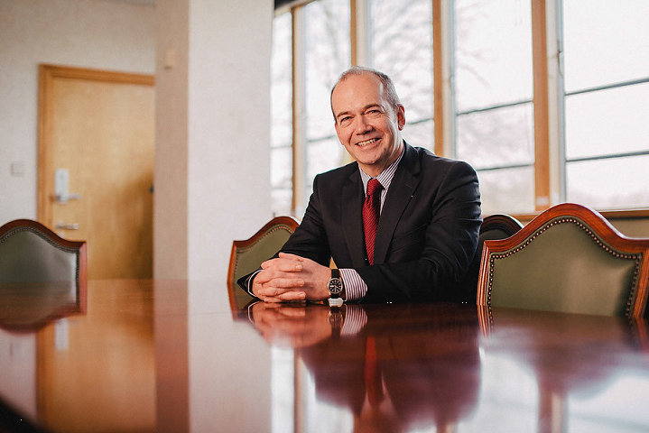 | Prof Sir Michael McBride was appointed to the post of Chief Medical Officer for the Department of Health, in September 2006.  Prior to joining the department, he had been Medical Director at the Royal Group of Hospitals from August 2002.  Prof Sir Michael McBride graduated with Distinction from Queen’s University Belfast in 1986 and completed his undergraduate and postgraduate training in Northern Ireland. In 1991 he attained a Research Fellowship at St Mary’s Medical School and Imperial College London, where he carried out research into new drug treatments for HIV.  Prof Sir Michael McBride has been a Consultant in the Health Service since 1994 when he was appointed Consultant Physician in HIV medicine at the Royal Group of Hospitals and has more than 10 years health service management experience.  He has a longstanding interest in continuing medical education and was Postgraduate Clinical Tutor in the Royal Group of Hospitals between 1996 and 2000 and Director of Education in the Royal Hospitals from 2000.  As Medical Director at the Royal Hospitals, he contributed to strategic change at trust, regional and national level. As the Trust lead for clinical and social care governance, he had responsibilities for all aspects of clinical quality and patient safety. Prof Sir Michael McBride took up the post of Chief Medical Officer during a time of significant change for Health and Social Care in Northern Ireland with responsibilities for Policy and Strategy in relation to Public Health, Quality and Safety and Research and Development. He also provides strategic advice to Minister and other Government departments on health-related matters. He has been closely involved in the development of the new Health and Social Care structures, post Review of Public Administration, including the establishment of the Public Health Agency. Prof Sir Michael McBride currently leads in the work to transform health and social services in Northern Ireland in line with Health and Wellbeing 2026 – Delivering Together.  At the request of the Health Minister Prof Sir Michael McBride took up the post of Chief Executive of Belfast Health and Social Care Trust from December 2014 to February 2017. He combined this role with Chief Medical Officer. As Chief Executive Prof Sir Michael McBride was head of an integrated health and social care Trust which provided hospital-based and social care services to the population of Belfast, as well as most of Northern Ireland’s regional specialist services. He had responsibility for key Ministerial priorities, corporate responsibility for the Trust’s 20,000 employees, and overseen the Trust’s annual budget of almost £1.3bn. Prof Sir Michael McBride was knighted in Her Majesty's 2021 Birthday Honours for services to public health in Northern Ireland. He was awarded a Professorship in Public Health Practice from Queens University Belfast in 2021 for services to Public Health.
Dr. Joanne McClean   | Dr Joanne McClean took up post as Director of Public Health on 1 September 2022. Joanne graduated from Queen’s University in Medicine with Honours in 1999. After graduation Joanne worked in junior doctor hospital training posts before completing specialist training in public health medicine. Joanne has a Masters in Population Health and is a member of the Faculty of Public Health and of the Royal College of Physicians. Joanne was appointed as a Consultant in Public Health in the Public Health Agency in January 2012. In her consultant post Joanne had a particular interest in health service public health and in child health. Between June 2021 and August 2022 Joanne was seconded to the Department of Health as Associate Deputy Chief Medical Officer to work on the COVID response. Joanne was made an Honorary Professor of Public Health Practice by Queen’s University in February 2023.
Dr. Jillian Johnston   | Consultant in health protection in Northern Ireland for 11 years with experience nationally and locally, from policy development to investigation and management of incidents, outbreaks and other hazards. Currently regional lead for TB prevention and control, strategic oversight of acute response function in Northern Ireland and the public health act.
Prof. Mary Horgan MD  FRCPI FRCP  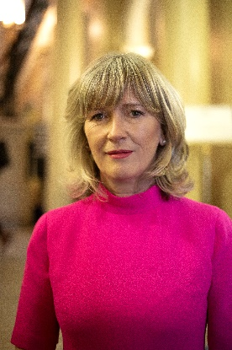 | Interim Chief Medical Officer, Department of Health and Professor of Infectious Diseases, UCD. Professor Mary Horgan is interim Chief Medical Officer and Professor of Infectious Diseases at UCD and Mater Misericordiae University Hospital. She is the immediate past President of the Royal College of Physicians of Ireland and is the first woman to hold this position since the College’s foundation in 1654. She is the former Dean of the School of Medicine at UCC and was the first woman to be appointed to this position. She is a graduate of UCD School of Medicine in 1986 and was awarded the UCD Alumni award for health in 2019.  She is a Director of Education of the European Society of Infectious Diseases and Clinical Microbiology (ESCMID). She also served on the National Public Health Emergency Team (NPHET) and led the expert advisory group on rapid testing and chaired Ireland’s first National Research Ethics Committee.
Dr. Éamonn O’Moore  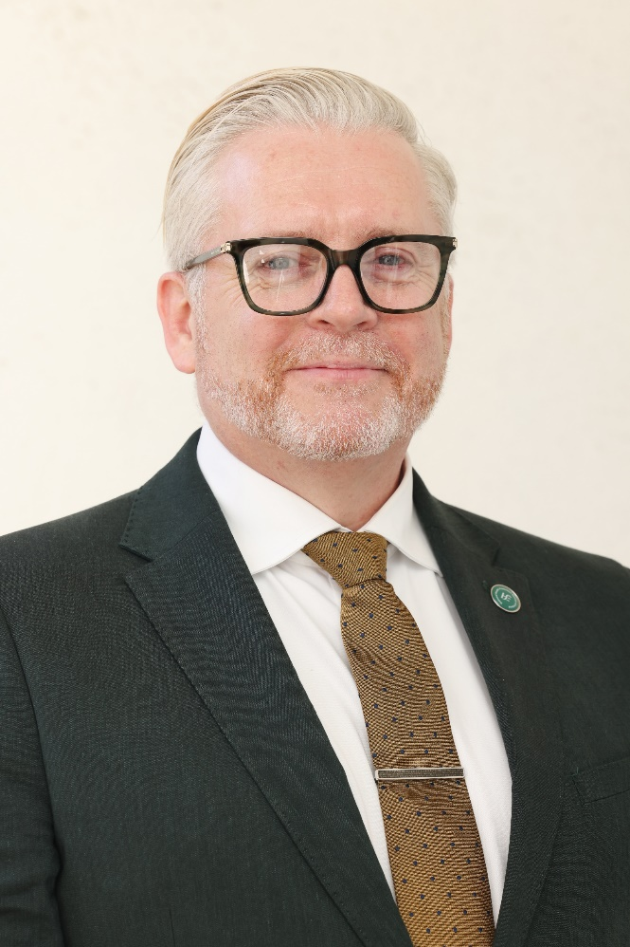 | Dr Éamonn O’Moore is Director of National Health Protection. A UCD graduate (1991), he has worked extensively in the UK and internationally with WHO and ECDC in health protection. He trained in Public Health in Oxford and at the London School of Hygiene & Tropical Medicine.  His UK roles have included Director of Thames Valley Health Protection Unit, National Lead for Health & Justice (PHE), and Deputy Director for Vulnerable People (UKHSA). During COVID-19, he was SRO for the PHE public health response in adult social care and secure settings. He was National Incident Director the UK response to the 2014/15 Ebola outbreak in West Africa  Dr O’Moore has a strong focus on health equity, prison health, and infectious diseases such as TB, blood-borne viruses and migrant health. He led the development of surveillance and epidemiological resources nationally and internationally to inform health needs and health impact assessments. He has advised national and international governments, published widely in peer-reviewed journals, contributed to international guidelines with ECDC & WHO, presented internationally, and is editor and senior contributor to the Oxford University Press textbook on Prison Medicine & Health.
Dr John Cuddihy  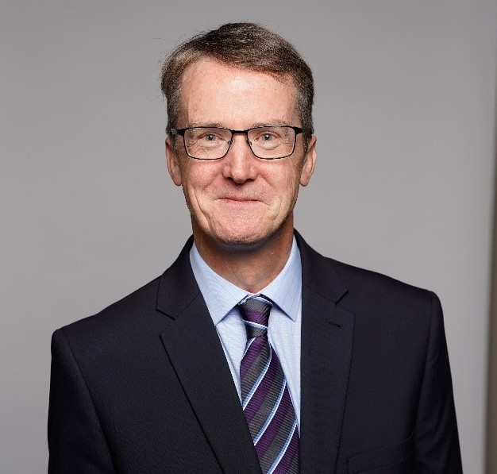 | Dr. John Cuddihy is HSE National Director of Public Health. John has been involved in Public Health reform in Ireland from the Crowe Horwath review and report implementation to more recently leading the implementation of the Public Health reform programme.  He has previously held positions as Director of Public Health, Director of HPSC and National Clinical Director of Health Protection.
Dr. Mike Ryan   | Dr Mike Ryan has been at the forefront of managing acute risks to global health for nearly 25 years. He served as Assistant Director-General for Emergency Preparedness and Response in WHO's Health Emergencies Programme from 2017 to 2019. Dr Ryan first joined WHO in 1996, with the newly established unit to respond to emerging and epidemic disease threats. He has worked in conflict affected countries and led many responses to high impact epidemics. He is a founding member of the Global Outbreak Alert and Response Network (GOARN), which has aided the response to hundreds of disease outbreaks around the world. He served as Coordinator of Epidemic Response (2003-2000), Operational Coordinator of WHO’s response to the SARS outbreak (2003), and as WHO’s Director of Global Alert and Response (2011-2005), He was a Senior Advisor on Polio Eradication for the Global Polio Eradication Initiative from 2013 to 2017, deploying to countries in the Middle East. He completed medical training at the National University of Ireland, Galway, a Master’s in Public Health at University College Dublin, and specialist training in communicable disease control at the Health Protection Agency in London and the European Programme for Intervention Epidemiology Training.

