Talking really helps suicide prevention campaign
Please support the campaign through your own social media channels by liking and sharing the Public Health Agency’s posts or by creating your own posts using the assets linked on the page and the suggested words. Don’t forget to tag the Public Health Agency and follow us at:
Facebook: @PublicHealthAgency
Instagram: @PublicHealthNI
Campaign hashtags: #TalkingReallyHelps #Lifeline #MentalHealth
Asset | Suggested words
Lifeline service user quotes 1 video  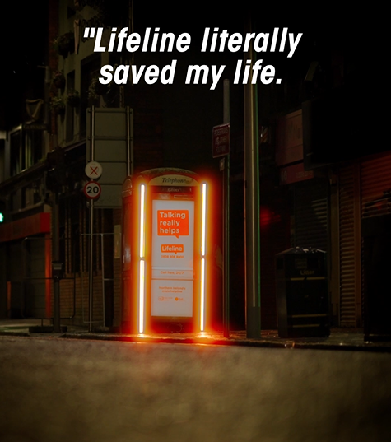 | Talking is the first step to feeling better. Whatever you're struggling with, there's a way through it. Call Lifeline's qualified counsellors for free, 24/7 on 0808 808 8000.  Learn more at lifelinehelpline.info  #TalkingReallyHelps #Lifeline #MentalHealth
Lifeline service user quotes 2 video  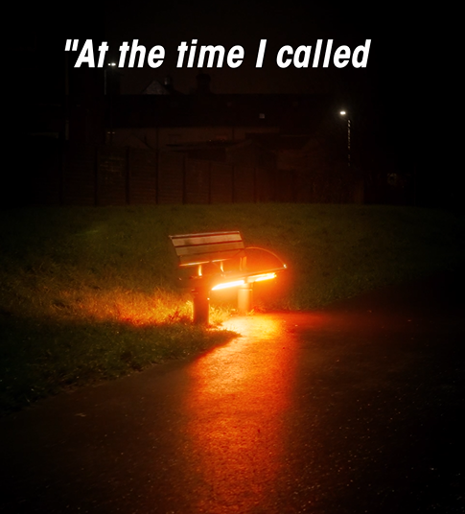 | When life feels overwhelming, you don't have to face it alone. Lifeline's qualified counsellors are here to talk 24/7.  Call #Lifeline on 0808 808 8000 or visit lifelinehelpline.info  #TalkingReallyHelps #MentalHealth
Lifeline service user quotes 3 video  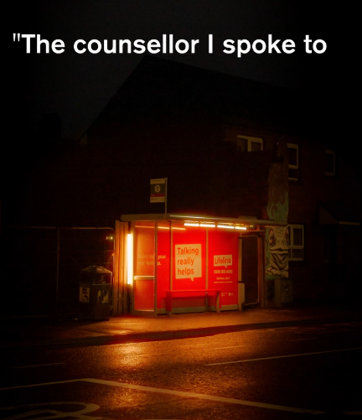 | Lifeline's qualified counsellors are here for you, 24/7. If you or someone you know is struggling, you can talk to #Lifeline for free on 0808 808 8000.  Learn more at lifelinehelpline.info  #TalkingReallyHelps #MentalHealth
Lifeline phone kiosk social edit video  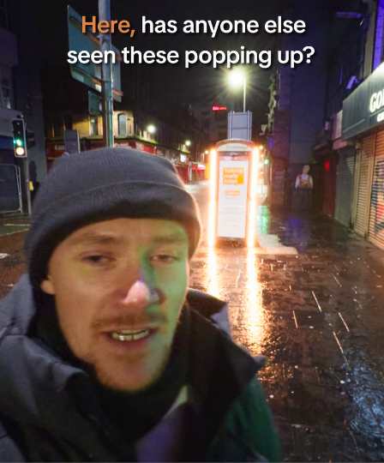 | If you need someone to talk to, #Lifeline is here to listen. Call Lifeline's qualified counsellors for free, 24/7.  Call #Lifeline on 0808 808 8000 or visit lifelinehelpline.info  #TalkingReallyHelps #MentalHealth
Talking really helps 30s video  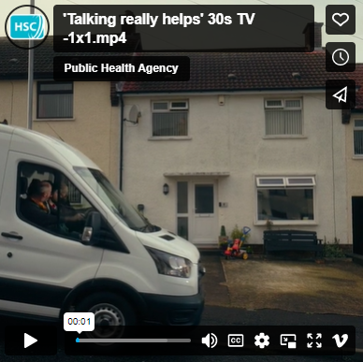 | If you are in distress or crisis, or you know someone who is, you can talk to one of Lifeline’s qualified counsellors for free, 24/7. Call #Lifeline on 0808 808 8000.  Learn more at lifelinehelpline.info  #TalkingReallyHelps #MentalHealth
Talking really helps 15s male video  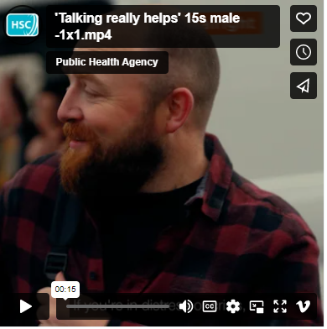 | Sometimes life can get on top of us. But that’s when talking matters most. If you’re struggling, you can pick up the phone and talk to one of Lifeline’s counsellors for free, 24/7.  Call #Lifeline on 0808 808 8000 or visit lifelinehelpline.info  #TalkingReallyHelps #MentalHealth
Talking really helps 15s female video  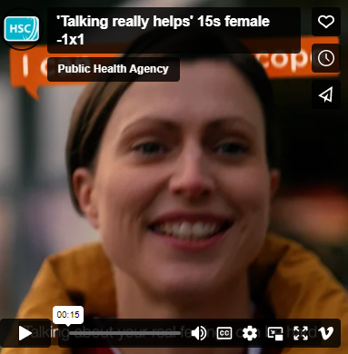 | When you’re struggling to cope, #TalkingReallyHelps. Talk to a friend, family member or someone you trust. You can also call #Lifeline and speak to a counsellor for free, 24/7.  Call Lifeline on 0808 808 8000 or visit lifelinehelpline.info  #MentalHealth
Lifeline counsellor video (calls)  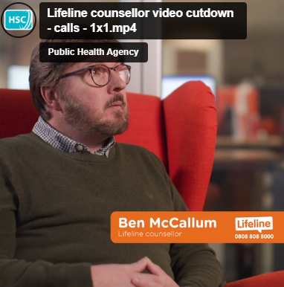 | Lifeline has a brilliant team of counsellors like Ben on the other end of the phone. If you’re struggling, you can talk to one of Lifeline’s counsellors for free, 24/7.  Call #Lifeline on 0808 808 8000 or visit lifelinehelpline.info  #TalkingReallyHelps #MentalHealth
Lifeline counsellor video (not a burden)  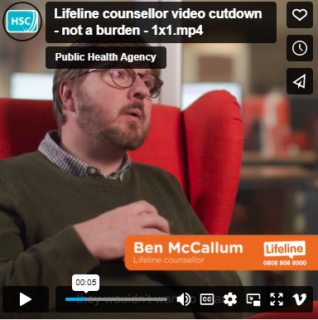 | Trained counsellors like Ben are able to provide immediate help and support to anyone in crisis or despair. If you’re struggling, don’t suffer alone. Talk to #Lifeline today.  Call Lifeline on 0808 808 8000 or visit lifelinehelpline.info  #TalkingReallyHelps #MentalHealth
Lifeline counsellor video (things can get better)  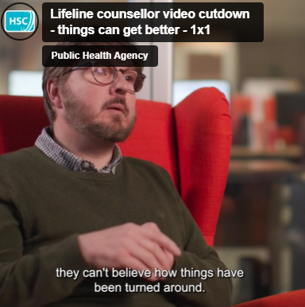 | When you’re struggling or feeling low, #TalkingReallyHelps. Because when you start talking, you can start feeling better. Speak to a qualified #Lifeline counsellor for free, 24/7.  Call Lifeline on 0808 808 8000 or visit lifelinehelpline.info  #MentalHealth
Texting video  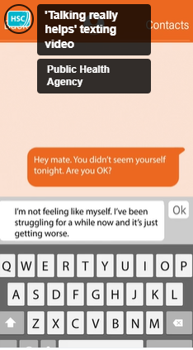 | If you are worried about someone but aren’t sure how to talk to them, you can call #Lifeline for advice on 0808 808 8000.  Learn more at lifelinehelpline.info  #TalkingReallyHelps #MentalHealth
Signs to call Lifeline video  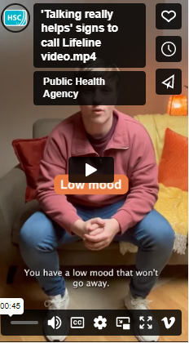 | Do you spot some of these signs in yourself? Talking is the first step in starting to feel better. You can talk to one of Lifeline’s qualified counsellors for free, 24/7.  Call #Lifeline on 0808 808 8000 or visit lifelinehelpline.info  #TalkingReallyHelps #MentalHealth
Signs you may need to call Lifeline animation  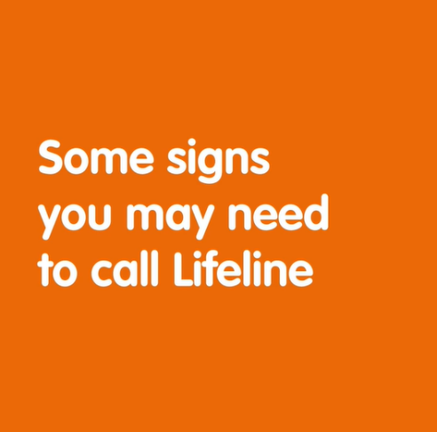 | If you spot these signs in yourself or someone you know, talk to #Lifeline. Qualified counsellors are available for free, 24/7. When you start talking, you can start feeling better.  Call Lifeline on 0808 808 8000 or visit lifelinehelpline.info to learn more.  #TalkingReallyHelps #MentalHealth
I can barely cope static image  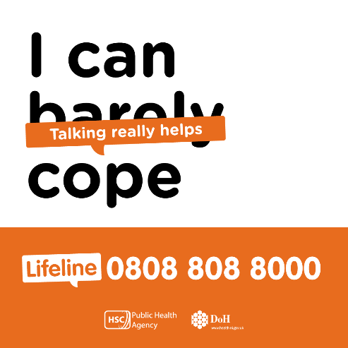 | When you start talking, you can start feeling better. You can talk to #Lifeline if you're struggling, or are worried about someone else. Qualified counsellors are available 24/7.  Call Lifeline on 0808 808 8000 or visit lifelinehelpline.info  #TalkingReallyHelps #MentalHealth
I’m not feeling okay static image  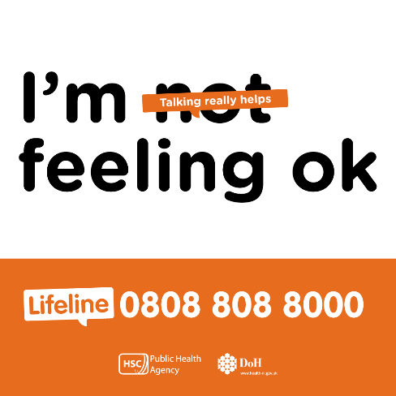 | When you start talking, you can start feeling better. You can talk to #Lifeline if you're struggling, or are worried about someone else. Qualified counsellors are available 24/7.  Call Lifeline on 0808 808 8000 or visit lifelinehelpline.info  #TalkingReallyHelps #MentalHealth
I’m not fine static image  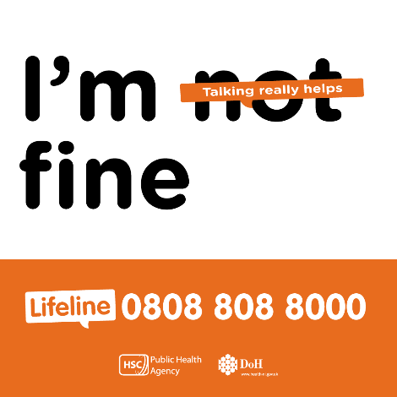 | When you start talking, you can start feeling better. You can talk to #Lifeline if you're struggling, or are worried about someone else. Qualified counsellors are available 24/7.  Call Lifeline on 0808 808 8000 or visit lifelinehelpline.info  #TalkingReallyHelps #MentalHealth

