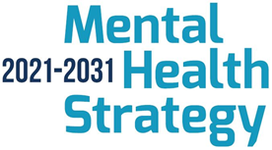

Mental Health Strategy

Early Intervention and Prevention
Action Plan

Delivery Report (2022-2025)

Introduction 3
Summary 4
Delivery Updates 5
Action 1 5
Action 2 - 8
Action 3 12
Action 4 - 14
Action 5 - 16
Action 7 - 21
Action 8 23
Appendix 1 – Current Steering Group Membership 26

Introduction

The Department of Health published the Mental Health Strategy, 2021-2031, in June 2021. The Strategy set out 35 actions under three overarching themes:

Theme 1 - promoting mental wellbeing, resilience and good mental health across society;
Theme 2 – providing the right support at the right time; and
Theme 3 – new ways of working.

In May 2022, the Department of Health requested that the PHA lead on a cross sectoral approach to delivering on Actions 1 and 2.

Action 1 Increase public awareness of the distinction between mental wellbeing, mental ill health and mental illness, encouraging public understanding and acceptance of how life can impact upon mental wellbeing, and recognition of the signs of mental ill health and mental illness. Using public mental health education and effective awareness raising methods, increase public knowledge of the key measures that can be taken to look after mental wellbeing, increase understanding of mental ill health, and encourage public discourse and dialogue to reduce stigma.

Action 2 Create an action Plan for promoting mental health through early intervention and prevention, with year on year actions covering a whole life approach, reaching from infancy to older age. The action Plan must consider groups disproportionally affected by mental ill health who often struggle to access early intervention services and seek to reduce stigma associated with mental ill health.

The Early Intervention & Prevention Action Plan (2022 – 2025) was developed by a cross sectoral and cross departmental Steering Group and set out eight areas of focus to deliver on Actions 1 and 2.

This report provides a summary of progress and key achievements in delivering against that plan.

Summary

The eight areas of action within the Early Intervention & Prevention Action Plan are;

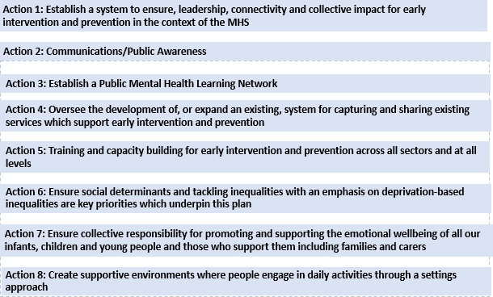

Across these eight action areas there are 29 sub actions. Progress against those 29
sub actions is detailed in this report and each sub action has been RAG rated.

- 18 (62%) have been rated Green (Achieved)
- 9 (31%) have been rated as Amber (Progress made but not fully achieved)
- 2 (7%) have been rated as Red (Not progressed)

Actions which will require further work are carried forward to the Promoting Mental Health and Emotional Wellbeing Action Plan 2026 – 2029 which has recently been developed.

Delivery Updates
Action 1 - Establish a system to ensure, leadership, connectivity and collective impact, at both regional and local levels, for early intervention and prevention in the context of the MHS
Actions | Progress | RAG
1.1 A Reference Group will be responsible for influencing relevant government policy, overseeing implementation of this plan and all work related to Actions 1&2, including ensuring links to other Actions within the MHS. | - Steering Group established in 2022 with representation from 27 partner organisations including from the community and voluntary sector, health and social care, academia, departments of health, education, justice, economy, communities and rural affairs.  - 15 Steering group meetings were held in total between April 2022 and March 2026 | G
1.2. An Early Intervention and Prevention Co-ordination Team to provide backbone support to co-ordinate this work, to report to the Steering Group and link to other areas of early intervention and prevention work. | - Co-ordination team in place since 2022 including; project management, health improvement support and health intelligence support. Two Communications posts – not yet in place, job descriptions have been developed and work continuing to recruit to these positions.  - Strategies which contribute to mental health early intervention and prevention have been mapped and collated.  - Programme management arrangements have been put in place to help ensure strong connections across stakeholders and a quarterly stakeholder newsletter has been developed. | A
1.3. A Data and Outcomes group for early intervention and prevention to be established to ensure equal priority with service provision in the MHS Outcomes Framework, to develop datasets specific to early intervention and prevention, to co-ordinate the sharing of outcomes from other relevant areas, and to monitor effectiveness of this plan. | - The Sub group was established in April 2023 and met 6 times with membership from a range of stakeholders.  - A working group was also established in March 2024 and met 13 times  - A Rapid review of international approaches was commissioned and then carried out by QUB  - Two evidence reviews carried out by the PHA Health Intelligence team; one in relation to the social determinants of public mental health and one in relation to those at higher risk of poor mental health  - Engagement was carried out with a wide range of stakeholders and a Data and Outcomes Framework was developed and signed off by the Steering Group in May 2025 which includes; agreed regional population measures, a toolkit to support measurement of outcomes at a programme level from interventions or services and a number of recommendations for next steps.  - To support population level measurement a Mental Health Survey was commissioned and results published  - A telephone survey included testing of 2 stigma measurement tools has been carried out and results published. | G
1.4. An Engagement Group to be established to develop, implement and monitor a user engagement and involvement strategy for this work based on coproduction and to link with other actions in the strategy. | - An Engagement Group was established in June of 2023 and met twice within that year. It was agreed that it was more appropriate for engagement to be taken forward through each sub group’s work and so the subgroup was stood down.  - The Data and Outcomes framework was developed in a collaborative process through a sub group and a working group. Six additional engagement sessions were arranged; those included sessions with; representatives from a number of government departments, a youth committee, two local community groups, the Public mental health ECHO network and an open online session for anyone with an interest in this work. Feedback was gathered and the framework adapted to reflect the key messages.  - The Student mental health sub group has worked to identify mechanisms to enable student’s views to be central to it’s work by connecting with National Union of Students and student wellbeing advisory panels.  - As part of the Digital Discovery exercise, 41 stakeholder engagement sessions were held, which involved more than 70 organisations and included discussion with the Patient Client Council mental health engagement platform. | A
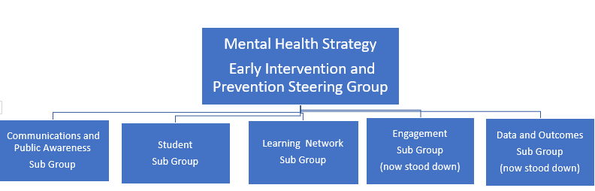

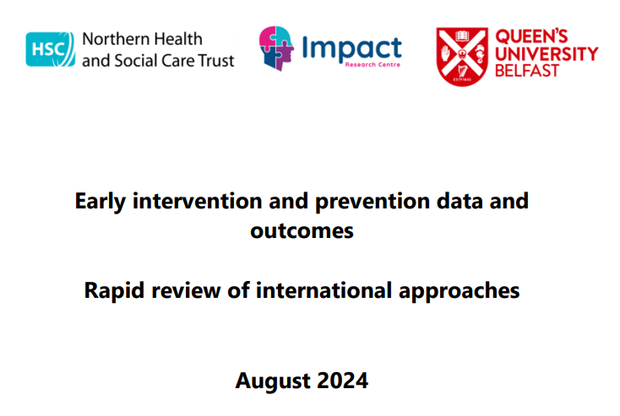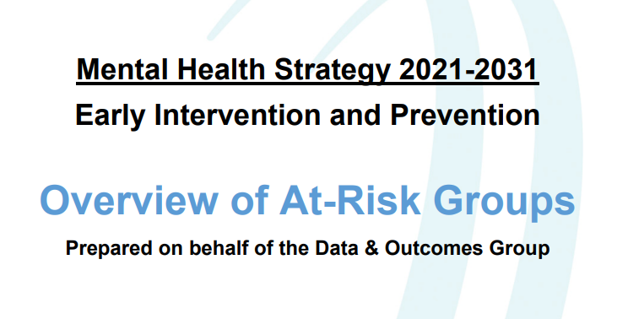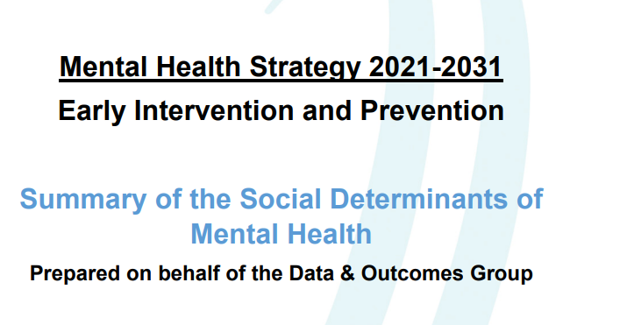

Action 2 - Establish a Communication/Public Awareness Raising Group to oversee the development of a cross sectoral approach to increasing public awareness on mental health and to reducing stigma. This will include identifying priorities and models of good practice, developing a public messaging model (including increasing mental health literacy) and consider capacity in all sectors. Work will cover regional and local, total population plus targeting groups most at risk, consider digital implications and develop a cross sectoral brand for positive mental health.
Actions | Progress | RAG
2.1 Establish a Communication / Public Awareness Raising Group with an agreed Terms of Reference and appropriate cross sectoral representation. | - A Communications and Public Awareness Raising Sub Group was established with membership from across government departments, the HSC system as well as research and academia and the voluntary and community sector.  - TOR were agreed in July 2023 and the sub group met four times.  - The need to focus on three specific areas was identified and three task and finish groups were established in 2025 to focus on; Campaigns, Research, Best practice and Targeting, and Brand and Digital.  This sub group also contributed to the delivery of a Digital Discovery exercise to explore opportunities to increase access to digital early intervention and prevention options as per Action 4 of this plan (further detail on page 10). | G
2.2 Establish a Campaigns Task and finish group to; scope current and planned public mental health campaigns,  develop recommendations to deliver improved coordination and consistency of messaging, develop recommendations about how to sustain partnership working in relation to public mental health campaigns. | - Group established and met 6 times between Feb 2025 – September 2025  - Scoping of planned campaigns was carried out  - Identified a number of ways to improve co-ordination and consistency of messaging including the establishment of a Mental Health Communications and Public Awareness Forum to bring key stakeholders together to strengthen and build relationships, discuss and share campaign plans and information, help plan and co-ordinate campaigns/communications activity across the year and share learning | G
2.3 Establish a Research/best practice/targeting task and finish group to  - complete a best practice review in relation to increasing public awareness on mental health and to reducing stigma.  - Identify target groups and best practice in how to reach each group | - Group established and met 4 times  - Discussed and agreed key criteria to commission an evidence review, developed a specification and following a process commissioned the review from the Northern Trust Impact Centre and QUB.  - Evidence review delivered  - A number of recommendations for next steps were identified to address other aspects of the group’s terms of reference. | G
2.4 Establish a Brand/digital task and finish group to; develop proposals for cross-sectoral brand for mental health promotion, early intervention & prevention, to develop proposals for a digital development programme which will increase access to digital early intervention and prevention options to increase choice for individuals. | - Task and finish group was established and met 4 times between February 2025 and September 2025.  - Agreed to focus on development of the Minding Your Head and Youth Wellness web platforms.  - Agreed to focus on how the existing “Minding Your Head” brand could be used more broadly and to develop guidelines for it’s use.  - Agreed the need to continue to work with partners to make the case for the Collaborative Mental Health platform as recommended within the Digital Discovery report. | A
2.5 Deliver two mental health and wellbeing early intervention and prevention campaigns on an annual basis | - The PHA and HSC Trusts worked together to deliver mental health and emotional wellbeing campaigns which ran in September and October 24/25 and 25/26 focussed on mental wellbeing.  - The Living Well campaign provides key public health messages and advice through community pharmacies that are contracted to provide the service. The campaign focussed on mental health in December and January 24/25 and in February and March 25/26. | G
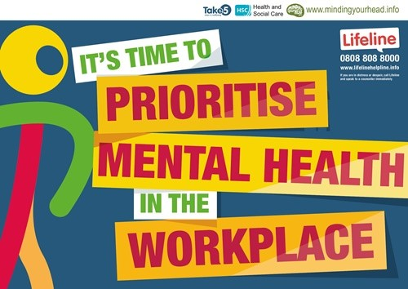
The Public Health Agency worked in partnership with Health and Social Care Trusts to develop a campaign to encourage people across NI to prioritise workplace mental health. The campaign ran from 11 September to 10 October 2024 to mark the period between World Suicide Prevention Day and World Mental Health Day. The campaign reached and was supported by over 30 partners including government departments, community and voluntary sector, primary care, professional training providers, the business/ commerce sector and more. Over the course of the campaign timeframe, the online resource was directly accessed by 2214 people; the ‘Minding your head’ campaign page was clicked on 3853 times; social media posts were seen at least once by 99,278 users

A campaign was also delivered again in 25/26 urging people to prioritise their mental wellbeing. This campaign included a collaboration with former rugby player Jonny Murphy which proved successful as he shared campaign messages to his 130k TikTok followers and 292k Instagram followers.
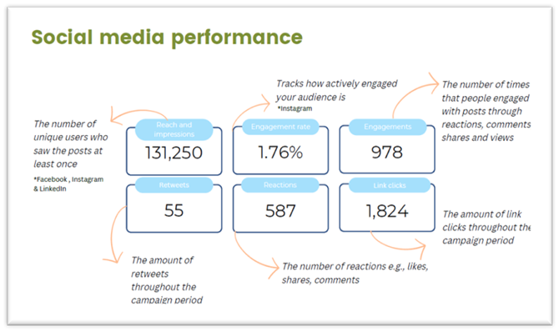

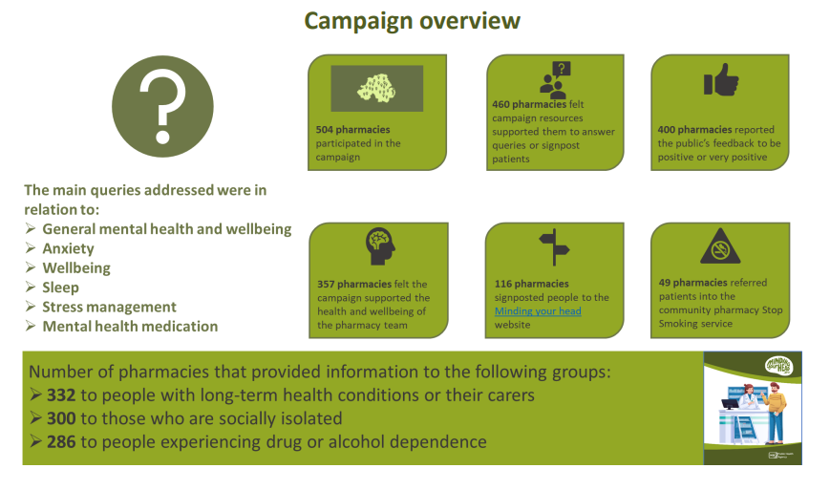

As part of the Living Well partnership with Community Pharmacies The ‘Looking after your mental health’ campaign highlighted the importance of looking after your mental health, being aware of any signs of problems and using self-care techniques to manage
your mental health.

The campaign also promoted the Minding your head website.

The campaign ran throughout February and March 2025
Action 3 - Public Mental Health Learning Network to be established as a means to collate and expand the evidence base, including building evidence and understanding of how structural inequalities impact on mental health. The Network will support the development of reflective practice across all sectors and develop models peer support.
Actions | Progress | RAG
3.1 Establish a Public Mental Health Learning Network Sub Group | - A Sub Group was established in 2023 with leadership and support from the Mental Health Foundation and has met 9 times June 2023 and January 2026 with a broad membership from across sectors and has driven significant progress against this action and against action 6 of this plan. | G
3.2 Enable partners to share best practice on the effectiveness of interventions (including cost effectiveness) and work collaboratively.  Support the development of reflective practice across all sectors and advise on models of peer support as required. | - ECHO Network - A virtual learning network for anyone with an interest in public mental health was established in May 2024 on the Project ECHO platform and chaired by the Mental Health Foundation.  - 200 people from a broad range of backgrounds joined the network, and 9 sessions were held between May 2024 and May 2025  - An ECHO evaluation was carried out and a report developed.  - Two regional conferences were held; one in March 25 in partnership with QUB and one in May 25 in partnership with UU with almost 200 attendees at each. | G
3.3 Collate and expand the evidence base including building evidence and understanding of how structural inequalities impact mental health | - A seminar exploring the impact of Poverty on Mental health was held in November 2024 with 60 attendees. Through presentations and group discussion a number of recommendations to advocate for policy change and to alleviate the impact of poverty on mental health were identified. A seminar report summarised the proposed recommendations and work continues to seek opportunities to implement those recommendations.  - An evidence review was commissioned and delivered in February 2025 in relation to mental health in all policies and work is underway to consider how this approach can be tested in NI to develop a whole of government approach to improving the mental health of the population. | G
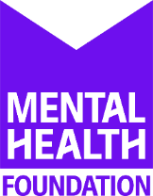
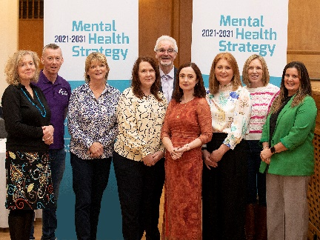
The first conference; Developing a Public Mental Health Approach - The Case for Prevention was held on Thursday 21st March 2024 at Whitla Hall, Queens University Belfast. The conference brought together 200 attendees including; policymakers, academics and professionals from statutory, voluntary and community sector organisations to focus on prevention and to consider the impact of their work on public mental health. They heard from key note speakers and shared local work and good practice displayed through over 20 poster presentations.
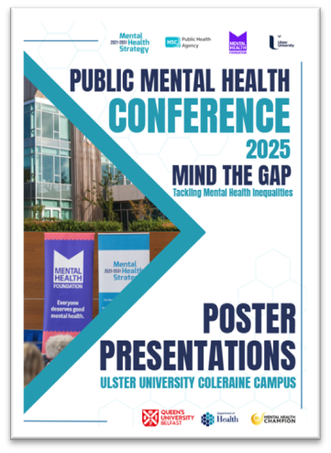

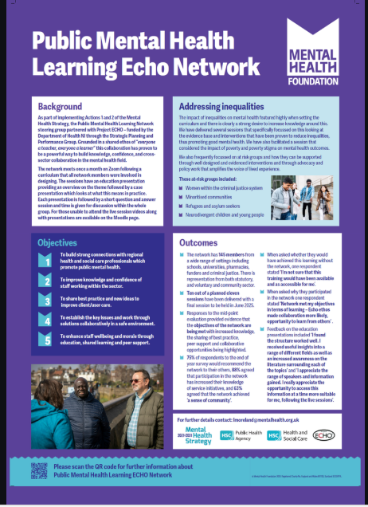
In May 2025 the conference was held at the University of Ulster Coleraine Campus. Tackling Mental Health Inequalities – Using a Public Mental Health Approach to Close the Gap. Key partners in the conference were the Department of Health, Mental Health Foundation NI, the University of Ulster the Mental Health Champions office, Queens University Belfast and the University of Ulster who hosted the conference on their Coleraine campus. The report from the conference is available here and includes a slideshow of the posters presented is available to review.

The Public Mental Health ECHO network met 9 times and covered topics such as poverty and mental health, protective and risk factors, developing community based intervention and measuring impact.
Feedback was gathered from members of the network and an Evaluation report is available.

Action 4 - Oversee the development of, or expand an existing, system for capturing and sharing existing services which support early intervention and prevention in the context of mental health, including self-direct support resources and automated systems to help people self-help.

Actions | Progress | RAG
4.1 Oversee the development of, or expand an existing, system for capturing and sharing existing services which support early intervention and prevention in the context of mental health and alignment with co-occurring issues.  Desktop review of existing systems undertaken. | - A Digital Discovery exercise undertaken to explore the role of Digital technologies in mental health promotion, early intervention and prevention and to identify recommendations for next steps. A wide range of engagement was carried out as part of the process and review of existing digital platforms was undertaken.  - A report was developed and a number of recommendations were made to progress the development of a new Collaborative Mental health platform. Discussions are ongoing with partners at a departmental level to identify potential next steps and required funding. | A
4.2 Partner information on early intervention and prevention services collated and shared with the Reference Group. | - Some partner information was collated, however there were challenges in capturing the breadth of information available and in ensuring it was up to date. It was agreed that a digital platform is required in order to be able to effectively capture and share relevant information. | A
4.3 A process will be agreed for commissioning a new or revised system, including the process for maintaining the system, including greater alignment with related issues such as substance use or suicide prevention. | - Work has been undertaken to refresh the Minding Your Head site and to develop the service directory with guidance and process for adding services to the site circulated widely. | A
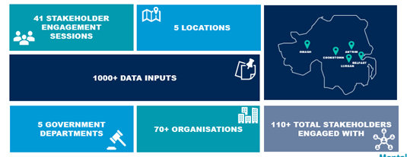
A Digital Discovery exercise was carried out in 24/25 to explore the role of digital tools to support mental health promotion, early intervention and prevention in NI.

More than 110 stakeholders were engaged in the process through one to one interviews, focus groups and workshops. Reports from the digital discovery exercise have been shared with contributors and stakeholders. They present an analysis of the current digital landscape for mental health promotion and early intervention and outline a roadmap for the phased development of a Collaborative Mental Wellbeing Platform. This will require a strong partnership approach and significant funding to progress and discussions have been had across government departments to identify potential avenues to take this forward.

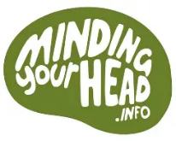
The PHA Health Improvement team undertook a refresh of the Minding Your Head website which has now been relaunched https://www.mindingyourhead.info

This site is a valuable informational resource created to provide up-to-date information and self-help advice for mental health and wellbeing. The website provides; clear, up-to-date information on mental health and wellbeing, including anxiety, low mood and depression, stress and more, clear information on how you can support someone with their mental health, including information on supporting children and young people; a service directory for people to find help with their mental health and wellbeing in their local area, information on training available.

Action 5 - Training and capacity building for early intervention and prevention across all sectors and at all levels
Actions | Progress | RAG
5.1 Undertake a desktop analysis of early intervention and prevention training and capacity building programmes available, or planned, across sectors.  5.2 Scope out and review the opportunities for having a cross sectoral and cross-issue approach to the provision of early intervention training on protective factors through the development of a universal programme. | - Training provision for mental health early intervention and prevention was scoped in 2025 with 71 unique training courses identified and a report on the findings and recommendations for next steps identified developed.  - Recommendations have been developed for next steps to improve access to appropriate training in line with the existing PHA Mental Health training framework. | G
5.3 Explore the role of mental health literacy in early intervention and prevention through linking with the Learning Network. | - Through the work of the learning network and facilitated by the Mental Health Foundation a workshop to explore mental health literacy was held in March 2026. There were 50 attendees from across sectors discussing their understanding of mental health literacy and the best ways to measure it and proposed to establish a task and finish group to focus on developing a definition and an approach to measurement. | G
5.4 Explore how community organisations can be supported to develop capacity-building programmes to reduce mental health problems and co-occurring issues in their communities | - In 23/24 additional resources were allocated to the PHA Making Life Better through Short Term Funding Programme which is available to C&V organisations and supported communities to enhance capacity to address the themes of mental health, emotional well-being, suicide prevention and self-harm. In total £1.4 million was allocated from Protect Life 2 and EIP budgets to enable delivery of 438 projects with 29,454 beneficiaries. | G
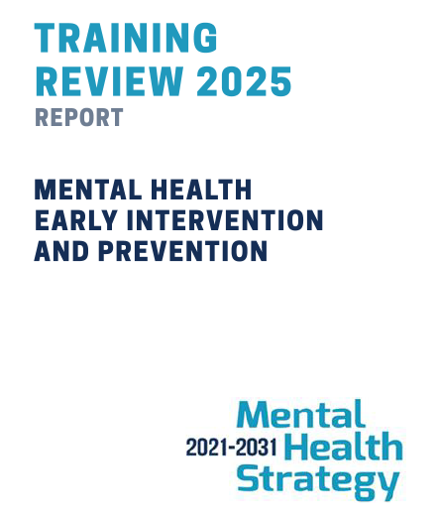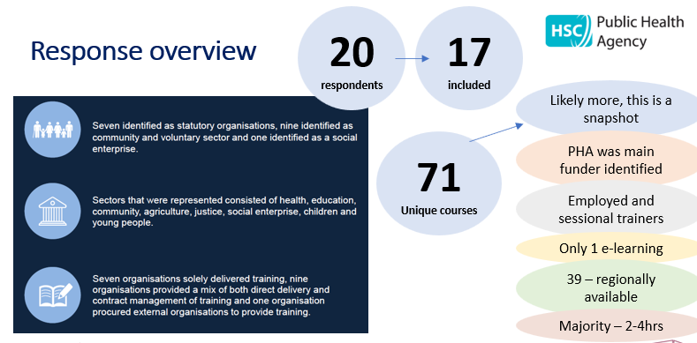
Action 6 Ensure social determinants and tackling inequalities with an emphasis on deprivation-based inequalities are key priorities which underpin this plan, including understanding the links with mental health and the opportunities for early intervention and prevention, considering and influencing the policies and strategies highlighted in Appendix 2 and increasing supports available to address the social factors that impact on mental health, including social prescribing. This will require reviewing capacity across all sectors, ensuring that information on existing services is easily available and kept up to date.
Actions | Progress | RAG
6.1 Scope out policies which have can influence early intervention and prevention | - Policies which have an influence on early intervention and prevention have been scoped and collated  - There has been a specific focus on poverty and mental health through the learning network seminar held in November 2024 (as referenced in action 3.3) | G
6.2 Support all sectors to understand the impact of their work on mental health and to influence the policy making process to ensure early intervention and prevention is embedded at all stages. | - Evidence reviews have been carried out and reports developed and shared widely in relation to the social determinants of mental health and to identify groups who may be at higher risk of poor mental health.  - The Data & Outcomes framework has been developed with a focus on supporting all sectors to embed population level measures of mental health in their work.  - The learning network has embedded a focus on the social determinants and inequalities in it’s work in particular through the ECHO network and through the annual conference; the Conference held in May 2025 was focussed on the theme of Inequalities and Public Mental Health. | G
6.3 Map the provision and policy context of social prescribing in NI, across all sectors and scope the provision and policy context of community ambassadors and connectors across all sectors. | This action has not been progressed as is covered under Mental Health Strategy Action 4 – “Work with delivery partners across Government and the health and social care system, to maximise the availability and use of a range of social wellbeing supports, including social prescribing, to encourage and support mental wellbeing and positive mental health.  More recently there is also consideration being given to development of social prescribing as part of the work to develop the Neighbourhood model within health and social care. | R
6.4 Review cross govt policy making processes and work with the Learning Network to develop a mental health policy group that policy makers can engage with to support their learning and development  6.5 Steering group to agree a priority area to demonstrate how wide-ranging policies can include approaches which are supportive of early intervention | - An evidence review was commissioned in relation to Mental Health in all Policies and delivered in February 2025 by the Northern Trust Impact Centre and QUB.  - Proposals were developed for an action research project to capture learning from the testing of the application of a MHiAP approach.  - Discussion was had with the All Department Officials Group and support received to test the concept to support a whole of government approach to improving the mental health of the population.  - Plans are underway in partnership with QUB for a MHiAP seminar in April 2026. | G
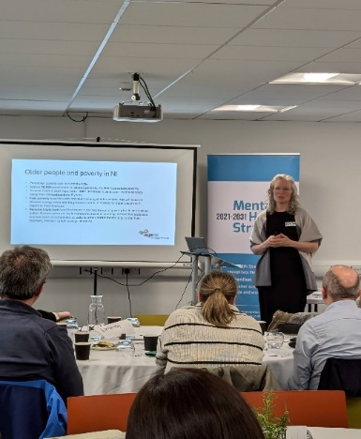
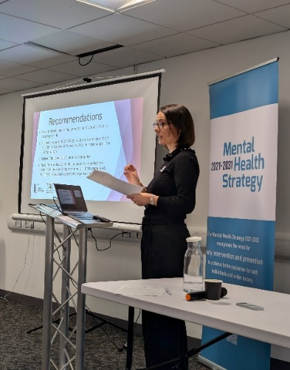
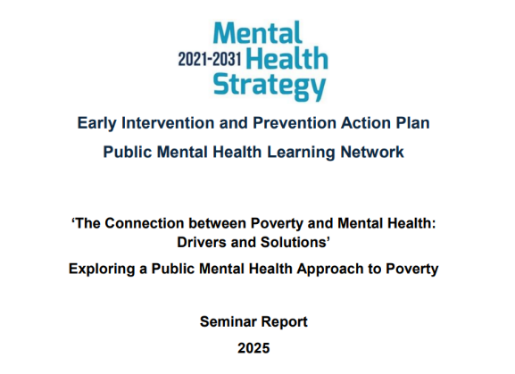
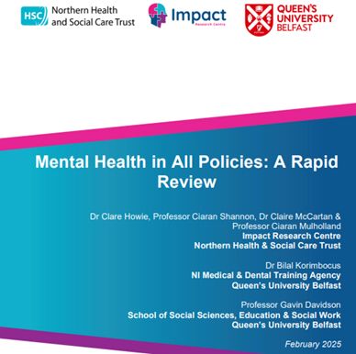

Action 7 - Ensure collective responsibility for promoting and supporting the emotional wellbeing of all our infants, children and young people and those who support them, including families and carers; through development and implementation of a framework which identifies provision of age appropriate universal and targeted evidence-based programmes, and ensures quality assurance and measurement of collective impact across all prevention and early intervention activities in all settings, including the home.
Actions | Progress | RAG
7.1 Extend parenting programmes | - Additional funding has been allocated to the Early Intervention Support Service to enhance its capacity so that more families can access the service. The service offers short term support to families with children 0-18 years who have additional needs or are facing challenges that are difficult to overcome.  - Multi user licence funded for Solihull online learning resources for parents. | G
7.2 Coordinate a system wide perspective through the development of a common framework for early intervention and prevention, looking at both risk and protective factors across all 8 action areas | - Funding allocated to staff training (health visitors, allied health professionals) and to the development of resources for use in schools.  - Additional Steering group meeting held in March 25 to focus on infants, children and young people and to help ensure a collaborative approach to promoting positive social and emotional development.  - Worked closely with partners to ensure inclusion of appropriate population levels measures of wellbeing in children and young people within the Data & Outcomes framework.  - Children and Young Peoples Emotional Health & Wellbeing Framework in Health developed and public consultation carried out.  - Information collated regarding the breadth of PHA work in relation to emotional health and wellbeing of infants, children & young people.  - Focus on groups at risk of poor mental health;  - University of Ulster research “Exploring the experiences of discrimination for care experienced people in Northern Ireland”.  - Special Schools Partnership Pilot NI - Involvement through Therapy Engaging over 70 children and young people in special schools with the most complex special educational needs and disabilities, through provision of Art, Drama, Music and Play Therapies to enable and encourage them to express themselves and improve emotional wellbeing. | A

The Early Intervention Support Service is funded by PHA and delivered by community and voluntary sector partners.
- In 24/25 children’s emotional needs was the primary reason for referral, 840 families completed the service.
- Of those families, 91% made progress in at least one outcome area and 82% in at least 2 areas
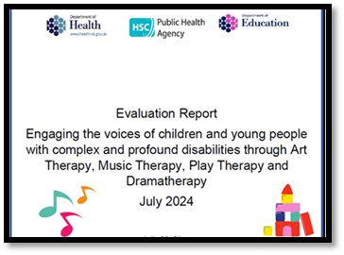
This initiative aims to determine how alternative and tailored communication methods can enable the capture of voices, experiences and aspirations of ‘seldom heard’ children and young people to inform and shape the work of the Special School Partnership pilot. Funding enabled Music, Art, Drama and Play Therapists to use creative methods to engage with 80 CYP attending the 7 pilot Special Schools in a conversation about what is important to them.

Action 8 Create supportive environments where people engage in daily activities, through a settings approach. This will include: workplaces, schools, colleges, universities, training establishments, communities, criminal justice, hospitals, primary care and homes.
Actions | Progress | RAG
8.1 Develop a model, or support the rollout of existing models, which illustrates how settings, partnerships and public health approaches can come together to create early intervention and prevention settings and can connect and contribute to the wider community. | - Evaluation carried out of the PHA Workplace Health – “Work Well Live Well’ programme. This service aims to address health disparities by focusing on workplaces where inequalities are most prevalent. Following evaluation, additional funding has been provided to ensure a stronger focus on mental health and emotional wellbeing within the program.  - Established a working group with representatives from the Department for the Economy, Further Education, Higher Education, Training providers, and HSC Trusts to focus on student and trainee mental health and wellbeing.  - Workshop held in October 25 with those partners to consider how a settings-based approach can be embedded and developed a workplan. | A
8.2 Provide short term support through provision of cross sectoral small grant awards to support at risk groups | - Small grants programme developed in partnership with DfE for Higher Education, Further Education and Training providers to deliver initiatives to improve the emotional health and wellbeing of students and trainees. A total of £322k has been allocated in grants between April 2023 and March 2026 for the delivery of 46 projects. | A
8.3 Engage with DoF to review the opportunity to include the promotion of workplace based early intervention and prevention mental health initiatives as a core requirement when assessing social value in awarding public sector contracts. | This action has not been progressed to date and is being carried over into the next 3 year plan for 2026-2029. | R

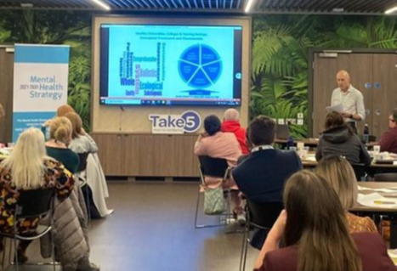
Student settings were identified as an area of focus within this sub action 8 and a workshop was held (25th October 2024) to explore opportunities to improve student mental health across university, further/higher education and training provider settings.
A range of partners including PHA, Department for Economy, NUS-USI, Inspire, SPPG, Mental Health Champion Office and HSC Trusts were in attendance
The workshop was facilitated by Professor Mark Dooris, Emeritus Professor in Health & Sustainability, University of Central Lancashire and previous Chair of the UK Healthy Universities Network

The small grants programme has allocated more than £300k since 2023 to projects within Universities, Further Education Colleges and within Training Provider organisations.
Those projects have focussed on improving the mental health and emotional wellbeing of students, trainees and staff. There have been a wide variety of approaches adopted including; training for staff; development of resources, wellness days; one to one mentoring and counselling services; awareness raising workshops and meaningful activities.

Appendix 1 – Current Steering Group Membership

Name | Organisation | Name | Organisation | Name | Organisation
Denise O’Hagan | PHA (Chair) | Jeff Scroggie | PHA | Seamus Ward | WHSCT
Bryan Dooley | DoH | Jenny McAlarney | DoJ | Gerard O'Hanlon | SPPG (DoH)
Bryan Leonard | PHA | Joanne Vance | CDHN | Siobhan Slavin | PHA
Bryan Nelson | BHSCT | Karen Collins | Aware | Stephen McCartney | NRC
Caroline Cunningham | NSPCC | Karen Hall | MHF | Stephen Murray | PHA
Caroline Ferguson | AMH | Kathy Owens | PHA | Stephen Wilson | PHA
Catherine Millman | PHA | Kevin Bailey | PHA | Valerie Finlay | DAERA
Claire McClelland | DE | Leah Rea | NICCY | Veronica Holland | DoJ
Dominic McSherry | UU | Lesley-Anne Beacom | DAERA | Michael McKenna | Youth Action
Emily Keenan | Forward South Partnership | Lisa Mcelherron | Inspire | Bevin O’Hare | Stronger from the Start Alliance
Fiona McCausland | DoH | Lorna Conn | SPPG (DoH)
Fiona Teague | PHA | Lynda Vladeanu | SEHSCT
Paul Canning | DoH | Mark O'Hara | DfC
Gary Maxwell | DoH | Mary Emerson | PHA
Gavin Davidson | QUB | Melaine Brown | PHA
Gavin Quinn | SPPG (DoH) | Siobhan O’Neill | MH Champion
Gemma Hughes | DAERA | Michael Weatherup | DfE
Gerard Rocks | SHSCT | Ryan Harper | DfE
Gillian McMaster | DfC | Carol Picton Lynas | DoH
Glenda Davies | DE | Nicola Topping | EA
Hugh Nelson | NHSCT | Paul Deighan | EA
Jan McGall | SHSCT | Valerie Maxwell | SPPG (DoH)
Janet Shearer | Mid & East Antrim Council | Sara Graham | Long Term Conditions Alliance

