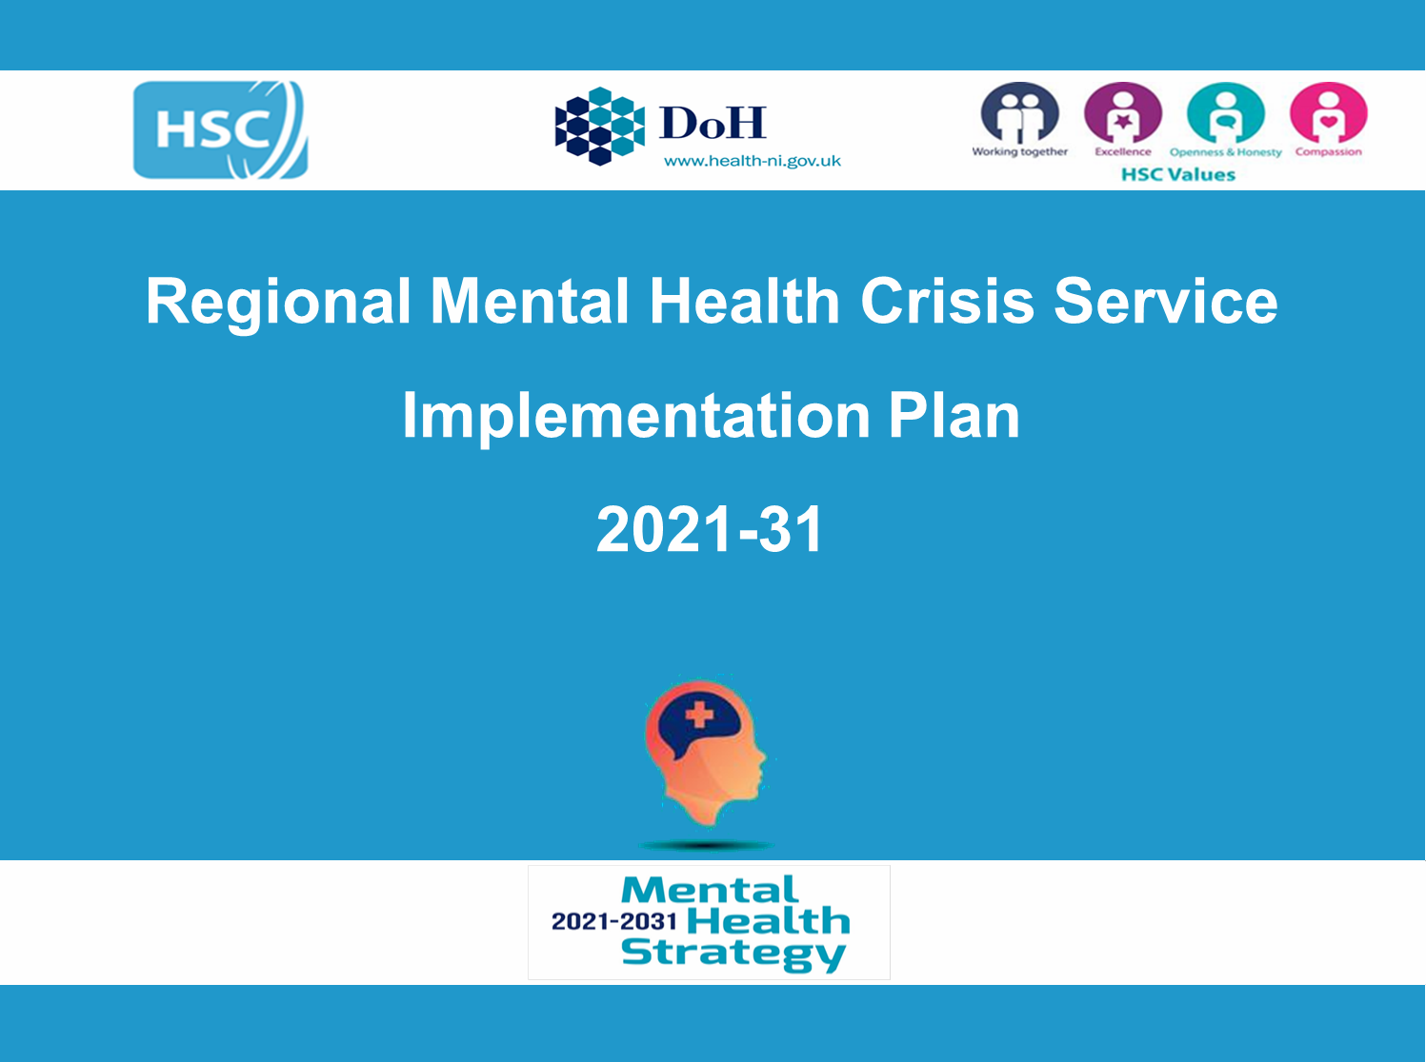
Promoting Mental Health and Emotional Wellbeing
Action Plan

2026-29

Table of Contents
1.0 Introduction 3
2.0 Background and Context 5
3.0 Learning from delivery of the 2022 – 2025 Plan 9
4.0 Scope and Focus of the 2026 – 2029 Plan 11
5.0 Governance and Monitoring 12
6.0 Action Plan 14
Appendix 1 – Steering Group Membership 23
Appendix 2 - Related Policies and Strategies 24
Appendix 3 - Definitions 26
Appendix 4 – Evidence Base (Key Sources) 27
Appendix 5 – Regional Population Measures 29

Introduction

In recognition that mental ill health is one of the greatest challenges facing both society and services, the Department of Health published in June 2021 the Mental Health Strategy (2021-2031).

The Strategy sets out 35 actions under three overarching themes:

Theme 1 - promoting mental wellbeing, resilience and good mental health across society;
Theme 2 – providing the right support at the right time; and
Theme 3 – new ways of working

In 2022 The Public Health Agency was asked to take a lead on co-ordinating a cross departmental and cross sectoral approach to delivery of Actions 1 and 2 under Theme 1 of the Strategy.

Action 1 | Increase public awareness of the distinction between mental wellbeing, mental ill health and mental illness, encouraging public understanding and acceptance of how life can impact upon mental wellbeing, and recognition of the signs of mental ill health and mental illness. Using public mental health education and effective awareness raising methods, increase public knowledge of the key measures that can be taken to look after mental wellbeing, increase understanding of mental ill health, and encourage public discourse and dialogue to reduce stigma.
Action 2 | Create an action plan for promoting mental health through early intervention and prevention, with year on year actions covering a whole life approach, reaching from infancy to older age. The action plan must consider groups disproportionally affected by mental ill health who often struggle to access early intervention services and seek to reduce stigma associated with mental ill health.

This document sets out the three year Promoting Mental Health and Emotional Wellbeing Action Plan to enable delivery of Actions 1 and 2 for 2026 – 2029. This plan builds on the work which has been undertaken to deliver on the Early Intervention & Prevention Action Plan (2022 – 2025). It has been developed by a cross sectoral and cross departmental Steering Group which has been in place since 2022. Membership of the steering group is detailed in Appendix 1.

This action plan is focussed on promoting good mental health and emotional wellbeing and on preventing the onset of mental health problems or mental illness across the life course. While the action plan mainly takes a population focus, it also incorporates targeted actions and actions which support the early steps in the Health and Social Care Regional Mental Health Care Pathway. The pathway outlines how services are arranged around a stepped care approach to match individuals needs with the right level of support.

The delivery of this action plan will take account of the range of guidelines from the National Institute for Health and Care Excellence (NICE) relating to Mental Health and Emotional Wellbeing. This includes guidance available across different stages of the life course such as; early years, children and young people, older people and applicable to various settings; workplaces, communities, criminal justice and education settings.

The Action Plan include actions at two levels:

- Universal; interventions or solutions aimed at the whole population;

b) Targeted; interventions or solutions targeting sub-sections of the population:
- those considered at higher risk of poor mental health, and
- those experiencing early signs of poor mental health.

The plan also recognises the need for strong partnership and action to address the wider determinants of mental health.

The plan sets out four objectives:

- Increase public awareness, knowledge and understanding of:
      - the distinction between mental wellbeing, mental ill health and mental illness;
      - the key measures that can be taken to look after mental wellbeing;
      - how life can impact upon mental wellbeing;
      - how to recognise the signs of mental ill health and mental illness;
and to encourage public discourse and dialogue to reduce stigma.

- Add value to existing work being taken forward by partners in relation to the emotional health and wellbeing of infants, children and young people and those who support them, including families and carers.

- Build and share the evidence base for, and grow understanding of, public mental health with all stakeholders, liaising with research networks and other best practice networks as required.

- Influence government in terms of adopting policy approaches that promote good mental health across the life course and address the wider determinants of mental health.

2.0 Background and Context

Mental Health Strategy
The Mental Health Strategy places a strong emphasis on promoting mental wellbeing, resilience and good mental health across society. It recognises that good mental health is linked to good physical health and positive relations with families, friends, and colleagues. It enables us to fulfil our potential, engage in community life, and lead full and rewarding lives.
The profound impact that the wider societal and economic context in which an individual lives has on their health and mental health is now widely accepted. Inequalities also exist across a range of other dimensions, including ethnicity, gender, sexuality and disability. The underlying causes of these inequalities often cluster together, with people experiencing ‘multiple disadvantage’. There are also certain groups who experience poorer health outcomes than the wider population, such as people who are at risk of, or are experiencing homelessness, leaving care, and offenders in prison or in the community.
Northern Ireland faces significant mental health challenges. These are exacerbated by sizeable socioeconomic factors, the legacy of the Troubles, and persistent underfunding of a wide range of services for a broad spectrum of people with poor mental health, from those with common mental health problems to those with severe and enduring mental ill-health.
We know from the NI Health Survey in 24/25 that approximately 1 in 5 in NI have a potential mental health problem. Around a quarter (24%) of those in the most deprived areas had a high GHQ12 score, compared to 14% of those living in the least deprived areas.
Mental health problems are estimated to cost the NI economy at least £3.4 billion per year.
It is important to highlight that while there has been significant work underway to date (further detail in Section 3.0) and recurrent funding provided for delivery of Actions 1 and 2, the funding available has not been to the degree required to fully implement all actions.
There has been progress against other actions within the Strategy which will contribute to the mental health and emotional wellbeing of the NI population:
- Actions 10 & 11: Increase funding for Child and Adolescent Mental Health Services (CAMHS) to 10% of adult mental health funding. Ensure that the needs of infants are met in mental health services, and meet the needs of vulnerable children and young people when developing and improving CAMHS, putting in place a ‘no wrong door’ approach.
- Actions 17: Fully integrate community and voluntary sector in mental health service delivery with a lifespan approach including the development of a protocol to make maximum use of the sector’s expertise.
- Action 30: Develop and implement a comprehensive digital mental health model that provides digital delivery of mental health services at all steps of care.
A review of deliverability of the Mental Health Strategy was published by the Department of Health in October 2025 which recognised that due to funding constraints only 20 of the 35 actions have commenced with partial funding and only £12.3 million has been allocated to 14 actions within the strategy by the end of 2024/25, representing just 16% of the funding deemed necessary to implement the Strategy in that period.
However, some actions have not yet received dedicated funding and are very important for the mental health and emotional wellbeing of the population including:
- Action 3: Increase the support available to individuals, families and communities to address the social factors that impact their mental health.
- Action 4: Work with delivery partners across Government and the health and social care system to maximise the availability and use of a range of social well-being supports, including social prescribing, to encourage and support mental wellbeing and positive mental health.
- Action 6: Further promote positive social and emotional development throughout the period of infancy and childhood, including in pre-school and school settings, and provide new evidence-informed interventions and support for families and support to ensure that children and young people get the best start in life.
System Wide Approach
It is important to recognise that improving the mental health and emotional wellbeing of the population requires a strong system wide partnership approach and connections across a number of other related strategies and policies.
The work delivered to date on Actions 1 and 2 supports delivery of other strategies and policies, most directly Making Life Better- Strategic Framework for Public Health, the Protect Life 2 – Suicide Prevention Strategy and the Substance Use Strategy; Preventing Harm & Empowering Recovery.
These strategies and many others also include actions which contribute to improved mental health and emotional wellbeing of the population.
The Healthy Futures strategy was launched in November 2025 and clearly states that providing children with the appropriate foods and their participation in physical activity helps support their growth and development. But there is a growing body of research showing that what children eat and their physical activity levels, can affect not only their physical health but also their mood, mental health, and learning outcomes.
The Public Health Agency’s Corporate plan outlines it’s key objectives from 2025 – 2030 to improve and protect health and wellbeing, reduce health inequalities, improve the quality and safety of care services, and support research and development to deliver better health for everyone in Northern Ireland. This work across a number of public health priorities will support improved population mental health and emotional wellbeing.
Since a wide range of determinants impact on public mental health, this issue cuts across many wider policy areas outside of health and social care in both government and non-government sectors, including education, criminal justice, economy and environment, including housing.
It is important to recognise the links between these policies, and it is essential that government departments and other agencies continue to collaborate and communicate to ensure their work is joined up to improve mental health and emotional wellbeing across Northern Ireland. (See Appendix 2 – Related Strategies and Policies)
Infants, Children & Young People
It is well evidenced that improving the mental health and emotional wellbeing of the population requires a strong focus on the wellbeing of infants, children and young people and their families and carers.
Many developments in this area are already underway and are being driven by other strategies, policies and partnerships as outlined in Appendix 2 including;
- The Children and Young People’s Strategy, (2020- 2030) which is the delivery plan for Programme for Government Outcome 12: “We give our children and young people the best start in life”.
- Healthy Child Healthy Future
- The PHA Infant mental health framework
- Children & Young Peoples Emotional Health and Wellbeing in Education Framework
- The Health and Social Care Children and Young People’s Emotional Health and Wellbeing Framework
- Reform of Children’s Social Care Services
- Children & Young Peoples Strategic Partnership Children & Young People’s Plan
- Safeguarding Board NI Strategic Plan
- The Northern Ireland Framework for Integrated Therapeutic Care (NIFITC) for Care Experienced Children and Young People Department of Health

3.0 Learning from delivery of the 2022 – 2025 Plan

A report on progress in delivering on the 2022-2025 plan is available and has included; establishment of partnership structures to enable joined up working, enhanced capacity within PHA to support delivery, investment in the Early Intervention Support Service, evidence reviews to inform actions, development of a data and outcomes framework to support measurement of outcomes, a range of shared learning opportunities to bring stakeholders together and a small grants programme to support student and trainee mental health and emotional wellbeing.
A broad range of stakeholders have been engaged in this work across health and social care, government departments, the community and voluntary sector, local councils and academia.

Review of Definitions and Language
The language regarding emotional health, emotional wellbeing and mental health and mental illness is often used interchangeably across a spectrum of areas and can encompass different meanings. An early action of the Steering Group was to consider the terms used in this context and to agree some definitions as detailed in Appendix 3 (Definitions.)
These definitions will be kept under review as the work continues and where appropriate, will be updated to reflect greater clarity and consistency across partners.
The 2022-2025 plan was entitled the Early Intervention and Prevention Action Plan. Feedback has highlighted that this language caused some confusion with the terminology of early intervention being understood differently across contexts.
The steering group agreed that it would be clearer and more consistent with language used in other related strategies and policies to call this 2026-2029 plan the Promoting Mental Health and Emotional Wellbeing Action Plan. This change of language is reflected throughout, with the focus refined as being to; promote good mental health and emotional wellbeing and to prevent the onset of mental health problems or mental illness.

Limited Resources and Capacity
The 2023- 2026 plan had eight action areas and required a variety of working groups and projects to be established. While there has been considerable progress, stakeholders have highlighted limited capacity to fully contribute to the work.
Some funding has been provided to support this work, however it has not been to the degree which is required and the Review of Deliverability of the Mental Health Strategy (referenced in section 2.0) has highlighted the challenge of delivering within current financial constraints.
In recognition of this the 2026 – 2029 plan aims to have a more refined focus with a smaller number of prioritised actions. Supporting structures will be streamlined to enhance stakeholder engagement.

Using and Developing the Evidence Base
The work to date has taken account of the existing evidence base for improving public mental health (key sources are highlighted in Appendix 4- Evidence Base).
A number of evidence reviews have also been undertaken to support the work including:
      - A rapid review of international approaches to data and outcomes for early intervention and prevention
      - Reviews of the evidence in relation to the social determinants of mental health and of those population groups who may be at higher risk of poor mental health.
      - A rapid review of mental health in all policies.
      - A rapid review of the impact of mental health awareness mass media campaigns

It will be important to maintain a focus on growing our collective understanding of the evidence base and providing opportunities for shared learning.

Adding Value
As previously highlighted, there is already a wide range of work ongoing across Government Departments and sectors which contributes to the delivery of Actions 1 and 2. This Action Plan does not attempt to reflect all of this work. The intention of this plan is to complement ongoing work and to focus on new actions where there can be added value through making system wide connections on this shared agenda.
In recognition of the many stakeholders in this area of work, the existing structures to support delivery of the 2023- 2026 plan will be refreshed to ensure that connections are strengthened and that effective partnership working arrangements are in place at both a regional and local level and that there are mechanisms to engage with communities and with people with lived experience through the various partners.

Scope and Focus of the 2026 – 2029 Plan

This Action Plan is focussed on promoting good mental health and emotional wellbeing and on preventing the onset of mental health problems or mental illness.
This will be achieved through actions at two levels:
• Universal; Interventions or solutions aimed at the whole population.

• Targeted; Interventions or solutions targeting sub-sections of the population:
- those considered at higher risk of poor mental health and
- those experiencing early signs of poor mental health.
The plan will also recognise the need for strong partnership and action to address the wider determinants of mental health.

5.0 Governance and Monitoring

Effective multiagency partnerships require leadership and support at both a regional and a local level to enable effective working, to build a shared vision, coordinate plans, allocate resources and evaluate success. The interactions between partners in a complex collaboration is likely to change over time, so the connectivity needs to be supported in a structured and sustainable way to achieve sustainable change in public mental health outcomes. Connections and understanding need to be built and maintained over time between individuals, organisations and sectors.

The PHA will continue to provide a leadership, co-ordination and project management role in delivering this plan and in supporting a partnership approach to delivery of the plan.

Building on the learning from the work to date the existing programme structures will be refreshed and streamlined to support implementation.

The Promoting Mental Health and Emotional Wellbeing Steering Group will meet quarterly. The membership of that steering group will be refreshed to ensure it includes representation from stakeholders including from local level partnerships focussed on promoting mental health and emotional wellbeing such as Area Integrated Partnership Boards, Community Planning Partnerships and emerging Neighbourhood structures and if appropriate the Local Area Mental Health Collaboratives. This landscape is evolving and appropriate representation will be kept under review. Task and finish groups will be established as required to deliver on actions in the plan, with involvement from stakeholders as required.

A considerable stakeholder list has been established through the work to date and includes health and social care staff, members of the community and voluntary sector, representatives from across government departments, local councils, and from research and academia and is open to anyone with an interest in this area of work to join.

A quarterly newsletter will continue to be issued to share information and stakeholders will also be invited to attend an annual workshop to hear about the progress in delivering against this plan, to shape the work underway and to highlight challenges and opportunities.

Task and finish groups leading on particular actions will put in place measures to ensure the involvement of local communities, service users and people with lived experience as appropriate.

Work will continue to implement the Data and Outcomes framework and the agreed population level measures will be monitored and reported on a regular basis. (Appendix 5- Regional Population Measures).

Progress reports, and where possible, programme level outcomes will be reported to the Promoting Mental Health and Emotional Wellbeing Steering Group.

The delivery of this plan will be monitored by the Mental Health Strategy Operational Delivery Board (co-ordinated by MHS Delivery Unit).

There are also structures in place to further support areas of work within this plan which require cross departmental engagement and co-ordination, the All Departments Officials Group and the Executive Working Group for Wellbeing, Mental Health and Suicide Prevention.

6.0 Action Plan
Objective 1.0 Increase public awareness, knowledge and understanding of; the distinction between mental wellbeing, mental ill health and mental illness, the key measures that can be taken to look after mental wellbeing, how life can impact upon mental wellbeing, how to recognise the signs of mental ill health and mental illness and also work to encourage public discourse and dialogue to reduce stigma
Action | Deliverable | Timeframe | Lead Agency | Partners
1.1 Establish a Mental Health Communications and Public Awareness Forum to bring leads for public communications in the mental health sector together. | Agree terms of reference and hold first meeting.  Develop a shared campaign plans calendar.  Share campaign evaluations and learning.  Connect with and learn from work underway on mental health communications and public awareness across the UK and RoI. | May 26  Sept 26  Ongoing  Dec 26 | PHA | MH Champions office, C&V sector, Govt Depts
1.2 Develop a rolling programme of communications and public awareness raising activity which will aim to address Objective 1 and which will involve both a universal and a targeted approach. | Collate baseline data, review current activity and resources, engage partners and produce a 2 year communications and public awareness plan focussed on a universal/ whole population approach.  Agree a phased approach to ensure communications activities and resources are accessible for target groups. This will include those at higher risk of poor mental health (identified within the Overview of high risk groups report) as well as across the life course and across settings i.e.  - Children & Young People, Older people  - Communities, Workplaces  - Higher education, Further Education, Training providers, schools, and youth sector settings | March 27 | PHA | MH Champions office, SPPG, HSC Trusts, C&V sector, local councils, Govt depts, Academia, Education Authority. Higher Education /Further Education
Action | Deliverable | Timeframe | Lead Agency | Partners
1.3 Deliver the planned programme of communications and public awareness raising activity; and collate and create a range of resources to support organisations and sectors to raise awareness and improve mental health and emotional wellbeing and promote help-seeking. | Develop a mental health communications guide/toolkit for organisations to support them in undertaking communications activity to include; key statistics, messages and signposting.  Work with partners to review and update the PHA standards/guide on the involvement of people with lived experience in communications campaigns/activity.  Collate resources to support  - local/community based activity to improve emotional wellbeing and mental health and to prevent mental health problems.  - workplace based activity to improve emotional wellbeing and mental health and to prevent mental health problems.  - *Training providers to improve the mental health and wellbeing of YP in these programmes.  Support HE/FE organisations as they embed a ‘settings based approach’ through the provision of information and support resources.  *Training providers contracted by Dept for the Economy to provide the Skills for life & work programme and Apprenticeships for young people aged 16-24 | April 27 – March 29 | PHA | MH Champions office, SPPG, HSC Trusts, C&V sector, local councils, Govt depts, Academia, Higher Education /Further Education
Action | Deliverable | Timeframe | Lead Agency | Partners
1.4 Develop the Minding Your Head and Youth Wellness Web (in alignment with implementation of the C&YP EH&WB frameworks) to optimise and streamline the existing sites as a resource for both the public and professionals and to ensure consistency of messaging across the life course. This work should take consideration of the Digital Mental Health action plan. | Work with leads in PHA to produce a development plan  for Minding Your Head to include user involvement and  testing and consider resources available to support.  Work with leads in SPPG to produce a development  plan for Youth Wellness Web to include user  involvement and testing and consider resources  available to support.  Agree regionally consistent high quality psychoeducational and self-help resources; (in line with NICE guidelines).  Plans should include messaging across the life course and ensure accessibility, and where possible tailor to target groups.  Update service directories to enable users to identify supports available in their locality.  Consider how the existing “Minding Your Head” brand could be used more broadly and develop guidelines for its use. | March 27  March 27  March 28  March 29  March 28 | PHA, SPPG | HSC Trusts, C&V Sector, Govt Depts, Academia, MH Champions office, local councils,  Higher Education /Further Education
1.5 Gather population level data to inform Objective 1 and to track changes over time. | Commission the PHA mental health survey annually with appropriate content based on required indicators and engagement with stakeholders. Results to be published on PHA website.  Collaborate with producers of other population surveys (e.g. DoH Health Survey, YBAS etc.) to ensure each survey has distinct focus and that data collection is coordinated, efficient and capable of generating a wider and richer understanding of population mental health. | Ongoing  On an annual basis | PHA | MH Champions office, SPPG, HSC Trusts, C&V sector, local councils, Govt depts, Academia, Higher Education /Further Education
Action | Deliverable | Timeframe | Lead Agency | Partners
1.6 Ensure the provision of training/awareness programmes to meet Tiers 1, 2 and 3 as  outlined within the PHA Mental and Emotional Health and Wellbeing and Suicide  Prevention Training Framework | Identify or procure easily accessible training aligned to Tiers 1, 2 and 3 of the Training Framework to support universal and targeted approaches to promoting mental health and prevention of mental health problems.  Promote the training resources available including those provided through Recovery Colleges | March 29  March 28 | PHA | MH Champions office, SPPG, HSC Trusts, C&V sector, local councils, Govt depts, Academia, Higher Education /Further Education
1.7 Seek approvals and resources for the development and delivery of regional multi-year mass media campaigns in line with Action 1 of the Mental Health Strategy. | Develop a business case for the development and delivery of regional multi-year mass media campaigns.  This business case should highlight the learning from previous campaigns work and the evidence base.  Plans should include messaging across the life course and for target groups and settings and involvement approaches to ensure activities and resources are accessible for target groups. | March 28 | PHA, MH Champions Office | MH Champions office, SPPG, HSC Trusts, C&V sector, local councils, Govt depts, Academia, Higher Education /Further Education

Objective 2 Add value to existing work being taken forward by partners in relation to the emotional health and wellbeing of infants, children and young people and those who support them, including families and carers
Action | Deliverable |  | Timeframe | Lead Agency | Partners
2.1 Partners to update the Promoting Mental Health and Emotional Wellbeing Steering Group on ongoing work in relation to infants, children & young people and identify where the group can bring added value. | An integrated approach to the implementation of the frameworks for Emotional Health & Wellbeing of Children & Young People  Ensure effective connections in place with the Regional Infant Mental Health Implementation Group to support implementation of the Refreshed IMH Action Plan.  Review the evaluation of the pilot project in special schools “Engaging the voices of children and young people with complex and profound disabilities” and consider next steps  In line with Action 1.2 agree a programme of Communications and Public awareness activity targeted at children and young people. |  | Dec 26  Sept 26  Dec 26  March 28 | SPPG (DoH)  DE  PHA  PHA, Dept of Education  PHA | PHA, HSC Trusts, Dept of Education, Education Authority, C&V sector, local councils, MH Champions office  PHA, HSC Trusts, Dept of Education, Education Authority, C&V sector, local councils, MH Champions office  MH Champions office, SPPG, HSC Trusts, C&V sector, local councils, Dept of Education, Govt depts, Academia  MH Champions office, SPPG, HSC Trusts, C&V sector, CYPSP, Children’s sector organisations, SBNI, local councils, Govt depts, Academia, Higher Education /Further Education
Action | Deliverable |  | Timeframe | Lead Agency | Partners
2.2 Work with key stakeholders across Health and Education regarding the regionalisation of ‘Take 5 in Schools’ model to improve mental and physical health and wellbeing | Workshop to discuss current models and identify opportunities for a regional approach.  Development of a business case to support a regional approach. |  | May 26  Dec 26 | PHA | CYPSP, HSC Trusts, Dept of Education, Education Authority, SPPG (DoH)
2.3 Review delivery model for the Youth Engagement Services (YES) and explore expansion of the model to develop a universal youth prevention service covering a range of physical and mental health issues. | Position paper / options appraisal developed for consideration and engagement with key partners. |  | April 27 | PHA | SPPG, Dept of Education, Education Authority, Statutory and Community Youth Work providers
Objective 3: Build and share the evidence base for, and grow understanding of, public mental health with all stakeholders, liaising with research networks and other best practice networks as required

Action |  | Deliverable | Timeframe | Lead Agency |  | Partners
3.1 Establish mechanisms to enable shared learning and reflective practice among stakeholders. |  | Relaunch the Public Mental health learning network via Project ECHO and evaluate the impact.  Work with partners to identify an appropriate online platform where evidence and good practice can be easily shared and accessed.  Deliver two regional Conferences. | April 26  April 27  March 29 | PHA,  MH Foundation |  | Government departments, MH Champions office, HSC staff, C&V sector, Academia, local councils. Higher Education /Further Education
3.2 Work with the Regional Health Literacy Forum to develop a shared understanding regarding the role of mental health literacy in promoting mental health and emotional wellbeing and preventing mental health problems. |  | Develop a position paper outlining agreed definitions for mental health literacy and mechanisms for measurement  Identify and collate good practice for improving mental health literacy to inform ongoing work. | March 27  March 28 | PHA,  MH Foundation |  | Regional Health Literacy Forum, Government departments, MH Champions office, HSC staff, C&V sector, local councils, Academia, Higher Education /Further Education
3.3 Identify effective mechanisms to connect with existing research and practice networks to ensure an ongoing focus on the evidence base for public mental health. |  | Map the existing research and practice networks relevant to public mental health across UK and RoI  Effective mechanisms in place to ensure a strong focus on the evidence base for public mental health.  Work with partners to scope the need for and deliver further evidence reviews including:  - how to reduce the experience of mental health stigma and its impact on help seeking;  - effective interventions with identified target groups. | Dec 26  April 27  March 29 | PHA,  MH Foundation, MH Champions Office, Academic Networks |  | Government departments, MH Champions office, HSC staff, C&V sector, local councils, Academia, Higher Education /Further Education
Action |  | Deliverable | Timeframe | Lead Agency |  | Partners
3.4 Collate and highlight the evidence base for public mental health and share with stakeholders. |  | Evidence briefings on promoting mental health and emotional wellbeing to be developed to inform policy makers on key themes e.g.; promoting mental health and emotional wellbeing in workplaces, and in education settings | March 30 | PHA,  MH Foundation, MH Champions Office, Academic Networks |  | Government departments, MH Champions office, HSC staff, C&V sector, local councils, Academia, Higher Education /Further Education

Objective 4: Influence government in terms of adopting policy approaches that promote good mental health and address the
wider determinants of mental health

Action | Deliverable | Timeframe | Lead Agency | Partners
4.1 Undertake a test project to enable action on the wider determinants of health with a focus on public mental health. This can be used to inform further development of the ‘Health in all Policies’ approach across government. | Agree methodology to take forward this approach.  Establish a working group and agree a project plan.  Implement a test project.  Produce a project report outlining outcomes and learning and next steps. | June 26  Sept 26  June 27  December 28 | DoH | PHA, Mental Health Foundation, Govt Depts, ALBs, Research/Academia
4.2 Work with Dept of Finance and partners across government to consider the inclusion of mental health promotion as a core requirement under social value considerations in awarding public sector contracts. | Review the international evidence on the implementation of social clauses in public procurement to inform this work.  Identify options for inclusion of mental health promotion as a core requirement under social value considerations in awarding public sector contracts. | Sept 28  March 29 | DoH | PHA, Govt Depts, Research/Academia,  Strategic Investment Board
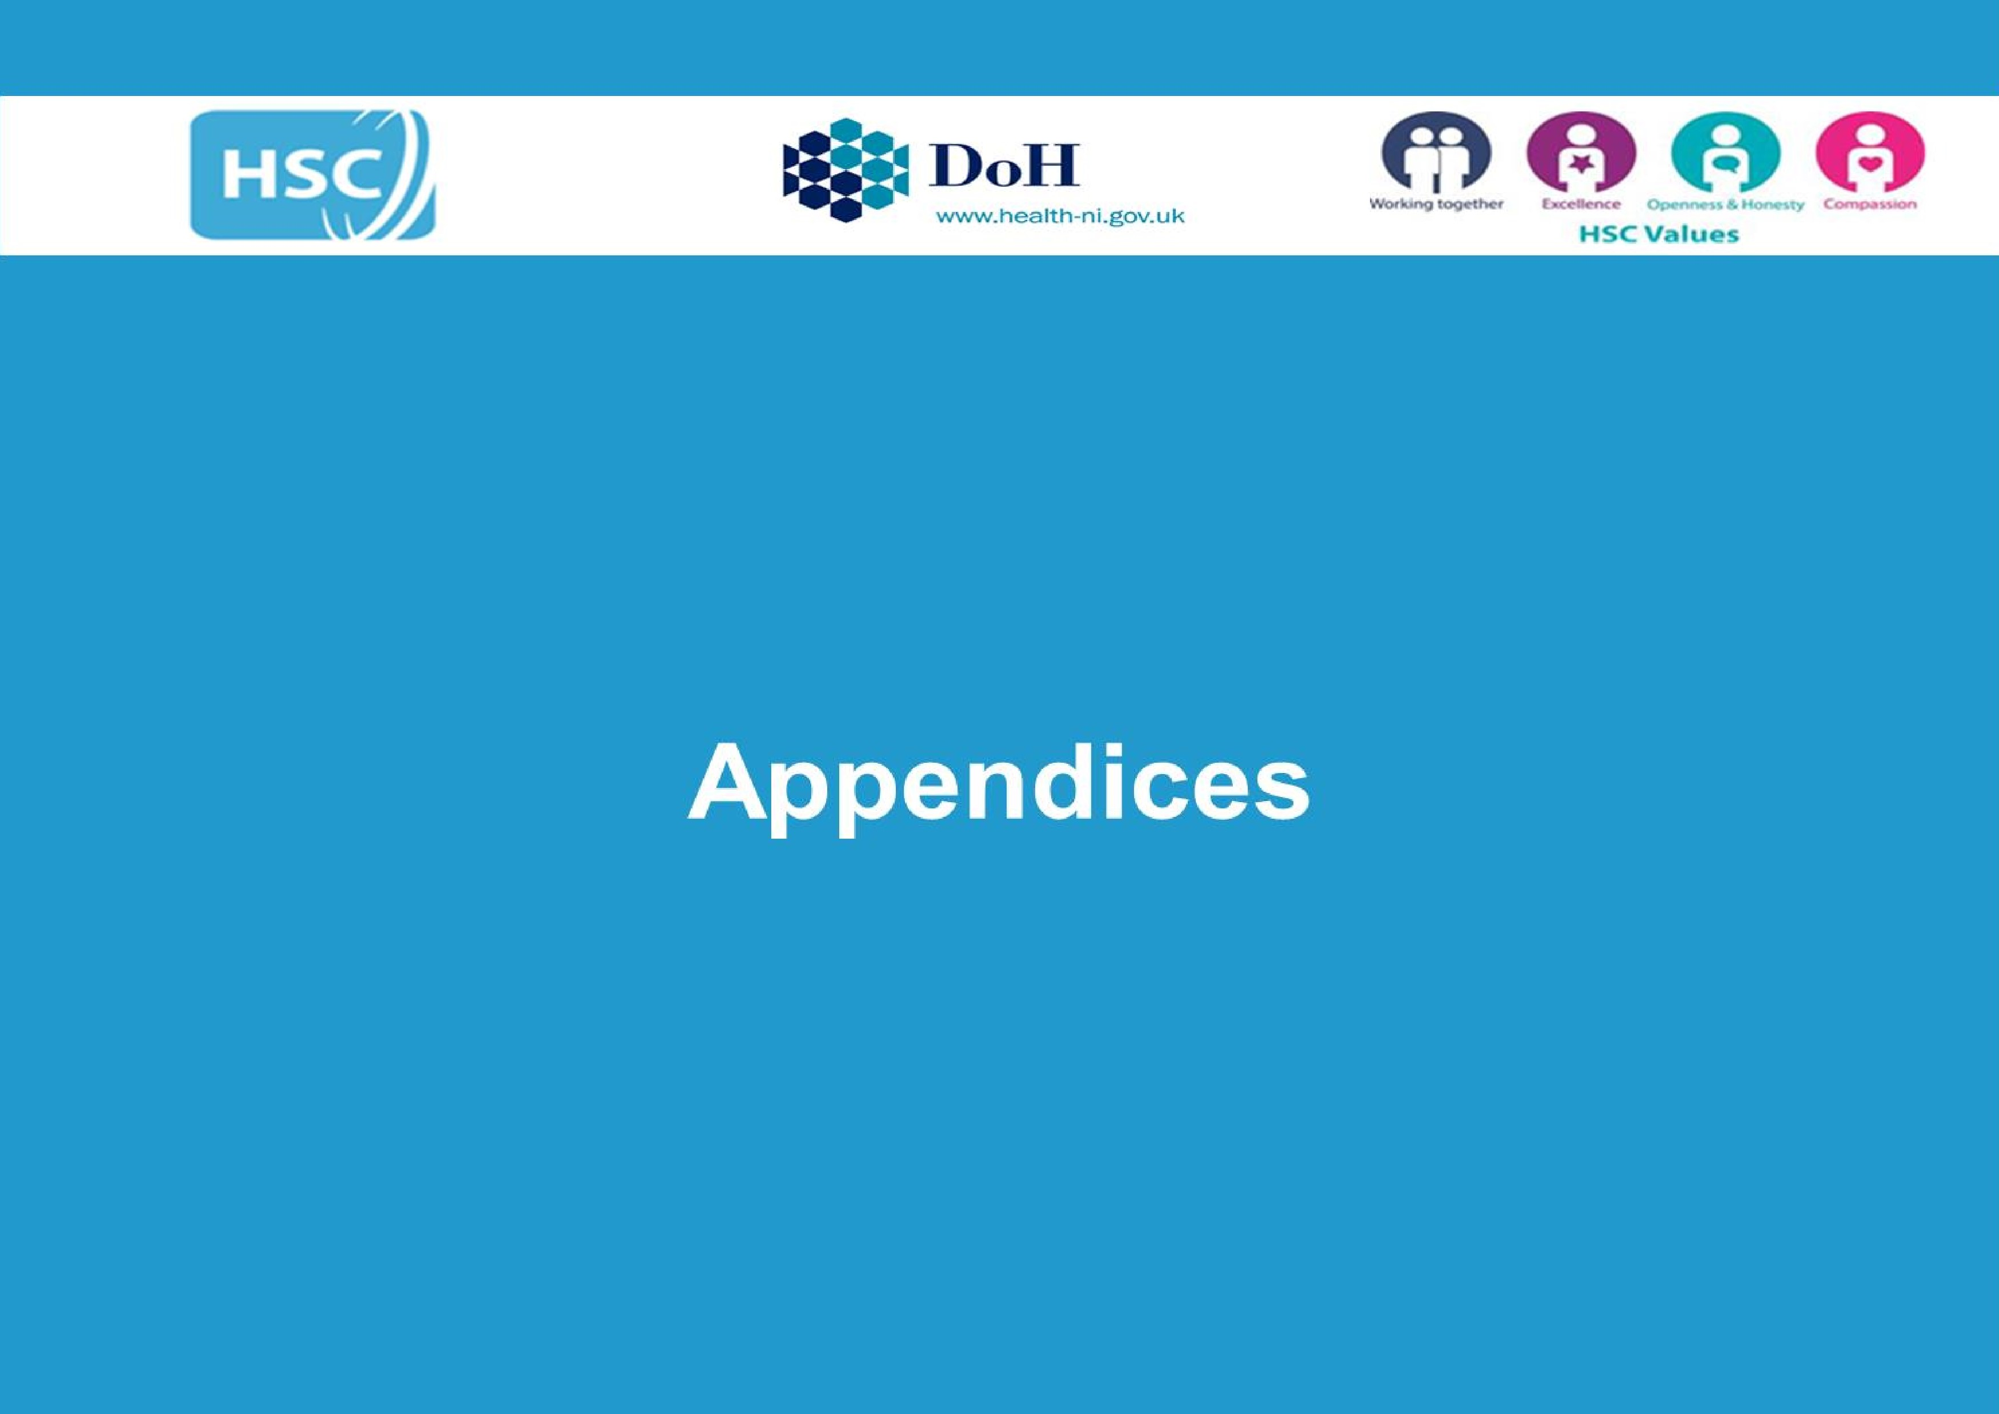
Regional Mental Health Crisis Service for NI Implementation Plan

Appendix 1 – Steering Group Membership

Name | Organisation | Name | Organisation | Name | Organisation
Denise O’Hagan | PHA (Chair) | Jeff Scroggie | PHA | Seamus Ward | WHSCT
Bryan Dooley | DoH | Jenny McAlarney | DoJ | Gerard O'Hanlon | SPPG (DoH)
Bryan Leonard | PHA | Joanne Vance | CDHN | Siobhan Slavin | PHA
Bryan Nelson | BHSCT | Karen Collins | Aware | Stephen McCartney | NRC
Caroline Cunningham | NSPCC | Karen Hall | MHF | Stephen Murray | PHA
Caroline Ferguson | AMH | Kathy Owens | PHA | Stephen Wilson | PHA
Catherine Millman | PHA | Kevin Bailey | PHA | Valerie Finlay | DAERA
Claire McClelland | DE | Leah Rea | NICCY | Veronica Holland | DoJ
Dominic McSherry | UU | Lesley-Anne Beacom | DAERA | Michael McKenna | Youth Action
Emily Keenan | Forward South Partnership | Lisa Mcelherron | Inspire | Bevin O’Hare | Stronger from the Start Alliance
Fiona McCausland | DoH | Lorna Conn | SPPG (DoH)
Fiona Teague | PHA | Lynda Vladeanu | SEHSCT
Paul Canning | DoH | Mark O'Hara | DfC
Gary Maxwell | DoH | Mary Emerson | PHA
Gavin Davidson | QUB | Melanie Brown | PHA
Gavin Quinn | SPPG (DoH) | Siobhan O’Neill | MH Champion
Gemma Hughes | DAERA | Michael Weatherup | DfE
Gerard Rocks | SHSCT | Ryan Harper | DfE
Gillian McMaster | DfC | Carol Picton-Lynas | DoH
Glenda Davies | DE | Nicola Topping | EA
Hugh Nelson | NHSCT | Paul Deighan | EA
Jan McGall | SHSCT | Valerie Maxwell | SPPG (DoH)
Janet Shearer | Mid & East Antrim Council | Sara Graham | Long Term Conditions Alliance

Appendix 2 - Related Policies and Strategies

A Fair Start – Final Report & Action Plan – https://www.education-ni.gov.uk/publications/fair-start-final-report-action-plan
A Life Deserved: Strategy for Looked‑After Children – https://www.health-ni.gov.uk/publications/life-deserved-strategy-looked-after-children
Skills Action Plan 2025 – 2028 https://www.economy-ni.gov.uk/publications/skills-action-plan
Active Ageing Strategy 2016–2022 – https://www.communities-ni.gov.uk/publications/active-ageing-strategy-2016-2022
Active Living – Sport & Physical Activity Strategy https://www.communities-ni.gov.uk/publications/active-living-sport-and-physical-activity-strategy-northern-ireland
Anti‑Poverty Strategy – https://www.communities-ni.gov.uk/sites/default/files/2025-06/ni-executive-anti-poverty-strategy-2025-2035.pdf
Building Inclusive Communities Strategy 2020–2025 – https://www.northernireland.gov.uk/publications/department-communities-building-inclusive-communities-strategy-2020-2025
Child Criminal Exploitation (CCE) Action Plan https://www.health-ni.gov.uk/publications/child-criminal-exploitation-cce-action-plan-health
Children and Young People’s Strategy 2020–2030 – https://www.education-ni.gov.uk/publications/children-and-young-peoples-strategy-2020-2030
Children & Young Peoples Strategic Partnership Children & Young People’s Plan https://cypsp.hscni.net/children-and-young-peoples-strategic-partnership/our-plan/
Community Safety Strategy and Framework – https://www.nihe.gov.uk/getattachment/68b1ecb3-90db-42e1-a1f9-3caffe45bed4/Community-Safety-Strategy-2025-30.pdf
Co-operating to Safeguard Children and Young People in Northern Ireland
https://www.health-ni.gov.uk/publications/co-operating-safeguard-children-and-young-people-northern-ireland
Consultation on the NI Executive Disability Strategy 2025-2035 https://www.communities-ni.gov.uk/consultations/consultation-ni-executive-disability-strategy-2025-2035
Domestic and Sexual Abuse Strategy https://www.justice-ni.gov.uk/publications/domestic-and-sexual-abuse-strategy-2024-2031
Emotional Health & Well‑Being in Education Framework: https://www.northernireland.gov.uk/publications/children-young-peoples-emotional-health-and-wellbeing-education-framework-final-version
Ending Homelessness Together Strategy: https://www.nihe.gov.uk/getattachment/73313718-aa0e-4aae-b122-6573dcab88c7/Ending-Homelessness-Together-Homelessness-Strategy-2022-27.pdf
Ending Violence against Women and Girls; Strategic Framework https://www.executiveoffice-ni.gov.uk/topics/ending-violence-against-women-and-girls
Executive Programme for tackling paramilitary activity and organised crime | Department of Justice https://www.justice-ni.gov.uk/articles/executive-programme-tackling-paramilitary-activity-and-organised-crime
Health and Social Care Children and Young People’s Emotional Health and Wellbeing Framework https://www.health-ni.gov.uk/consultations/consultation-hsc-children-and-young-peoples-emotional-health-and-wellbeing-framework
Healthy Child Healthy Future: https://www.health-ni.gov.uk/sites/default/files/2025-09/Healthy%20Child%20Healthy%20Future%202025%20-%20Tagged_3.pdf
Healthy Futures https://www.health-ni.gov.uk/sites/default/files/2025-12/Final%20-%20Healthy%20Futures%20-%20Final%20strategy%20document%20-%202025%20with%20accesibility%20check%20updated%20tables%202%20December%202025.pdf
Heritage, Culture and Creativity Framework https://www.communities-ni.gov.uk/articles/heritage-culture-and-creativity-hcc-programme
HSC Digital Strategy : https://www.health-ni.gov.uk/publications/digital-strategy-health-and-social-care-northern-ireland-2022-2030
HSC Data Strategy: https://www.health-ni.gov.uk/publications/hsc-data-strategy
Making Life Better – Strategic Framework for Public Health – https://www.health-ni.gov.uk/articles/making-life-better-strategic-framework-public-health
Northern Ireland Innovation Strategy https://www.economy-ni.gov.uk/publications/northern-ireland-innovation-strategy
Online Safety Strategy and Action Plan | Department of Health
https://www.health-ni.gov.uk/publications/online-safety-strategy-and-action-plan
People and Place Review https://www.communities-ni.gov.uk/articles/people-and-place-review
Preventing Harm, Empowering Recovery – Substance Use Strategy https://www.health-ni.gov.uk/publications/preventing-harm-empowering-recovery-substance-use-strategy
Programme for Government https://www.northernireland.gov.uk/articles/programme-government-2024-2027-our-plan-doing-what-matters-most
Protect Life 2 – Suicide Prevention Strategy https://www.health-ni.gov.uk/publications/protect-life-2-suicide-prevention-strategy
Race Equality Strategy https://www.executiveoffice-ni.gov.uk/publications/racial-equality-strategy-2015-2025
Reform of Children’s Social Care https://www.health-ni.gov.uk/topics/reform-childrens-social-care
Refugee Integration Strategy https://www.executiveoffice-ni.gov.uk/publications/refugee-integration-strategy-documents
Restorative Justice Strategy https://www.justice-ni.gov.uk/publications/adult-restorative-justice-strategy-ni
Safeguarding Board NI https://www.safeguardingni.org/strategic-plan-2026-2030-consultation
Special Educational Needs Framework https://www.education-ni.gov.uk/articles/new-sen-framework
The Northern Ireland Framework for Integrated Therapeutic Care (NIFITC) for Care Experienced Children and Young People Department of Health https://www.health-ni.gov.uk/articles/northern-ireland-framework-integrated-therapeutic-care-nifitc-care-experienced-children-and-young-people
Volunteering Strategy and Action Plan https://www.communities-ni.gov.uk/articles/volunteering-strategy-and-action-plan

Appendix 3 - Definitions

Emotional Health and Wellbeing describes how we think, feel, and relate to ourselves and others, and how we interpret the world around us. Good emotional health and wellbeing relates to our awareness and understanding of our emotions, and affects our capacity to manage, communicate, and form relationships. It impacts how we can function on a day-to-day basis, and also gives us resilience to cope with change, challenges, uncertainty of different life events.

Mental health/ mental wellbeing is a state of well-being in which an individual realises his or her own abilities, can cope with the normal stresses of life, can work productively and is able to contribute to his or her community.

Mental illness /mental disorder A mental disorder is characterised by a clinically significant disturbance in an individual’s cognition, emotional regulation, or behaviour. It is usually associated with distress or impairment in important areas of functioning. There are many different types of mental disorders. Mental disorders may also be referred to as mental health conditions. The latter is a broader term covering mental disorders, psychosocial disabilities and (other) mental states associated with significant distress, impairment in functioning, or risk of self-harm.

Mental ill health is interpreted as minimum wellbeing and can occur with/without a diagnosis of a mental disorder/ mental illness.

Appendix 4 – Evidence Base (Key Sources)

NICE Guidance on Mental Health and Emotional Wellbeing
Mental health and wellbeing | Topic | NICE
- Mental
The Economic Case for Investing in the prevention of mental health conditions in the UK, 2022; London School of Economics and Political Science / Mental Health Foundation.(Available at https://www.mentalhealth.org.uk/sites/default/files/2022-06/MHF-Investing-in-Prevention-Report-Summary.pdf)

Summary of evidence on public mental health interventions; Royal College of Psychiatrists, June 2022. (Available at https://www.rcpsych.ac.uk/docs/default-source/improving-care/pmhic/summary-of-evidence-on-pmh-interventions-june-2022.pdf)

Mental Health in Northern Ireland: Fundamental Facts, October 2023, Northern Ireland: Mental Health Foundation; Office of Mental Health Champion (Available at https://www.mentalhealthchampion-ni.org.uk/publications/mental-health-northern-ireland-fundamental-facts-2023)

The Northern Ireland Assembly All-Party Group on Mental Health Evidence Summary Report of The Inquiry
into Mental Health Education and Early Intervention in Schools, May 2024 (Available at https://www.mindwisenv.org/media/3287/apg-report-final.pdf)

The Foundation Reports – Tackling Mental Health Inequalities in the UK: Expert Consensus on Priority
Areas. Delphi Study. The Mental Health Foundation, UK 2025 (Available at
https://www.mentalhealth.org.uk/our-work/research/foundation-reports-tackling-mental-health-inequalities-uk)

The Prevalence and Impact of Adverse Childhood Experiences in Northern Ireland February 2025 (Available at https://www.endingtheharm.com/wp-content/uploads/2025/02/Impact-of-Adverse-Childhood-Experiences-report-060225-1.pdf)

Centre for Mental Health; Investment Priorities for Mental Health, 2025
(Available at https://www.centreformentalhealth.org.uk/publications/investment-priorities-for-mental-health-2025/)

Mental Health Promotion and Prevention Best Practices in Public Health, OECD 2025 (Available at
https://www.oecd.org/en/publications/mental-health-promotion-and-prevention_88bbe914-en.html)

Guidance on policy and strategic actions to protect and promote mental health and well-being across government sectors 2025 World Health Organisation (Available at https://www.who.int/publications/i/item/9789240114388)

Appendix 5 – Regional Population Measures

As part of the work to develop a data and outcomes framework a number of population outcome measures were selected to provide a robust overview of the mental health and emotional wellbeing of the population and which can be consistently gathered through population surveys and be sustainable over time.

Adults | Children & Young People
Mental Wellbeing (WEMWBS) | Mental wellbeing (WEMWBS)
Potential mental health problems (GHQ12) | Potential mental health problem (GHQ12)
Concerns about your mental health | Concerns about mental health
Help Seeking | Help Seeking
Mortality due to mental health disorders
Stigma – public and help seeking

Health survey Northern Ireland: first results 2024/25 | Department of Health
The General Health Questionnaire (GHQ) aims to provide information about an individual’s mental well-being by identifying distressing symptoms Its shorter version (GHQ 12-item) has become one of the most widely used scales for assessing psychological distress and short-term changes in mental health
https://www.mentalhealth.org.uk/sites/default/files/2022-06/MHF-Investing-in-Prevention-Full-Report.pdf
https://www.health-ni.gov.uk/consultations/consultation-hsc-children-and-young-peoples-emotional-health-and-wellbeing-framework
https://www.who.int/Data/Gho/Data/Major-Themes/Health-and-Well-Being
https://www.who.int/news-room/fact-sheets/detail/mental-disorders

