

GUIDELINES FOR COMPLETION OF THE
APPLICATION FORM
SKIN CANCER PREVENTION

The Public Health Agency is committed to making information as accessible and equitable as possible and to promoting positive and meaningful dialogue with local people.

ALTERNATIVE FORMATS

In an effort to make information as accessible as possible, the guidance has been produced in Arial 14 pt.
The guidance can also be made available in the following alternative formats:
Large Print (size as required)
Translation

For an alternative format, additional copies, or general queries regarding the grant process please contact: phaprocurement@hscni.net

Introduction

The Public Health Agency (PHA) is the major regional organisation in Northern Ireland responsible for protecting and improving the health and social wellbeing of the population and reducing health inequalities. It is a multi-disciplinary, multi-professional body with a strong regional and local presence.

In taking forward actions to improve long term health and wellbeing outcomes the PHA recognises the importance of having strong partnerships with individuals, communities and other key public, private and voluntary organisations. The PHA believes that greatest progress will be achieved by organisations working collaboratively and sharing resources and expertise in working towards common goals and outcomes.

For the purposes of this grant process, the PHA is using the following name for the programme: Skin Cancer Prevention Programme. This operational name will be used by all parties involved in this programme to support branding, ensure consistent referral mechanisms, and enhance regional awareness of the programme.

The PHA will hold the intellectual property rights for this programme as well as the rights to all literature or promotional materials or media produced about the programme.

These guidance notes explain to organisations, interested in making an application for grant funding, the following:

- Aims of the funding available;
- Criteria against which applications will be assessed;
- Scale of funding available and the time period for allocation;
- Eligibility criteria for applications; and,
- Guidance on the type of information that should be provided under each question.

The PHA is keen to develop programmes that demonstrate real and sustained impact. The successful applicant must develop and implement an Outcomes-Based Accountability (OBA) Monitoring and Evaluation Framework in support of delivery against this programme.

Eligibility Criteria

In order to be eligible for this funding, your organisation must clearly demonstrate that the organisation is able to meet the objectives of the Grant Award Programme set out below.

All organisations evaluated as a priority to fund must be able to provide or submit the following information before any Contract will be issued, should your application be successful.

- The bank account details which must be in the name of the organisation and include sort code and bank account number.
- Confirmation that there are at least two unrelated authorised cheque signatories.
- That the organisation has robust management and financial control procedures in place to administer public funds as set out in question 6 of the application form.
- A copy of the governing document of the organisation e.g. memorandum/articles of association, constitution or set of rules defining the aim, objectives and operational procedures for your organisation. These must be signed and dated as adopted;
- A copy of the organisation’s most recent signed audited/unaudited annual accounts (or, for new groups, a statement of income and expenditure which are signed by an office holder or auditor).
- A list of current committee members/trustees/directors indicating if they represent other organisations or if they serve in an individual capacity.
- A completed grant reference questionnaire

If you do not currently have these documents/policies, they must be in place prior to any contract being issued.

Please note we will not fund:

- General running costs which are not related to the specific project for which funding is sought;
- Applications from individuals;
- Endowments;
- Loan payments;
- Activities promoting political beliefs;
- Activities promoting religious beliefs, this does not preclude Faith Community Groups applying for activities related to the aims of the scheme;
- Costs already incurred (retrospective funding);
- Donations (to individuals, groups or charities);
- Fundraising events or activities;
- Building programmes;
- Affiliation or membership fees;
- Counselling sessions
- Unreasonable costs.

Guidance on Completing the Application Form

The application form is in two parts: Part A is about the Organisation, its governance, procedures and size (Questions 1 -6); PART B is about your project/proposal and the funding sought (Questions 7 onwards).

Part A - Your organisation, its governance, procedures and size

Question 1 | Information about your Organisation  Please provide the name in full of the organisation applying for the funding (including Ltd Company if appropriate). (Put any acronym [abbreviation] used for your organisation in brackets after the full name)  Contact Address  Please provide the contact details for the organisation. Ensure that the full postcode is included.  If your organisation is a limited company please provide the registered name and full address of the registered office.  Contact Person  Please provide the name of the main contact person in the organisation and address if different from above. This should be the person who will be responsible for the management of the proposed project and who will be most familiar with it.
 | Questions 2 – 6 are intended to provide the PHA with some history of your organisation including type of organisation and size
Question 2 | How long has the applicant organisation/Group been established?  Please provide the year the organisation was constituted /set up.
Question 3 | Type of Group  Please refer to the categories detailed and indicate all those, which apply to your organisation:  - A Social Enterprise Organisation  - Unregistered charity, club, society or association, community-based group or organisation;  - Organisation recognised by HM Revenue and Customs as Charitable for tax purposes;  - Charity registered with Charity Commission in NI.  - Charity registered in England or Scotland or Wales;  - Other (please specify)  or  Provide details on the registration of the organisation where applicable.

Question 4 | Scale of Organisation  Please provide the numbers of employees and volunteers in your Organisation.
Question 5a | Aims and activities of the organisation  Detail in no more than 250 words the main aims and activities of your organisation including the general services the organisation provides. Specific detail about the proposal for which you are seeking funding is requested in Question 10 of the application form.
Question 5b | Relevant experience  Please detail your recent relevant experience (in the last 3-5 years) in the management and delivery of similar projects/services. (maximum word limit: 500 words)  Please note that this question is for information purposes and is not scored
Question 6 needs to be answered fully. This provides the PHA with assurance regarding your organisation’s management, governance and financial control practices and procedures.

Question 6 | Organisation Financial Controls and Policies/ Procedures  Please complete the financial controls checklist which outlines the necessary financial controls required to ensure the appropriate financial management of the project. You may have these requirements in a single financial procedures document. If you do not currently have these controls in place, they must be in place prior to any contract being issued. (See further guidance note regarding financial controls in Appendix B attached).  Please tell us how often you review these controls.  Please tell us about the IT security measures you have in place, including approved UK/EU-hosted cloud systems, restricted staff access, secure data storage and backups, GDPR compliance, and procedures for managing data breaches.  Provide a list of your IT security policies and procedures.

PART B – About your Project and the Costs

Question 7 | Project Name  In delivery of the Skin Cancer Prevention Programme please give details about what you propose to spend the funding on i.e. the specific work area the funding will cover.
Question 8 | Start dates for the project  The Programme must be able to deliver within the 18-month timeframe specified.
Question 9 | Project location and geographic coverage  The PHA is responsible for ensuring equity of access to services and therefore will need to understand where the services it funds are delivered. There are a number of geographic units which are routinely used in Health and Social Care. Northern Ireland is divided into 5 locality commissioning groups which are co-terminus with HSC Trust boundaries. It would be helpful if you could use these geographical units to locate the service and describe what population it is intended to serve.  State where the project is based and try to profile the area you will cover with the project as clearly as possible. Identify the Local Commissioning Group area(s) (Southern LCG, Northern LCG, Western LCG, Belfast LCG, South Eastern LCG), the district council area(s) and ward(s). NISRA website can help you to identify the locality profile, ward/district areas (www.nisra.gov.uk – click into NI Local Statistics Explorer) - (See Appendix A - map).
Question 10 | Tell us about the project for which you are seeking funding for (word limit: 500 words)  In line with the Skin Cancer Prevention Strategy Action Plan this grant process has a number of key objectives including:  - Increase public awareness of UV risks  - Reduce use of artificial tanning devices  - Increase adoption of sun-safety behaviours  - Increase awareness of early signs and self-checking  - Support earlier detection of malignant melanoma  - Increase use of research evidence in prevention  Please specify how your project will meet the objectives of the funding scheme.  The objectives, and information from the activities listed in question 11 will be used to form the basis of performance indicators, and will be included in the progress monitoring returns for successful projects. Therefore, it is important that you are confident that you can deliver on them.
Question 11 | Using an Outcomes-Based Accountability (OBA) approach, please describe how your project will contribute to achieving the aims and objectives of the funding programme.  In your response, clearly set out:  - What will change as a result of your project (outcomes) – How will people, communities or systems be better off?  - How you will measure this change (indicators) – How will you know if the outcome has been achieved?  - The activities that will deliver these outcomes, including:  - The target group (age range, profile and location)  - The period and frequency of delivery  - The number of people participating  - The number of sessions delivered  - The volume of resources produced (e.g. leaflets or materials)  An example of how the table in the application form should be completed is as follows:
  Outcome (So What?) | Indicator (How would we know?) | Baseline | Target (By end of project) | Data Source / Evidence | Reporting Frequency
  Improved mental wellbeing among participants | % of participants showing improved wellbeing scores (e.g. WEMWBS or equivalent) | 48% report low wellbeing at project entry | 70% show improved scores | Pre- and post-programme questionnaires | End of programme
  Increased confidence to manage health and wellbeing | % of participants reporting increased confidence | No baseline data available | 75% report increased confidence | Participant self-assessment survey | Quarterly
  Reduced social isolation | % of participants engaging regularly in group activities | 40% report feeling socially isolated | Reduction to 20% | Attendance records and follow-up survey | Quarterly
  Improved access to support services | Number of participants signposted or referred to relevant services | 0 formal referrals | At least 30 individuals supported | Referral logs and partner confirmation | Quarterly
Question 12 | Objective 1: (word limit of 1000)  As part of this grant process providers should meet the following minimum outputs:  - 1 Delivery Plan  - 1 Communications Plan  - 1 Annual & End of Programme Report  - 1 Infographic including quantitative and qualitative data  - 2 Campaigns per year;  - A minimum of 50 targeted social media posts to high risk groups including:  - Young people aged 16+ and young adults living in deprived areas particularly in relation to sun bed usage:  - Outdoor and manual labour populations including agricultural workers and employers  - Families with young children  - Immuno-suppressed individuals  - Culturally/ethnically diverse populations  - Affluent groups  - Dissemination of a minimum of 10 Skin Cancer Prevention Programme leaflets for various targeted populations;  - Minimum of 15,000 people reached via community engagement events  As these are minimum outputs the PHA would welcome innovation and additional activity to achieve the overall objective.
Question 13 | Objective 2: (word limit of 500)  As part of this grant process providers should meet the following minimum outputs:  - a) Minimum of 200 School, summer scheme and community interventions;  - b) Support Councils across NI in ensuring and reporting on compliance with Sunbed Act (NI) 2011 Support local council staff to monitor and report on Sunbed salon visits/spot checks providing relevant UV safety information packs/leaflets.  As these are minimum outputs the PHA would welcome innovation and additional activity to achieve the overall objective.
Question 14 | Objective 3: (word limit of 500)  As part of this grant process providers should meet the following minimum outputs:  - Deliver 25 Presentations to Public and professional audiences;  - Deliver 50 education sessions to community groups, schools/summer schemes etc;  As these are minimum outputs the PHA would welcome innovation and additional activity to achieve the overall objective.
Question 15 | Objective 4: (word limit of 500)  As part of this grant process providers should meet the following minimum outputs:  - Deliver skin cancer prevention training to a minimum of 100 individuals via public and professional training sessions  As these are minimum outputs the PHA would welcome innovation and additional activity to achieve the overall objective.
Question 16 | Objective 5: (word limit of 500)  As part of this grant process providers should meet the following minimum outputs:  Deliver skin cancer prevention training to a minimum of 10 specialists and 100 healthcare professionals via engagement sessions; e.g. multidisciplinary training (including but not limited to GPs, Nurses, Pharmacists etc)  As these are minimum outputs the PHA would welcome innovation and additional activity to achieve the overall objective.
Question 17 | Objective 6: (word limit of 500)  As part of this grant process providers should meet the following minimum outputs:  - Develop and deliver briefings/resources with reference to relevant National Institute for Health and Care Excellence (NICE) guidelines (NG34, PH32, QS130 and NG12).  - Promote awareness on emerging research into Skin Cancer incidence including recommendations on prevention, detection and the importance of early treatment  As these are minimum outputs the PHA would welcome innovation and additional activity to achieve the overall objective.
Question 18 | Equality, accessibility, inclusion and safety (Section 75) (word limit of 500)  As part of this grant process providers should meet the following minimum outputs:  - Inclusive delivery plan; accessible materials; targeted outreach; safeguarding processes  - Comply with PHA requirement for annual submission of Section 75 data within Progress Monitoring Reports.  As these are minimum outputs the PHA would welcome innovation and additional activity to achieve the overall objective.
Question 19 | Accessibility, inclusion and safety – delivery detail (word limit of 500)  As part of this grant process providers should meet the following minimum outputs:  Activities delivered using accessible venues and/or online options, in line with relevant disability legislation (including the Disability Discrimination Act 1995) and staff trained, vetted and supported by appropriate risk assessments.  Information must be made available in alternative formats and digital communications must be designed, developed and tested to meet Web Content Accessibility Guidelines (WCAG 2.2 Level AA) (or latest applicable standard), ensuring usability and accessibility to all users, including those with disabilities.  As these are minimum outputs the PHA would welcome innovation and additional activity to achieve the overall objective.
Question 20 | Barriers and mitigations (word limit of 500)  As part of this grant process providers should meet the following minimum outputs:  - Risk register; mitigation actions; partnership agreements  As these are minimum outputs the PHA would welcome innovation and additional activity to achieve the overall objective.
Question 21 | Service User Engagement (word limit of 500)  As part of this grant process providers should meet the following minimum outputs:  - Co-design sessions; feedback loops; advisory group; peer champions  As these are minimum outputs the PHA would welcome innovation and additional activity to achieve the overall objective.
Question 22 | Environmental Impact (word limit of 500)  As part of this grant process providers should meet the following minimum outputs:  Demonstrate consideration of the Northern Ireland Climate Change Act 2022, the NHS Green Delivery Plan, and NICCAP3 (Northern Ireland Climate Action Plan) by minimising environmental impact through a digital-first approach where appropriate, reducing travel and resource use, and embedding sustainable practices in delivery.  As these are minimum outputs the PHA would welcome innovation and additional activity to achieve the overall objective.
Question 23 | Provide evidence that your project will address a local need (word limit of 500)  How has the need for this project been identified and what process was involved? What evidence do you have that this project is required? Have you carried out surveys or interviews for instance? Has the need emerged from research or from public meetings? Have you local knowledge or research, such as reports provided by Statutory bodies, District Councils, NISRA etc.

Question 24 | Is your organisation receiving funding or seeking funding from the PHA, The Strategic Planning and Performance Group or Health and Social Care (HSC) Trust(s)? for delivery of this programme?  Please detail this, including:  - project title,  - amount awarded  - funding source  - funding status- secured funding/awaiting confirmation
Question 25 | Have you applied to any other agency for funding for this project/proposal?  Answer yes or no. Please indicate whether the organisation is currently seeking, or has recently received funding for this programme from the SPPG, HSC Trusts or any other sources.  Outline the status of any application made for funding in respect of the project. The status of the application tells us whether you have received funding or any other contributions in kind relating to this application.
Question 26 | Breakdown of funding requested  It is important to breakdown the project costs by item/element, if possible. It is also necessary to provide a rationale for the cost you attribute to these items, e.g. mileage – breakdown the allowance per mile and expected number of miles, heat, light and power. How are these calculated?
Referee | Referee for your Project/Service  Please have a current/recent funder/commissioner complete the grant reference questionnaire. This questionnaire should be submitted with your grant application. The person completing the reference should be independent of your organisation i.e. should not be a member, trustee, beneficiary or a relation.
Declaration | REMEMBER TO SIGN THE APPLICATION!  Two signatures are required from your organisation, one of which should be the Chairperson, Chief Executive or most senior staff member. The PHA reserves the right to reject any application that is incomplete.

Please send your completed application and supporting documentation to:

phaprocurement@hscni.net with the subject title of Skin Cancer Prevention Programme

Please note late applications will not be considered.

Please remember to keep a copy of this application for your own use.

Appendix A Map of Northern Ireland showing HSC Trust localities

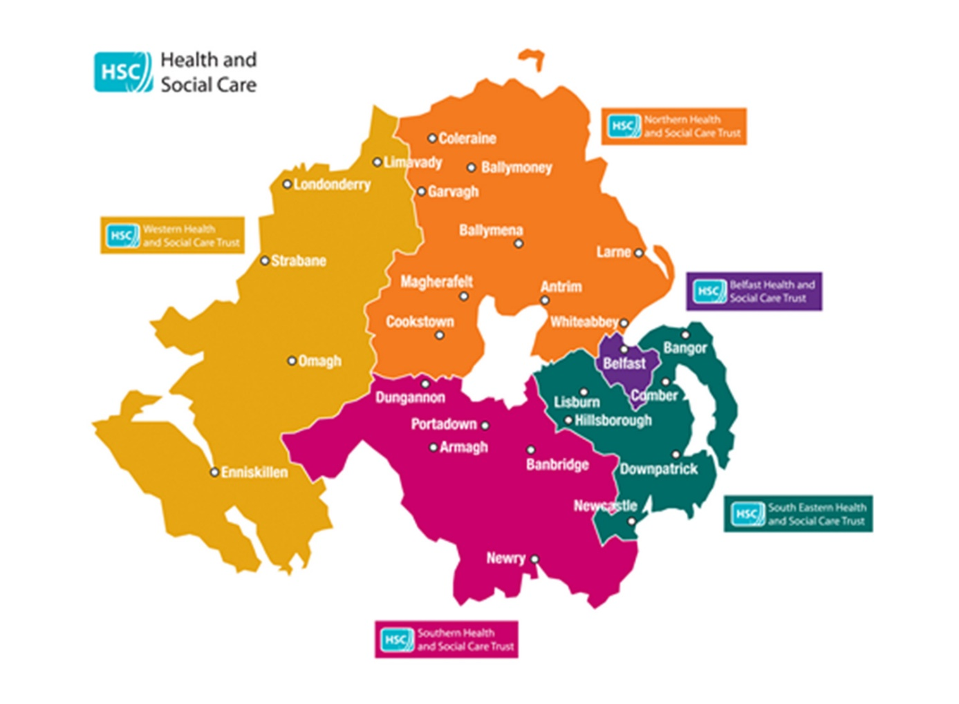
Appendix B

Internal Financial Controls
The following guidelines are intended to assist organisations that are in receipt of funding from the PHA.
All organisations must have robust systems of financial control in place i.e. proper procedures, controls, accounting records and supporting documentation in respect of funding provided by the PHA.

The organisation must have the following procedures in place before funding will be released and should include;

Cash Handling
- An outline of how all income is receipted.
- An outline of how the Petty Cash system is operated to include maximum limits, the procedure for increasing/decreasing floats, recoupment procedures and access to Petty Cash.
- Procedures to ensure cash boxes, cheque books and other financial documents are kept in a safe place and that appropriate responsibility and restrictions are laid down for access to the keys to any safe.
- A statement regarding regular cash lodgements i.e. lodgements shall be made in order to keep amounts of ‘cash in hand’ to a minimum.
- A list of authorised cheque signatories should be maintained.

Bank Account / Cash Book
- The organisation should have a bank account in the name of the organisation. Funding in respect of the project shall only be paid into the official bank account of the organisation.
- The name and address of the Bank/Building Society or Post Office branch and name of account.
- Details on the type of account, whether it attracts interest.
- Balance/overdraft limits
- Bank mandates must be formally approved by the Management Committee or Board.
- Payments from the bank account in respect this project/funding shall be on the signature of two authorised signatories.
- A statement of how, when and who shall complete the bank reconciliation, this will be countersigned by Treasurer/Secretary or Chairperson as evidence of review.
- A procedure for dealing with digital banking
- A procedure for dealing with cheques that are outstanding for a period of time.
- A procedure for stopping, cancelling and reissuing payments/cheques.
- How the bank balance is monitored.
- A cash book with details of all income received (including date, source and receipt number) and a summary of expenditure (including date, payee, nature and cheque/payment reference number) shall be maintained and reconciled to the bank statement on a monthly basis.

Purchasing Procedures
Organisations shall ensure that the procurement in relation to projects complies with the requirements for quotations and tendering stipulated in guidelines available from the PHA (known as the mini code).

Delegated Authority
Details of who is authorised in the organisation to commit and approve expenditure and what the limits of authorisation are.

A policy on how to report and respond to a Suspected Fraud
- Avenues for how and to whom a suspected fraud is reported.
- The roles and responsibilities of all staff within the organisation in relation to fraud awareness.
- The response plan should lay out the responsibilities of the senior management within the organisation in terms of handling suspicions or allegations of fraud.
- Any suspected fraud or other financial irregularity shall be reported to the Funder, the Police and the PHA at the earliest opportunity.

Segregation of Duties
This policy should prevent any one person carrying out a transaction without another authorised person being involved within the organisation.
- Where this is not possible due to the small number of staff employed then work should be reviewed by the management or Committee members.

Travel and Subsistence Expenses
- Details on insurance requirements, mileage rates, public transport rates, passenger supplements, car parking and incidental expenses, subsistence and accommodation.
- How payment will be made.

Payment of Invoices
- All invoices paid by the organisation must be supported by original invoices, not photocopies, which shall be retained for inspection.
- Invoices shall be properly checked before payment. This shall include checking against delivery and purchase orders and where appropriate contracts for accuracy.
- Invoices should be approved by an appropriate staff member with delegated authority.
- VAT shall be accounted for in accordance with Revenue legislation and HM Revenue and Customs Regulations.

Cheque Journal
The organisation shall maintain a cheque journal, which includes the information necessary for the completion of financial claims to the PHA. This may be done through the use of separate cost centres with a clear audit trail.

Maintenance of Records
Bank mandates, statements and reconciliations shall be retained for audit inspection for the period stipulated by the PHA.
All records of income and expenditure shall be retained and filed in an orderly system with a clear audit trail to allow for audit inspection. Records shall be readily accessible for monitoring purposes. This will include, original invoices paid (not photocopies), receipts for cash transactions, such as petty cash expenses and any other documentation to support disbursements of money. Cancelled receipts and cancelled cheques should be retained.

Security of Assets
The organisation shall maintain a record of assets purchased (Asset Register), which will include the source of funding for each individual asset. This will enable assets to be returned to the appropriate ‘owner’ in the event of a project coming to an end.

Financial Management
The Service Provider shall put in place and maintain systems for sound financial management including an appropriate budgetary control system. The Treasurer/Secretary or Chairperson shall review financial records on a monthly basis and shall present a financial report to the Management Committee, which will highlight any variances from forecasts and budgets. The Management Committee shall take immediate and appropriate action to address variances from agreed budgets. The PHA shall be notified at an early stage of any non-compliance with the terms of the funding agreement.

Reimbursement Claims to the PHA
- The Service Provider shall adhere to the monitoring and evaluation timescales outlined in the Contract.
- Authorised claim forms and other financial returns shall be approved by an appropriate official.

IT Security
- Where a financial IT system is in operation, security and control procedures should be in place to ensure restricted access, integrity of data and information and secure storage and transmission of data.
- Examples of such controls include separate administrator and user access, system to change passwords regularly, virus guards and fire walls, and system recovery plans.
- These controls should be previous payment controls and should be exercised jointly when an on-line treasury function is in place.

Payment of Salaries and Wages
Either a manual or a computerised payroll system shall be maintained. This shall clearly show the amount of gross and net wages for each employee. All payments to staff shall be through the payroll and shall be in accordance with Legislation and HM Revenue and Customs Regulations. A separate record of payments to the HM Revenue and Customs for Tax and National Insurance shall also be maintained.

Other - Staff
- Persons responsible for financial transactions in the organisation should be properly trained.
- Contracts of employment should be in place for all staff employed and made available for inspection by the PHA.

