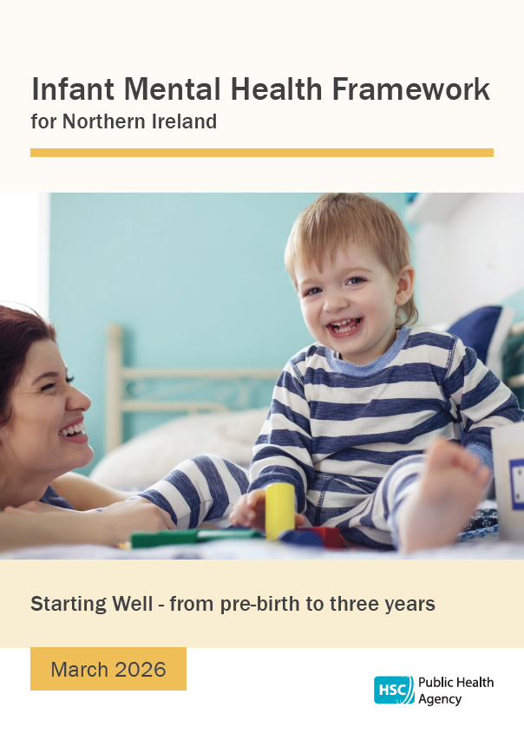
Voice of

Index
Foreword 3
Part 1: Setting the scene 5
Strategic Lenses 8
Policy updates 19
Infant mental health in Northern Ireland – key statistics 22
Part 2: Progress to date – reporting against the IMH Action Plan 2016 26
Part 3: Infant Mental Health Action Plan 2026 - 2029 35
References 48
Foreword
This Framework is a refreshed and updated version of the Public Health Agency’s (PHA) previous regional Infant Mental Health Framework. The original Framework, launched in 2016 with support from the National Children’s Bureau, enabled the PHA, Health and Social Care Trusts (HSCTs), the Strategic Planning and Performance Group (SPPG), and a wide range of voluntary and community organisations, including Sure Starts, to strengthen workforce knowledge and skills and to enhance interventions during pregnancy and early infancy.
The new Framework builds on the strong foundation of inter-sectoral and interagency commitment to early intervention with families during pregnancy and throughout the first 1000 days. The case for a whole system approach continues to be reinforced by growing evidence that the experiences of a child’s earliest years have profound and lasting effects on physical and mental health across the lifespan.
Since publication of the original framework in 2016, research and policy attention have increasingly focused on the long-term impacts of adversity and trauma, particularly during the earliest years of life. This reflects a deeper understanding of the critical importance of neurodevelopment and biological growth during this period. Leading global authorities, including the World Health Organization, UNICEF, and the Harvard Centre on the Developing Child, consistently demonstrate that secure and responsive early relationships support healthy development, while chronic stress, parental mental ill health, domestic violence, neglect, and substance misuse can increase the risk of later mental and physical health difficulties. Importantly, systems that recognise and respond early to families experiencing unmanageable stress can offset against risk and harm.
Delivering on the aims of this Infant Mental Health Framework requires coordinated action across multiple sectors. Maternity services, health visiting, primary care, mental health services, early years education (including Sure Start), social services, community-based providers, and voluntary and community organisations all have vital roles to play. Strengthening references to Infant Mental Health NI across Government Departments and their related Strategies ensures integrated actions on the wider determinants of Mental Health e.g. Poverty, Education and Justice.
The PHA acknowledges the significant achievements and the extensive efforts of many organisations over the past decade, particularly the dedication of the PHA Infant Mental Health Framework Implementation Group. The Agency has reaffirmed its commitment to the Starting Well agenda within its new organisational arrangements and looks forward to continuing and strengthening its collaboration with stakeholders to advance Infant Mental Health in the years ahead.
This document sets out the case for action. It presents key population data, scientific evidence, the economic rationale, and priorities for moving forward.
The future begins in the earliest relationships, and through collective responsibility and collaboration we look forward to working with others to protect and strengthen them.

Emily Roberts
Interim Director of Nursing, Midwifery & Allied Health Professionals
March 2026

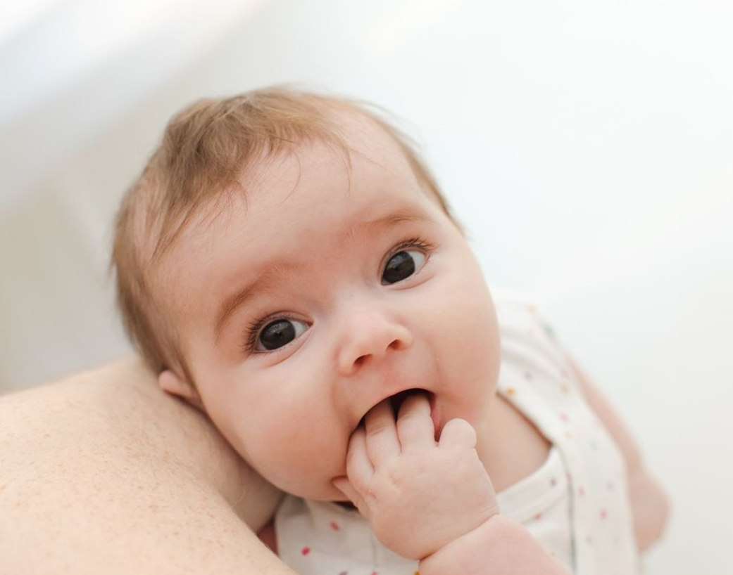
Part 1: Setting the scene
The Infant Mental Health (IMH) Framework was published in 2016 by the Public Health Agency, following substantial engagement with key stakeholders and public consultation. The Framework sought to give all children the best start in life by prioritising and supporting families during pregnancy and the first three years of life. Since then, there have been significant positive policy, workforce and service developments which have implications for the next phase of this important work. This includes the Mental Health Strategy which has a number of specific targets relating to the inclusion of infants in mental health services.
This refreshed framework has been informed by a range of research and engagement activities, including a scoping study of infant and family needs, challenges, successes and priorities (NCB, 2022) and the follow-up Insights in Infant Mental Health (NCB, 2024) which summarises good practice in infant family and support services in NI. Supporting babies, infants and their families, particularly those experiencing vulnerabilities, represents challenges for all parts of the system including the early years sector, health, social care, justice and education;
- 20% of children (110,000) in NI are living in absolute poverty (NISRA). 39% of NI households are in fuel poverty and increased reliance on food banks for many families are evident. Rising cost of living, increased number of households experiencing fuel poverty and increased reliance on food banks for many families are evident.
- Social complexities during pregnancy are a key priority in Northern Ireland, particularly in relation to pregnant women with complex social factors including those who misuse alcohol or drugs, who are recent migrants or have asylum seeker status, have difficulty reading or speaking English, are aged under 20 years old and/or those who experience domestic abuse (see NICE Guidance CG110 for more information).
- Concern for parental mental ill-health and increased pressures within the home, including drug and alcohol use, and the rising incidence of domestic violence, with many young children at increased risk of witnessing or experiencing abuse.
- Services are under increased pressure as they seek to deliver essential support to infants, parents and their families. Family needs are constantly changing, and services must adapt responsively.
- Growing levels of diagnosis and presentation of neurodivergence in NI children. It is vital services are equitable, in order for all infants to thrive. UNICEF (2023) notes that “Developmental conditions, developmental delay, neurodivergence, disability and ill health will affect what being mentally healthy looks and feels like for different babies and young children. Some diagnoses and disorders may also make it more difficult for children to be mentally healthy without additional support or adaptations.”
- TinyLife reports that every year, over 1900 babies in NI are born prematurely or sick and require neonatal support. This brings a range of additional considerations to support positive social and emotional development.
The demographic landscape in NI has changed over the recent years. Noticeably, there is an increasing number of migrant and asylum-seeking families across NI for whom English is not their first language. Some families may live in challenging accommodation circumstances and are far from familial support. Therefore, services must be adaptive to different cultures and address barriers to the delivery of safe and supportive maternity and early years care.
Early interventions have a strong protective role for the infants of the future. New research (for example Walsh, 2026) has shown Positive Childhood Experiences (PCE) are key in improving health outcomes. The research shows adults with higher PCEs than ACEs are less likely to have contact with the criminal justice system (arrest or incarceration); to be excluded from school; to misuse substances; or have a mental health diagnosis.
In Fair Society, Healthy Lives (The Marmot Review, 2010) Sir Michael Marmot describes the economic benefit of early intervention in infant mental health. The review highlighted the benefits of interventions including parenting programmes, health visiting, and good quality early education in supporting strong parent-child relationships. It also highlighted investing in early years can yield significant economic returns on investment by reducing impact on poor health and care.
The forthcoming SPPG led Children’s and Young People’s Emotional Health and Wellbeing Framework (consulted on by Dept. of Health, 2025) highlights the key importance of early support for families to offset escalation of risk. The Infant Mental Health Framework and the focus of early intervention closely aligns with this and other frameworks/strategies.
The Mental Health Champion for NI explains in the new report Mental Health in Northern Ireland: Current Services and Strategic Priorities (2026) that the availability of mobile devices, including smartphones and social media, have also accelerated a change in how children and young people relate to each other and the wider world. It is essential we develop our understanding of how this may impact babies who are at the earliest stages of child development.
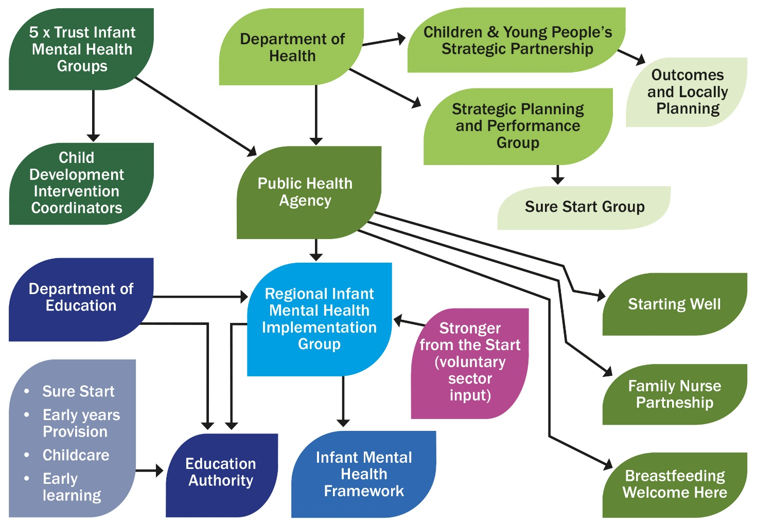
Key stakeholders in Infant Mental Health in NI
Strategic Lenses
The 2016 Infant Mental Health Framework highlighted that IMH is ‘everyone’s business’. In this refreshed framework and action plan, the widespread, lifelong impact of positive infant mental health is further demonstrated by framing priorities through four ‘strategic lenses’. These are:
- Trauma-informed practice
- Addressing health inequalities
- Offsetting risk to later life health and wellbeing outcomes
- Improving Public Health outcomes
These ‘lenses’ are described below, along with implications for infant mental health, setting the scene for the next phase of work and building the case for the critical importance of early intervention for life-long benefit.
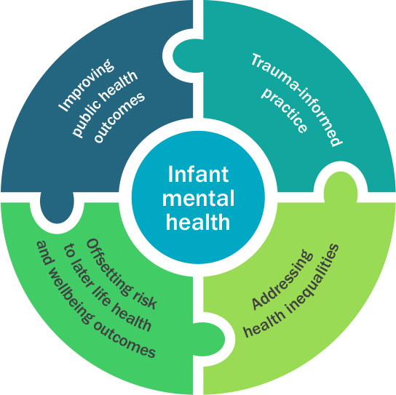

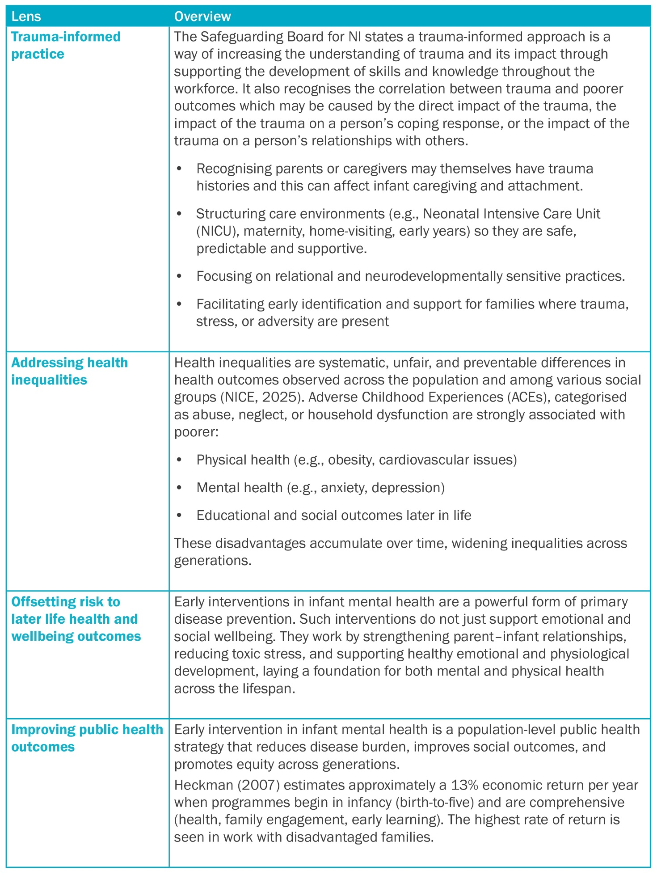

- Trauma-informed practice
The early years (especially the first 0-3 years) are a highly sensitive period for brain development. Infants are particularly vulnerable, and adverse early experiences (trauma, neglect or stress) are linked with poorer outcomes in infant mental health, attachment, emotional regulation, and cognitive development. (Shonkoff et al, 2012; Smith et al, 2020)
The Parent Infant Foundation describes how infants are vulnerable to psychological trauma when their home environments include ongoing negative or unsafe actions towards them or their parent/carer. These encounters are often known as Adverse Childhood Experiences (ACEs) and may involve experiencing repeated conflict at home, physical or emotional abuse, neglect, or exposure to domestic abuse.
Erickson et al (2019) note that when parents experience mental illness, such as depression or PTSD, this can negatively impact their ability to parent positively, which impacts early child attachment and relationships.
Evidence shows the importance of infants’ feelings of security in their relationships with their parent/carer. This security can help inhibit levels of stress initiated by trauma. This positive, secure relationship can consequently have a protective, longstanding impact on infant’s development.

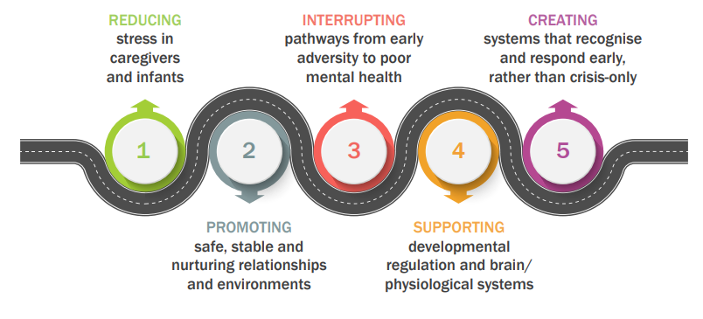

Methods by which trauma-informed practices can improve infant mental health:

1. Reducing stress in caregiver/infant dyad
- If parents/carers have trauma histories or perinatal trauma, this can impair sensitive parenting, bonding, and attachment.
- Trauma-informed care can provide support for parents/carers (psychological and relational) which in turn improves the caregiving environment for the infant through more secure attachment and sensitive responses.

2. Promoting safe, stable, nurturing relationships and environments
- For infants, relational safety (having a responsive caregiver and secure attachments) is foundational for mental health. A trauma-informed society emphasises relational safety.

3. Interrupting pathways from early adversity to poor mental health
- We know early adversities, such as parent/carer trauma, NICU stress, or early maltreatment, can increase risk of infant mental health difficulties. A trauma-informed system aims to intervene earlier, thereby reducing the degree or severity of exposure, or buffering its effects.
- In the longer-term, fewer adverse early experiences or more mitigated/adapted experiences mean less risk of later behavioural, emotional, or cognitive problems.

4. Supporting developmental regulation and brain/physiological systems
- Early trauma, including trauma during pregnancy, can dysregulate physiological systems, such as the hypothalamic-pituitary-adrenal axis (HPA axis) or cortisol regulation in infants and young children (Howland et al, 2017).
- By promoting more regulated, supportive home environments and reducing toxic stress, a trauma-informed system may help infants’ physiological systems develop more adaptively, leading to improved stress regulation, better mental health and resilience.
- This also supports parent-infant co-regulation, safe touch, stable environment, and consistent relationships.

5. Creating systems that recognise and respond early, rather than crisis-only
- A society that is trauma-informed will be more likely to:
(a) identify parent/infant risk earlier,
(b) provide supports, such as home visiting, relational interventions, or parent trauma support, and
(c) avoid re-traumatisation by services for example where there are judgmental responses or the abrupt removal of support.
- For infants and their families, this means fewer disruptions, better relational continuity, less service-induced stress, and better outcomes for infant mental health.

How do the proposed actions contribute?
- Workforce development: Infant mental health training at all levels, supports staff to continue the development of expertise and knowledge sharing.

- Trauma-informed services: Continuing to model a trauma-informed practice approach to service delivery across all disciplines; learning how trauma presents, both for the expectant mother and infant, and the health harming behaviours that may impact an infant’s mental health.

- Evidence: Assessment of distress using the Baby Distress Scale (ABDD), which will help practitioners to assess needs and put in place early interventions when negative signs are recognised.

- Widening the audience: making IMH everyone’s business through wider messaging across government and related agencies, services and communities.
- Addressing Health Inequalities

Investing in infant mental health is one of the most effective strategies to reduce health inequalities. It works by nurturing early relationships, reducing the impact of adversity, supporting parental wellbeing, and promoting healthy development, all of which lay the foundation for equitable health and life outcomes. (Woodhead, 2025; Bateson, 2019)

Examples of effective infant mental health interventions include:

- Family Nurse Partnership UK: This programme offers an intensive home visiting programme for first time teenage mothers, focusing on strengthening attachment and supporting education goals.
- Infant–Parent Psychotherapy: Strengthens attachment and reduces parental depression. (Barlow et al 2015)
- Sure Start / Early Start programmes: Provide community-based early years support focused on health, education, and parenting. (Carneiro et al., 2015)

Long-term, infant mental health interventions can:

- Reduce later demand on health, education, and social care systems
- Improve population mental health and productivity
- Narrow the life expectancy gap linked to social deprivation

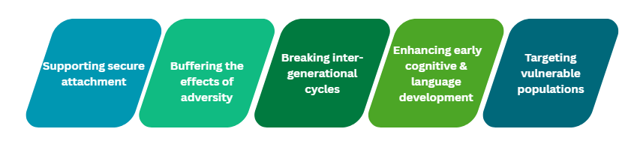
How early interventions can help make improvements in health inequalities

1. Supporting Secure Attachment
- Programmes that promote sensitive, responsive caregiving. For example, home visiting programmes or parent–infant therapy builds secure attachments.

- Secure attachment supports emotional regulation, resilience, and later social competence, all protective factors against the effects of poverty and stress.

2. Buffering the Effects of Adversity
- Early interventions can mitigate the impact of toxic stress (chronic stress without adequate support), which disproportionately affects disadvantaged families.

- By strengthening parent–child relationships and providing social support, interventions help regulate stress responses, reducing risk for later mental and physical health problems.

3. Breaking Intergenerational Cycles
- Supporting parents’ own mental health and reflective capacity can interrupt cycles of trauma and deprivation.

- When parents are supported to understand and respond to their infant’s cues, they are less likely to repeat patterns of neglect or harsh parenting.

4. Enhancing Early Cognitive and Language Development
- Early relational interventions often improve communication and stimulation in the home environment.

- This promotes early brain development and school readiness, which are key predictors of lifelong health and socioeconomic outcomes.

5. Targeting Vulnerable Populations
- When infant mental health interventions are delivered proportionately to need, they ensure that support reaches families most at risk. For example, through perinatal mental health services or early years programmes. This directly reduces inequality in access to developmental opportunities.

How do the proposed actions contribute?
- Health and Social Care Trust collaboration: delivering a consistent regional approach to support, regardless of postcode while allowing for adaption to local needs.

- Support a regional approach to early intervention: includes service provision through interventions such as Family Nurse Partnership, parent-infant specialist teams and perinatal mental health teams.
3. Offsetting risks to later life health and wellbeing
It is critical that the impact of long term ‘toxic’ stress on an individuals’ health in later life is addressed. Without intervention, individuals may be at higher risk of developing physical or mental health conditions which are irreversible and require many years of heath care support (Shonkoff et al, 2012). Intervening in the early years, through a range of approaches, brings opportunity to reduce this risk of disease later in life.

Reducing prevalence of disease by identifying risks at an early stage
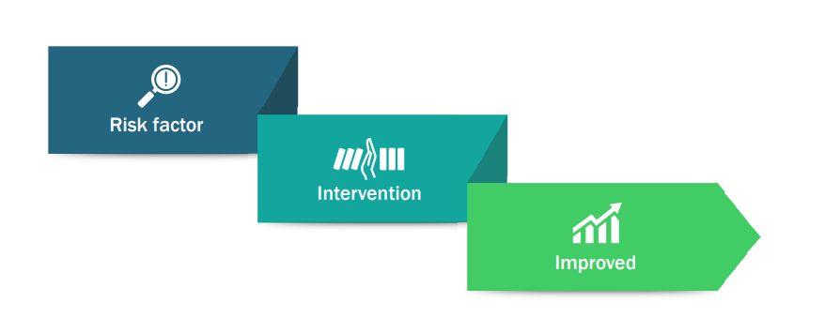

1. Reducing Toxic Stress and Its Biological Effects
- Toxic stress activates the body’s stress response system (the HPA axis) for long periods. This can lead to inflammation, weakened immunity, and altered brain development.
- Early infant mental health interventions, such as parent–infant therapy or home visiting programmes, help parents respond sensitively to infants, buffering stress and supporting regulation. This can prevent:
- Later cardiovascular disease
- Metabolic disorders (e.g., obesity, diabetes)
- Immune-related illnesses

2. Promoting Healthy Brain and Emotional Regulation
- Early experiences literally shape the brain structure. Secure attachments promote optimal neural connectivity in regions that control emotion, behaviour, and stress regulation. This can prevent:
- Mental health disorders (such as depression, anxiety, or substance use)
- Stress-related physical illnesses

3. Supporting Parental Mental Health
- Interventions often target parental mental health, helping parents manage depression, anxiety, or trauma that can disrupt their parenting role.
- A regulated, emotionally available parent supports a healthy infant stress response and attachment pattern. This can prevent:
- Intergenerational impact of mental illness
- Early-onset behavioural and emotional disorders

4. Encouraging Healthy Lifestyle Foundations
- Early parent–infant interactions influence feeding, sleep, and activity routines.
- Supportive infant mental health interventions help families establish nurturing, predictable environments that promote physical wellbeing. This can prevent:
- Obesity and sleep disorders
- Malnutrition or feeding difficulties

5. Strengthening Immune and Endocrine Function
- Secure attachment and reduced stress improve immune system development and hormonal balance. This can prevent:
- Chronic inflammatory conditions
- Autoimmune and metabolic diseases

6. Reducing Risk Behaviours in Later Life
- Early IMH support improves emotional stability, impulse control, and social connectedness, which are protective factors against later risky behaviours. This can prevent:
- Smoking, alcohol and drug use
- Injury, violence, and sexually transmitted infections

4. Improving Public Health Outcomes
How do the proposed actions contribute?
- Strategic collaboration: Continuing to champion the critical importance of infant mental health, the influencing factors and long-term impact. Seeking opportunities to actively influence emerging strategy implementation and investment, encourage the inclusion of infant-specific language and promote the first 1001 days through joined-up messaging e.g. across the Breastfeeding Strategy

- Dissemination of information: Supporting access to information in relation to infant mental health and wellbeing, and wider information on parental mental health and healthy behaviours. For professionals, Lunchtime Learning webinars will continue, and the recordings will be available online for public access.

There are trends in public health, the health of the nation, which require significant attention and investment to enhance the quality of life for individuals and society (Crealey et al, 2024). In order to address these trends, Royal College of Paediatrics and Child Health (RCPCH) suggest that investment is required in early childhood interventions to support infants and families, providing improved child development, parenting and long term-health outcomes.

Linkages to public health priorities

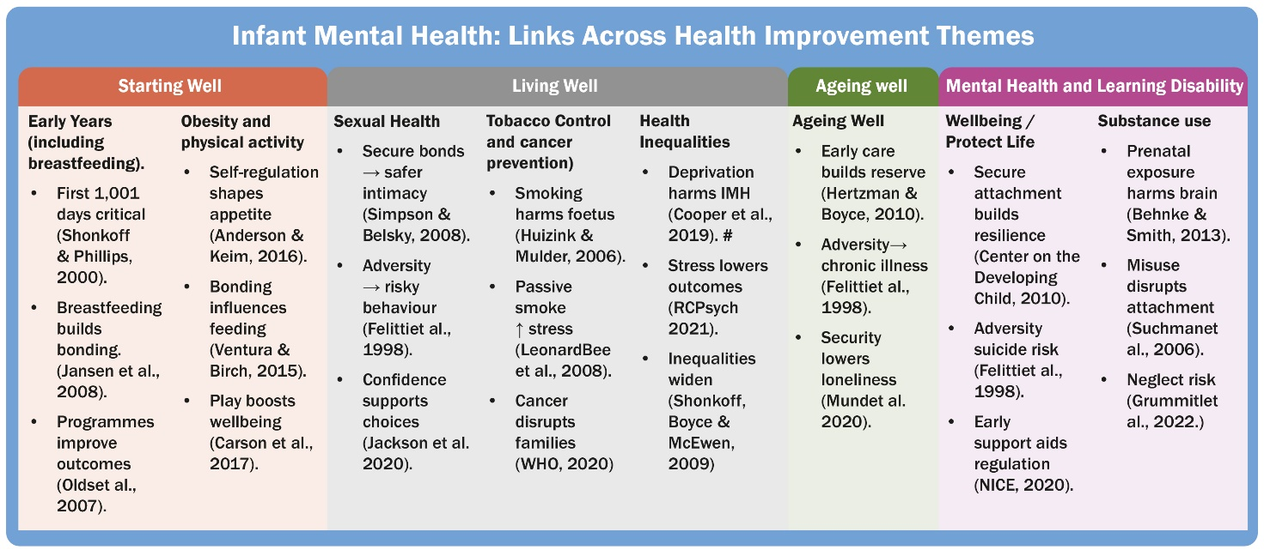

Positive infant mental health interventions contribute to public health priorities in several ways:

1. Improved Brain Development
- Early stress, such as neglect or inconsistent parental support, alters brain architecture.
- Early interventions reduce toxic stress, promoting healthy neural and emotional development.
- Long-term, this results in fewer cognitive and emotional difficulties later in life.

2. Reduced Incidence of Mental Illness
- Early attachment support lowers risks for later depression, anxiety, and behavioural disorders.
- Secure attachment serves as a protective factor throughout life.

3. Enhanced Physical Health
- Early emotional regulation and reduced chronic stress lower lifelong risks for conditions like:
  - Cardiovascular disease
  - Diabetes
  - Immune dysfunction
These are all linked to early-life stress and cortisol dysregulation.

4. Better Educational and Social Outcomes
- Children with early social-emotional support are more ready for school, have better attention and self-regulation, and experience higher academic achievement.
- Positive emotional wellbeing leads to lower dropout rates, higher employability, and better socioeconomic outcomes, all public health determinants.

5. Reduced Violence and Substance Use
- Early interventions foster empathy, impulse control, and problem-solving.
- Communities with early childhood supports show lower rates of youth violence, delinquency, and substance use.

6. Economic Benefits
- Studies (e.g., Heckman’s work on early childhood investment) show that every $1 spent on early intervention yields up to 7–13 times that in long-term savings due to:
  - Reduced healthcare costs
  - Lower special educational needs
  - Decreased crime rates
  - Higher lifetime earnings

7. Intergenerational Effects
- Early interventions strengthen parent–child relationships, reducing the transmission of trauma, neglect, and poverty-related stress across generations.

How do the proposed actions contribute?
- Increased public awareness: encourage a widespread and collaborative public awareness campaign to reach all parents, not just those attending services or receiving support.

- Parent support initiatives: to improve parents’ knowledge and skills in providing the best start in life for their infants.

- Breastfeeding support: to ensure parents who wish to breastfeed are encouraged to do so in order that infants can receive the long-term health benefits that breastfeeding provides.
Policy updates
Since the 2016 launch of the Framework, there have been several significant strategic developments across Northern Ireland which have had implications for the lives of infants and their families, and therefore the priorities identified in this refreshed action plan. As each of these strategic developments is implemented, infants and their families must be held in mind and opportunities for collaboration sought to ensure a coordinated approach.
Within the updated Protect Life 2: Suicide prevention strategy (Department of Health, 2019), perinatal mental health has now been identified as an area for enhancement in pre-crisis intervention.
The Children & Young People’s Strategy 2020-2030 (Department of Education, 2021) gives parity of esteem at strategic level to physical and mental health. This is of critical importance in building a recognition of the impact emotional wellbeing has on wider life outcomes, and the need to prioritise mental health alongside physical health in funding decisions. Infancy and the early years are a priority within the strategy, with a range of commitments, including: proactive prevention from the prenatal period onwards; prioritising increased knowledge and awareness raising for parents and families; early intervention and support where needs are identified; and the development of trauma-informed services.
A Fair Start: Final Report and Action Plan (Department of Education, 2021) recommends a redirection of focus to the early years to ensure that from pregnancy and beyond, children are given equal opportunities to achieve their full potential. Relevant actions include an increased policy and investment focus on the learning and development of 0-6-year-olds; enhancement of services in the antenatal period, including getting ready for a baby/toddler; and a review of early years staff pay and continued professional development to reflect the role and importance of the skills required.
The Mental Health Strategy 2021-2031 (Department of Health, 2021) for the first time takes into consideration the mental health and wellbeing of the youngest children and commits to ensuring that infant mental health is prioritised by embedding infants within a whole system mental health approach. Key priorities include the consideration of infant mental health within the development of CAMHS pathways for infants; the need for specific psychological interventions for infants and very young children where there are symptoms of psychological distress; and the strengthening of the regional specialist perinatal and parent-infant community mental health services, providing essential care for expectant and new mothers experiencing mental ill-health. The strategy recognises that a trauma-informed approach from pregnancy onwards is essential. Building capacity and providing development opportunities within the workforce is key to providing sustainable services for infants and families.
A refreshed Healthy Child, Healthy Future (Department of Health, 2025) outlines the universal child health prevention programme across NI, from pregnancy through to 19. It brings a renewed recognition of the first 1000 days, with huge relevance for the development of positive infant mental health. In particular, the framework reinforces the need for a whole-child, whole-systems, cross-departmental response and commitment to early intervention. The critical importance of strengthening the parent-infant relationship is highlighted, through evidence-based parenting support and positive practice, with a commitment to reducing health inequalities, recognising the role of early years for life-long outcomes. The Framework also reinforces the importance of workforce investment for early childhood support, with the Solihull Approach (now Togetherness) referenced throughout as a recognised model to promote good practice in infant mental health, and as an effective parental support programme.
The substance use strategy, Preventing Harm, Empowering Recovery (Department of Health, 2021), recognises that experiencing substance use in the family home is one of the core Adverse Childhood Experiences (ACEs) which lead to poorer outcomes. The strategy highlights the link between substance use and family history, the increased likelihood of domestic violence where there is substance use in the home, and the trauma of witnessing substance use by family members in childhood. It emphasises the need to provide support for wider family members, in particular children who have been present, and critically, whether they are old enough to have understood the circumstances or not.
The subsequent Substance Use Strategic Commissioning and Implementation Plan (2023) notes the impact of ‘hidden harm’ on young children, compromising parenting ability and impacting child social and emotional development. The impact of Foetal Alcohol Disorder is also recognised, with the need to assess and mitigate risk.
The draft Early Learning and Childcare Strategy (Department of Education, 2025) has been released for consultation, with actions spanning improved early childhood provision; support for families with childcare and early learning costs; and sustainability and capacity building for the early years' workforce. The Department has recently announced significant investment in early years provision, pre-school education and childcare support. Future developments must be child-centred, integrated with the wider strategic context, and built on the fundamentals of developing good infant mental health.
In 2025 the Department of Health consulted on the draft Emotional Health and Wellbeing Framework (EHWB). This framework aims to establish integrated pathways across the 0–18 continuum. It takes into consideration core commitments including prevention, early support, trauma-informed practice, workforce development, multi-agency collaboration and robust data use.
An Independent review of social care, chaired by Professor Ray Jones, began in February 2022, and the final report was launched in June 2023. The review examined the quality, equity, resilience and sustainability of children’s services to ensure they can respond to and meet the current and future needs of children, while also supporting the workforce to perform their duty effectively. The review does not explicitly reference infant mental health, rather highlights the need for prevention and early intervention more widely within family support services. An acknowledgement is made of the key role by the workforce across statutory, voluntary and community services, and the need to ensure they are skilled and supported to best support families.
The Safeguarding Board for Northern Ireland Strategic Plan 2022 – 2026 also has relevance for infant mental health, particularly in relation to preventing and responding to domestic abuse, and in awareness raising and prevention of children’s mental ill-health. SBNI’s work to train multi-sectoral practitioners in trauma-informed practice has been a significant achievement in terms of bringing a common understanding of the impact of early trauma. [Note that at the time of publication, consultation is ongoing for a revised 2026-2030 plan].
The voluntary and community sectors have come together to bring a united voice through the Stronger from the Start Infant Mental Health Alliance. The Alliance, alongside the (now closed) Association for Infant Mental Health NI (AIMH NI), was instrumental in campaigning for the inclusion of infants in the mental health strategy and has recently updated its Manifesto for infant mental health and hosted several influential events to raise awareness and inform discussions.
According to Royal College of Paediatrics and Child Health (RCPCH) physical punishment is consistently associated with a variety of negative health and developmental consequences for children. Many have called for equal protection for children in Northern Ireland, with a motion for the equal protection amendment tabled in September 2025. This calls for an amendment to the Justice Bill to petition the abolition of the common law defence of ‘reasonable punishment’ in relation to physical punishment of a child.
This refreshed Infant Mental Health Framework recognises the developments above, and the implementation plans already in place and planned. Therefore, actions below seek to build on and add value to this work, supporting collaboration where possible, including co-production with service users so developments are informed by lived experiences. This is in line with the Children’s Services Cooperation Act (NI) 2015, which places a statutory duty on departments, public authorities and others to collaborate to support the health and wellbeing of infants, children and young people.
Summary of engagement activities undertaken to inform this refreshed framework and action plan
In preparing this refreshed action plan to build on the commitments from the 2016 infant mental health framework, a scoping study, including research and engagement activities, was undertaken to reflect on progress, and to identify changing needs, priorities, and policy drivers. Ongoing stakeholder engagement has also fed into the plan, ensuring commitments meet changing needs.
Research activities included:
- Survey on needs, challenges and priorities (75 respondents, representing a wide range of statutory and voluntary sector organisations)
- Targeted organisational survey on significant achievements (8 organisational respondents – including Health Trusts, Sure Starts and IMH membership body)
- Focus groups with key stakeholders (50 participants representing practitioners, parents, commissioners and policy makers)
- A review of strategic and policy developments
- Summary of emerging research on infant mental health
You can read a summary of research (2022) findings here.
- Stakeholder engagement workshop (June 2025)

Infant mental health in Northern Ireland – key statistics
Key information for arrows:
Green = positive change; Red = negative change; Blue = change of direction (neither good nor bad, attributed to birth rate & child population changes).
Data | Trend | Link to Dataset
Number of Births annually
19,416 Births in NI in 2024 |  | NISRA Registrar General Annual Report 2024 Births
Child Population
107,266 children aged between 0-4 |  | NISRA Registrar General Annual Report 2024 Population and Migration
No. of Births to Teenage Mothers annually
417 births to mothers aged 19 and under (in 2023/4)  2.1% of all births |  | Children’s Health in NI Report 2023/24  April 2025
Premature or Low Birth Weight
5.4% (<2500g)  Most deprived areas: 6.6%  Least deprived areas: 3.4% | Overall trend & difference by deprivation: no notable change | Health Inequalities Annual Report Department of Health, 2025
Infant mortality rate (4-year average)
4.4 deaths per 1000 live births  The 2025 Report indicates this ranges from 3.7 in least deprived areas to 5.6 in most deprived areas | No notable difference, but there is a widening gap between most and least deprived areas. | Health Inequalities Annual Report Department of Health, 2025
Child Protection Register
2,283 children on the child protection register (as of 2024) |  | Children’s Social Care Statistics for Northern Ireland, 2024-25
Of these 10% are under 1, and 23% aged 1- 4. An increase in under 1s, but no change in age 1-4.
Children Looked After in Care
As of 31 March 2025, 4,188 children were in care in Northern Ireland. The number of children in care continues to rise. It was the highest recorded number of children in care since the introduction of the Children (Northern Ireland) Order 1995.  The number of looked after children in 2025 was 5% higher than at the same time the previous year (3,999).  Of these, 3% were under 1 year old and 17% were between 1 and 4. |  | Children’s Social Care Statistics for Northern Ireland, 2024-25
More than four in five children were placed in foster care arrangements (52% in kinship care placements, 23% in non-kinship placements, 9% independent foster care providers).  6% placed with parents, 5% in residential care, and 5% other placements | Only small variations in placement type | Children’s Social Care Statistics for Northern Ireland, 2024-25
Smoking during pregnancy
Overall, 8.8% but ranging from 2.9% in least deprived areas to 17.2% in most deprived quintile |  | Health Inequalities Annual Report Department of Health, 2025
Breastfeeding rate at discharge
Overall – 53% fully or partially breastfeeding at discharge.  Most deprived quintile: 42%  Least deprived quintile: 66% |  | Health Inequalities Annual Report Department of Health, 2025
Breastfeeding at 3/6/12 months
30.9% babies totally or partially breastfed at 3 months  25.6% babies totally or partially breastfed at 6 months  17.4% babies totally or partially breastfed at 12 months |  | Children’s Health in NI 2023/24 Public Health Intelligence Unit, 2025
Child Poverty
23% Children are living in relative poverty and 20% Children living in absolute poverty (before housing costs) |  | Northern Ireland Poverty and Income Inequality Report 2023/24, NISRA March 2025
Domestic abuse
5,293 children with mothers accessing Women's Aid services (this number is not broken down by age)  Refuge services  - 10 babies born whilst mum is living in refuge accommodation  - 145 children 0-5 lived in refuge accommodation  - 266 pregnant women lived in refuge accommodation | No comparison available | Women’s Aid Federation Annual Report 23/24
475 children aged 0-4 recorded as being victims of domestic abuse crimes |  | PSNI Statistics 2024 Domestic abuse crimes recorded by age of victim, 2004/05 to 2023/24
Population Diversity
153,000 people (8.1% of the total  population) are identifying as any ethnic group other than White British, Irish or Northern Irish. |  | Ethnic identity in Northern Ireland: a comparison of Census 2011 and Census 2021 outputs (NISRA)
Childhood Obesity
 |  | Health Inequalities Annual Report 2024/25  Department of Health NI
  In 2024/25 the percentage of primary 1 pupils affected by obesity in the most deprived areas was 73% higher than the rate in the least deprived areas.

Part 2: Progress to date – reporting against the IMH Action Plan 2016

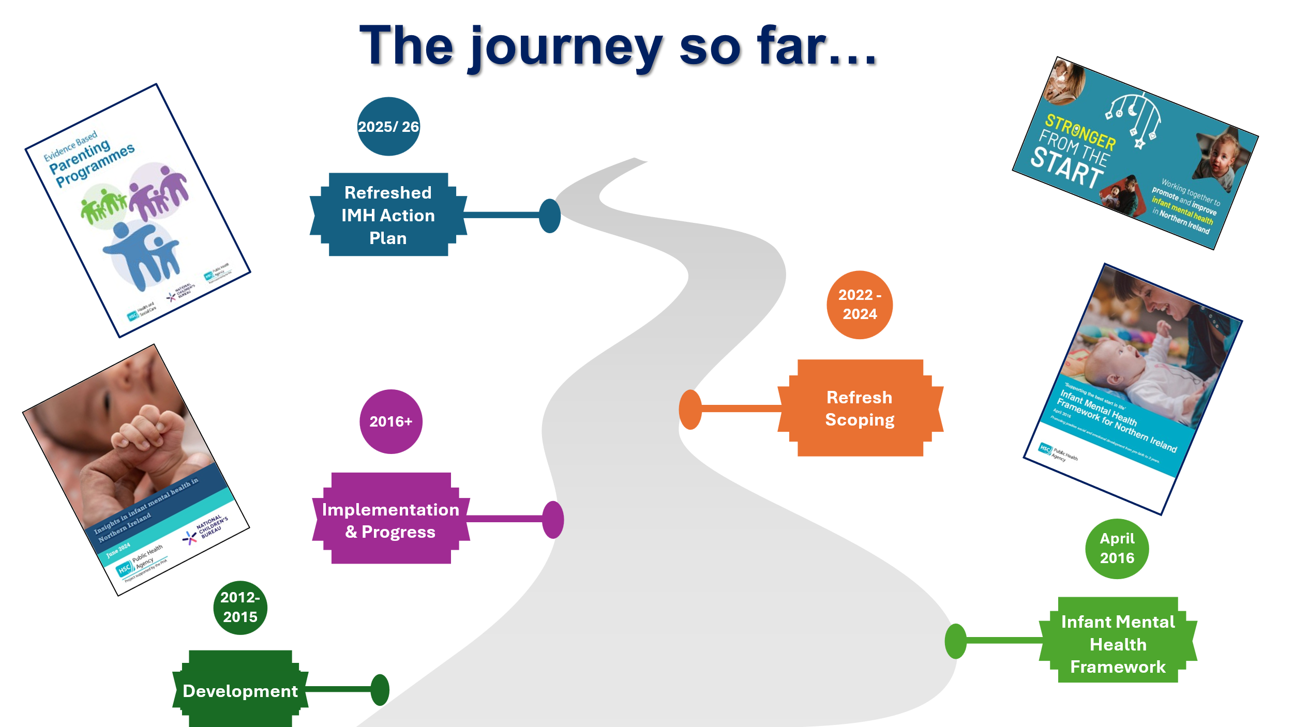

The table below summarises some of the key achievements against the 2016 IMH Framework and action plan to date, and priorities identified through engagement activities.
2016 IMH Action Plan commitments | Progress to date
Evidence and policy  Action Plan activities included the following:  - Strengthen IMH strategy, legislation, and programmes based on IMH evidence, including:  - Informing a new mental health strategy for NI  - Developing local Health Trust IMH strategies  - Supporting dissemination of IMH messaging and evidence through events, networking and resource development  - Promotion of best practice standards within universal services such as UNICEF UK Baby Friendly Initiative. | Achievements include:  Policy  - The influence of infant mental health work on policy is clear, as summarised above.  - Protect Life 2: suicide prevention strategy was launched in 2019 with the inclusion of infant mental health/ prevention & early intervention recognition.  - NI Mental Health Strategy for the first time recognises infants and their families, following lobbying and engagement from across the statutory and voluntary sectors.  - The importance of perinatal mental health, and the linkages with IMH, is also gaining traction in policy and practice with the implementation of Perinatal Mental Health teams in each of the five Trusts.  - HSC Trusts each have infant mental health plans (reflecting the PHA regional themes) in place addressing local priorities. Trusts have developed special interest groups and other activities which lead to better information sharing and collective training and use of resources.  - Infant mental health is a central theme on a range of other organisational strategies and drivers (as highlighted in the strategic updates section above).  - NSPCC with PHA produced a Report on the Importance of Infant Mental Health called ‘Looking After Infant Mental Health in Northern Ireland: Our Case for Change – A Summary of Research Evidence’ which was published and widely disseminated.  Evidence  - Dissemination of IMH evidence continues to a wide audience, through a range of key groups and organisations, e.g. IMH Regional Group membership (40+ members), and the Stronger From the Start (SFTS) Alliance. The Alliance continues to lobby for the inclusion of infants in policy developments.  - Since April 2023, the PHA, supported by NCB, has delivered over 30 lunchtime learning webinars, to a combined audience of over 1200 attendees, enhancing shared learning opportunities and continued professional development for people working with infants and their families.  - A wide range of resources have been developed to identify and collate evidence and good practice and share key messages of IMH with wide-ranging audiences. This video, compiled to highlight the breadth of IMH work across NI, is one example.  - Opportunities to share information on IMH in places where parents frequent are being sought and utilised – for example at Foodbanks, supermarkets, via the Family Support NI website, pharmacies, GPs and others. The ‘Making Every Contact Count’ approach to behaviour change has also been widely adopted across health and social care, aiming to introduce conversations on health and wellbeing during everyday health and social care interactions.  - Since the IMH Framework was launched, there have been numerous local and regional events, with visiting and local speakers, to disseminate evidence and good practice. Local organisations and agencies have come together to celebrate Infant Mental Health Awareness Week over the past number of years, with a variety of events and activities drawing significant audiences. This has led to increased awareness of the importance of infant mental health, and the sharing of good practice by organisations working to support positive wellbeing.  - Sure Starts have collaborated with parents to develop resources aimed at increasing communication and interaction between parents and babies. East Belfast Sure Start and others have played a key role in place-based focus on parenting.  Areas for development:  - Commitment to local research, both to understand local needs, and to build the evidence base for what works in local service delivery.  - Expanding the audience for IMH messages beyond the immediate early years workforce, for example with those working in family courts, youth justice, education, substance use, and other sectors. Considering the opportunity to embed simple language changes to reflect the importance of infant wellbeing, e.g. through a wide-reaching public campaign using parent friendly language and resources supported by PHA.  - A specific focus on parental education, using accessible language, highlighting the positive, low-cost actions that can be taken to strengthen and build good mental health. Examples include talking, singing and reading together; eye contact and ‘serve and return’ interactions; skin-to-skin contact. Health visitors, Sure Starts, voluntary and community services and other key early years services/settings are already delivering important work in this regard which can/should be built upon.  - Involving service users including pregnant people, parents and carers, and wider support networks in developing IMH messaging, resources and services is key.  - Further effort to collate and increase visibility of existing evidence and resources. The development of a central multi-disciplinary digital repository for IMH resources would better facilitate access and evidence-sharing.  - Making connections across the regional cross-departmental policy landscape to harness opportunities brought by recent policy developments, including but not limited to the Mental Health Strategy, Substance Use strategy, A Fair Start, and the forthcoming Early Learning and Childcare Strategy.  - Recognising opportunities brought by the new Integrated Care System introduced in Northern Ireland and the new Neighbourhood Model of Care, which will bring together health, social care and community services to better support children, adults and families.  - Building connections between the local and regional IMH strategies, continuing to share learning and improve regional consistency.  - All the above must be informed by evidence of need. Further effort is needed to establish data sharing systems and use the data to inform strategic developments. Encompass brings opportunities to better understand the ‘whole child’ needs.
Workforce development  Action Plan activities included the following:  - Expansion of Togetherness, Togetherness Plus and ‘Train the Trainer’ training; targeted Tavistock M7 & M9 courses for advanced practitioners; and Video Interaction Guidance training for relevant practitioners across the region.  - Influence the development of infant mental health content on third-level curriculum courses across relevant subjects.  - Create opportunities to educate parents, families and practitioners across clinical, educational and other relevant fields on infant mental health. | Achievements include:  - HSC based Child Development Intervention Coordinators, commissioned by the PHA are now in place to support the implementation of evidence-based practice & capacity building of staff across all Trust areas. This role is bringing widespread consistency across the Trusts, while allowing space for important regional innovation.  - Infant mental health-focused training roll-out is acknowledged as a significant achievement for many. Examples include Togetherness, trauma-informed practice, the Community Resiliency Model, Incredible Years accreditation and peer coach training, & Five to Thrive.  - Establishment of the PHA-led Togetherness Task & Finish group to: review current impact reporting and consideration of any potential added value to the ‘Is anyone better off’ outcome measures; support the network of current providers to share benefits to C&YP and families; encourage network of providers to achieve and apply high standards of programme fidelity and implementation; and, support wider awareness and sharing of learning across sectors and settings to inform adoption and implementation of Togetherness Programmes.  - Overall, good practice in workforce development is spreading across health, led by health visiting, midwifery, social work and allied health professionals, and spreading beyond health to education, the criminal justice system and others. Opportunities are being sought to expand training to all those professionals who encounter infants in any way during their work, recognising the wider context within which infants develop.  - Tavistock M7/M9 training has brought much-needed specialist skills for those working directly with infants and families.  - Many services have introduced workforce wellbeing initiatives to support staff and acknowledge the work of the early years workforce and their resilience and efforts during the pandemic and beyond to continue to support families.  - Brazelton Newborn Behaviour Observations training has been undertaken by allied health professionals including occupational therapists and physiotherapists, speech and language therapists and others. This tool, and accompanying training, provides practitioners with enhanced knowledge, skills and confidence in supporting parent-baby relationships.  Areas for development:  - Take stock of the scale, reach and impact of workforce training initiatives, and the capacity for implementation. It is also critical that gaps can be identified in terms of audience and messaging and synergies with other training and subject matters considered.  - Promote consistency in IMH training through an IMH competencies framework to define the key skills and knowledge required at each level of practice.  - Continue an overall focus on trauma-informed and responsive practice, which will benefit both practitioners and service users.  - Continue to invest in workforce wellbeing, acknowledging the significant pressures faced. Within this, minimising compassion fatigue and vicarious trauma across the workforce should be prioritised.  - Drive recruitment from school onwards and invest in 3rd level educational places to attract the necessary skilled and committed workforce.
Service development  Action Plan activities included the following:  - Development of evidence-based and accessible antenatal parent education, breastfeeding support and guidance  - Expansion and adoption of Baby Friendly Initiative standards  - Development, expansion, training, accreditation and delivery of parenting programmes, including Incredible Years & Family Nurse Partnership  - Development of Child Development Intervention Coordinator role  - Revision of existing guidance and provision, including Relationships and Sex Education, maternal mental health provision and the Perinatal Care Pathway  - Identify gaps in knowledge of data and service delivery  - Develop the capacity of CAMHS practitioners and Primary Mental Health Teams  - Introduction of 5 Early Intervention Teams across NI, and mental health and wellbeing HUBs to support families with new-borns. | Achievements include:  Successful development and delivery of evidence-informed services to support infants and their parents is widespread. Many examples of good practice in service delivery are evident, with IMH messages and evidence clearly embedded in universal, targeted and specialist services.  - Many services are delivered under the Sure Start umbrella, with examples including infant massage, breastfeeding support, peer support groups, Incredible Years baby, parent and toddler groups, Let’s Get Sure Start Singing, Chatting Time and others.  - Outside of Sure Starts, voluntary and community groups, including Home-Start, Barnardo’s, Action for Children, Aware NI, The Parent Rooms, Tiny Life, NSPCC, and many others provide programmes, interventions and activities to support infant mental health.  - Family Nurse Partnership, delivered by family nurses including health visitors, continues to provide much needed support for young families, as does Star Babies (NHSCT) and other regional approaches.  - PHA commissioned regional roll-out and delivery of the ‘Mood Matters: Parent and Baby Programme’ in partnership with Aware NI.  - Trust health visiting Getting Ready for Baby & Getting Ready to Learn are noted examples of transformative work to support infants & their families.  - The implementation of the Breastfeeding Strategy, and adoption of the UNICEF Baby Friendly Initiative, continues. One example of good practice is the PHA ‘Breastfeeding Welcome Here’ scheme, with more than 1000 services now signed up. In 2022, Translink joined other businesses in signing up, meaning all 39 bus and rail stations, 1,400 buses and trains, and Translink employees, are welcoming to and supportive of breastfeeding mums.  - Specialist parent-infant relationship services, including I-CAMHS (SHSCT), & SIGNETS (BHSCT), and the now closed ABC PiP (SEHSCT) are significant achievements in supporting parent-infant relationships through multi-disciplinary working.  - All Trusts now have a multidisciplinary community perinatal mental health team in place, offering support and interventions for women from pregnancy through to one year after birth and bringing regional consistency to the support available for new parents. These teams employ a part time Child and Adolescent Psychotherapist to ensure a key focus on the parent infant relationship.  - Primary care multi-disciplinary teams (MDTs) now include health visitors and district nurses, alongside social workers, mental health practitioners, and others, meaning appointments can be booked directly where MDTs are in place and making services more accessible. This is also supporting an integrated, holistic approach to health and wellbeing and promoting links between GPs and other key health professionals.  - During the Covid-19 pandemic, most services adapted delivery, embracing new technology and approaches to continue to support families through the pandemic.  - There are various examples of specific roles being developed within services with an IMH focus, for example parent-infant mental health support workers, and IMH Champions across health and social care, health visiting and midwifery, allied health professionals, education and wider.  - There are strong examples of peer support opportunities across the region, including NHSCT ‘Baby and Me’ groups, led by health visitors and open to mothers and fathers; Aware NI postnatal education; the MAS project; TinyLife peer support; and The Parent Rooms services.  - The Family Integrated Care model (FICare) has been developed within neonatal care across the region. This approach promotes a culture of partnership and collaboration between families and neonatal staff, integrating families as partners in the care team and supporting bonding and attachment while also ensuring the infant receives the necessary medical care.  Areas for development:  - Despite the areas of good practice above, and significant developments across NI, there remains a need for the development and resource of a regional model for IMH, ensuring a range of universal, targeted and specialist support and services, with clear pathways, to meet the needs of all families as and when required.  - Within this, an increased focus on services for those with mild to moderate needs (Tier 1 and Tier 2) is important. Likewise, specialist support (Tier 3) for parent-infant relationships across Northern Ireland is a priority.  - Workforce development for Parent Infant Services, if prioritised, requires a process and resource to establish a Child and Adolescent Psychoanalytic Psychotherapy workforce.  - Longer term recurrent funding for services is critical to allow investment in building staff capacity and resilience and strengthen long-term delivery.  - Service development should focus on building resilience in parents and infants, coping skills, self-regulation, social/separation anxiety and speech, language and developmental delays.  - Parental mental health and wellbeing is an increasing concern and should be addressed in wider service delivery, as should support for vulnerable groups. Peer support and networking opportunities are also critical.  - Services must be supported to collect and report on impact data, demonstrating how their service users are better off as a result, and using data to inform service development. A consistent approach across the region is essential, with equitable and consistent voluntary/community and statutory requirements for reporting.

Part 3: Infant Mental Health Action Plan 2026 - 2029
Aims of the action plan
This Action Plan 2026 – 2029 builds on the priorities established in the 2016 Infant Mental Health Framework, and sets out the commitments from the Public Health Agency to continue to drive forward the regional approach to infant mental health. The three overarching Framework themes remain current and form the structure of this action plan:
- Evidence and policy: We believe that investment in services must be firmly based on existing and emerging evidence, ensuring best possible outcomes for all children, young people and families. Investment in infant mental health should not be seen in isolation, but rather as an evidence-based approach to transforming child and family outcomes. The ever-growing body of evidence on the impact of adverse experiences in utero and the first three years of life must drive decision making across health, education and social care policy and practice.
- Workforce development: Central to the early identification of infant mental health issues is ensuring that all practitioners working with babies, pregnant or new mothers, fathers (who are often overlooked), and support networks with young infants (up to three years of age) are fully equipped to promote positive social and emotional learning, as well as being able to identify the early signs of infant mental health problems and to seek timely help for those families at risk. Key professionals include health visitors and midwives, allied health professionals, family support workers and early years practitioners, nurses, GPs, and a wide range of others. The wellbeing of the workforce itself is also a critical element in providing effective support for families.
- Service development: Increased capacity of practitioners to identify additional needs around infant mental health will necessitate not only a clear referral pathway to identify appropriate support, but increased service capacity to meet this need. Workforce development and service development must therefore go hand in hand. Appropriate services must provide a range of universal, targeted and specialist support, considering the individual and specific needs of infants and their families.

Priorities for the next three years are summarised below, against these three themes. The actions below acknowledge the significant contributions already made by, and ongoing role of Departments, Health and Social Care Trusts, and other organisations, including the Public Health Agency and those from the voluntary and community sector. The actions below therefore recognise the need for cross-cutting, multi-agency collaboration to build on existing work and ensure the Best Start in Life for all children.

Guiding principles
- Championing infant and children’s rights: The PHA endeavours to ensure all infant mental health priorities are viewed through a lens which enables all infants to thrive by having their rights upheld. In particular, the PHA will focus on ensuring all infants, inclusive of all backgrounds, ethnicities, abilities and neurodiversity, will have equitable access to support. This work will ensure both infants and parents are valued appropriately throughout service delivery, supporting their communication needs and abilities.
- Supporting the whole population to access appropriate and timely support involves ensuring services are culturally competent and, therefore, adaptive to needs and addressing barriers to the delivery of safe and supportive maternity and early years care.
- Celebrating success of the wide range of partners: The PHA acknowledges and celebrates the progress made across Northern Ireland to support infant mental health, the significant achievements and the wide range of people and organisations who have a role to play across the voluntary and statutory sectors. Within this, the examples of multidisciplinary approaches to supporting infants, their families and support networks are key. This work has undoubtedly influenced the wider strategic direction for services across Northern Ireland.
- Harnessing opportunities for strategic collaboration: The PHA will continue to seek opportunities for strategic collaboration to maximise planning and delivery efforts across all relevant strategies, groups and organisations who are working to support positive infant mental health. The significant policy developments across Northern Ireland, including the launch of the Department of Health Mental Health Strategy, and the Department of Education Fair Start Implementation, represent an opportunity to prioritise the needs of 0-3-year-olds and their families. The PHA is committed to informing and indeed adding value to the 0-3 agenda, rather than duplicating efforts.
- Co-production: The Department of Health, Health Trusts and regional HSC bodies in NI have a statutory duty to involve and consult with service users and carers in care planning and delivery. Furthermore, the Co-Production Guide (2018) supports the application of effective co-production principles across health and social care services, beyond statutory requirements. In line with the Public Health Agency’s leadership role in Personal and Public Involvement (PPI), we will monitor, promote and support the engagement of service users in policy and service development, working alongside them to ensure they can actively inform issues affecting them.
- Focusing on impact: An outcomes-based approach to service design and delivery, ensuring demonstration of how infants and their families are better off because of the services delivered, is an ongoing priority. The PHA will actively consider child health and relevant data to inform commissioning and service development. The Joint Commissioning Groups are used by SPPG to review performance and relevant population health and social care need. The Children and Young Peoples Outcomes Groups have access to a SPPG comprehensive data set that allows detailed profile of need for children, young people and families.
Actions and Implementation Plan 2026 - 2029
The tables below set out the Framework commitment to supporting infant mental health against the themes of the Infant Mental Health Action Plan, and the key actions prioritised over the next three years. These actions acknowledge the significant efforts and achievements for infants and families through local and regional service delivery across all sectors and seek to support and add value to existing efforts. The actions below also reflect a core commitment to working in partnership with Departments and Agencies in delivering the Best Start in Life for infants and their families.
Implementation will continue to be overseen by the Regional Infant Mental Health Implementation Group.
Table 1: Evidence and Policy
Commitment
To work collaboratively with key departments and agencies to strengthen IMH focus on legislation and programmes based on existing and emerging evidence of local need and of what works to support positive infant mental health.

Regional priorities
• Support the case for investment in parent-infant mental health services.
• Align key strategies to maximise impact.
• Support joined-up commissioning, planning and service delivery.
• Collate and share data to inform strategic direction.
• Increase visibility and accessibility of evidence.

Action | Year | Lead / delivery partners
POLICY
1. Strategic collaboration  Disseminate the refreshed IMH Framework to wider stakeholders to promote the critical importance of infant mental health and related evidence and research, including on societal impacts. | 2026-27 | IMH RIG; Trusts; PHA; C&V sector
2. UK, ROI and north-south links  Ensure the IMH Regional Implementation Group links with relevant UK and ROI infant mental health networks and builds north-south connections. | 2026-29 | IMH RIG; PHA
3. Regional Implementation Group membership  Review and renew the composition of the IMH Regional Implementation Group to ensure optimum connectivity across key stakeholders. | 2026-27 | IMH RIG
4. Strategy and investment influence  Use opportunities to contribute to emerging strategy formulation, implementation and investment and encourage the inclusion of infant-specific language and promote the first 1001 days. | 2026-29 | Trusts; PHA; DoH; DE; SPPG
5. Regional policy alignment  Ensure connections across the regional policy landscape, harnessing and challenging opportunities brought by recent policy developments, in particular the Mental Health Strategy, A Fair Start, Healthy Child, Healthy Future, Substance Use Strategic Commissioning and Implementation Plan 2024-2028, Draft Children and Young People’s Emotional Health and Wellbeing Health framework, and the next phase of the Maternity Strategy, to ensure infants and their families are included in strategic commitments. This is in line with requirements set out in the Children’s Services Cooperation Act (Northern Ireland) 2015. | 2026-29 | Trusts; PHA; C&V sector
6. Trust collaboration  The five HSC Trusts have undertaken significant work to build local infant mental health strategies and structures. In the next phase of work, the priority will be collaboration between local Trust IMH groups, facilitating a regional approach which combines regional consistency with local flexibility. | 2026-29 | Trusts; PHA
EVIDENCE
7. Data and evidence-gathering  Key partners to progress data systems including Encompass and infant mental health and family-related data, using standardised tools with established norms, to ensure that strategic developments are informed by current evidence of need. | 2026-29 | Trusts; PHA; SPPG
8. Needs assessment and standardised tools  The IMH Needs Assessment model undertaken in Scotland is a strong example to guide this work. The ADBB Alarm Distress Baby Scale tool has an ongoing piloted in NHSCT (due for completion 2026) and may have relevance for wider NI practice. The ASQ SE tool is another example of consistent data collection, used by Healthy Visitors across NI at the 3+ Review. | 2026-29 | Trusts; PHA; SPPG
9. Service user and lived experience involvement  Ensure service user involvement and lived experience is prioritised by providing opportunities for service users to participate in decision-making, service planning, and evaluation of services. | 2026-29 | Trusts; PHA; C&V sector
10. Research priorities  Identify relevant infant mental health research, both to understand local needs and local impact, and wider evidence base to inform local service delivery. The recently published ‘The Implications of Covid-19 restrictions for children and young people’ is an example of collating evidence. | 2026-29 | IMH RIG; PHA; Trusts; C&V sector; Universities
11. Emerging research and best practice  Engage with relevant stakeholders to consider emerging research and best practice in relation to screen time e.g., local implementation of screen time guidance in under-fives, such as the guidance introduced in England (2026). | 2026-29 | IMH RIG; PHA; Trusts; C&V sector; Universities
DISSEMINATION AND PUBLIC AWARENESS
12. Research and good practice dissemination  Provide opportunities and increase the reach of sharing relevant research and good practice across the region, for example through the continued delivery of the series of IMH Lunchtime Learning webinars, three IMH e-bulletins per year, regional networking events and accessible resources. | 2026-29 | IMH RIG; PHA; Trusts; C&V sector
13. Central online repository  Develop and promote a central online information repository for practitioners supporting parents and carers. This will support access to information in relation to infant mental health and wellbeing, and wider information on parental mental health and healthy behaviours. We will harness the opportunities brought by digital platforms, such as podcasts and blogs, to reach a wider audience. | 2026-29 | PHA; Trusts; C&V sector
14. Widen the audience  Extend the reach of infant mental health messaging, resources and services beyond the existing audience, including but not limited to:  - Fathers, caregivers, and wider support networks  - Other professionals supporting young children and families, such as GPs and wider health professionals, family courts and the justice sector, childminders, teachers, early years staff and community and voluntary sector, including volunteers.  In doing this, we will also challenge and address existing stigma to create an inclusive environment for fathers, wider family and others to engage. | 2026-29 | PHA; Trusts; C&V sector
15. Public-facing communication  Use Members and available social media and communication channels to share relevant information with parents, extending beyond those attending services/receiving support. This will promote infant mental health and the positive actions that can be taken to strengthen and build early emotional wellbeing through positive brain development (with a focus on low cost or no cost activities). This requires cross-sector collaboration and engagement including health, social care, youth justice, education, community and voluntary partners. | 2026-29 | Trusts; PHA; C&V sector
16. Infant Mental Health Awareness Week  Continue to use Infant Mental Health Awareness Week to collectively raise the profile of work ongoing across the region and disseminate key messages. | 2026-29 | PHA; Trusts; C&V sector

Table 2: Workforce Development
Commitment
Collectively continue to support the upskilling and professional development of the early years workforce across all disciplines to ensure they have appropriate knowledge, skills and confidence to best support positive infant mental health.

Regional priorities
• A skilled multidisciplinary workforce committed to evidence-based services delivered to fidelity.
• Availability of ongoing opportunities for professional development, practice-sharing and peer networking and support.
• Continued development of a common language for all those with a role to play in supporting infant mental health.

Action | Year | Lead / delivery partners
1. Competency framework  Further exploration of formal development of an infant mental health competency framework, such as those provided by the Association of Infant Mental Health or the Michigan Association for IMH (adapted by Ireland and other countries) to define the key skills and knowledge required at each level of practice. | 2026-29 | IMH RIG; PHA; DoH; SPPG
2. Sharing best practice  Facilitate opportunities for workforce peer networking and sharing of best practice across services, through practitioner forums and events, and the dissemination activities described above. | 2026-29 | PHA; Trusts; C&V sector
3. Practitioner wellbeing  Promote initiatives to support staff wellbeing and psychological safety, based on emerging evidence of need and of ‘what works’ to best support practitioner wellbeing. The Regional Workforce Wellbeing Network is a useful example, providing resources including a Manager’s Framework, signposting/contacts and a recovery toolkit for staff. | 2026-29 | PHA; Trusts; C&V sector
4. Further and higher education  Continue to work with partners in third level education settings to identify opportunities to further embed infant mental health core competencies in relevant third level education curriculum. | 2026-29 | Universities; Colleges
5. Retention and recruitment  Recruitment drives from school onwards, & investment in third level educational places are much needed to attract the necessary skilled and committed workforce. This work should be informed by emerging evidence of local vulnerabilities and needs, with areas of greatest need prioritised in terms of recruitment. | 2026-29 | PHA; Trusts; C&V sector
6. Tavistock M7 course  The PHA will support professional development of practitioners by facilitating access to the Tavistock M7 course: Perinatal, child, adolescent and family work: a psychoanalytic observational approach. | 2026-29 | PHA
7. Substance use workforce development  Substance use workforce development training and development opportunities should be provided for the early years workforce to build knowledge, skills and capacity, recognising the risks for infants associated with parental substance use. ASCERT | Reducing alcohol & drug related harm in our communities is one example. | 2026-29 | PHA

Table 3: Service Development
Commitment
Encourage and support a tiered and multidisciplinary approach to evidence-based services for 0-3s and their families.

Regional priorities
• A commitment to the establishment and sustainability of multi-disciplinary teams including parent-infant specialists, across Northern Ireland.
• A suite of high quality and evidence-based services, taking a tiered approach with universal, targeted and specialist services.
• Regional consistency in availability and access to services.
• A recognition of and commitment to embedding coproduction models in service design and delivery.
• An outcomes-based approach where services regularly gather, analyse and share data on impact, and use this to better inform services, locally and regionally.

Action | Year | Lead / delivery partners
UNIVERSAL
1. Early intervention parenting programmes and family support  PHA will continue to support the Child Development Intervention Coordinator role in each Health and Social Care Trust. This will provide coordination and improved implementation for the early intervention agenda for children and families. Equity of access to services for all infants and their families, as and when they need it, is paramount. | 2026-29 | PHA; Trusts; CDICs
2. Parenting support initiatives  Build on the significant investment made to date on parenting programmes and support across the region by:  - Encouraging the application of high standards of programme fidelity and implementation.  - Supporting a network of current providers to share best practice benefits to infants, children, young people and families.  - Prioritising support for fathers/partners given their key role in parenting.  - Reviewing, alongside programme delivery agents/developer, current impact reporting and consideration of any potential added value to the ‘Is anyone better off’ outcome measures.  - Support wider awareness and sharing of learning across sectors and settings, including publication and dissemination of evidence, to inform adoption and implementation of such programmes.  - Continued purchase and roll-out of Togetherness multi-user licence by PHA. | 2026-29 | PHA; Trusts; CDICs; C&V sector
3. Breastfeeding support  Continue to promote and support breastfeeding through implementation of the DoH/PHA Breastfeeding Action Plan and related Baby Friendly Initiative. | 2026-29 | DoH; PHA; Trusts; C&V sector
TARGETED
4. Together for Families  Transformation funding is likely but not confirmed at time of publication. This investment represents significant family support provision aimed at families experiencing complexity and vulnerability. One of the underpinning principles of the proposed investment is to address infant mental health. Progress and evaluation on implementation of new service models will be important. IMH Regional Implementation Group will invite membership from those involved in the implementation of the programme. | 2026-27 | IMH RIG; PHA; TfF Programme Board
5. Parent-Infant Teams  The Mental Health Strategy commits to ensuring the needs of infants, particularly those at risk of developing later childhood mental illness, are met in mental health services. If Parent-Infant Teams are identified as a priority, investment in workforce development and services will be critical. A recent report from the Centre for Mental Health and Parent-Infant Foundation measured potential savings of over £1.15 billion per year across the UK by expanding access to parent-infant teams. The Regional IMH implementation Group will hold a strategic workshop with key stakeholders on the case for developing Parent Infant services in Northern Ireland. | 2026-29 | PHA; Trusts; SPPG; DoH
6. Family Nurse Partnership  PHA continues to lead on the implementation of the FNP programme across NI. As teenage pregnancy rates fall, consideration will be given to revising the eligibility criteria to ensure the programme is offered to those young women experiencing additional complex needs. | 2026-29 | PHA; Trusts
7. Family Integrated Care  Continued promotion of the FICare model of neonatal care across all HSC Trusts in NI. This model promotes a culture of partnership and collaboration between families and neonatal staff, with the aim of enhancing the healthcare experience of both the infant and their wider families and improving longer-term neonatal outcomes. | 2026-29 | PHA; Trusts
8. Early Intervention Support Services  PHA-commissioned family support teams delivered by a number of voluntary sector providers. This will include support to expectant families who are experiencing emerging vulnerability. | 2026-29 | PHA; C&V sector
9. Trauma-informed approach and services  Through support from the Safeguarding Board NI, organisations should develop services with an explicit trauma-informed practice approach to service delivery e.g. Probation Board NI, Youth Justice Agency and Barnardo’s. This benefits both practitioners and service users. For infant mental health this is particularly important in, for example, how Inter-generational trauma may impact on expectant parents. | 2026-29 | All
GENERAL APPROACH
10. Champion co-production  In line with the PHA and HSC policy on Personal and Public Involvement (PPI), champion the voice of service users in all service development and delivery through promotion of a coproduction model to better target services to needs. This includes the consideration of innovative ways to capture the infant experience and harness the infant voice, rather than relying on feedback from caregivers. | 2026-29 | IMH RIG; PHA; Trusts; C&V sector
11. Outcomes-based approach  Support and encourage the use of an outcomes-based approach to gather, analyse, review and share (between services and publicly where relevant) available impact data from services, and consider how this can be better used to inform services and plan more strategically. This data must demonstrate the impact that services are having on infants, families and beyond. | 2026-29 | IMH RIG; PHA; Trusts; SPPG; C&V sector

References

Anderson, S.E. and Keim, S.A. (2016) ‘Parent–child interaction, self-regulation, and obesity prevention in early childhood’, Current Obesity Reports, 5(2), pp. 192–200. Available at: https://pmc.ncbi.nlm.nih.gov/articles/PMC4856567/

Barlow J, Bennett C, Midgley N, Larkin SK, Wei Y. (2015) Parent-infant psychotherapy for improving parental and infant mental health. Cochrane Database System Review. Jan 8;1(1):CD010534 Parent-infant psychotherapy for improving parental and infant mental health - PubMed

Bateson K, et al (2019) Development and Implementation Toolkit Chapter 2, Parent Infant Foundation Chapter 2 - Parent-Infant Foundation

Behnke, M. and Smith, V.C. (2013) ‘Prenatal substance abuse: Short- and long-term effects on the exposed fetus’, Pediatrics, 131(3), pp. e1009–e1024. Available at: https://pubmed.ncbi.nlm.nih.gov/23439891/

Carson, V. et al. (2017) ‘Systematic review of the relationships between physical activity and health indicators in the early years (0–4 years)’, BMC Public Health, 17(Suppl 5), p. 854. Available at: https://bmcpublichealth.biomedcentral.com/articles/10.1186/s12889-017-4860-0

Carneiro P et al (2025) Sure Start’s wide-ranging and long-lasting benefits highlight the impact of integrated early years services. Institute of Fiscal Studies Sure Start’s wide-ranging and long-lasting benefits highlight the impact of integrated early years services | Institute for Fiscal Studies

Center on the Developing Child at Harvard University (2010) The Foundations of Lifelong Health Are Built in Early Childhood. Cambridge, MA: Harvard University. Available at: https://developingchild.harvard.edu/resources/report/the-foundations-of-lifelong-health-are-built-in-earlychildhood/

Cooper, K., Stewart, K. and Atherton, K. (2019) ‘Pathways to inequalities in child health’, Archives of Disease in Childhood, 104(10), pp. 998–1003. Available at: https://adc.bmj.com/content/archdischild/early/2019/02/23/archdischild-2018-314808.full.pdf

Crealey, GE, Hickey G & McGilloway S. (2024) A cost-effectiveness analysis of a universal, preventative-focused, parent and infant programme. BMC Health Services Research

Erickson N, Julian M, Muzik M. Perinatal depression, PTSD, and trauma: Impact on mother-infant attachment and interventions to mitigate the transmission of risk. Int Rev Psychiatry. 2019 May;31(3):245-263. Perinatal depression, PTSD, and trauma: Impact on mother-infant attachment and interventions to mitigate the transmission of risk - PubMed

Felitti, V.J. et al. (1998) ‘Relationship of childhood abuse and household dysfunction to many of the leading causes of death in adults’, American Journal of Preventive Medicine, 14(4), pp. 245–258. Available at: https://pubmed.ncbi.nlm.nih.gov/9635069/

Foundations Guidebook (2021) guidebook-intervention-info-sheet-family-nurse-partnership.pdf

Grummitt, L.R., Kelly, E.V., Barrett, E.L., Lawler, S., Prior, K., Stapinski, L.A. and Newton, N.C. (2022). Associations of childhood emotional and physical neglect with mental health and substance use in young adults. Australian & New Zealand Journal of Psychiatry, 56(4), pp.365-375. Available at: https://pubmed.ncbi.nlm.nih.gov/34250829/

Heckman, J. (2017) There’s more to gain by taking a comprehensive approach to early childhood development. The Heckman Equation. https://heckmanequation.org/resource/research-summary-lifecycle-benefits-influential-early-childhood-program/

Hertzman, C. and Boyce, T. (2010) ‘How experience gets under the skin to create gradients in developmental health’, Annual Review of Public Health, 31, pp. 329–347. Available at: https://pubmed.ncbi.nlm.nih.gov/20070189/

Howland MA, Sandman CA, Glynn LM. (2017) Developmental origins of the human hypothalamic-pituitary-adrenal axis. Expert Review Endocrinol Metab. Developmental origins of the human hypothalamic-pituitary-adrenal axis - PMC

Huizink, A.C. and Mulder, E.J.H. (2006) ‘Maternal smoking, drinking or cannabis use during pregnancy and neurobehavioral and cognitive functioning in human offspring’, Neuroscience & Biobehavioral Reviews, 30(1), pp. 24–41. Available at: https://pubmed.ncbi.nlm.nih.gov/16095697/

Jackson, C., Geddes, R., Haw, S. and Frank, J. (2012). Interventions to prevent substance use and risky sexual behaviour in young people: a systematic review. Addiction, 107(4), pp.733-747. Available at: https://pubmed.ncbi.nlm.nih.gov/22151546/ Jansen, J., de Weerth, C. and Riksen-Walraven, J.M. (2008) ‘Breastfeeding and the mother–infant relationship: A review’, Developmental Review, 28(4), pp. 503–521. Available at: https://doi.org/10.1016/j.dr.2008.07.001

Leonardi-Bee, J., Smyth, A., Britton, J. and Coleman, T. (2008) ‘Environmental tobacco smoke and fetal health: Systematic review and metaanalysis’, Archives of Disease in Childhood – Fetal and Neonatal Edition, 93(5), pp. F351–F361. Available at: https://pubmed.ncbi.nlm.nih.gov/18218658/

Marmot, M. (2010) Fair Society, Healthy Lives: The Marmot Review. London: Institute of Health Equity. Available at: https://www.instituteofhealthequity.org/resources-reports/fair-society-healthy-lives-the-marmot-review

Mental Health Champion for NI (April 2026) Mental Health in Northern Ireland Current Services and Strategic Priorities
Mental Health in Northern Ireland 2026 Final Version 1.pdf

Mund, M., Freuding, M.M., Möbius, K., Horn, N. and Neyer, F.J. (2020). The stability and change of loneliness across the life span: A meta-analysis of longitudinal studies. Personality and social psychology review, 24(1), pp.24-52. Available at: https://pubmed.ncbi.nlm.nih.gov/31179872/

National Institute for Health and Care Excellence (2015) Children’s attachment (NG26). London: NICE. Available at: https://www.nice.org.uk/guidance/ng26

National Institute for Health and Care Excellence (2010) Pregnancy and complex social factors: a model for service provision for pregnant women with complex social factors (CG110). London: NICE, Available at: https://www.nice.org.uk/Guidance/CG110

Olds, D.L., Sadler, L. and Kitzman, H. (2007) ‘Programs for parents of infants and toddlers: Recent evidence from randomized trials’, Journal of Child Psychology and Psychiatry, 48(3–4), pp. 355–391. Available at: https://pubmed.ncbi.nlm.nih.gov/17355402/

Parent Infant Foundation, Understanding early trauma and the importance of early relationships (2022) Understanding-Early-Trauma-Report-final.pdf

Public Health Agency (2016) Infant Mental Health Action Plan. Belfast: PHA. Available at: https://www.publichealth.hscni.net/publications/infant-mental-health-framework-northern-ireland

Royal College of Paediatrics and Child Health The case for investing in early childhood interventions | RCPCH

Royal College of Psychiatrists (2021) Infant and Early Childhood Mental Health: The Case for Action (CR238). London: RCPsych. Available at: https://www.rcpsych.ac.uk/docs/default-source/improving-care/better-mh-policy/college-reports/College-reportCR238---Infant-and-early-childhood-mental-health.pdf

Sheng J, et al. (2021) The Hypothalamic-Pituitary-Adrenal Axis: Development, Programming Actions of Hormones, and Maternal-Fetal Interactions, Frontiers in Behavioural Neuroscience https://doi.org/10.3389/fnbeh.2020.601939

Shonkoff, J.P., Boyce, W.T. and McEwen, B.S. (2009) ‘Neuroscience, molecular biology, and the childhood roots of health disparities’, JAMA, 301(21), pp. 2252–2259. Available at: https://pubmed.ncbi.nlm.nih.gov/19491187/

Shonkoff JP, Garner AS (2012) Committee on Psychosocial Aspects of Child and Family Health; Committee on Early Childhood, Adoption, and Dependent Care; Section on Developmental and Behavioral Pediatrics. The lifelong effects of early childhood adversity and toxic stress. Pediatrics. Jan;129(1): e232-46. The lifelong effects of early childhood adversity and toxic stress - PubMed

Simpson, J.A. and Belsky, J. (2008) ‘Attachment theory within a modern evolutionary framework’, in Cassidy, J. and Shaver, P.R. (eds.) Handbook of Attachment: Theory, Research, and Clinical Applications. 2nd edn. New York: Guilford Press, pp. 131–157.

Smith, K.E., Pollak, S.D. (2020) Early life stress and development: potential mechanisms for adverse outcomes. Journal of Neurodevelopmental Disorders 12, 34. https://doi.org/10.1186/s11689-020-09337-y

Suchman, N.E., McMahon, T.J., Zhang, H., Mayes, L.C. and Luthar, S.S. (2006) ‘Substance-abusing mothers and disruptions in child custody: An attachment perspective’, Journal of Substance Abuse Treatment, 30(3), pp. 197–204. Available at: https://pmc.ncbi.nlm.nih.gov/articles/PMC1850760/

Ventura, A.K. and Birch, L.L. (2008) ‘Does parenting affect children’s eating and weight status?’, International Journal of Behavioural Nutrition and Physical Activity, 5(1), p. 15. Available at: https://ijbnpa.biomedcentral.com/articles/10.1186/1479-5868-5-15

Woodhead, D. (2025) Invest in Childhood: Priorities for preventing mental ill health among children and young people. Centre for Mental Health CentreforMH_InvestInChildhood.pdf

World Health Organization (2019) WHO report on the global tobacco epidemic 2019: Offer help to quit tobacco use. Geneva: WHO. Available at: https://iris.who.int/bitstream/handle/10665/326043/9789241516204-eng.pd

This Framework has been supported by the National Children’s Bureau

