Northern Ireland
Abdominal Aortic Aneurysm (AAA)
Screening Programme

Annual Report 2023/2024

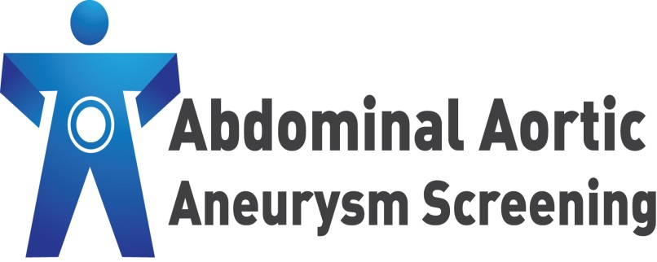




About this publication

Document title: | NI AAA Screening Programme Annual Report 2023/2024
Version: | Version 1.0
Authors: | Gemma Reid (PHA), Claire Black (BHSCT), Leanne McClay (BHSCT), Christine McKee (PHA)
Owners: | NI AAA Screening Programme
Final approved release date: | PHA AMT 09.02.2026

Distribution to:

- Co-Director of Surgery and Specialist Services - Belfast Health and Social Care Trust

- NI AAA Screening Programme Team - Belfast Health and Social Care Trust

- Deputy Director of Public Health, Screening - Public Health Agency

- NI AAA Screening Programme Team - Public Health Agency

- NI AAA Screening Programme Co-ordinating Group

The final version of the report will be circulated to the above distribution list.

Contents Page

1 | Summary and Highlights for 2023-24 | 4
2 | Background and Programme Objectives | 6
3 | Governance and Accountability | 9
4 | Programme Delivery and the Screening Pathway | 11
5 | Programme Performance | 15
6 | Health Inequalities | 21
7 | Personal and Public Involvement (PPI) | 25
8 | Role of Primary Care | 27
9 | Programme Promotion | 29
 | Appendices
1 | Map of Screening Locations | 31
2 | The Screening Pathway | 32

Section 1:
Summary and Highlights for 2023-2024
_____________________________________________________________

This is the ninth annual report for the Northern Ireland Abdominal Aortic Aneurysm (AAA) Screening Programme since it was introduced in June 2012. It has been produced jointly by the Belfast Health and Social Care Trust and the Public Health Agency.

The Belfast Health and Social Care Trust is responsible for the management and delivery of the programme, whilst the Public Health Agency (PHA) is responsible for commissioning and quality assuring it. The two organisations work closely together to provide an effective, safe and accessible service.

All men registered with a GP in Northern Ireland are invited for screening in the year they turn 65. Men over the age of 65, who have never been screened before, can self-refer by contacting the screening programme office on 02896 151212.

The overall performance of the programme for 2023 – 2024 is as follows –

Table 1 : Performance Summary for 2023 – 2024

Cohort | 23/24
Number of cohort men invited to a screening appointment | 10907
Number of cohort men who attended a screening appointment | 8736
Newly detected AAA’s | 74
Large aneurysms referred to the vascular team | 43
Self-referrals | 31

Highlights of some of the work carried out by the programme from 2023- 2024 are as follows -

- The ninth annual service user event took place on the 1st December 2023.

- A new information sheet was introduced on 1st September 2023. The new information sheet is for men who have had abdominal aortic aneurysm (AAA) screening and no aneurysm has been detected. The information sheet is given to men at their screening appointment and advises them that their result of no aneurysm detected will be sent to their GP and includes information about how they can share their screening story with Care Opinion. This was introduced following shared learning visits to the Welsh Screening Programme in May 2023, South Devon & Exeter AAA Screening Programme in October 2023 and Leicestershire AAA Screening Programme in January 2024.

- The screening programme worked with Care Opinion to produce a leaflet specific for the AAA Screening programme to hand out at screening appointments, this started in March 2023 and stories shared from March 2023 to April 2024 are detailed under section 8.

- The third and fourth issue of the NI Abdominal Aortic Aneurysm (AAA) Screening Programme’s Service User newsletter was published and posted to surveillance men in June 2023 and February 2024.

- The AAA Screening Programme’s ninth annual service user event was held in Belfast on Friday 1st December which brought together a wide range of health care professionals and men who have, or had, an AAA detected through screening.

- The screening team attended Maghaberry and Magilligan prison in November 2023. The team visit on an annual basis offering screening to eligible men.

- The programme made a full recovery following backlogs made by the COVID-19 pandemic.

Section 2:
Background and Programme Objectives
_____________________________________________________________

What is an AAA?

The aorta is the main vessel that circulates blood from the heart, through the abdomen to the rest of the body. Over time, the walls of the aorta can weaken, causing it to balloon out. This results in an abdominal aortic aneurysm (AAA).

AAAs usually cause no symptoms, therefore most people who have one will not feel anything. As the aneurysm grows so too does the risk of it rupturing if left untreated. Rapidly expanding or ruptured aneurysms do produce symptoms (typically severe abdominal, back or flank pain, low blood pressure or shock and a mass in the abdomen which pulsates; however only a minority of patients have all of these features). Patients with a ruptured AAA have a very low chance of survival. In contrast, those detected who undergo planned surgery for a non-ruptured AAA have an excellent rate of survival.

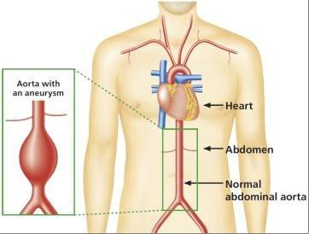

Image courtesy of the NHS England AAA Screening Programme

AAAs are more common in men aged 65 and older. Other factors known to increase the risk of developing an AAA are smoking, high blood pressure and high blood cholesterol. Close relatives of someone who has been diagnosed with an AAA are also more likely to develop one.

Aim of the Northern Ireland AAA Screening Programme

The overall aim of the Northern Ireland AAA Screening Programme is to reduce deaths from ruptured abdominal aortic aneurysms through early detection, monitoring and treatment.

On average, compared to men, women are six times less likely to develop an AAA. In addition, women tend to develop an AAA ten years later than men. The NI AAA Screening Programme is therefore targeted at men in keeping with the recommendations of the UK National Screening Committee.

Programme Objectives

The Public Health Agency and the Belfast Health and Social Care Trust work together to meet the programme’s core objectives. These include:

- Monitoring delivery of the programme against national pathway standards and taking appropriate action where performance is not on target

- Ensuring all necessary failsafe systems are in place at each stage of the screening process

- Ensuring staff are trained on all aspects of the programme, including the Health and Social Care organisations’ mandatory training

- Actively engaging with stakeholders at relevant events and opportunities, particularly in those geographical areas where uptake rates are lower than the programme average

- Continuing to explore opportunities for Personal and Public Involvement (PPI)

- Ensuring information materials remain relevant and up-to-date, with a particular emphasis on promoting self-referral for men aged 65 or over who have never attended for AAA screening

- Ongoing review and development of the Northern Ireland AAA Screening Programme website content, with engagement of stakeholders to support this.

- Continuing to develop and formalise an external quality assurance structure and function in collaboration with the English NHS AAA Screening Programme.

- Continuing to build on existing relations with the other three UK AAA Screening Programmes (England, Scotland and Wales).

- Identifying and addressing health inequalities to ensure all eligible men can make an informed decision about whether or not to attend for screening.

- Identifying and disseminating examples of regional and national best practice with regard to all elements of programme delivery.

- Promoting and participating in research initiatives.

Section 3:
Governance and Accountability
_____________________________________________________________

The Public Health Agency

The Public Health Agency has a number of key functions in relation to screening programmes including:

- Leading on the implementation of screening policy, including the introduction of new screening programmes and any changes required to existing screening programmes.

- Ensuring the delivery of high quality, safe, effective and equitable screening programmes for people in Northern Ireland.

- Supporting continuous quality improvement through programme monitoring and evaluation, and adverse incident investigation and management.

The Agency takes lead responsibility for quality assurance (QA) of the programme. This involves the establishment of a robust QA structure and function, to ensure it meets the responsibilities outlined above.

The Belfast Health and Social Care Trust

The Belfast Health and Social Care Trust is responsible for the operational management and delivery of the NI Abdominal Aortic Aneurysm Screening Programme.

The Trust ensures all eligible men are invited to attend for screening in their 65th year. It ensures they are provided with appropriate information, support and advice, particularly those men who have an AAA detected through the programme.

Staff who have responsibility for the operation of the programme are employed by the Trust and carry out all of the scans, including rescans and surveillance scans.

The surveillance programme for men identified with a small or medium AAA is provided by the Trust as part of the NI AAA Screening Programme. Those men who are identified with a large AAA are referred to the vascular surgery team at the Royal Victoria Hospital within the Belfast Trust to discuss potential treatment options.

The Trust also has responsibility for:

- Setting operational policy for the programme and ensuring appropriate failsafe systems are in place.

- Liaising with GPs regarding secondary care, particularly when a man is detected as having an aneurysm.

- Local quality assurance of the entire screening process.

- Providing reports on the performance of the programme and data for quality assurance purposes.

- Engaging with stakeholders regarding development of the programme.

- Organising and taking part in promotional activities for the programme.

Audit and Research

Both organisations take joint responsibility for developing and facilitating audit and research activities related to the programme as and when these become available.

Section 4:

Programme Delivery and the Screening Pathway
_____________________________________________________________

The programme is run by a multidisciplinary team of staff. All staff play an important role at various stages in the screening pathway.

The programme office is based in the Royal Victoria Hospital within the Belfast Trust.

Ten screening technicians (7.0WTE) run clinics on a daily basis. There are 24 clinic locations across Northern Ireland, including health and wellbeing centres and community hospitals (see Appendix 1).

Eligibility for Screening

All men in Northern Ireland who are registered with a GP are eligible for screening in the year they turn 65 (1 April to 31 March). This includes those men in prison or other secure accommodation. Any man who already has a known AAA can transfer to the care of the screening programme. However, if a man has previously had surgery for an AAA he does not require screening.

Men over the age of 65 and registered with a GP, who have not previously been scanned as part of the programme or been told they have an aneurysm, are also eligible for screening. These men can contact the screening programme office on 02896 151212 to request an appointment.

Details of all men registered with their GP who are eligible to be invited for screening are transferred to the Belfast Trust IT system on an annual basis. Daily updates are then automatically provided with changes to any demographic information.

The Screening Pathway

Appendix 2 provides an overview of the whole screening pathway. The key stages within the pathway are:

- Screening Invitation
- The Scan
- The Result
- Surveillance
- Referral and Treatment

Screening Invitation

The programme office sends all eligible men an invitation letter to attend a local screening clinic. This includes those men registered with a GP during the year in which they turn 65 and those eligible men over the age of 65 who have self-referred to the screening programme.

Invitations for men on surveillance are also sent:
- Men who have a small aneurysm detected will be invited back every twelve months for a surveillance scan.
- Men who have a medium aneurysm detected will be invited back every three months for a surveillance scan.

The Scan

The screening test involves a simple ultrasound scan of the abdomen. It is quick and painless. The screening technician measures the widest part of the abdominal aorta. The whole process usually lasts less than fifteen minutes.

The Result

All men will be informed of their results verbally at the clinic. Both the man and his GP will then be sent a letter confirming the result. If a man is identified as having an aneurysm his GP practice will also be informed by telephone the same day.

There are FIVE possible results from screening:

- NO AAA FOUND: aortic diameter less than 3cm
Over 98% of men will have this result. This means that the aorta is not enlarged (there is no aneurysm). No treatment or monitoring is needed and the men will be discharged from the screening programme. They will not need to be screened again.

- SMALL AAA: aortic diameter measuring between 3cm and 4.4cm
Men who have a small aneurysm detected will be invited back every twelve months for a surveillance scan to monitor the size of the aneurysm. Some small aneurysms will grow in size over time and become medium or large aneurysms.

- MEDIUM AAA: aortic diameter measuring between 4.5cm and 5.4cm
Men who have a medium aneurysm detected will be invited back every three months for a surveillance scan to monitor the size of the aneurysm. Some medium-sized aneurysms will grow over time to become large aneurysms.

- LARGE AAA: aortic diameter measuring 5.5cm or over
Men who have a large aneurysm detected are referred to a vascular surgeon within the Royal Victoria Hospital at the Belfast Health and Social Care Trust for further investigation and to discuss possible treatment options. All men referred are required to be seen at outpatients within two weeks of the initial scan.

- NON-VISUALISATION: sometimes the aorta cannot be fully visualised and a man will be invited to come back on a different day for another scan.

Surveillance

As indicated above, if a man has either a small or medium-sized aneurysm he will be invited back for surveillance appointments on a regular basis to monitor its size.

Men under surveillance are also offered an appointment with a vascular nurse specialist for additional support and advice. The nurse will contact every man who has an AAA detected within two working days and offer either a face to face appointment or a telephone consultation. The nurse will explain the significance of having an AAA and offer lifestyle advice (including advice on smoking cessation) and advice on blood pressure control (if relevant) to help decrease the risk of the aneurysm growing. The man will also be asked to attend his GP to have measurements taken for his height, weight and blood pressure and to discuss the need for any medication.

Referral and Treatment

The Northern Ireland AAA Screening Programme refers all men with a large aneurysm to the vascular service within the Belfast Health and Social Care Trust.

All men referred to the vascular service are required to be seen by a consultant vascular surgeon within two weeks of the scan when the large AAA was detected. During this period, the man will have a CT scan to confirm the size of the aneurysm. This detailed imaging will help decide if the man is suitable for treatment and if so, what the best option is. All men diagnosed with a large AAA are discussed at a weekly vascular multidisciplinary team meeting (MDT) and also undergo vascular pre-assessment by a specialist nurse and vascular anaesthetist. If suitable, the vascular consultant will then discuss treatment options at outpatient review. The two main treatment options are open surgery or endovascular (EVAR) surgery. Open surgery requires a longer hospital stay and initial recovery period. Endovascular treatment, with a stent graft, allows for quicker recovery but has a longer follow-up period with X-ray surveillance. The decision regarding the choice of operation depends on many factors and is discussed in detail by the vascular team. The nominated consultant will then discuss the appropriate options with the man to enable him to make an informed choice. For some men further investigation and optimisation of underlying medical issues may be required prior to treatment of their AAA.

End Point of Screening Programme for Men

As outlined within Public Health England guidance, active inclusion in the screening programme ends when:
- the scan is found to be within normal limits .
- an AAA reaches 5.5cm diameter on ultrasound and the man has been referred to the vascular unit.
- the director of the local screening programme, or the GP, decides referral for treatment should be considered based on other factors (for example, symptoms or co-morbidities) .
- three consecutive scans show an aortic diameter less than 3cm on ultrasound where the initial scan was 3cm or greater.
- the man has had 15 scans at one-year intervals and the AAA remains below 4.5cm .
- the man declines to be in the screening programme, fails to attend consecutive appointments as per local policy, moves out of the area and becomes the responsibility of another screening programme (if one exists) or dies.

Section 5:
Programme Performance
_____________________________________________________________

This section of the report focuses on the performance of the programme. Data included covers the 23/24 cohort, the self-referrals and others offered screening through the programme. All data outlined within this report have been provided by the Belfast Trust programme team and quality assured by the Public Health Agency.

Eligible Cohort

The table below details the number of men who were eligible to be offered AAA screening by the programme for 2023 – 2024.

Table 2: AAA Screening cohort for 2023 - 2024
Category / Men: | 23/24
Eligible screening cohort | 11271

Self-referrals

Men over 65 who have never been screened can self-refer to the programme and request a screening appointment. The figure below shows the number of self-referrals the programme has had since it started.

The number of self-referrals to the programme has reduced significantly from 2016-17. The Programme has been unable to facilitate or participate in as many promotional events compared with previous years which has contributed to the decrease in self-referrals. Self-referrals were also paused from 23rd March 2020 due to the COVID-19 pandemic, the programme started to accept self-referrals again from February 2021. The numbers of men eligible to self-refer will also reduce the longer the programme runs as men are automatically called for screening.

Figure 1: Self-referrals for AAA Screening 2023 to 2024

AAAs Detected and Prevalence

Table 3 below outlines the number of AAAs detected within the 23/24 cohort, including cohort men and self-referrals. It also notes the number of overall referrals for large AAAs to the Vascular Unit within the Belfast Trust and the prevalence rate.

Table 3: AAAs detected by the Screening Programme for the 23/24 cohort
Detected AAAs: | 23/24
AAAs newly detected by the programme within the 23/24 cohort (including self-referrals) | 73 plus 1
Referrals to the Vascular Unit (April 2023 – March 2024) | 43
Prevalence (calculated using the cohort year only) | 0.8%

Figure 2 below outlines the AAA detection rate for the programme, broken down by year. AAA screening should remain cost effective unless the prevalence of AAAs in 65-year-old men falls below 0.35%.

Figure 2: Detection rate of AAAs by screening cohort year

Performance against Key Pathway Standards for 2023 – 2024

The Department of Health and the Northern Ireland Screening Committee (NISC) formally endorsed the revised national standards for the NHS Abdominal Aortic Aneurysm Screening Programme updated in February 2022 as the standards to be adopted by the Northern Ireland Screening Programme. These new standards were to be adopted from 1st April 2023 to support performance monitoring of the programme.

The table below compares the programme’s overall performance against key national pathway standards for 2023 - 2024.

Table 4: Performance against Key Pathway Standards for 2023 – 2024

 | Pathway Standard | Acceptable | Achievable
1 | Completeness of offer – initial screening Percentage of eligible subjects who are offered screening | > 95.0% | > 99.9% | 96.8%
2 | Completeness of offer – annual surveillance Percentage of eligible subjects who are offered screening | > 95.0% | > 99.0% | 97.9%
3 | Completeness of offer – quarterly surveillance Percentage of eligible subjects who are offered screening | > 95.0% | > 99.0% | 98.4%
4 | Coverage – initial screening  Percentage of eligible subjects who are tested | >75.0% | > 85.0% | 77.5%
5 | Coverage – annual surveillance  Percentage of eligible subjects who are tested | > 85% | > 95% | 91.8%
6 | Coverage – quarterly surveillance  Percentage of eligible subjects who are tested | > 90.0% | > 95.0% | 93.1%
7 | Coverage- initial screening  Percentage of eligible subjects who are tested in the most deprived 30% of local areas | > 75.0% | > 85.0% | 70.6%
8 | Uptake - initial screen  Percentage of subjects offered screening who are tested | > 75.0% | > 85.0% | 80.1%
9 | Uptake – annual surveillance  Percentage of subjects offered screening who are tested | > 90.0% | > 95.0% | 93.8%
10 | Uptake – quarterly surveillance  Percentage of subjects offered screening who are tested | > 90.0% | > 95.0% | 94.7%
11 | Non-visualised initial screens  Percentage of initial screens where aorta could not be visualised | < 3.0% | < 1.0% | 1.1%
12 | Time to internal quality assurance  Proportion of abnormal screens (aorta greater than or equal to 3.0 to less than 5.5cm) reviewed less than or equal to 21 calendar days of the initial screen date | < 60.0% | < 95.0% | 94.7%
13 | Time to nurse assessment  Percentage of men who had a small or medium aneurysm detected at initial screen and the number of men who had a medium aneurysm detected at the annual surveillance scan who had a nurse assessment less than or equal to 12 weeks of their conclusive scan | < 50.0% | < 80.0% | 100%
14 | Time to first vascular surgeon assessment  Percentage of men with an aorta greater than or equal to 5.5cm appropriately referred, or an aorta greater than or equal to 4.0cm that has grown 1cm or more in 1 year, seen by vascular surgeon less than or equal to 2 weeks of their last conclusive ultrasound scan | > 90.0% | < 95.0% | 83.3%
15 | Timely treatment/intervention by specialist (measured from date of referral)  Percentage of men with aorta > 5.5cm deemed fit for intervention and not declining, operated on by a vascular specialist within 8 weeks | > 60.0% | > 80.0% | 17.1%

The acceptable threshold is the lowest level of performance which screening services are expected to attain. The achievable threshold represents the level at which the screening service is likely to be running optimally.

Along with the above national pathway standards, the NI programme has adopted an additional standard outlined below in relation to AAAs measuring over 7cm.

Table 5: Timely treatment (men with AAA >7cm deemed fit for intervention and not declining, operated on by a vascular specialist within four weeks)
 | 23/24
Timely treatment (men with AAA >7cm deemed fit for intervention and not declining, operated on by a vascular specialist within four weeks ) | 100%

The standard below was withdrawn as a national standard however it continues to be monitored at national level across vascular services.

Table 6: Timely treatment (men with AAA >7cm deemed fit for intervention and not declining, operated on by a vascular specialist within four weeks)

 | 23/24
30 day mortality (following elective surgery on screen-detected AAAs) | 0%

Section 6:
Health Inequalities
_____________________________________________________________

Population screening programmes need high levels of participation to achieve their desired public health impact. Informed personal choice is central to the screening strategy and the decision to have a screening test or not is for the individual involved. However, people may choose not to make a decision about screening, are not aware of the offer or do not attend their appointment.

Health inequalities are systematic, avoidable and unjust differences in health and wellbeing between different groups of people. The Marmot Review, Fair Society, Healthy Lives (2010) highlighted the social gradient of health inequalities, i.e. the more disadvantaged the person’s social position the worse their health.

Studies on inequalities in AAA screening have found a number of factors:
- the Multi-centre Aneurysm Screening Study (MASS) found that higher age and social deprivation are associated with poorer screening attendance and having an AAA
- a Scottish analysis found that both urban residence and social deprivation were associated with lower uptake among men invited for AAA screening

In April 2020 the English AAA Screening programme introduced a new screening standard –

AAA-S07: coverage: initial screen in the most deprived 30% of local areas is the proportion of men in the eligible cohort who were tested and who lived in a lower super output area (LSOA) classed as decile 1 to 3 in the English indices of deprivation 2019.

Men living in more deprived areas are less likely to attend for screening but are more likely to have an aneurysm. It is therefore important for the AAA screening programme to engage with men living in more deprived areas to make sure they can make a personal informed choice.

This standard only focuses on one aspect of inequalities in access to AAA screening. It is acknowledged that there are many sources of inequalities which need to be identified and reduce drivers of inequalities relevant to the local area.

The performance thresholds for this standard are -
Acceptable level: greater than or equal to 75.0%

Achievable level: greater than or equal to 85.0%

The following table and chart shows the coverage for initial AAA Screening appointments in Northern Ireland (NI) broken down by areas of deprivation for the 23/24 cohort.

Table 7: % men in Northern Ireland who attended for Abdominal Aortic Aneurysm screening by deprivation decile 1 – 3 for 19/20, 20/21, 21/22 and 22/23

 | No. eligible  NIMDM 2017 Decile 1-3 (SOA) | No. screened  NIMDM 2017 Decile 1-3 (SOA) | % screened (coverage)  NIMDM 2017 Decile 1-3 (SOA) | Total cohort  No. eligible | Total cohort  No. screened | % screened (coverage)
23/24 | 3468 | 2450 | 70.6% | 11271 | 8736 | 77.5%

Source: AAA Screening Programme, Public Health Agency and Belfast Health and Social Care Trust
Data refers to men screened by their cohort year
Northern Ireland Statistics and Research Agency, NI Multiple Deprivation Measure 2017 (Super Output Area (SOA) level)
https://www.nisra.gov.uk/statistics/deprivation/northern-ireland-multiple-deprivation-measure-2017-nimdm2017

Figure 3: % Coverage by NI Multiple Deprivation Measure 2017 quintile (SOA) 1-3 and total coverage for 19/20, 20/21, 21/22, 22/23 and 23/24

Trust uptake

Similar to previous years the highest uptake is in the South Eastern Health and Social Care Trust and the lowest uptake is in the Belfast Health and Social Care Trust.

Table 8: Trust uptake for 2023-2024

Health and Social Care Trust | No invited for screening 23/24 | No screened 23/24 | Uptake by Trust %
Belfast | 2,224 | 1,729 | 77.7%
Northern | 2,830 | 2,271 | 80.2%
South Eastern | 2,029 | 1,666 | 82.1%
Southern | 2,087 | 1,647 | 78.9%
Western | 1,736 | 1,422 | 81.9%
Northern Ireland | 10,906* | 8,735* | 80.1%
* One record was postcode unknown.

Section 7:
Personal and Public Involvement (PPI)
_____________________________________________________________
Personal and Public Involvement (PPI) enables the public to influence the planning, commissioning and delivery of health and social care (HSC) services. It includes actively engaging with communities, specifically those who use services such as screening. The Public Health Agency is the lead organisation responsible for the implementation of PPI policy across all HSC organisations within Northern Ireland.

During 2023-2024, the Northern Ireland AAA Screening Programme completed the PPI projects outlined below.

- The AAA Screening Programme’s ninth annual service user event was held in Belfast on Friday 1st December 2023 and brought together a wide range of health care professionals and men who have, or had, an AAA detected through screening. The event was facilitated by PHA and Belfast HSC Trust staff and included presentations about programme updates, prehabilitation and vascular surgery, promotion of the programme, arm chair exercises, cookery demonstrations and a group discussion exercise. Over 60 service users and staff attended the event and feedback was very positive.

- The screening programme worked with Care Opinion to produce a leaflet specific for the AAA Screening programme to hand out at screening appointments. Care Opinion is a place where service users can share their experience of health or care services, and help make them better for everyone. Staff started to hand out the care opinion leaflet in March 2023 and 101 stories were received up until 31st March 2024. Feedback is anonymous and the service user is asked to share what was good and what could have been better.

The majority of feedback from the 101 stories was very positive with some minor issues that the programme will be looking to improve going forward.

Infographic 1: Word cloud for what was good?



Infographic 2: Word cloud for what could have been better?



Section 8:
Role of Primary Care
_____________________________________________________________

Primary Care teams are integral to the successful delivery of the NI AAA Screening Programme. Since the programme began in 2012, the considerable contribution and partnership working with primary care teams has been invaluable, particularly in the areas outlined below.

Supporting men with a screen-detected AAA

When an aneurysm is detected, the programme informs the man’s GP practice by telephone on the same day. This is followed up in writing.

GPs are then asked to arrange to take measurements for height, weight, BMI and blood pressure, and consider commencing the man on anti-platelet and statin therapy (unless contra-indicated).

For men with a large AAA, GPs are also asked to make a standard referral to the vascular team for further intervention / treatment and to arrange an urgent blood test (U&E).

GPs are the key providers of aftercare for men who have undergone surgical repair.

Providing information to facilitate screening appointments for eligible men

The programme continually liaises with primary care on a range of issues such as:

- Ensuring patient records are accurate – information is downloaded into the programme’s IT system on eligible men registered with GPs; programme staff liaise with practices about any discrepancies.

- Seeking information about particular needs of men invited for screening, e.g. a physical or sensory disability, limited mobility or a learning disability – this helps facilitate the screening appointment and allows appropriate arrangements to be made e.g. extra time for the appointment if required.

- Organising an appropriate interpreter or signer when required to facilitate an appointment.

Promoting screening

People often rely on the advice of primary care teams when making health decisions. It is therefore important that these teams are well informed about the programme and can discuss the benefits and risks of AAA screening to enable eligible men to make an informed choice.

GPs are notified when a man does not attend his screening appointment. Some GP practices, upon being informed of non-attendance, will either talk to men opportunistically about screening or proactively contact men to specifically encourage attendance.

Section 9:
Programme Promotion
_____________________________________________________________

During 2023-24, representatives from the programme attended a number of health fayres to promote the programme.

- COLIN Neighbourhood Partnership Men’s Health Day - Brook Leisure Centre - 14/06/23.

- Annual Community Health Information Morning - Glen Community Centre – 08/08/23.

- European Vascular Society Conference Public Engagement Event 26/09/2023.

- Volunteers Now Men’s 55+ Health Day - Girdwood Community Hub – 13/10/23.

- NIAS Association of Retired Personnel (NIASARP) AGM - Tullyglass Hotel Ballymena – 21/02/24.

Appendices
_____________________________________________________________

1 | Map of Screening Locations
2 | The Screening Pathway

Appendix 1 – Map of Screening Locations

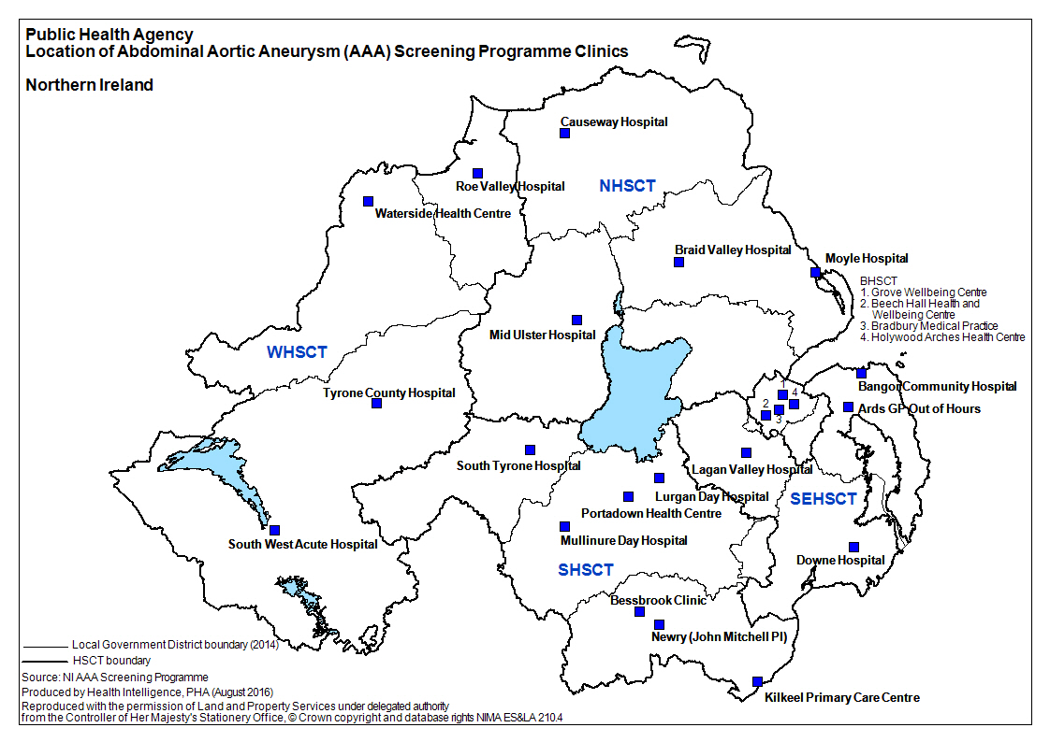

Appendix 2 – The Screening Pathway
_____________________________________________________________

Invite for screening
Abdominal ultrasound scan
No aneurysm
(approx. 98.5%)
Large Aneurysm ≥ 5.5cm
(approx.0.1%)
referred
surveillance
discharged
Identify screening cohort
Vascular
surgery
Small / Medium
Aneurysm
3cm – 5.4cm
(approx. 1.4%)

Abdominal aortic aneurysm: the UK NSC policy on abdominal aortic aneurysm screening in men over 65. UK Screening Portal. Available at: https://view-health-screening-recommendations.service.gov.uk/abdominal-aortic-aneurysm/
https://www.gov.uk/government/publications/aaa-screening-standard-operating-procedures
Impact of the first 5 years of a national abdominal aortic aneurysm screening programme Jacomelli J, Summers L, Stevenson A, Lees T, Earnshaw JJ Br J Surg. 2016 Aug
https://www.gov.uk/government/publications/aaa-screening-quality-standards-and-service-objectives/abdominal-aortic-aneurysm-screening-programme-standards-valid-for-data-collected-from-1-april-2022
https://www.gov.uk/government/publications/population-screening-our-approach-to-screening-standards/our-approach-to-nhs-population-screening-standards#performance-thresholds
https://journals.sagepub.com/doi/10.1177/096914130301100112
https://onlinelibrary.wiley.com/doi/pdf/10.1002/bjs.9803

