Northern Ireland
Abdominal Aortic Aneurysm (AAA)
Screening Programme

Annual Report 2018-19

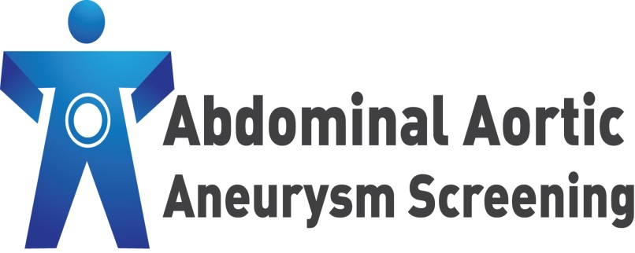




About this publication

Document title: | NI AAA Screening Programme Annual Report 2018-19
Version: | Final Version 15/07/2022
Authors: | Jacqueline McDevitt (PHA), Gemma Reid (PHA), Claire Black (BHSCT), Leanne McClay (BHSCT), Joanne Murphy (Health Intelligence, PHA).
Owners: | NI AAA Screening Programme
Final approved release date: | 5th December 2022

Distribution to:

- Co-Director of Surgery and Specialist Services - Belfast Health and Social Care Trust

- NI AAA Screening Programme Team - Belfast Health and Social Care Trust

- Assistant Director of Screening and Professional Standards - Public Health Agency

- NI AAA Screening Programme Team - Public Health Agency

- NI AAA Screening Programme Co-ordinating Group

The final version of the report will be circulated to the above distribution list.

Contents Page

1 | Summary and Highlights for 2018-19 | 4
2 | Introduction | 6
3 | Background and Programme Objectives | 7
4 | Programme Delivery and the Screening Pathway | 10
5 | Programme Performance | 14
6 | Health Inequalities | 21
7 | AAA Screening Programme Across the UK | 24
8 | Personal and Public Involvement (PPI) | 27
9 | Role of Primary Care | 29
10 | Programme Promotion | 31
11 | Governance and Accountability | 32
12 | Future Developments | 34
 | Appendices
1 | Map of Screening Locations | 37
2 | The Screening Pathway | 38
3 | Governance and Accountability Structure: Public Health Agency | 39
4 | Governance and Accountability Structure: Belfast Health and Social Care Trust | 40

Section 1:
Summary and Highlights for 2018-19
_____________________________________________________________

This is the seventh annual report for the Northern Ireland Abdominal Aortic Aneurysm (AAA) Screening Programme since it was introduced in June 2012. It has been produced jointly by the Belfast Health and Social Care Trust and the Public Health Agency.

The Belfast Health and Social Care Trust is responsible for the management and delivery of the programme, whilst the Public Health Agency (PHA) is responsible for commissioning and quality assuring it. The two organisations work closely together to provide an effective, safe and accessible service.

All men registered with a GP in Northern Ireland are invited for screening in the year they turn 65. Men over the age of 65, who have never been screened before, can self-refer by contacting the screening programme office on 02896 151212.

Throughout 2018-19 the programme continued to work on developing existing services. The 2017-18 annual report set out a number of core objectives (page 8) for the programme. These objectives have either been met in full or are on target, as evidenced throughout this report.

Overall performance of the programme remained high (please refer to Section 5 for more detail). Of note:

- Over 9,700 men in their 65th year were invited to attend for screening

- Uptake remained high with 85% of those invited attending for screening

- 211 men over 65 who had never been screened before self-referred to the programme and were screened

- 95 men screened had a newly detected AAA

- 31 men had a large aneurysm and were referred to the vascular team to consider treatment options

The 2017-18 annual report also set out a number of future developments for the programme to focus on in 2018-19. Progress on this work is outlined on the following page.

- On 29th March 2019, in collaboration with PHA quality assurance staff, English NHS AAA Screening Programme colleagues undertook an External Quality Assurance Visit to the Northern Ireland AAA Screening Programme.

- Over the summer and autumn of 2018, the programme recruited and appointed two new Patient Representatives to its main management group (the Co-ordinating Group) to ensure continuity of service user involvement and build on existing successful engagement initiatives.

- The sixth annual service user event took place on 26th April 2018.

- British and Irish sign language were added to the new NI AAA Screening Programme video and DVDs ordered to facilitate programme promotion during 2018-19.

- Migration of content from the dedicated AAA Screening Programme website (www.aaascreening.info) to NI Direct, the official government site for Northern Ireland citizens, was successfully completed and the dedicated NIAAASP site stood down.

- The NIAAASP produced a case study on mechanisms they had used to successfully engage with men with a known learning disability, to facilitate production of an Easy Read information leaflet for AAA screening. Content from this case study was included as part of a GOV.UK Blog on initiatives progressed by English AAA Screening Programmes to help tackle health inequalities.

- The programme continued to work in partnership with appropriate prison healthcare providers to facilitate screening clinics for eligible men.

- The programme continued to consider further opportunities to raise general awareness of the programme and encourage further self-referrals, eg through promotional opportunities and continued engagement with Men’s Sheds, etc

- The programme continued to engage with GPs and other primary care teams to raise awareness of the programme and continue to promote the self-referral pathway.

- As appropriate, the programme continued to identify additional venues to enable AAA screening to be provided within local areas

Section 2:
Introduction
_________________________________________________________________
2018-19 has been another year of notable achievements for AAA screening in Northern Ireland.

The programme’s sixth annual Service User Event on Thursday 26th April 2018 was very well attended with over 70 participants. More than 50 of these participants were service users. As per requests from service users at last year’s event, the size of a man’s screen-detected AAA is now contained in his results letter. Participants at these yearly events also continue to enjoy meeting and sharing their experiences of AAA screening with both new service users and those they have met in former years. Overall, the programme continues to benefit hugely from innovative suggestions for future improvement which are generated during group discussions. An update on the initiatives taken forward will be fed back to attendees at the next event planned for June 2019.

The NIAAASP produced a case study on mechanisms they had used to successfully engage with men with a known learning disability, to facilitate production of an Easy Read information leaflet for AAA screening. Content from this case study was included as part of a GOV.UK Blog on initiatives progressed by English AAA Screening Programmes to help tackle health inequalities

Finally, 2018 saw the recruitment and appointment of two new Patient Representatives to the programme’s main management group (the Co-ordinating Group) to ensure continuity of service user involvement and build on existing successful engagement initiatives.

As Clinical Lead for the NI AAA Screening Programme, I am pleased to outline some of the work which has taken place during 2018-19. The continued success of the programme is due to ongoing help and support from many different sources, some of which I have outlined below.

The programme aims to reduce mortality from AAA in men by earlier diagnosis and timely intervention .The programme requires men in their 65th year to accept an invitation for an ultrasound scan and it is gratifying that 85% of men during the year did so.

We are grateful for the large number of screening locations made available to the programme enabling our hard working screening teams to travel the province to undertake initial and surveillance scans .The work of our small admin team ensures the programme runs smoothly and individual queries can be dealt with quickly. Men diagnosed with a large AAA requiring intervention can be reassured that they will receive careful assessment and treatment in the Regional Vascular Unit in the Belfast Trust. The unit currently performs the largest volume of infra-renal AAA repairs in the UK with excellent outcomes published annually in the National Vascular Registry and available on the HQIP website (https://www.hqip.org.uk/).

We continue to meet twice a year with our colleagues representing national AAA screening programmes in England, Wales and Scotland and some of our senior team members undertake external QA visits to programmes in the UK. This Four Nation cooperation has undoubtedly helped ensure the high standards and continued success of our local screening programme in Northern Ireland.





Mr Andrew McKinley
Consultant Vascular Surgeon / Clinical Lead
NI AAA Screening Programme

Dr Christine McKee Consultant Lead
NI AAA Screening Programme

Section 3:
Background and Programme Objectives
_____________________________________________________________

What is an AAA?

The aorta is the main vessel that circulates blood from the heart, through the abdomen to the rest of the body. Over time, the walls of the aorta can weaken, causing it to balloon out. This results in an abdominal aortic aneurysm (AAA).

AAAs usually cause no symptoms, therefore most people who have one will not feel anything. As the aneurysm grows so too does the risk of it rupturing if left untreated. Rapidly expanding or ruptured aneurysms do produce symptoms (typically severe abdominal, back or flank pain, low blood pressure or shock and a mass in the abdomen which pulsates; however only a minority of patients have all of these features). Patients with a ruptured AAA have a very low chance of survival. In contrast, those detected who undergo planned surgery for a non-ruptured AAA have an excellent rate of survival.

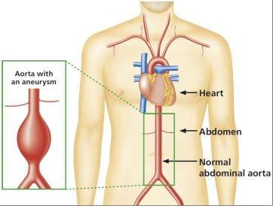

Image courtesy of the NHS England AAA Screening Programme

AAAs are more common in men aged 65 and older. Other factors known to increase the risk of developing an AAA are smoking, high blood pressure and high blood cholesterol. Close relatives of someone who has been diagnosed with an AAA are also more likely to develop one.

Aim of the Northern Ireland AAA Screening Programme

The overall aim of the Northern Ireland AAA Screening Programme is to reduce deaths from ruptured abdominal aortic aneurysms through early detection, monitoring and treatment.

On average, compared to men, women are six times less likely to develop an AAA. In addition, women tend to develop an AAA ten years later than men. The NI AAA Screening Programme is therefore targeted at men in keeping with the recommendations of the UK National Screening Committee.

Programme Objectives

The Public Health Agency and the Belfast Health and Social Care Trust work together to meet the programme’s core objectives. These include:

- Monitoring delivery of the programme against national pathway standards and taking appropriate action where performance is not on target

- Ensuring all necessary failsafe systems are in place at each stage of the screening process

- Ensuring staff are trained on all aspects of the programme, including the Health and Social Care organisations’ mandatory training

- Actively engaging with stakeholders at relevant events and opportunities, particularly in those geographical areas where uptake rates are lower than the programme average

- Continuing to explore opportunities for Personal and Public Involvement (PPI)

- Ensuring information materials remain relevant and up-to-date, with a particular emphasis on promoting self-referral for men aged 65 or over who have never attended for AAA screening

- Ongoing review and development of the Northern Ireland AAA Screening Programme website content, with engagement of stakeholders to support this.

- Continuing to develop and formalise an external quality assurance structure and function in collaboration with the English NHS AAA Screening Programme

- Continuing to build on existing relations with the other three UK AAA Screening Programmes (England, Scotland and Wales)

- Identifying and addressing health inequalities to ensure all eligible men can make an informed decision about whether or not to attend for screening

- Identifying and disseminating examples of regional and national best practice with regard to all elements of programme delivery

- Promoting and participating in research initiatives

Section 4:

Programme Delivery and the Screening Pathway
_____________________________________________________________

The programme is run by a multidisciplinary team of staff. All staff play an important role at various stages in the screening pathway.

The programme office is based in the Royal Victoria Hospital within the Belfast Trust.

Ten screening technicians (7.0WTE) run clinics on a daily basis. During 2018-19 there were 24 clinic locations across Northern Ireland, including health and wellbeing centres and community hospitals (see Appendix 1).

Eligibility for Screening

All men in Northern Ireland who are registered with a GP are eligible for screening in the year they turn 65 (1 April to 31 March). This includes those men in prison or other secure accommodation. Any man who already has a known AAA can transfer to the care of the screening programme. However, if a man has previously had surgery for an AAA he does not require screening.

Men over the age of 65 and registered with a GP, who have not previously been scanned as part of the programme or been told they have an aneurysm, are also eligible for screening. These men can contact the screening programme office on 02896 151212 to request an appointment.

Details of all men registered with their GP who are eligible to be invited for screening are transferred to the Belfast Trust IT system on an annual basis. Daily updates are then automatically provided with changes to any demographic information.

The Screening Pathway

Appendix 2 provides an overview of the whole screening pathway. The key stages within the pathway are:

- Screening Invitation
- The Scan
- The Result
- Surveillance
- Referral and Treatment

Screening Invitation

The programme office sends all eligible men an invitation letter to attend a local screening clinic. This includes those men registered with a GP during the year in which they turn 65 and those eligible men over the age of 65 who have self-referred to the screening programme.

Invitations for men on surveillance are also sent:
- Men who have a small aneurysm detected will be invited back every twelve months for a surveillance scan.
- Men who have a medium aneurysm detected will be invited back every three months for a surveillance scan.

The Scan

The screening test involves a simple ultrasound scan of the abdomen. It is quick and painless. The screening technician measures the widest part of the abdominal aorta. The whole process usually lasts less than fifteen minutes.

The Result

All men will be informed of their results verbally at the clinic. Both the man and his GP will then be sent a letter confirming the result. If a man is identified as having an aneurysm his GP practice will also be informed by telephone the same day.

There are FIVE possible results from screening:

- NO AAA FOUND: aortic diameter less than 3cm
Over 98% of men will have this result. This means that the aorta is not enlarged (there is no aneurysm). No treatment or monitoring is needed and the men will be discharged from the screening programme. They will not need to be screened again.

- SMALL AAA: aortic diameter measuring between 3cm and 4.4cm
Men who have a small aneurysm detected will be invited back every twelve months for a surveillance scan to monitor the size of the aneurysm. Some small aneurysms will grow in size over time and become medium or large aneurysms.

- MEDIUM AAA: aortic diameter measuring between 4.5cm and 5.4cm
Men who have a medium aneurysm detected will be invited back every three months for a surveillance scan to monitor the size of the aneurysm. Some medium-sized aneurysms will grow over time to become large aneurysms.

- LARGE AAA: aortic diameter measuring 5.5cm or over
Men who have a large aneurysm detected are referred to a vascular surgeon within the Royal Victoria Hospital at the Belfast Health and Social Care Trust for further investigation and to discuss possible treatment options. All men referred are required to be seen at outpatients within two weeks of the initial scan.

- NON-VISUALISATION: sometimes the aorta cannot be fully visualised and a man will be invited to come back on a different day for another scan.

Surveillance

As indicated above, if a man has either a small or medium-sized aneurysm he will be invited back for surveillance appointments on a regular basis to monitor its size.

Men under surveillance are also offered an appointment with a vascular nurse specialist for additional support and advice. The nurse will contact every man who has an AAA detected within two working days and offer either a face to face appointment or a telephone consultation. The nurse will explain the significance of having an AAA and offer lifestyle advice (including advice on smoking cessation) and advice on blood pressure control (if relevant) to help decrease the risk of the aneurysm growing. The man will also be asked to attend his GP to have measurements taken for his height, weight and blood pressure and to discuss the need for any medication.

Referral and Treatment

The Northern Ireland AAA Screening Programme refers all men with a large aneurysm to the vascular service within the Belfast Health and Social Care Trust. Vascular units are required to meet national standards set by the Vascular Society of Great Britain and Ireland (VSGBI).

All men referred to the vascular service are required to be seen by a consultant vascular surgeon within two weeks of the scan when the large AAA was detected. During this period, the man will have a CT scan to confirm the size of the aneurysm. This detailed imaging will help decide if the man is suitable for treatment and if so, what the best option is. All men diagnosed with a large AAA are discussed at a weekly vascular multidisciplinary team meeting (MDT) and also undergo vascular pre-assessment by a specialist nurse and vascular anaesthetist. If suitable, the vascular consultant will then discuss treatment options at outpatient review. The two main treatment options are open surgery or endovascular (EVAR) surgery. Open surgery requires a longer hospital stay and initial recovery period. Endovascular treatment, with a stent graft, allows for quicker recovery but has a longer follow-up period with X-ray surveillance. The decision regarding the choice of operation depends on many factors and is discussed in detail by the vascular team. The nominated consultant will then discuss the appropriate options with the man to enable him to make an informed choice. For some men further investigation and optimisation of underlying medical issues may be required prior to treatment of their AAA.

End Point of Screening Programme for Men

As outlined within Public Health England guidance, active inclusion in the screening programme ends when:
- the scan is found to be within normal limits
- an AAA reaches 5.5cm diameter on ultrasound and the man has been referred to the vascular unit
- the director of the local screening programme, or the GP, decides referral for treatment should be considered based on other factors (for example, symptoms or co-morbidities)
- three consecutive scans show an aortic diameter less than 3cm on ultrasound where the initial scan was 3cm or greater
- the man has had 15 scans at one-year intervals and the AAA remains below 4.5cm
- the man declines to be in the screening programme, fails to attend consecutive appointments as per local policy, moves out of the area and becomes the responsibility of another screening programme (if one exists) or dies

Section 5:
Programme Performance
_____________________________________________________________

The current population of Northern Ireland is just over 1.88 million. Within this, the number of men aged 65 and over in 2018 was 139,433 of which 9,164 were men aged 65.

During its seventh year, the Northern Ireland AAA Screening Programme invited all men who turned 65 between 1 April 2018 and 31 March 2019 for screening.

This section of the report focuses on the performance of the programme. Data included covers the 2018-19 cohort, the self-referrals and others offered screening through the programme as at end of March 2019. All data outlined within this report have been provided by the Belfast Trust programme team and quality assured by the Public Health Agency.

Eligible Cohort

The table below details the number of men who were eligible to be offered AAA screening by the programme from the 2018-19 cohort.

Table 1: 2018-19 AAA Screening cohort
Category / Men: | Number:
Identified Screening cohort for 2018-19  (all men who had their 65th birthday during the year 1 April 2018 – 31 March 2019) | 9,988
Cohort not eligible for screening  (these men were not eligible for screening as they either (a) died before being offered an appointment; (b) were no longer registered with a GP; (c) had previously had surgery for an AAA; or (d) had previous imaging to confirm they did not have an AAA) | 257
Eligible screening cohort 2018-19 | 9,731

Self-referrals

Men over 65 who have never been screened can self-refer to the programme and request a screening appointment. During 2018-19, 211 men self-referred. The figure below shows the number of self-referrals the programme has had since it started.

The number of self-referrals to the programme has reduced significantly from 2017-18. The Programme was unable to facilitate or participate in as many promotional events compared with previous years which has contributed to the decrease in self-referrals; this was due to reduced staffing levels in the programme. The numbers of men eligible to self-refer will also reduce the longer the programme runs as men are automatically called for screening.

Figure 1: Self-referrals for AAA Screening 2012-13 to 2018-19

Screening and Uptake

All men who turned 65 between 1 April 2018 and 31 March 2019, and who were registered with a GP in Northern Ireland, were sent at least one screening appointment by the end of March 2019 All men who did not attend their first appointment were offered a further appointment by the end of June 2019. Table 2 below shows the number of men actually screened during the year.

Table 2: Number of men screened in 2018-19 and uptake rate
 |  |  | TOTAL
2018-19 eligible men and self-referrals aged 65 and over | 2018-19 cohort | 9,731 | 9,942
2018-19 eligible men and self-referrals aged 65 and over | Self-referrals | 211 | 9,942
Those screened:
Total men 65 and over screened for the first time | 2018-19 cohort | 8,278 | 8,489
Total men 65 and over screened for the first time | Self-referrals | 211 | 8,489
Uptake of initial screening (calculated using 2018-19 cohort only) |  |  | 85%

Uptake for 2018-19 was 85%; Figure 2 below shows the uptake rates by screening year.

Figure 2: Uptake of AAA Screening for initial appointment by year

The following table outlines the number of men screened by Trust areas across Northern Ireland. Please note that for this purpose a Trust is allocated based on the postcode of a man’s GP rather than the man’s postcode.

Table 3: Uptake rates for AAA Screening by Trust for 2018-19
TRUST | Eligible Men Invited | Number Screened | Uptake
Belfast | 2504 | 2013 | 80.4%
Northern | 1794 | 1513 | 84. 3%
South Eastern | 1680 | 1480 | 88.1%
Southern | 2197 | 1838 | 84. 7%
Western | 1687 | 1428 | 84.6%
TOTAL | 9862 | 8272 | 83.8%

AAAs Detected and Prevalence

Table 4 below outlines the number of AAAs detected during the 2018-19 screening year, including cohort men and self-referrals. It also notes the number of overall referrals for large AAAs to the Vascular Unit within the Belfast Trust and the prevalence rate.

Table 4: AAAs detected by the Screening Programme 2018-19
Detected AAAs:
AAAs newly detected by the programme (a moderate number of these newly detected AAAs are made up of self-referrals) | 107
Referrals to the Vascular Unit | 31
Prevalence (calculated using 2018-19 cohort only) | 1.2%

Figure 3 below outlines the AAA detection rate for the programme, broken down by year. The prevalence of AAA (aortas measuring 3.0cm in diameter or wider) was 1.2% compared to 4.7% reported in the 20-year-old randomized trial, probably reflecting the reduction in smoking rates and the increase in use of statins during that time. AAA screening should remain cost effective unless the prevalence of AAAs in 65-year-old men falls below 0.35%.

Figure 3: Detection rate of AAAs by screening cohort year

Surgery by Type

The vascular team within the Belfast Trust performed surgery on 23 men referred by the programme during 2018-19. Of these, 83% had an elective open repair of their abdominal aortic aneurysm, compared to 17 % having endovascular surgery.
Performance against Key Pathway Standards for 2018-19

The table below compares the programme’s overall performance against key national pathway standards for 2018-19.

Table 5: Performance against Key Pathway Standards for 2018-19
 | Programme Performance | Pathway Standard -Acceptable | Pathway Standard -Achievable
Uptake for initial screening | 85% | > 75% | > 85%
Uptake for surveillance | 97% | > 90% | > 95%
Definitive outcome of scan (screening encounters where aorta could not be visualised) | 1.3% | <3% | <1%
Timely referral (men with AAA > 5.5cm referred within one working day) | 100% | > 95% | 100%
Timely intervention (men with aorta > 5.5cm seen by a vascular specialist within two weeks) | 80% | > 90% | > 95%
Timely treatment (men with AAA > 5.5cm deemed fit for intervention and not declining, operated on by a vascular specialist within eight weeks) | 10% | > 60% | > 80%

The acceptable threshold is the lowest level of performance which screening services are expected to attain. The achievable threshold represents the level at which the screening service is likely to be running optimally.

Along with the above national pathway standards, the NI programme has adopted an additional standard outlined below in relation to AAAs measuring over 7cm.

 | Programme Performance | Pathway standard
Timely treatment (men with AAA >7cm deemed fit for intervention and not declining, operated on by a vascular specialist within four weeks ) | n/a | 100%
There were no men recorded with an AAA >7cm deemed fit for intervention and not declining in the 2018/2019 cohort.

The standard below was withdrawn as a national standard however it continues to be monitored at national level across vascular services.

 | Programme Performance | Pathway standard | Pathway Standard -Achievable
30 day mortality (following elective surgery on screen-detected AAAs) | 0% | n/a | n/a

There were no men recorded to have had a 30 day mortality following elective surgery on screen-detected AAAs in the 2018/2019 cohort.
Section 6:
Health Inequalities
_____________________________________________________________

Population screening programmes need high levels of participation to achieve their desired public health impact. Informed personal choice is central to the screening strategy and the decision to have a screening test or not is for the individual involved. However, people may choose not to make a decision about screening, are not aware of the offer or do not attend their appointment.

Health inequalities are systematic, avoidable and unjust differences in health and wellbeing between different groups of people. The Marmot Review, Fair Society, Healthy Lives (2010) highlighted the social gradient of health inequalities, i.e. the more disadvantaged the person’s social position the worse their health.

Studies on inequalities in AAA screening have found a number of factors:
- the Multi-centre Aneurysm Screening Study (MASS) found that higher age and social deprivation are associated with poorer screening attendance and having an AAA
- a Scottish analysis found that both urban residence and social deprivation were associated with lower uptake among men invited for AAA screening

The following table and chart show the uptake rates for initial AAA Screening appointments in Northern Ireland (NI) broken down by areas of deprivation for the 2018-19 screening year.

Table 6: % men in Northern Ireland who attended for Abdominal Aortic Aneurysm screening by deprivation quintile, 2018/19

NIMDM 2017 Quintile (SOA) | No. eligible | No. screened | % screened (uptake)
1 (most deprived) | 1,654 | 1,273 | 77.0%
2 | 1,931 | 1,603 | 83.0%
3 | 1,963 | 1,685 | 85.8%
4 | 1,951 | 1,685 | 86.4%
5 (least deprived) | 1,992 | 1,790 | 89.9%
Unknown | 14 | 13 | 92.9%
Northern Ireland | 9,505 | 8,049 | 84.7%

Source: AAA Screening Programme, Public Health Agency and Belfast Health and Social Care Trust
Data refers to men invited in the year they turn 65 years of age
National Pathway Standards: Acceptable uptake: >75%, Achievable uptake: >85%
Northern Ireland Statistics and Research Agency, NI Multiple Deprivation Measure 2017 (Super Output Area (SOA) level)
https://www.nisra.gov.uk/statistics/deprivation/northern-ireland-multiple-deprivation-measure-2017-nimdm2017

Figure 4: % uptake by NI Multiple Deprivation Measure 2017 quintile (SOA), Northern Ireland, showing National Pathway Standards, 2016/17 - 2018/19

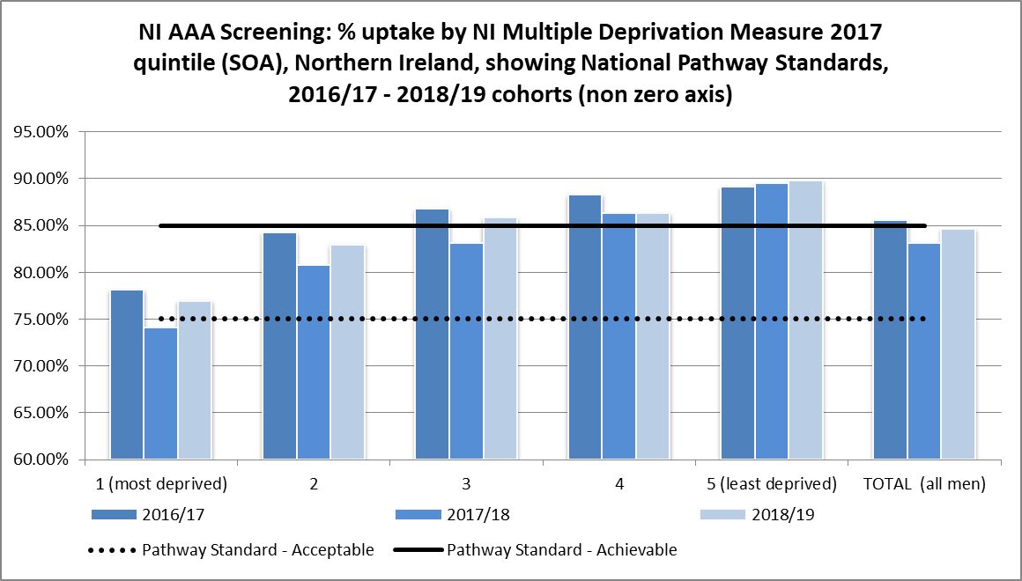

Source: AAA Screening Programme, Public Health Agency and Belfast Health and Social Care Trust
Data refers to men invited in the year they turn 65 years of age
National Pathway Standards: Acceptable uptake: >75%, Achievable uptake: >85%
Northern Ireland Statistics and Research Agency, NI Multiple Deprivation Measure 2017 (Super Output Area (SOA) level)
https://www.nisra.gov.uk/statistics/deprivation/northern-ireland-multiple-deprivation-measure-2017-nimdm2017

Screening uptake varies considerably by deprivation quintiles. In 2018/19, uptake in areas of Northern Ireland considered most deprived was 77%, rising to almost 90% in least deprived areas (NI = 84.7%). However, compared to the previous year (2017/18), the percentage uptake in more deprived areas of Northern Ireland has increased from 74% to 77%, with those areas considered least deprived, increasing slightly from 89.5% to 89.9%.

Section 7:

AAA Screening Programmes across the UK
_____________________________________________________________

Each of the four countries of the UK commenced an Abdominal Aortic Aneurysm (AAA) Screening Programme as follows:
- Northern Ireland: implemented in June 2012 on a phased basis with full roll-out during 2013
- England: implemented between 2009 and 2013
- Scotland: implemented in June 2012 on a phased basis with full roll-out in November 2013
- Wales: implemented on 1 May 2013

Table 7: % uptake, by United Kingdom country, 2013/14 - 2018/19

Year | % screened (uptake)
Year | Northern Ireland | England | Scotland | Wales
2013/14 | 82.7% | 78.2% | - | 74.1%
2014/15 | 83.1% | 79.5% | 84.3% | 74.4%
2015/16 | 83.8% | 80.0% | 84.0% | 79.1%
2016/17 | 84.1% | 81.1% | 84.4% | 80.8%
2017/18 | 83.3% | 80.9% | 84.5% | 79.2%
2018/19 | 85.0% | 81.4% | 84.4% | 80.8%

Figure 5: Abdominal aortic aneurysm uptake rates, by United Kingdom country, 2013/14 - 2018/19

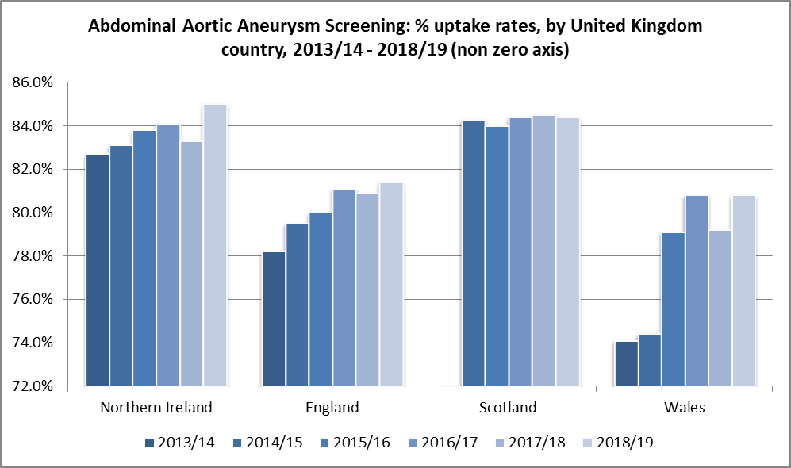
Source:
Northern Ireland: Northern Ireland AAA Screening Programme, Public Health Agency
http://www.publichealth.hscni.net/directorate-public-health/service-development-and-screening/abdominal-aortic-aneurysm-aaa-screening
NI Abdominal Aortic Aneurysm Screening: http://www.aaascreening.info
England: NHS England https://www.gov.uk/government/collections/nhs-population-screening-programmes-kpi-reports
NHS Screening Programme - KPI Reports (Indicator "AA2") - data available for this indicator from 2016/17 only
AA2: AAA – coverage of initial screen. The proportion of men eligible for abdominal aortic aneurysm screening who are conclusively tested
Scotland: Data and Intelligence, Public Health Scotland. Data not available for 2013/14
https://beta.isdscotland.org/topics/abdominal-aortic-aneurysm-aaa-screening/
Wales: Wales Abdominal Aortic Aneurysm Screening Programme
https://phw.nhs.wales/services-and-teams/screening/abdominal-aortic-aneurysm-screening/
Figures for Wales for 2013/14 refer to the time period May 2013 to March 2014
Definition of uptake changed in 2015/16 to allow comparison with other UK countries i.e. those invited in 2015/16 receiving a scan by 30 June 2016. Previously uptake was calculated based on those men who attended within four months of their invite for screening.

Uptake is defined as the number of men who responded to an invitation sent between April and March of the stated year and who had attended for screening by 30 June of the following year (e.g. men invited during 2018/19 were able to attend up until 30 June 2019), as a proportion of all men eligible for screening in that year.

Notes
- All men in Northern Ireland, who are registered with a GP, are invited for screening in the year they turn 65 years of age. However, men over the age of 65 years, who have never been screened before, can attend for screening by self-referral. Data shown excludes any self-referrals.
- 2018/19 data was run from the live AAA system on 22 April 2022.
- Data shown is extracted from a live system and so will differ slightly from previously published data due to different run dates.
- Deprivation data is based on the postcode of residence of the man invited/attending for screening. Previously published AAA data and other data in this annual report is analysed using the postcode of the GP Practice at which the man being screened is registered.
- Deprivation data is based on the Northern Ireland Multiple Deprivation Measure 2017 at Super Output Area level (NISRA) https://www.nisra.gov.uk/statistics/deprivation/northern-ireland-multiple-deprivation-measure-2017-nimdm2017

Section 8:
Personal and Public Involvement (PPI)
_____________________________________________________________
Personal and Public Involvement (PPI) enables the public to influence the planning, commissioning and delivery of health and social care (HSC) services. It includes actively engaging with communities, specifically those who use services such as screening. The Public Health Agency is the lead organisation responsible for the implementation of PPI policy across all HSC organisations within Northern Ireland.

During 2018-19, the Northern Ireland AAA Screening Programme completed the PPI projects outlined below.

- The programme’s annual Service User Event (for men with a screen-detected AAA and their wives/companions) continue to be popular and well-supported by service users and programme providers. An increasingly wide range of multi-disciplinary clinical staff from the specialist vascular team at Belfast HSC Trust provide valuable input to the events. The programme’s sixth Service User Event took place on Thursday 26th April 2018 in Belfast with over 70 participants.

- A new general information video on AAA screening was completed at the end of March 2018. It was produced in collaboration with service users from minority groups and focuses on what happens from when a man receives his initial invitation to the potential outcomes from his scan. It includes information on accessing screening for men with a physical or learning disability, as well as the different formats in which programme literature is available (e.g. braille and other languages). The video can be viewed with subtitles, and British and Irish Sign Language.

- The Royal Ulster Agricultural Society (RUAS) Balmoral Show celebrated its 150th anniversary between Wednesday 16th – Saturday 19th May 2018.
As at previous shows the PHA stand formed part of the Government Exhibition in the Eikon Exhibition Centre. This year the PHA focussed on raising awareness of population screening progammes. AAA Screening was particularly well represented with a significant turn-out from programme staff at the Belfast Trust and PHA.


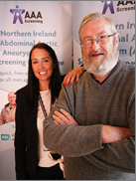
- In July 2018 we were delighted to announce the appointment of two new patient representatives to the NI AAA Screening Programme’s Coordinating Group. Mr Robert Connolly and Mr John Toner have both had an AAA detected through screening and are currently under the care of the surveillance element of the programme. Mr Connolly is pictured left with Deputy Programme Manager, Sarah Louise Dornan, at the 2018 Service User Event. The picture of Mr Toner (below right) is part of a feature run by the Belfast Telegraph last year to celebrate 70 years of the NHS.

Section 9:
Role of Primary Care
_____________________________________________________________

Primary Care teams are integral to the successful delivery of the NI AAA Screening Programme. Since the programme began in 2012, the considerable contribution and partnership working with primary care teams has been invaluable, particularly in the areas outlined below.

Supporting men with a screen-detected AAA

When an aneurysm is detected, the programme informs the man’s GP practice by telephone on the same day. This is followed up in writing.

GPs are then asked to arrange to take measurements for height, weight, BMI and blood pressure, and consider commencing the man on anti-platelet and statin therapy (unless contra-indicated).

For men with a large AAA, GPs are also asked to make a standard referral to the vascular team for further intervention / treatment and to arrange an urgent blood test (U&E).

GPs are the key providers of aftercare for men who have undergone surgical repair.

Providing information to facilitate screening appointments for eligible men

The programme continually liaises with primary care on a range of issues such as:

- Ensuring patient records are accurate – information is downloaded into the programme’s IT system on eligible men registered with GPs; programme staff liaise with practices about any discrepancies

- Seeking information about particular needs of men invited for screening, eg a physical or sensory disability, limited mobility or a learning disability – this helps facilitate the screening appointment and allows appropriate arrangements to be made eg extra time for the appointment if required

- Organising an appropriate interpreter or signer when required to facilitate an appointment

Promoting screening

People often rely on the advice of primary care teams when making health decisions. It is therefore important that these teams are well informed about the programme and can discuss the benefits and risks of AAA screening to enable eligible men to make an informed choice.

GPs are notified when a man does not attend his screening appointment. Some GP practices, upon being informed of non-attendance, will either talk to men opportunistically about screening or proactively contact men to specifically encourage attendance.

Primary care teams have continued to actively promote the programme during 2018-19 to those over 65 and eligible to self-refer. Most men who self-referred to the programme in 2018-19 did so after being advised of the programme by their GP / pharmacist, or after seeing a poster in the practice waiting area. In particular, GPs have recommended screening to eligible men who have a strong family history of AAAs.

The AAA Team Newsletter

During 2018-19, further editions of the newsletter ‘The AAA Team’ were also produced. This newsletter, aimed at healthcare professionals, is an important vehicle for the programme to continually engage with primary care teams.

In the 2018 Summer edition updates were provided on the addition of subtitles to the four videos about the AAA Screening Programme, promotion of the programme at the Balmoral show, review of letters and the sixth service user event.
Section 10:
Programme Promotion
_____________________________________________________________

Evidence of the successful promotion of the programme in 2018-19 is demonstrated by the 211 men who self-referred for AAA screening.

Men’s Sheds

Partnerships have continued to be developed between AAA screening and a number of Men’s Sheds across the country.

Men's Sheds originated in Australia to help improve the health and wellbeing of all males. Typically, a Shed is a larger version of what a man might have in his back garden – a place where he feels at home, pursuing practical interests on his own terms. The men share tools and resources to work on projects they’ve chosen at their own pace in a safe, friendly and inclusive venue. Many Sheds also welcome information sharing initiatives on a wide range of topics including healthcare. Some Sheds target older men to reduce the potential risks of social exclusion and any reduced access to healthcare they might encounter with ageing.

During 2018-19, representatives from the programme attended a number of Men’s Sheds’ local meetings to talk about the programme to members.

Health fayres and older peoples’ events

Programme staff attended a number of these events during 2018-19 to promote the programme. This included the Balmoral Show in May 2018.

Maximising promotional opportunities at existing screening locations

On an ongoing basis, screening technicians ensure promotional materials are available at all 24 venues across NI where they run clinics. They ensure all the venues are well stocked with posters, promotional packs and leaflets. They also continue to engage with staff in the venues and nearby GP surgeries, dental practices and pharmacies to make sure they are aware of the work of the programme.

Section 11:
Governance and Accountability
_____________________________________________________________

The Public Health Agency

The Public Health Agency has a number of key functions in relation to screening programmes including:

- Leading on the implementation of screening policy, including the introduction of new screening programmes and any changes required to existing screening programmes

- Ensuring the delivery of high quality, safe, effective and equitable screening programmes for people in Northern Ireland

- Supporting continuous quality improvement through programme monitoring and evaluation, and adverse incident investigation and management

The Agency takes lead responsibility for quality assurance (QA) of the programme. This involves the establishment of a robust QA structure and function, to ensure it meets the responsibilities outlined above.

Appendix 3 details the PHA’s governance and accountability reporting arrangements.

The Belfast Health and Social Care Trust

The Belfast Health and Social Care Trust is responsible for the operational management and delivery of the NI Abdominal Aortic Aneurysm Screening Programme.

The Trust ensures all eligible men are invited to attend for screening in their 65th year. It ensures they are provided with appropriate information, support and advice, particularly those men who have an AAA detected through the programme.

Staff who have responsibility for the operation of the programme are employed by the Trust and carry out all of the scans, including rescans and surveillance scans.

The surveillance programme for men identified with a small or medium AAA is provided by the Trust as part of the NI AAA Screening Programme. Those men who are identified with a large AAA are referred to the vascular surgery team at the Royal Victoria Hospital within the Belfast Trust to discuss potential treatment options.

The Trust also has responsibility for:

- Setting operational policy for the programme and ensuring appropriate failsafe systems are in place

- Liaising with GPs regarding secondary care, particularly when a man is detected as having an aneurysm

- Local quality assurance of the entire screening process

- Providing reports on the performance of the programme and data for quality assurance purposes

- Engaging with stakeholders regarding development of the programme

- Organising and taking part in promotional activities for the programme

Appendix 4 details the Belfast Trust’s governance and accountability reporting arrangements.

Audit and Research

Both organisations take joint responsibility for developing and facilitating audit and research activities related to the programme as and when these become available.

Section 12:
Future Developments
_____________________________________________________________

The NI AAA Screening Programme (NIAAASP) remains committed to continued development of the programme, building on achievements to date and continuing to improve the AAA screening experience for service users.

Whilst continuing to deliver on the core objectives of the programme as outlined in Section 3 of this report, during 2019-20 the programme will:

- Review the feedback from the External Quality Assurance (EQA) visit from Public Health England and English NHS AAA Screening Programme colleagues and implement any agreed changes. This is in line with the rollout of the NIAAASP’s EQA function and structure.

- Continue to support and engage with the Patient Representatives who are part of the programme’s main management group (the Co-ordinating Group) to ensure continuity of service user involvement and build on existing successful engagement initiatives

- Prepare for the seventh annual service user event

- Continue to participate in and contribute to the AAA Screening Four Nation online Health Inequalities’ Toolkit to help identify and address inequalities within the NI AAA Screening Programme

- Continue to work in partnership with appropriate prison healthcare providers to facilitate screening clinics for eligible men

- Consider any further opportunities to raise general awareness of the programme and encourage further self-referrals, eg through promotional opportunities and continued engagement with Men’s Sheds, etc

- Continue engagement with GPs and other primary care teams to raise awareness of the programme and continue to promote the self-referral pathway, eg by attending flu clinics

- As appropriate, identify additional venues to enable AAA screening to be provided within local areas

Appendices
_____________________________________________________________

1 | Map of Screening Locations
2 | The Screening Pathway
3 | Governance and Accountability Structure: Public Health Agency
4 | Governance and Accountability Structure: Belfast Health and Social Care Trust

Appendix 1 – Map of Screening Locations

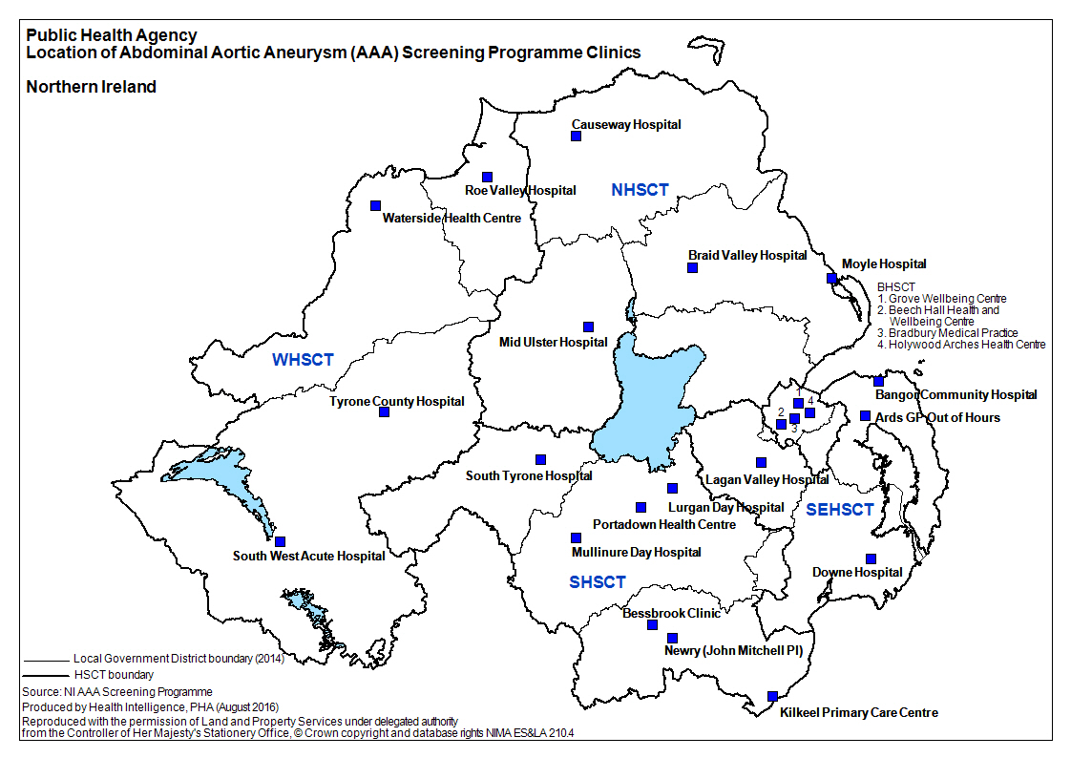

Appendix 2 – The Screening Pathway
_____________________________________________________________

surveillance
Abdominal ultrasound scan
Invite for screening
Vascular
surgery
referred
No aneurysm
(approx. 98.5%)
Large Aneurysm ≥ 5.5cm
(approx.0.1%)
discharged
Identify screening cohort
Small / Medium
Aneurysm
3cm – 5.4cm
(approx. 1.4%)
Appendix 3 – Governance and Accountability Structure: Public Health Agency
_____________________________________________________________

Chief Executive

Assistant Director of Screening
& Professional Standards
NIAAASP
Co-ordinating Group
NI Abdominal Aortic Aneurysm Screening Programme (NIAAASP)
Public Health Lead
QA & Commissioning Manager
Director of Public Health

Administrative Assistant
Appendix 4 – Governance and Accountability Structure: Belfast Health and Social Care Trust
Organisational chart as at March 2017
Chief Executive

Executive Director
Surgery & Specialist Services
Medical Director

Associate Medical Director
Co-Director Surgery Services

Services Manager
Specialist Surgery
AAA Screening Imaging Lead
AAA Screening Clinical Lead

Clinical Co-ordinator - Vascular, Plastics & Burns

AAA Lead Screening Sonographer
AAA Screening Programme Manager
Vascular Nurse Specialists (AAA)

Deputy AAA Screening Programme Manager
AAA Screening Technicians
AAA Screening Administration Team

If you are interested in finding out more about being screened please contact the Screening Programme Office on 02896 151212.

Abdominal aortic aneurysm: the UK NSC policy on abdominal aortic aneurysm screening in men over 65. UK Screening Portal. Available at: https://view-health-screening-recommendations.service.gov.uk/abdominal-aortic-aneurysm/
https://www.vascularsociety.org.uk/_userfiles/pages/files/Document%20Library/VSGBI-AAA-QIF-2011-v4.pdf
https://www.gov.uk/government/publications/aaa-screening-standard-operating-procedures
www.NISRA.gov.uk
Data for the 2018-19 cohort are as at 30/06/2019 to allow time for screening episodes to be completed; data for self-referrals and men on surveillance is as at 31/03/2019
2018-19 data was run from the live AAA IT system on 8th June 2022 . Data shown is extracted from a live system and so will differ slightly from other published data due to different run dates.
Impact of the first 5 years of a national abdominal aortic aneurysm screening programme Jacomelli J, Summers L, Stevenson A, Lees T, Earnshaw JJ Br J Surg. 2016 Aug
https://www.gov.uk/government/publications/population-screening-our-approach-to-screening-standards/our-approach-to-nhs-population-screening-standards#performance-thresholds
https://journals.sagepub.com/doi/10.1177/096914130301100112
https://onlinelibrary.wiley.com/doi/pdf/10.1002/bjs.9803

