

Recording of nursing/midwifery/AHP observations/interactions between parent/carer and children considered “at risk” or where there are safeguarding concerns.
(Regional Guidance for Acute Hospital Settings)

Version 2: September 2026
Review: September 2029

Introduction
The primary responsibility for safeguarding children and young people rests with their parents or carers. However those who work with children, young people or families, in whatever capacity, have a particular responsibility to promote their welfare and ensure they are safe. Nurses, midwives and allied health professionals play an essential role in ensuring that children and families receive the care, support and services they need to promote children’s health and development. This includes the importance of careful observation and recording of parent-child interactions during any hospital admission.

All practitioners involved in caring for children in hospital settings have the opportunity to observe parent-child interactions. This should be considered an essential element in the recognition of children considered “at risk” or where there are child safeguarding concerns. Over the past three decades, research has consistently reflected the importance of nurturing, responsive interactions that children have with their parents and their caregivers. The quality of parent-child interaction plays a crucial role in social and emotional development outcomes, not only in infancy, but throughout the life span.

Background
The Safeguarding Board for Northern Ireland (SBNI) undertook a Case Management Review under the name of Francis (CMR) http://www.safeguardingni.org/publications in relation to a young baby who sustained significant injuries. In this particular case a young baby had been in hospital for a period of time and whilst the ward staff had noted telephone calls and visits by the mother and her partner the detail of the quality of the contact was not recorded. This was viewed as a significant gap. The CMR team therefore recommended a structured recording format be introduced in all maternity wards, neonatal intensive care units and paediatric wards where children are admitted and are deemed to be at risk of harm and where those children are either cared for or visited in hospital by parents/carers, or others who may potentially pose risk to the child.

In response to this recommendation the Regional Nursing, Midwifery and Allied Health Professional Safeguarding Children Forum developed a regionally agreed recording sheet and associated guidance for practitioners. This guidance for practitioners has been embedded in practice since 2017 and recently has been incorporated into the regional Encompass Electronic Care Record. This revision therefore replaces:
- Regional Guidance for Acute Hospital Settings. Recording of Nursing/Midwifery/AHP Observations/Interactions between parent/care giver and children considered “at risk” or where there are safeguarding concerns (PHA, 2017)

Purpose of observing parent – child interactions
The purpose of observing parent-child interactions is to determine both the strengths and challenges in the interplay between parent and child. Positive parent-child interaction involves evidence of warm parental support and includes behaviours that convey acceptance, sensitivity and responsiveness to the child’s needs.

Children who experience poor parent-child interactions often fail to develop a secure attachment relationship with their parent, which can lead to long-term social and psychological problems. While neglect is a failure to provide adequate care, there are identifiable features in the interaction between neglected and/or emotionally abused children and their care-givers.

Gathering and interpreting information, in cases of children deemed to be at risk or where there are safeguarding concerns can be challenging in complex, multi-agency environments. Continued use of the regionally agreed recording sheet (Appendix 1) and associated Aide Memoire (Appendix 2), both now within Encompass, will facilitate a consistent approach in relation to capturing, analysing and sharing of relevant information between acute settings and children’s services to improve outcomes for children and young people.

Working with families
As in any area of child protection work it is of utmost importance to be open and transparent with parents and children. Staff should explain their role in observing parent-child interactions and the use of the observation recording sheet as a means of sharing information with other members of the multi-disciplinary team involved in the child’s care. Developing a focus on observing parent-child interactions for children where there are safeguarding concerns will not only help staff to identify and build on any strengths but also help identify areas of weakness which can be discussed at a multi-disciplinary level to ensure appropriate supports and/or interventions can be put in place to address any identified risks or needs.

Where significant or immediate concerns arise about a child’s safety staff should follow Regional Safeguarding Children Policy and Procedures and refer concerns to the appropriate hospital/ community social worker. Nurses, midwives and AHPs should also liaise with their Safeguarding Children Nurse Specialist/designated safeguarding lead for advice and support as required.

Recording sheet
The observation recording sheet is a multi-disciplinary record that can be completed by any staff involved in the child’s care and is built into Encompass as a flow sheet within the Child Safeguarding Encounter. It is intended that the observation recording sheet, is used in all maternity wards, neonatal wards, paediatric wards and general wards where children/young people may be admitted across the five Health and Social Care Trusts and are deemed to be “at risk” of harm or where there are identified safeguarding concerns. If a safeguarding concern is being considered, all professionals must record this and commence the flow sheet. The frequency of recording will depend on each individual case considering, for example, the visiting pattern of the parents/carers, whether they stay on the ward with the child, the actual interaction or care given by them and the frequency and nature of the health intervention by each professional. This may be determined and recorded in the nursing/midwifery care plan but may not be prescriptive to allow for recording at any time. Where parents/carers are staying with the child, nursing/midwifery observations must be recorded throughout the 24 hour period at various times.

The senior nurse/midwife on duty for example the ward sister, charge nurse/midwife or nurse/midwife in charge is responsible for ensuring that nurses, midwives, medical staff and AHPs caring for children and babies are aware of the recording sheet and how it should be used.

In providing a summary of the observation it will be useful to consider what should be recorded in respect of parent-child interactions. Key areas have been identified as indicators for positive parenting and include bonding and attachment, personal care, feeding, handling and general parenting behaviour. Whilst this list is not exhaustive it will assist practitioners in thinking more holistically and widely in respect of how parents/carers interact with their children.

Aide memoire
The Aide Memoire is displayed within the Flow sheet, once a Child Safeguarding Encounter is opened on Encompass.

Awareness raising
Trusts should ensure that this guidance is included in new staff induction for the relevant departments. It is mandatory for all Trust staff to complete Encompass training via LearnHSCNI/Learning Management System (LMS) and this is further supported by guidance from senior staff within departments and Encompass champions across all Trusts.

Review
This guidance document will be reviewed in September 2029 to ensure it remains fit for purpose, and reflects any relevant developments in safeguarding practice, policy and legislation.

If you have any comments on how this guidance can be improved, please contact:
Emily Roberts
Interim Director of Nursing (PHA)
Emily.roberts@hscni.net

Appendix 1: Regional Observations/Interactions Recording Sheet for Neonatal, Children’s and Maternity Units
Date  (dd/mm/yy) | Name of Parent/  Care Giver | Arrival  Time  (24 hr clock) | Departure Time  (24 hr clock) | Location i.e.  side-room,  open-bay  rooming in | Observations | Name:  Signature: Designation:
Name __________________________ Hospital No. ____________________________

This record is embedded into Encompass Flow Sheet within the Child Safeguarding (CSG) Encounter:
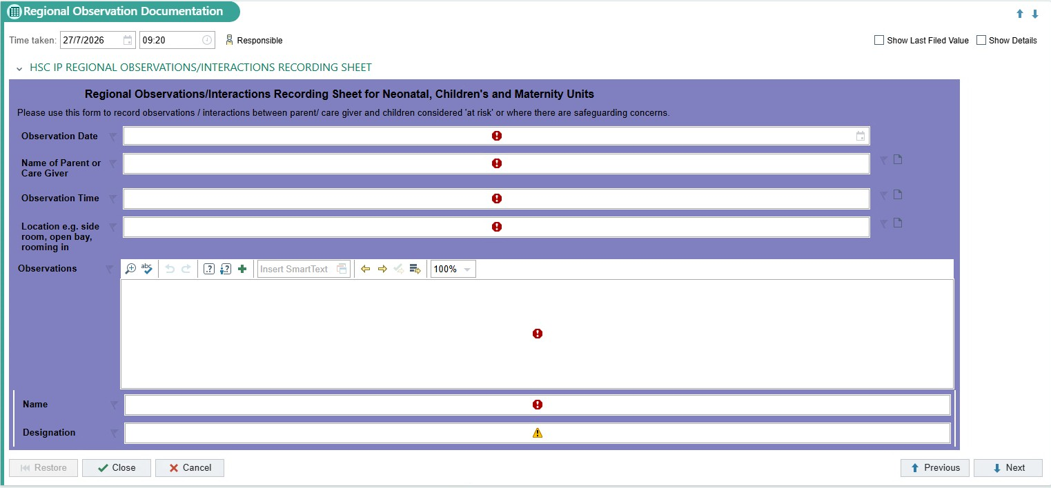

Appendix 2: Aide Memoire. Recording of observations / interactions between parent / carer and children considered “at risk” or where there are safeguarding concerns
This Aide Memoire is embedded in Encompass within the Child Safeguarding Encounter (CSG) and is to be used as a prompt for staff for areas to observe and record. This list is not exhaustive.
Area | Questions/prompts
Bonding/Attachment/Interaction  (Remember to ask parents how they feel about their baby/child) | - Is there eye contact, smiling between parent/carer and baby/child?  - Does parent/carer respond to baby/child who needs attention?  - Is there evidence of affection?  - Does parent/ carer use appropriate speech/tone of voice?  - How does baby/child respond to parent/carer?
Personal care | - Does parent/ carer prepare for and carry out bathing, nappy changing and dressing as expected?  - Do they require prompts/reminders?
Feeding | - Does parent/carer respond to baby’s cues for feeding and or child’s hunger?  - Do parents/carers have an awareness of how much/often to feed?  - Do parents assist child with menu choices and feeding at mealtimes as appropriate?
Handling | - Are parents/carers confident in handling baby/child?
General Parenting Behaviour | - Are parents receptive to advice?  - Is there any parental conflict? How do parents interact with each other?  - Is there parental insight? Do they recognise and ask for help when required?  - Do parents/carers have ability to understand and implement information received on the care of their baby/child?
Contact | - Record duration of observation  - Was there anyone else present?
This record is embedded into Encompass Flow Sheet within the Child Safeguarding (CSG) Encounter:
