

3+ Review

Guidance for Pre-school Education Teachers and Leaders

Health and Education Working in Partnership to Support Pre-school Children

Version 5
Date Issued: August 2026
Date for Review: August 2027
INTRODUCTION
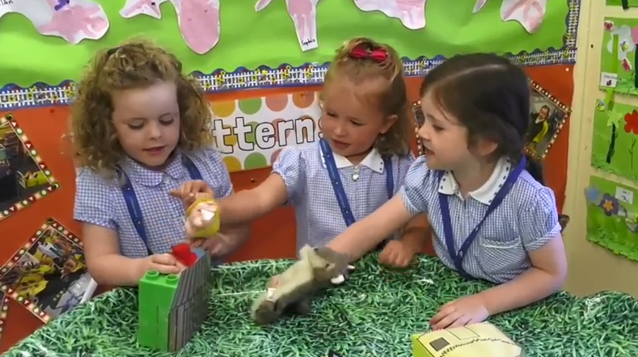

“Each child brings unique personal experiences to a new setting, including home environment, neighbourhood, and level of ‘readiness.’ These experiences will be both positive and negative and must be fully embraced and considered.”
Curricular Guidance for Pre-School Education, CCEA June 2018

The 3+ Review is a joint Health-Education initiative, initially introduced as part of the Early Intervention Transformation Programme (EITP). The 3+ Review links with the pre-school curricular guidance, providing parents and practitioners with valuable information that can be used to support a child’s development. The information also enables early identification of needs, and where necessary appropriate referral to support services.

This guidance has been developed to maximise the potential of health and education working collaboratively to improve outcomes for children and to support the planning and delivery of the 3+ Review by a member of the Health Visiting team in partnership with pre-school education settings and parents/carers.

Pre-school education settings recognise that parents/carers are the child’s first and continuing educators, who provide a wealth of information about each child on entry to pre-school.

Each DE funded pre-school education setting has a named health visitor who, with the co-operation of parents/carers and staff, will plan the initial meeting to discuss the 3+ Review. This may take place within a pre-school setting / home or clinic. If you are unsure who your Health Visitor is, you should contact your HSC Trust who can advise (contact details attached at Appendix 1).

The Review will help to assess children’s overall development at this key stage and also identify any developmental needs; facilitate early provision of support where required or onward referral if needed and assist the pre-school in planning.

The pre-school curricular guidance recognises and emphasises that all children are different and develop at different rates.

Pre-school education aims to develop the whole child by:
- promoting emotional, social, physical, creative, and intellectual development;
- developing self-esteem, self-control, and positive attitudes towards others;
- developing language and communication skills to encourage the sharing of thoughts and feelings; and
- creating confident, eager, enthusiastic, independent, curious learners with a positive and problem-solving attitude to learning.
Curricular Guidance for Pre-school Education, CCEA June 2018, Page 5

The 3+ Review focusses on social and emotional development and therefore can support the setting in planning for the delivery of the pre-school curriculum.

The 3+ Review is usually carried out in 2 stages:
- completion of a questionnaire by the child’s parent/carer;
- a meeting between the health visitor and the parents/carers to discuss the child’s development, including the information provided in the completed questionnaire.

The Ages and Stages Social and Emotional questionnaire, ASQ:SE-2 (See sample at Appendix 2) is used for the 3+ Review, and focusses on seven key areas of behaviour:

Self-regulation | Calming, settling down, or adjusting to physiological or environmental conditions or stimulation
Compliance | Conforming to others’ direction and following rules
Communication | Interacting with others by responding to or initiating signals to indicate interests, needs, and feelings
Adaptive functioning | Coping with psychological needs
Autonomy | Self-initiation or responding without guidance
Affect | Demonstrating feelings and empathy to others
Interaction with people | Responding to or initiating social responses to parents, older adults, and peers

Following the Review meeting with the parent/carer, the health visitor will provide feedback to the pre-school education setting. In addition to identification of need, this information can inform planning for the whole class, or for individual children.
Note: Parents must provide consent for information to be shared about their child.

WHO IS INVOLVED?

The 3+ Review involves the pre-school child, the parents/carers, health visitor, health care assistants, and pre-school education practitioners, working together to build a picture of the child, inform planning and identify any areas for development.

The 3+ Review is offered to children in DE-funded mainstream pre-school education.

Parents are encouraged to take part in this collaborative approach to improving outcomes for children. If the parent/carer does not wish to complete the ASQ:SE2 questionnaire, e.g. if they feel that it is not suitable for their child, they should still be encouraged to attend the 3+ Review meeting with the health visitor, to have a discussion about their child’s development and receive advice on any support the child may benefit from. Equally, if a child is already getting support from various health and education services, parents/carers should still be encouraged to be involved in the 3+ Review. Practitioners may wish to explain that the review process can provide valuable information to support the child at home and within the setting.

Supporting newcomer families to participate in the 3+ Review
We recognise that some families may find it difficult to complete the ASQ:SE2 questionnaire if English is not their first language. Developers of the Ages and Stages Questionnaire advise that it does not lend itself to translation into other languages, and therefore at present it is only available in English. If parents are unable to complete the questionnaire a review meeting will still be offered.

Settings should provide parents with the information leaflet in the appropriate language (Appendices 4 & 5), also available for download at: https://www.publichealth.hscni.net/publications/3-review-parent-letter-english-and-translations and encourage them to attend the review meeting. The health visitor will arrange for an interpreter to be present, if required.
3+ REVIEW SUMMARY
1. Getting Started
Pre-school education setting informs parents about the 3+ Review during induction where possible

health visitor contacts setting to make arrangements

- All children in their pre-school year , within this setting , will be offered a 3+ Health Review

2. Planning Meeting
Pre-school education teacher/leader and health visitor meet to make arrangements for the 3+ Review

- All children in their pre-school year, within this setting, will be offered a 3+ Health Review

3. Questionnaire for parent/carer
Pre-school education setting issues and collects completed questionnaires

Health visitor analyses completed questionnaires

l

- All children in their pre-school year, within this setting, will be offered a 3+ Health Review

4. Review meeting
Health visitor meets with parent and child in the pre-school education setting/at home or Clinic

- All children in their pre-school year, within this setting, will be offered a 3+ Health Review

5. Follow-up
Feedback to pre-school education setting to support planning and referrals as required - subject to parental consent

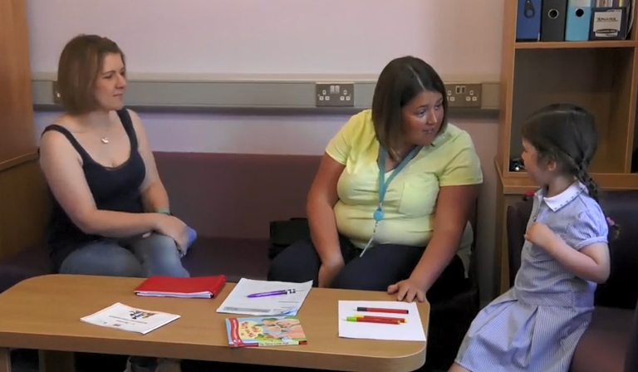
- Getting started

The pre-school education setting will inform parents about the 3+ Review during the induction process where possible. Information may be included in the pre-school induction booklet and/or the pre-school website.

Support materials are available that can be shared with parents, including a parent information flyer (Appendix 3).

Class lists will be transferred securely prior to start of academic year from the Education Authority to the NI Child Health System, following allocation of pre-school places. Parents will be invited to provide consent on their pre-school admissions form for sharing of information.

The health visitor will contact the pre-school to arrange an initial meeting to discuss the planned 3+ review.

- The Initial Meeting

The pre-school education practitioner and health visitor meet to plan the 3+ Review process. The meeting will usually take an hour and should happen as early as possible in the first term.

The purpose of the meeting is to:

- Discuss delivery of the 3+ year review;
- If required, set dates for 3+ Review and follow-up meeting;
- arrange distribution and collection of questionnaires;
- check the class list (only children in DE-funded pre-school education will be invited to attend);
- discuss any relevant information about individual children, e.g. relating to health or educational needs;
Note: If pre-school education practitioners wish to discuss individual children, consent must be obtained from parents before any information is shared.

- identify any parents/carers who may need help to complete the ASQ:SE2 questionnaire and agree together how to best facilitate this;
- identify suitable space for 3+ Review meeting, within the pre-school setting (including waiting area) if applicable;
- organise suitable resources for children to play with during the 3+ Review

3. Questionnaire for Parent /Carer
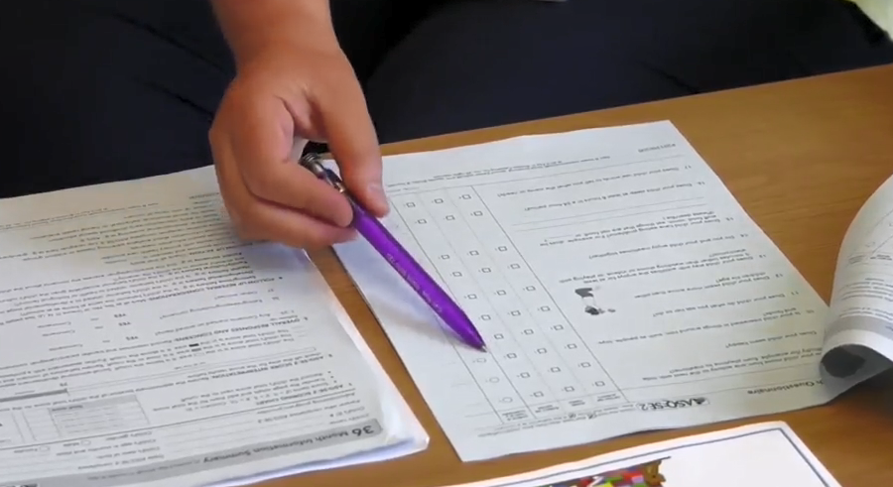

The pre-school education setting distributes and collects completed questionnaires and informs parents/carers of their Review date at least two weeks beforehand.

The parent/carer completes the questionnaire at home. This usually takes 10-15 minutes. If any parent requires help, the support agreed at the planning meeting is provided.

The parent returns the questionnaire to the pre-school.

The health visitor collects and analyses the questionnaires, in preparation for the 3+ Review meeting.

4. Review Meeting
The Review meeting can take place in the home/clinic or in the pre-school. If the meeting occurs in the Pre-school or clinic staff will direct parents/carers to the waiting area.

The health visitor sees the parent and child at the arranged time.
(If a parent cannot attend, where possible, a date should be arranged for another meeting)

During the review meeting, the parents/carers and health visitor will be able to observe and interact with the child as he/she is playing.

The health visitor will discuss the child’s development, using the questionnaire as a starting point. This will include:

Social skills | - how child is starting to make friends and interacting with friends / showing affection  - expressing emotions and developing imagination  - developing self-care / self-esteem / concept of self
Cognitive development | - problem-solving / creative play  - verbal / non-verbal reasoning
Behaviours | - toileting training /feeding /sleeping  - responding to instruction
Speech, language & communication | - eagerness to give and receive information verbally  - ability to talk in sentences most of the time and asks questions  - clarity - understood most of the time by health visitor / others not familiar with him/her
Fine-motor skills | - control of equipment, e.g. use of cutlery, pencils, scissors, etc.  - ability to manipulate materials e.g. play-dough, building blocks, threading
Vision and hearing  (If concerns are raised) | - will be discussed further with parent/carer to understand any concerns.

The health visitor will provide practical advice to help the parent/carer support development at home. If the parent/carer wishes to talk to the health visitor at the end of the meeting without the child present, arrangements should be made to do so. The health visitor will provide feedback to the setting. Parental consent is required before sharing information about individual children.

If a referral for intervention or support is required, the health visitor will liaise with the family health visitor.

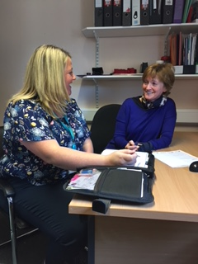
5. Follow-up

The pre-school education teacher / leader will meet or have a telephone call with the health visitor to receive general feedback on areas highlighted during the review that may:
- inform medium and short-term planning within the pre-school education setting;
- provide a focus for parent/carer information sessions and workshops.

With parental consent, the health visitor will also share information regarding specific areas for development required for individual children and discuss future steps to enable targeted support within the pre-school education setting, if appropriate.

In addition, the health visitor may make a referral to the family health visitor or to other agencies as required.

This process does not replace other routes of referral for the pre-school setting. Pre-school education practitioners should continue to make referrals to appropriate agencies, as required.
Practitioners should ensure that relevant personnel, e.g. SEN Coordinators or Child Protection officers, are involved in the process as appropriate, and kept informed about planned intervention.

The health visitor will record the outcome of the 3+ Review, including any referral for intervention or support, and any action agreed by the pre-school on the CHS70 form. The health visitor will record follow-up information on the CHS71 form. This information will then be recorded on the Northern Ireland Child Health System.

Appendices

Appendix 1
HSC Trust contacts

HSC Trust contacts Trust area |  | Email
Belfast Health & Social Care Trust |  | SineadX.hanna@belfasttrust.hscni.net
Northern Health & Social Care Trust |  | Pamela.mcbride@northerntrust.hscni.net
South eastern Health & Social Care Trust |  | Cathy.Burke@setrust.hscni.net
Southern Health & Social Care Trust |  | Marie.doran@southerntrust.hscni.net
Western Health & Social Care Trust |  | Omagh / Fermanagh:  Susan.Rogers@westerntrust.hscni.net
Western Health & Social Care Trust |  | L/Derry / Strabane:  Joyce.McKittrick@westerntrust.hscni.net

Appendix 2
48 Month Questionnaire
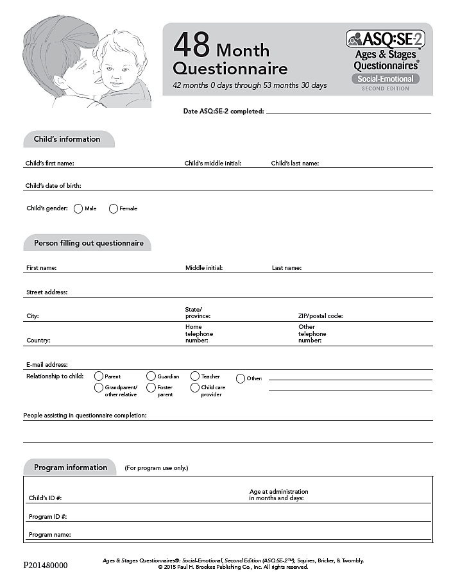
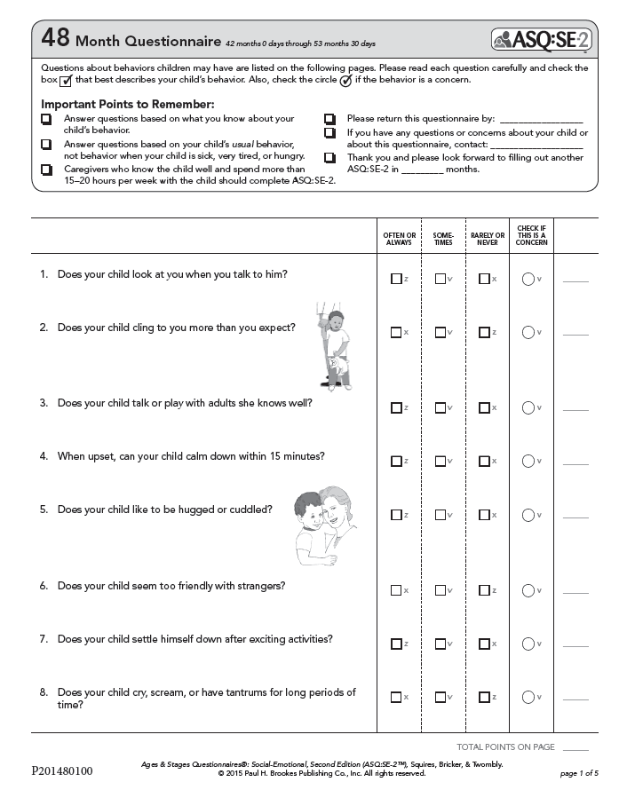

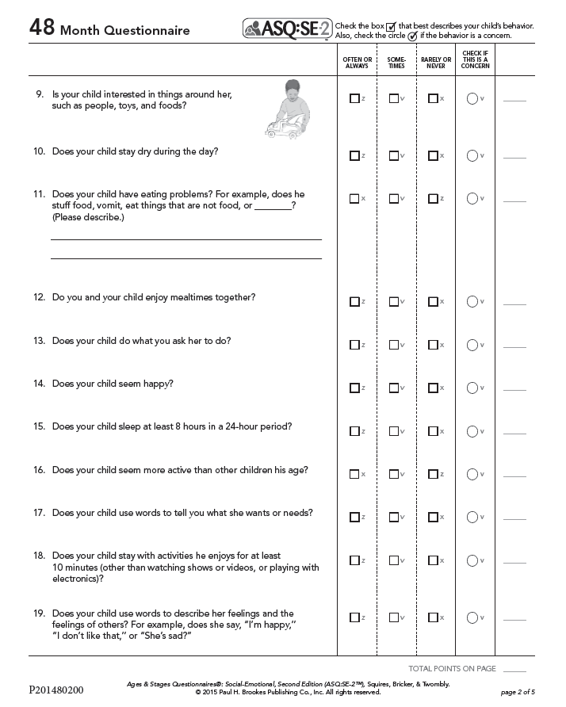

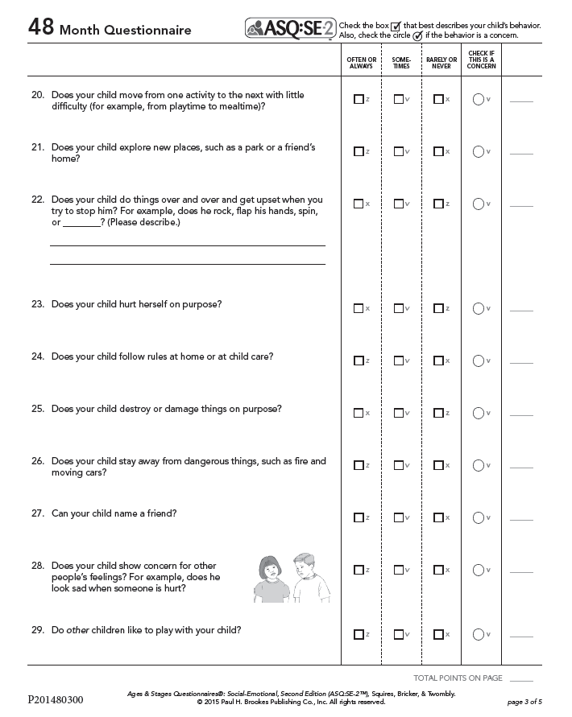

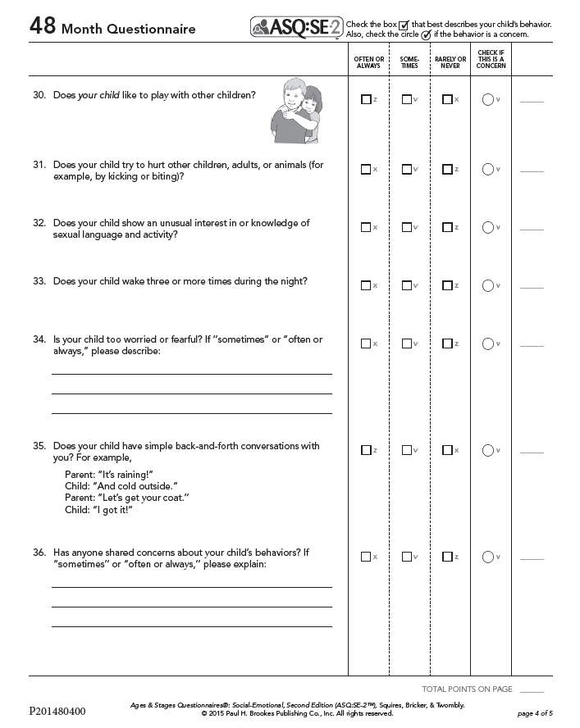

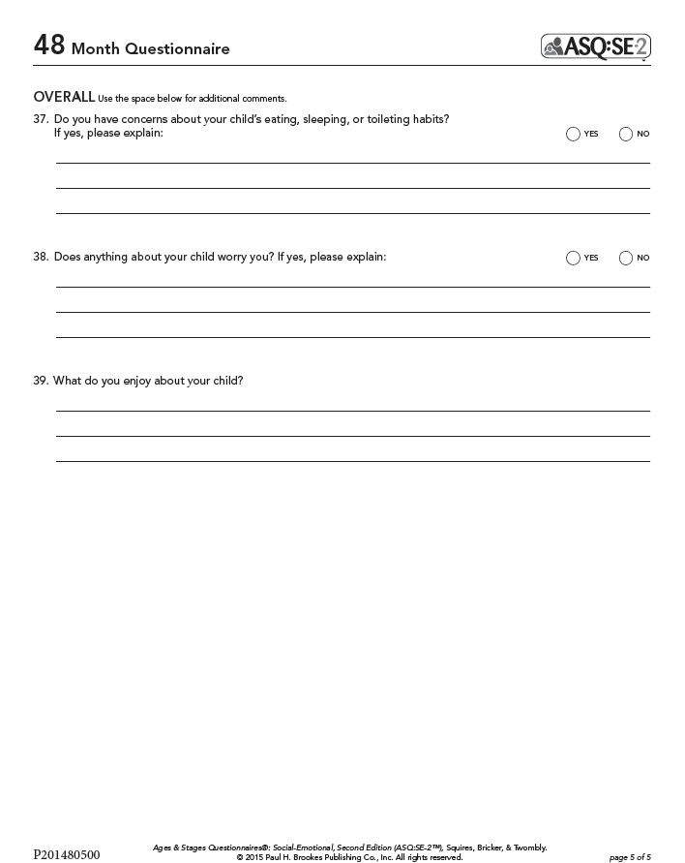
Appendix 3
3+ Review Flyer for Parents

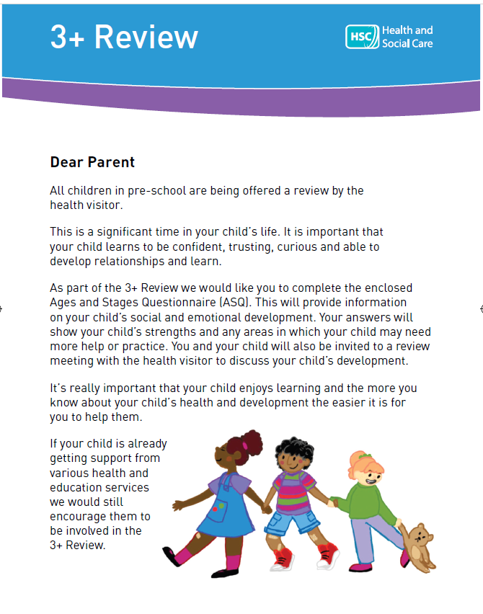

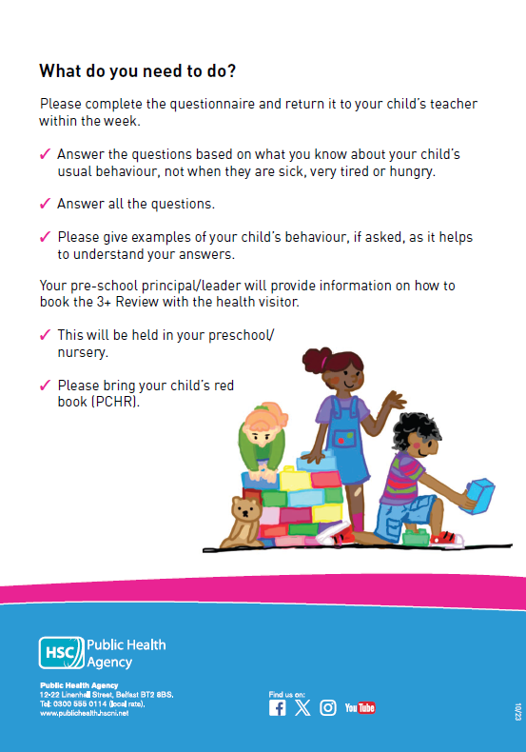

Appendix 4
3+ Review Flyer for Parents - Translations

Appendix 5
3+ Review Parent Flyer – Languages

- Arabic
- Bengali
- Bulgarian
- Chinese complex
- Chinese simplified
- Czech
- Farsi
- French
- Hindi
- Hungarian
- Irish
- Italian
- Latvian
- Lithuanian
- Polish
- Portuguese
- Romanian
- Russian
- Slovak
- Somali
- Spanish
- Tagalog (Filipino)
- Tetum

The Early Intervention Transformation Programme (EITP) was a Northern Ireland Executive /Atlantic Philanthropies Delivering Social Changes Signature Programme (2015-2019), funded jointly by the Delivery Social Change fund, DoH, DE, DoJ, DfE and the Atlantic Philanthropies. EITP aimed to improve outcomes for children and young people across Northern Ireland through embedding early intervention approaches.
There are different versions of the ASQ:SE-2 questionnaire according to the age of the child. The health visitor will determine which questionnaire is appropriate.

